Connector

**Description:** Create Dynamic Form (input, option, radio) Fields Using Json File.

**Json Format**: Always Data Prefer Like this.

**Demo Data :** assets/ appConfig.json and assets/ validation.json (App Path)

{

"Service1": {

PlcConfig:[{

"Parameters": [

{

"Name": "Switch_Status",

"Device": "Y",

"Address": "1",

"DevicePoints": "1",

"ResultDataType": "Int32"

}]

}],

"RabbitMQConfig": {

"HostName": "10.167.96.47",

"VirtualHost": "YMC",

"UserName": "ymc-user",

"Password": "yamaha",

"Exchange": "YMC-Direct",

"RoutingKey": "YMC-Direct.YMC-Hamakita"

}

},

"Service2": {

"Source": {

"HostName": "127.0.0.1",

"VirtualHost": "/",

"UserName": "admin",

"Password": "admin"

},

"Destination": {

"HostName": "10.167.96.47",

"VirtualHost": "/",

"UserName": "admin",

"Password": "admin"

}

}

1. Object Service1**,** Service2 used for Create Tabs.

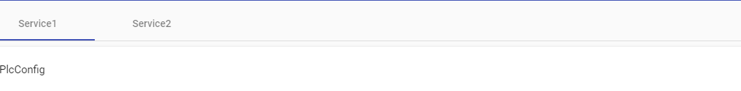

1. Object PlcConfig and RabbitMQConfig Used to create Expanded and Collapse Panel



1. Object Parameters Used to create Add and Remove Parameters Layout.

1. For Type Casting and Validation of Form Field Using validation.josn
2. Json Format for Data Type Casting Example Json

{

"Service1": {

"PlcConfig": {

"DeviceCode": {

"Type": "text"

},

"PlcSeries": {

"Type": "option",

"Options": [ "QL"]

},

"ReadIntervalInMilliseconds": {

"Type": "number"

},

"WaitForConfirmsOrDie": {

"Type": "boolean"

}

}

}

}

1. For Create Input Text Field Use {“Type”:”text”}
2. For Create Input Number Field Use {“Type”:”number”}
3. For Create Select Field Use {“Type”:”option”,”Options”:[“A”,”B”,”C”]}
4. For Create Radio Field Use {“Type”:”boolean”}
5. If You not assign any validation.js or type casting it will calculate typeof value assign to {Type: typeof value } for every field.