RESUME

Name - Vikas Gupta
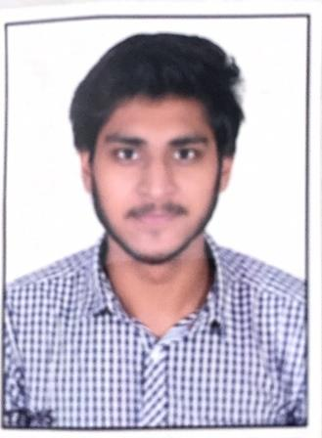

D.O.B - 27/06/1995

Mobile - 9589501324

E-mail - vikasg2512@gmail.com

Career Objective:

To foster a challenging career and to establish a competitive advantage for myself by aligning my career goals with organization goals and help in the growth and betterment of the esteemed organization. Also work in a progressive and stimulating work culture with the freedom to be creative, innovative and to excel in my area of work

Training:

- JAVA/J2EE Fresher’s Training DEC-2016/MARCH-2017

- Training at Cetpa Infotech 2015

Professional Work Experience:

- Project – BGC (Nov’2017 till present)

Company : Capgemini

Client : GE

Role : Developer

Developing an application for BGV of an employee.

- Responsibilities :

  - Requirement gathering and designing a flowchart

  - Working as Software developer with backend as Spring and frontend as AngularJS
- Project – ILM (May’2017-Nov’2017)

Company : Capgemini

Client : GE

Role : Developer

ILM (Inventory lifecycle management) comes under GE Power

- Responsibilities :

  - Worked as a developer on Spring technology.

.

Key Skills:

- Functional: Team Leader, Strategic Planning, Excellent Communication skills and Interpretation skills
- Technical: C/C++, Core Java, Spring, AngularJS, Python , Html/CSS, SQL

Education:

Degree | Percentage | Board/ University | Discipline | Qualifying year
Bachelor of Engineering | 7.19 | R.G.P.V. | Electronics and Communication | 2016
12th | 67 | C.B.S.E | Mathematics + science | 2012
10th | 70.3 | C.B.S.E | ------------ | 2010

Achievements & Extra Curricular Activities:

- Achieved 1st rank in school and 2nd rank in city in INTERNATIONAL MATHEMATICS OLYMPIADS.
- Achieved Level B2 in the Business English Certificate – Council of Europe conducted by University Of Cambridge, UK

