**Vinkle Khan**

|  |  |
| --- | --- |
| **Title:** | Analyst/Software Engineer |
| **Location:** | Chennai, India |
| **Languages:** | Punjabi, Hindi, English, German(conversational) |

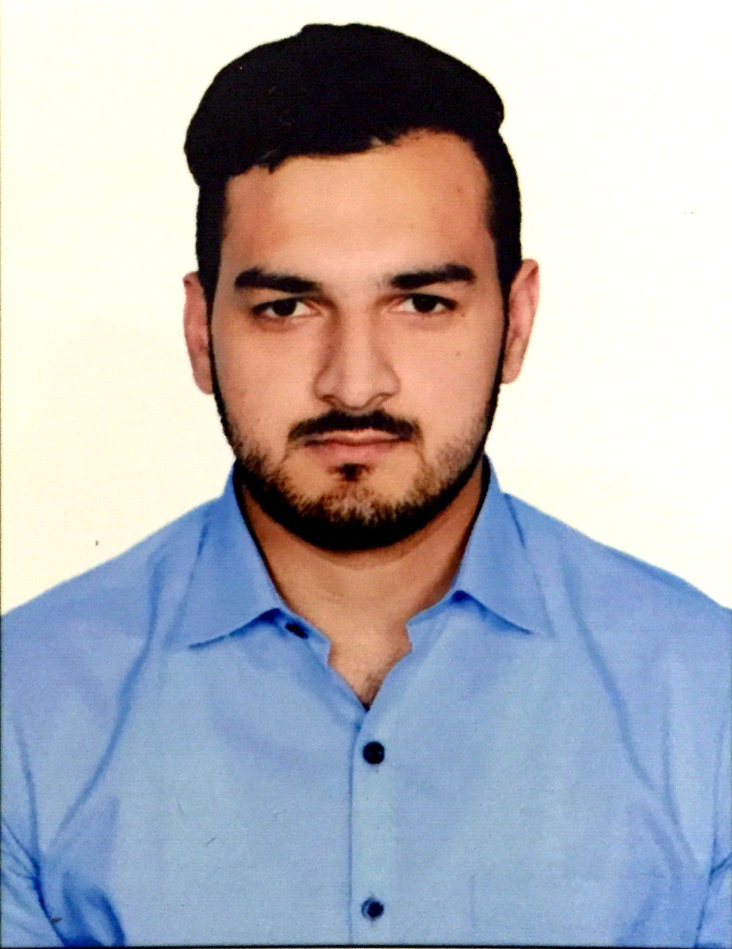

Experience Summary

Vinkle Khan is an Analyst/Software Engineer who joined the company in December 2016. He has successfully completed the induction training focused on JAVA. He has been allocated to AppsNA BU. He is currently assigned to CSDm service line. He has worked on a live project of Hotel Bookings Management System using both Servlets/Jsp and Spring.

**KEY SKILLS:**

* **Functional:** Excellent Communication and Interpretation skills, Presentation skills, Project Management, Team Leader, Team Player, Strategic Planning, Business Analysis and Development, Self Learner
* **Technical:** Java, C, C++, SQL, PLSQL, AngularJS, Javasrcipt, HTML,XML, CSS, Junit, Data Modelling, UML, PLC

Training, Certifications & Affiliations

* JAVA/J2EE Internal Training in 2016-17
* 6 Weeks Training in PLC and Automation in 2013
* 6 Months Training in Advanced Industrial Automation 2016

Published & Presented / Awards

* Research paper on Mars Orbiter mission.
* 3-D printer major project runner-up award for the final major project of batch 2012.
* Volunteer Work at International Youth Foundation World Camp India 20-23 Oct 2013 .

Higher Education

* Chitkara University – Bachelor of Engineering, Electronics and Communication