FEFOS01A: Kaplan-Meier Plot of Overall Survival; Intent-to-treat Analysis Set (Study GRN163LMYF3001)
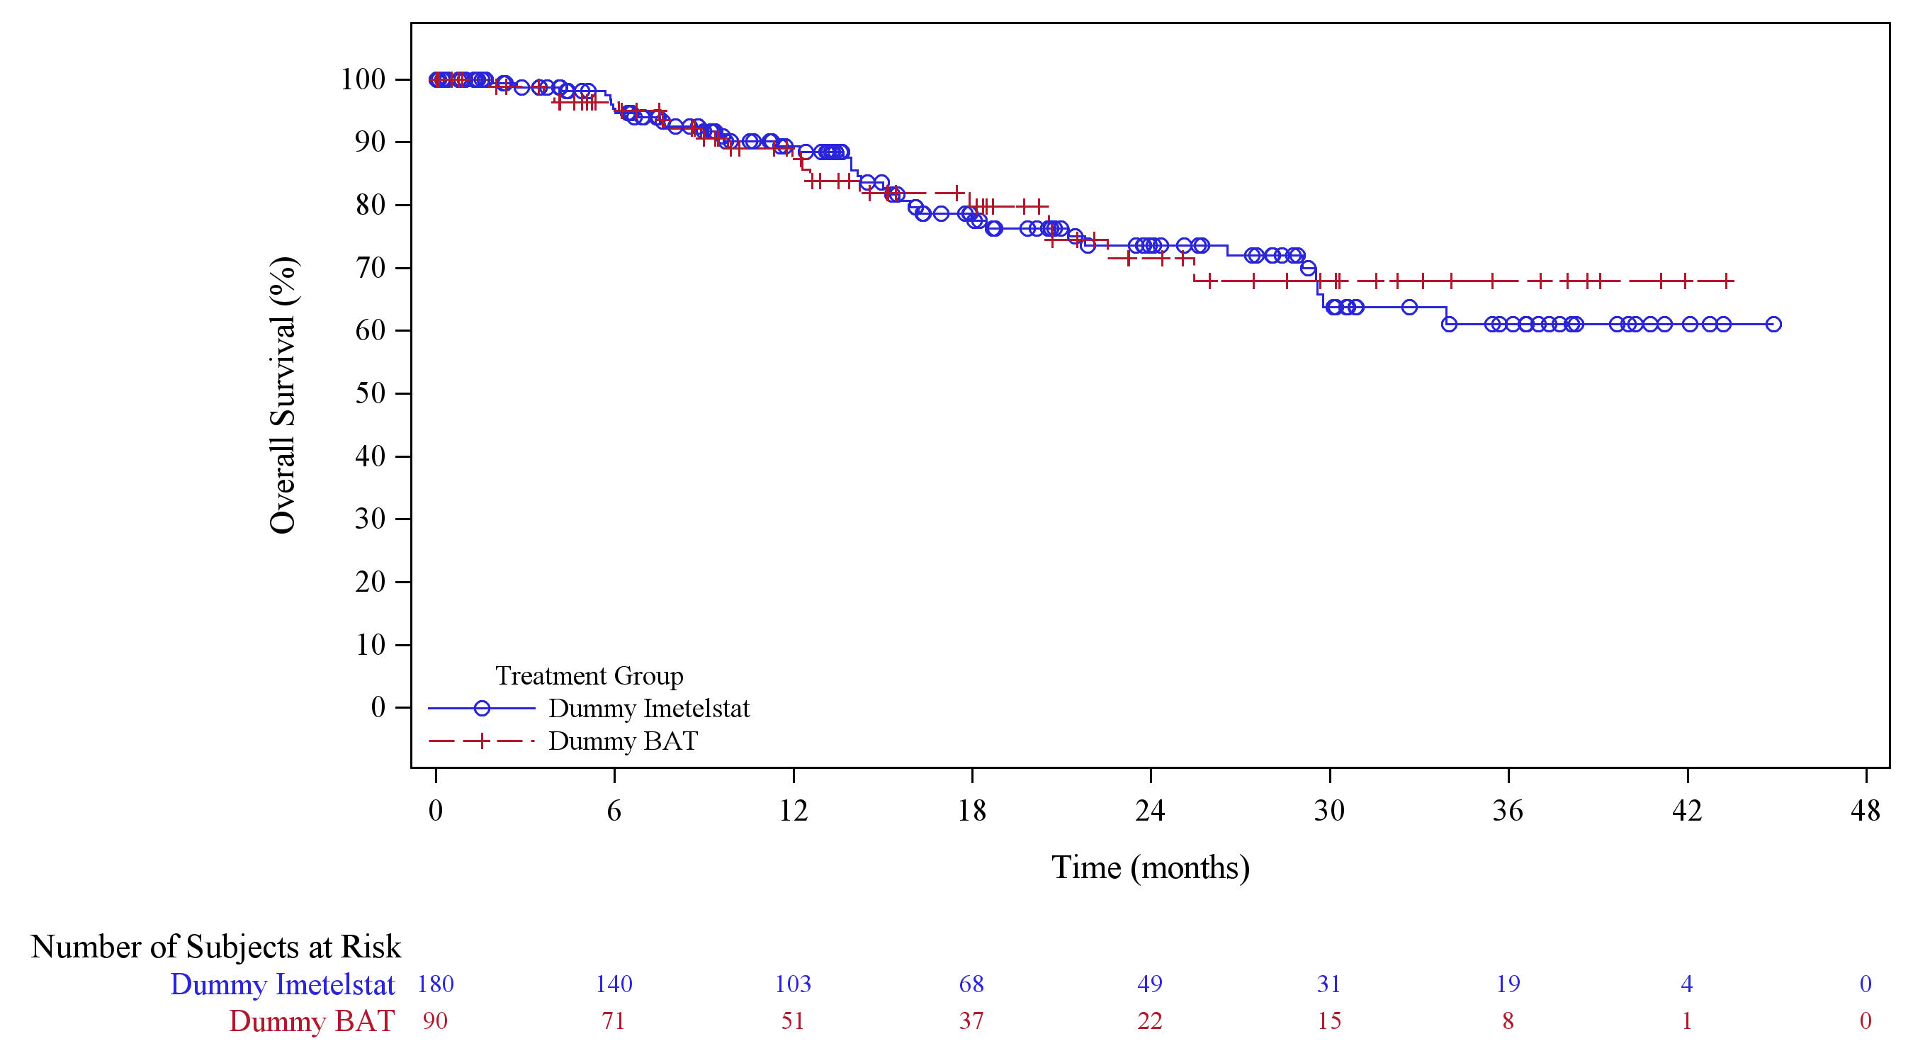
[\\vc01\biometrics\GRN163L_imetelstat\MYF3001\DB_IADryRun\RE_IADryRun\Preprod\PROGRAM\fefos01a.sas] 23APR2025, 20:48
Database Extract Date: 01apr2025; Cut-off Date: 2025-04-01

