Building Scalable Power Apps

General Guidance v0.1

# Content Map

Evaluate

* We want to build an app for 50K – 500K users with 500 – 5K concurrent users. Is this possible? If yes, which data sources can I use?
* What are the limits (tenant / environment / app / user) we need to keep in mind while evaluating the app for each data source / connector?

Design

* What are the design best practices we should follow for such large-scale apps?

Develop

* What tools are available at development stage to develop for scale and development?

Test

* Once we have built app, how can we load test it to ensure that it scales and performs as expected?

Monitor

* Once in production, how do we proactively monitor performance?

Resolve

* When facing performance issues, how can we troubleshoot and resolve?

# Evaluate

Even before building your app, evaluate if app requirements can be fulfilled by Power App platform for performance and scale.

## Requests limits and allocations

Effective October 2019, to help ensure service levels, availability, and quality, there are entitlement limits to the number of requests users can make each day across Power Apps, Power Automate, AI Builder, Power Virtual Agents, and customer engagement apps (Dynamics 365 Sales, Dynamics 365 Customer Service, Dynamics 365 Field Service, Dynamics 365 Marketing, and Dynamics 365 Project Service Automation).

Requests in Microsoft Power Platform consist of various actions that a user makes across various products. At a high level, below is what constitute an API request:

* **Power Apps** – all API requests to connectors and Microsoft Dataverse.
* **Dataverse (formerly Common Data Service)** – all create, read, update, and delete (CRUD), assign, and share operations including user-driven and internal system requests required to complete CRUD transactions, as well as special operations like share or assign. These can be from any client or application and using any endpoint (SOAP or REST). These include, but are not limited to, plug-ins, classic workflows, and custom controls making the earlier-mentioned operations.

The table below will describe the common requests limits as well as the allocation that a user gets based on the type of license assigned to the user.

**Request limits based on user licenses**

All the users of Microsoft Power Platform have limits on the number of requests based on the license they are assigned. The following table defines the number of requests a user can make in a 24-hour period:

If a user has multiple plans assigned from different product lines, the total number of requests allowed would be the sum of requests allocated to each license type. For example, if a user has both a Dynamics 365 Customer Service Enterprise license as well as a Power Apps per user license then that user will have a total of 20000 + 5000 = 25000 requests available per 24 hours.

**Requests limits not based on licensed users or flows**

The Dataverse provides the ability to have identities that do not require any user license to interact with the service. There are four types of these users:

* [Application users](https://docs.microsoft.com/en-us/power-platform/admin/create-users-assign-online-security-roles#create-an-application-user)
* [Non-interactive users](https://docs.microsoft.com/en-us/power-platform/admin/create-users-assign-online-security-roles#create-a-non-interactive-user-account)
* [Administrative users](https://docs.microsoft.com/en-us/power-platform/admin/create-users-assign-online-security-roles#create-an-administrative-user-account)
* [SYSTEM user](https://docs.microsoft.com/en-us/dynamics365/customer-engagement/web-api/systemuser?view=dynamics-ce-odata-9#operations)

For these identities, every tenant will get base request capacity per tenant that can only be used by these users and not by users with standard licenses.

This base request capacity is based on the type of subscription, as follows:

* If a tenant has at least one Dynamics 365 enterprise subscription, they will get 100,000 requests per 24 hours.
* If a tenant has at least one Dynamics 365 professional subscription, they will get 50,000 requests per 24 hours.
* If a tenant has at least one Microsoft Power Apps or Power Automate subscription, they will get 25,000 requests per 24 hours.

After base request capacity is exhausted, customers can increase this capacity by purchasing a Power Apps and Power Automate capacity add-on.

**Other applicable limits**

Apart from the daily API request limit, there are other service protection limits specific to each service. These limits may be lower or higher than the daily per user limits for a 24-hour period. As with the daily limits, these limits help maintain the quality of service by protecting the service from malicious or noisy behavior that would otherwise disrupt service for all customers.

Review the following resources for information about *current* service protection limits for each service:

* [Dataverse limits](https://docs.microsoft.com/en-us/powerapps/developer/common-data-service/api-limits): applicable for model-driven apps and customer engagement apps (such as Dynamics 365 Sales and Customer Service), Power Apps, and Power Automate connecting to Dataverse/customer engagement apps
* [Power Automate limits](https://docs.microsoft.com/en-us/flow/limits-and-config): applicable for automated, scheduled, and instant flows
* [Limits in connectors](https://docs.microsoft.com/en-us/connectors/): applicable for Power Automate and Power Apps

**What tools can I use to monitor and analyse API requests across the platform?**

Today, the Power Platform admin center contains reports on Dataverse API requests. This reporting today accounts for interactive and non-interactive traffic. This helps you to quickly view adoption and user metrics for your organization. If your apps or flows primarily use the Dataverse, then these reports can serve as good approximations of the total usage of your solutions.

Additionally, for Power Automate usage specifically, you can see the action usage for a given flow by selecting the Analytics action from the flow properties page, and this works across all types of actions. However, if your apps or flows do not use the Dataverse, then there are no reports available in the Power Platform admin center at this time.

**What happens if a user or integration exceeds request capacity?**

When users exceed their limits, administrators can see this in the admin center (see above). You can do either one of the following:

* Adjust the app or flow to use fewer API requests
* Purchase the **Power Apps and Power Automate capacity add-on** for your organization.

Users won't be blocked from using an app or flow for occasional and reasonable overages at this point in time. However, if a user or flow exceeds the limits consistently for an extended period of time (more than 14 days), that user may be disabled or flow turned off.

## Dataverse Limits

There are two categories of limits that apply for Dataverse: *Entitlement* and *Service protection* limits.

**Entitlement limits**

These limits represent the number of requests users are entitled to make each day. The allocated limit depends on the type of license assigned to each user.

If any user exceeds their request entitlement the administrator would be notified and would be able to assign Power Apps and Power Automate request capacity to that user. Users will not be blocked from using apps for occasional and reasonable overages at this point of time.

|  |  |
| --- | --- |
| **User licenses** | **Number of API requests / 24 hours** |
| Dynamics 365 Enterprise applications1 | 20,000 |
| Dynamics 365 Professional2 | 10,000 |
| Dynamics 365 Team Member | 5,000 |
| **Power Apps per user plan3** | 5,000 |
| Power Automate per user plan3 | 5,000 |
| Office licenses (that include Power Apps, Power Automate, or Power Virtual Agents)4 | 2,000 |
| Power Apps per app plan | 1,000 per app pass |
| Non-licensed users | See [Requests limits not based on licensed users or flows](https://docs.microsoft.com/en-us/power-platform/admin/api-request-limits-allocations#requests-limits-not-based-on-licensed-users-or-flows) below |

**Service protection limits**

To ensure consistent availability and performance for everyone we apply some limits to how APIs are used with Dataverse. Service protection API limits help ensure that users running applications cannot interfere with each other based on resource constraints. The limits will not affect normal users of the platform. Only applications that perform a large number of API requests may be affected. The limits provide a level of protection from random and unexpected surges in request volumes that threaten the availability and performance characteristics of the Dataverse platform.

We limit the number of concurrent connections per user account, the number of API requests per connection, and the amount of execution time that can be used for each connection. These are evaluated within a five-minute sliding window. When one of these limits is exceeded, an exception will be thrown by the platform.

Because service protection limits are usually only encountered by applications that perform a high volume of data operations, we recommend that developers building those applications apply patterns to retry operations after a period of time when these exceptions are returned. This will allow the application to respond to exceptions the service sends and reduce the total number of requests and achieve the highest possible throughput.

For information about the specific errors that can be returned and how developers can apply patterns to respond to these errors, see [Service Protection API Limits](https://docs.microsoft.com/en-us/powerapps/developer/data-platform/api-limits).

[Service protection API limits (Microsoft Dataverse) - Power Apps | Microsoft Docs](https://docs.microsoft.com/en-us/powerapps/developer/data-platform/api-limits)

## Connectors – Microsoft Teams

|  |  |  |
| --- | --- | --- |
| **THROTTLING LIMITS** | | |
| **Name** | **Calls** | **Renewal Period** |
| API calls per connection | 100 | 60 seconds |
| Frequency of trigger polls | 1 | 900 seconds |
| Non-Get requests per connection | 300 | 3600 seconds |

[Microsoft Teams - Connectors | Microsoft Docs](https://docs.microsoft.com/en-us/connectors/teams/)

## Connectors - SharePoint

|  |  |  |
| --- | --- | --- |
| **Name** | **Calls** | **Renewal Period** |
| API calls per connection | 600 | 60 seconds |

[Overview of the SharePoint connection - Power Apps | Microsoft Docs](https://docs.microsoft.com/en-us/powerapps/maker/canvas-apps/connections/connection-sharepoint-online)

[SharePoint - Connectors | Microsoft Docs](https://docs.microsoft.com/en-us/connectors/sharepointonline/)

## Reference

[Service protection API limits (Microsoft Dataverse) - Power Apps | Microsoft Docs](https://docs.microsoft.com/en-us/powerapps/developer/data-platform/api-limits#how-service-protection-api-limits-are-enforced)

[Requests limits and allocations - Power Platform | Microsoft Docs](https://docs.microsoft.com/en-us/power-platform/admin/api-request-limits-allocations)

# Design

## Canvas app execution phases and data call flow

When a user opens a canvas app, the app goes through several phases of execution before showing any user interface. While the app loads, it connects to different [data sources](https://docs.microsoft.com/en-us/powerapps/maker/canvas-apps/connections-list#popular-connectors)—such as SharePoint, Microsoft Dataverse, SQL Server (on-premises), Azure SQL Database (online), Excel, and Oracle.

A canvas app goes through the following phases of execution before showing the interface to a user:

1. **Authenticate the user**: Prompts the first-time user to sign in with credentials for whatever connections the app needs. If that user opens the app again, that person might be prompted again, depending on the organization's security policies.
2. **Get metadata**: Retrieves metadata, such as the version of the Power Apps platform on which the app runs and the sources from which it must retrieve data.
3. **Initialize the app**: Performs any tasks specified in the [OnStart](https://docs.microsoft.com/en-us/powerapps/maker/canvas-apps/functions/object-app#onstart-property) property.
4. **Render the screens**: Renders the first screen with controls that the app has populated with data. If the user opens other screens, the app renders them by using the same process.

**Data call flow with the Common Data Service connector (for Dataverse environments)**

[Canvas app execution phases and data call flow - Power Apps | Microsoft Docs](https://docs.microsoft.com/en-us/powerapps/maker/canvas-apps/execution-phases-data-flow)

## Data Loading Patterns

**Pattern 1: Load Data from Server**

**Pattern 2: Load Data From Server with Local caching**

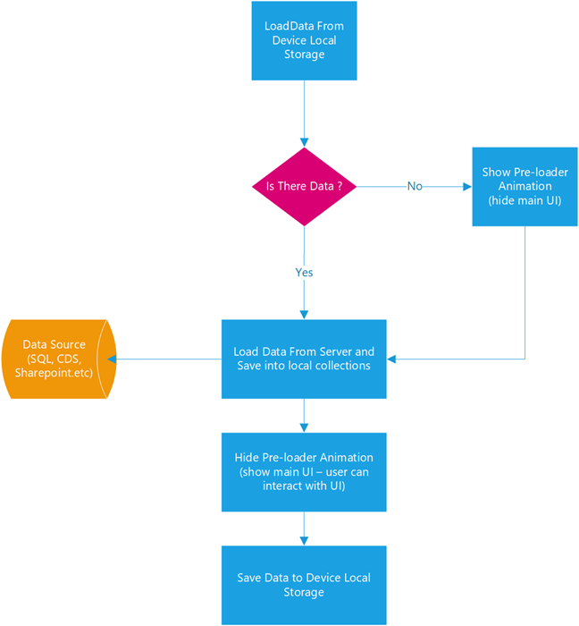

**Pattern 3: Concurrent Calls**

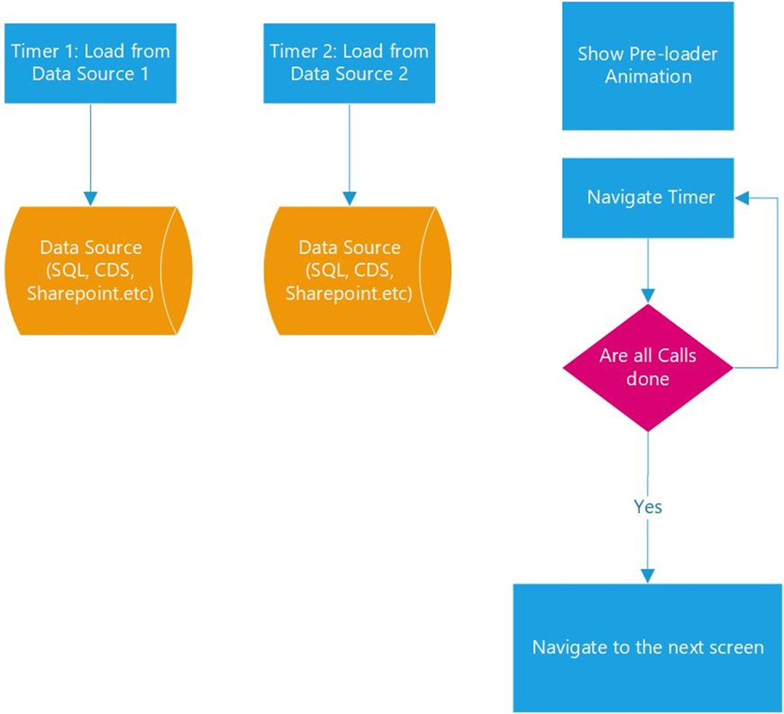

## Common Performance Issues

### OnStart

The OnStart event  runs when the application is loading and having lots of data called in the OnStart command will slow down the load of the app. If a screen, to be open, has a heavy dependency of controls and values defined on other screens, page load would also be affected by slow screen navigation.

The following are some issues observed in many cases.

1. Many data calls happened within OnStart event which made the app start slow. In enterprise, volume of data calls onto a central data source could drive server bottleneck, resource contention as well.
2. N+1 query problem observed from some galleries and it triggered too many requests to servers.
3. Big latency on OnStart due to heavy scripts. This is a common mistake from many canvas apps. Makers should get only the necessary data from the moment of app start.
4. Too many columns were retrieved.
5. Location of environment vs. end-users is a matter.
6. Whitelist [apps.powerapps.com](http://apps.powerapps.com/) in Firewall. Check Proxy settings of your clients if network proxy configured.

**Recommendations**

1. Leverage cache mechanism and optimize data calls. Your application would be used by N users at the end. Hence, the number of data calls per user would be landing at the server’s endpoints, which could be a spot where bottleneck or throttling could be occurred from.
2. Use View objects in SQL to avoid N+1 query problem or change the UI (user interface) scenarios not to trigger the problem.
3. Use ‘StartsWith’ instead of ‘IN’ in formula. If you use SQL data source, for instance, StartWith operator would use index SEEK in SQL database. However, the IN operator would require Index or table scan.
4. Optimize formula in an OnStart event. You can move some formulas to OnVisible event instead. By doing this way, you can let the app start fast and other steps can be continued along with app launching.
5. If you use Microsoft Dataverse, make sure you enabled Explicit Column Selection (ECS) at an advanced setting. Then, Microsoft Dataverse connector will interpret what columns been used in the app and only used columns in the app would be retrieved.
6. We recommend that users should use the new Microsoft Edge instead of IE (Internet Explorer). IE is not fully optimized when it comes to execute JS scripts.
7. Having an environment close to users is also suggested. Although Power Apps has already put in place the Content Delivery Network (CDN) delivering necessary contents of the app from the nearest CDN, data calls would still get the data from the backend data source which might be in different geographical locations. If your app gets a small set of data per request, the impacts would be minimized. Network footprints such as latency, throughput, bandwidth, and packet loss would be another crucial fact affecting performance.
8. Cross check with your network team to make sure *.[PowerApps.com](http://powerapps.com/) got whitelisted.

### SQL Server (on-premise)

Canvas app can reach out the data out of on-premises SQL via [on-premises data gateway](https://docs.microsoft.com/en-us/power-bi/service-gateway-onprem). Once on-premises data gateway is configured, Power Apps canvas app can manage data with various on-premises data sources such as SQL, Oracle, SharePoint on on-premises networks.

However, accessing on-premises data sources could suffer from slowness due to the following common causes. Although this topic is focusing on SQL on-premises. They are still valid for other data sources on-premises.

**Common causes**

1. **Thick client or excessive requests:** some canvas app formed formula to do Group By, Filter By, JOIN operations client-side. Although canvas app can do such operations, they would need CPU and memory resources from client devices. Depending on data size, these operations make extra scripting time at the client side on top of increasing JS heap size of the client. Be aware of each lookup data call also travel to data source via data gateway. In this case, the number of data calls is really a matter.
2. **Unhealthy on-premises data gateway:**As organizations can define multiple nodes of on-premises data gateway, all configured nodes should be healthy, on-premises data gateway service should be up and running. If one of nodes was unreachable, data requests onto the unhealthy node would not return the result within a decent time but ‘unreachable’ error message after waiting for a while.
3. **Scalability:** In some enterprises, a high volume of data access onto the on-premises data gateway would be expected. In this case, just one node of the on-premises data gateway could be a bottleneck to cover a large volume of requests. A single node of the on-premises data gateway can deal with concurrent connections up to 200. If all these concurrent connections are executing queries actively, other requests would be waiting for an available connection.

**Recommendations**

1. Do **use the View object in** SQL database for Group By, Filter By, JOIN operations instead of doing such operations at PowerApps client-side. Maker or DBA (Database administrator) can create view(s) with only necessary columns which require for canvas app. Then, use the view entity in canvas app. This approach would also address N+1 query problem.
2. Make sure all on-premises data gateway nodes are healthy and configured at decent network latency between the nodes and SQL instance.
3. In enterprises, having a scalable data gateway cluster would be recommended in case heavy data requests are expected. DBA (Database administrator) can check how many connections get set up between data gateway nodes and the SQL instance. By checking concurrent connections in an on-premises data gateway or in a SQL server, your organization can decide the point when the data gateway should be scaled out how many nodes are.
4. Please do [monitor and optimize on-prem data gateway performance](https://docs.microsoft.com/en-us/data-integration/gateway/service-gateway-performance) by following instructions in the link. As an on-premises data gateway is in organization’s network, Microsoft could not check its performance nor health, but organizations should do.
5. Do profile slow queries in a SQL database and tune if any slow queries are found. That is, tune indexes and queries.
6. Make sure your SQL database has no resource contentions such as CPU bottleneck, IO contention, Memory pressure and/or tempDB contention, apart from checking Locks & Waits, Deadlock and timeout of queries.

**Note**: Azure SQL provides a feature called [**Automatic tuning**](https://docs.microsoft.com/en-us/sql/relational-databases/automatic-tuning/automatic-tuning?view=sql-server-ver15). As it is named, it would create missing indexes automatically and fix the execution plan performance problems. Consider turning on this feature on SQL instance.

### Azure SQL

Organizations can connect to Azure SQL Online via SQL connector. In this case, slow requests were caused by slow queries in the database and/or the huge volume of data had to be transmitted to the client. In some case, Service tier of a SQL server was also attributed to slow response.

***Common issues***

1. **Data size** **transfer**to client: by default, PowerApps canvas app shows data entities which would be either tables or views from database objects. All columns of entities would be retrieving, which prompts slow response of data requests in case entities have many columns and define many big data types like NVARCHAR(MAX). Simply, total data size of transferring data to client requires transferring time and scripting time to keep that amount data in the JS heap at client side.
2. **Slow queries**: depending on filtering conditions of data requests, the SQL statement which was converted to could be executed with a certain execution plan. If the query executed with heavy IO operation by table scan or index scan, it means data entities might not have proper indexes covering the query. Although the execution plan of queries uses indexes, it could be slow too in case Key Lookup costs high.
3. [**Service tier**](https://docs.microsoft.com/en-us/azure/sql-database/sql-database-service-tiers-dtu): Multiple Azure SQL tiers are available. Each tier has a bit different CPU, IO Throughput and IO(Input/output) latency. Under heavy data requests, these resources could be throttled once the threshold hits. Then, query performance would be compromised.

***Recommendations***

1. **Monitor and turn slow queries**. check this article: [Monitor and Tune for Performance](https://docs.microsoft.com/en-us/sql/relational-databases/performance/monitor-and-tune-for-performance?view=sql-server-ver15).  
   [Query Store](https://docs.microsoft.com/en-us/sql/relational-databases/performance/monitoring-performance-by-using-the-query-store?view=sql-server-ver15) would also provide the necessary information to find slow queries. You can use [Extended Events](https://docs.microsoft.com/en-us/sql/relational-databases/extended-events/extended-events?view=sql-server-ver15) to trace SQL. If you need more details, please refer to [Quick Start: Extended events in SQL Server](https://docs.microsoft.com/en-us/sql/relational-databases/extended-events/quick-start-extended-events-in-sql-server?view=sql-server-ver15)and SSMS XEvent Profiler.
2. **Do use View** object in Azure SQL online for Group By, Filter By, JOIN operations instead of doing such operations at PowerApps client-side. In addition, View can define only necessary columns. View can select columns and remove some big data type like NVARCHAR(MAX), VARCHAR(MAX) and VARBINARY(MAX) unless necessary.  Maker or DBA (Database administrator) can create view(s) with only necessary columns which require for canvas app. Then, use the view entity in canvas app. This approach would also address N+1 query problem.
3. **Check the service tier of Azure SQL online if it is on DTU-Based purchase model**. Lower tier would have some limitations and constraints. From a performance perspective, CPU, IO throughput and latency would be matter. Hence, check the performance of the SQL database and check if resource usage exceeds the threshold or not. on-premises SQL normally sets the threshold of CPU usage on around 75%, for example.

### SharePoint Online

SharePoint connector pipelines to SharePoint list(s).

**Common issues**

1. **Data size**transmitting back to client is matters, especially when the SharePoint data source is remote. If formula in events at canvas app has nondelegable functions inside, Power Apps platform would retrieve records up to Data Row Limits, default 500 but maker can change it up to 2000. If Data Row Limits were set to 2000 and the SharePoint list has many columns, data size transmitting to client could be huge and it could lead to slowness.
2. **Too many dynamic lookup columns:**SharePoint supports various data types including dynamic lookup, Person or Group and Calculated. If a SharePoint list defines too many dynamics columns, it would take time to manipulate these dynamic columns within SharePoint itself before serving asked data requests. This would depend on the volume of data rows on the SharePoint list.
3. Picture column and Attachment: size of image and attached file will attribute to slow response if they are all retrieving to client unless specific columns specified.

**Recommendations**

1. As SharePoint provides many [delegable functions](https://docs.microsoft.com/en-us/powerapps/maker/canvas-apps/delegation-overview), it is worthy checking your formula to see if it would be delegable or not.  Otherwise, PowerApps would retrieve the number of records to client, which defined within Data Row Limits (Default 500), and then apply formula on a retrieved data set at client side. **Not only reducing Data Row Limits to a low value or at least staying at the default but also forming the formula to be delegable are important to make the app performant**. For instance, let say you have an ID column defined Number data type in the list. Both formulas below will return the results as expected. However, the former is nondelegable and the latter delegable.

As we assume that the ID column in SharePoint defined data type as Number, right-hand side value should be numeric variable instead of string variable. Otherwise, this type of mismatch would trigger the formula to be nondelegable.

1. Review your SharePoint list and make sure only the necessary columns have been defined. As number of columns in the list would affect performance of data requests because either matched records or records up to data low limits would be retrieving and transmitting back to client with all columns defined in the list whether the app uses some or not.  
   Enabling Explicit Column Selection (ECS) is highly recommended so that data requests would ask only used columns on the app.
2. Do not overuse dynamic Lookup columns and Person or Group type in SharePoint. Otherwise, extra overheads would be seen on the SharePoint side to manipulate data before applying any filter or search on.  You can use a static column to keep email aliases or names of people instead.
3. If you have a gigantic list having hundreds of thousands of records, consider partitioning the list to split into several ones per category or datetime. For instance, your data could be stored on different lists on a yearly or monthly base. Then, you can implement the app to let a user select a time window to retrieve data within that range.

Within a controlled environment, the performance benchmark has proved that the performance of OData requests against SharePoint list were highly related to the number of columns in the list and the number of rows retrieving limited by Data Low Limits. The lower column and the lower data row limits setting perform the better. In the real world, however, it is quite hard to simply reduce data rows limits and columns because the app needs a certain amount of data to cover business scenarios.  Hence, please monitor OData requests at the client side and tune these two knobs.

### Microsoft Dataverse

Microsoft Dataverse provides a handy way to define custom entities with built-in security model where you can securely store your business data in.

**Common issues**

1. Too much data transmitted to a client also made requests be slow. For instance, if your app has set Data Row Limits to 2000, instead of default 500, it adds up extra overhead on transferring data and manipulating received data to JS Heap at client side.
2. The app did run client-heavy scripting such as Filter By/Join at client side instead of doing such operation at server side.
3. Canvas app had used old commondataservice connectors. Firstly, the old commondatasource connectors got some overheads. Hence, OData requests via the connector were slower than that via Microsoft Dataverse connector.

**Recommendations**

1. **Enable Explicit Column Selection (ECS)** which would select only used columns in your app instead of retrieving all columns of the entity you used in your app.
2. **Leverage Microsoft Dataverse View.**Microsoft Dataverse View makes a logical view out of entities with joining/ filtering entities. For instance, if you should join entities and filter their data, you can define a view via Microsoft Dataverse View designer by joining them and define only necessary columns. Then, use this view in your app which put load to server by avoid the app from joining overhead at client side. This would reduce not only extra operations but also data transmission.
3. Reduce Data Row Limits to 500 at least. Please think about your app really requires retrieving more than 500 records or not. As your app might be running at mobile/tablet devices, having light-weight data at clients would perform better. In many cases, delegable functions cover your business logic.

# Develop

### Solution checker

The solution checker is a tool that checks whether the solution you've created is healthy. You can quickly review issues and see recommended fixes. More information: [Use solution checker to validate your model-driven apps in Power Apps](https://docs.microsoft.com/en-us/powerapps/maker/data-platform/use-powerapps-checker)

# Test

Build end-to-end UI tests for your canvas app using Test Studio. Maintain your app quality by continually validating that your app works as expected when new changes or updates are deployed.

Power Apps Test Studio is a low-code solution to write, organize, and automate tests for canvas apps. In Test Studio, you can write tests using Power Apps expressions or use a recorder to save app interaction to automatically generate the expressions. You can play written tests back within the Test Studio to validate app functionality, and also run the tests in a web browser and build the automated tests into your app deployment process.

[Test Studio for testing canvas apps - Power Apps | Microsoft Docs](https://docs.microsoft.com/en-us/powerapps/maker/canvas-apps/test-studio)

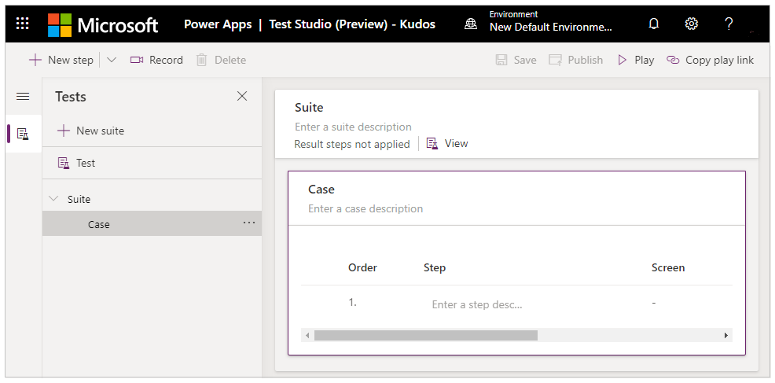

You can run your canvas app tests built in Test Studio using the [Azure Pipelines classic editor](https://docs.microsoft.com/en-us/azure/devops/pipelines/get-started/pipelines-get-started?view=azure-devops#define-pipelines-using-the-classic-interface) in [Azure DevOps Services](https://docs.microsoft.com/en-us/azure/devops/user-guide/what-is-azure-devops?view=azure-devops).

You can use a public project on GitHub - [Microsoft/PowerAppsTestAutomation](https://github.com/microsoft/PowerAppsTestAutomation) to:

* Automate operations of signing in to your application.
* Open a browser on the build agent and execute a set of test cases and suites.
* View the status of the test execution in the Azure DevOps pipeline.

[Automate tests with Azure Pipelines using classic editor - Power Apps | Microsoft Docs](https://docs.microsoft.com/en-us/powerapps/maker/canvas-apps/test-studio-classic-pipeline-editor)

**Monitor**

When you're testing for performance issues, you can use Monitor to check network activity, similar to a network trace in the browser.

[Introducing Monitor to debug apps and improve performance | Microsoft Power Apps](https://powerapps.microsoft.com/en-us/blog/introducing-monitor-to-debug-apps-and-improve-performance/)

**EasyRepro**

EasyRepro is the tool provided for Dynamics 365 and Power Apps model-driven apps. It not only includes a testing tool but also has over 200 sample test cases to help you speed up the testing process. For more information, see the blog post [EasyRepro automated testing framework](https://powerapps.microsoft.com/blog/easyrepro-automated-testing-framework-june-update-is-now-available/), and access it at the [EasyRepro GitHub repository](https://github.com/Microsoft/EasyRepro).

# Monitor

## Monitor Tool

Monitor is a tool that offers makers the ability to view a stream of events from a user's session to diagnose and troubleshoot problems. Makers of canvas apps can use Monitor either to view events while building a new app in Power Apps Studio or to monitor published apps during runtime. Makers of model-driven apps can monitor page navigation, command executions, [form-related issues](https://docs.microsoft.com/en-us/powerapps/developer/model-driven-apps/troubleshoot-forms), and other major actions to understand app behavior and make improvements.

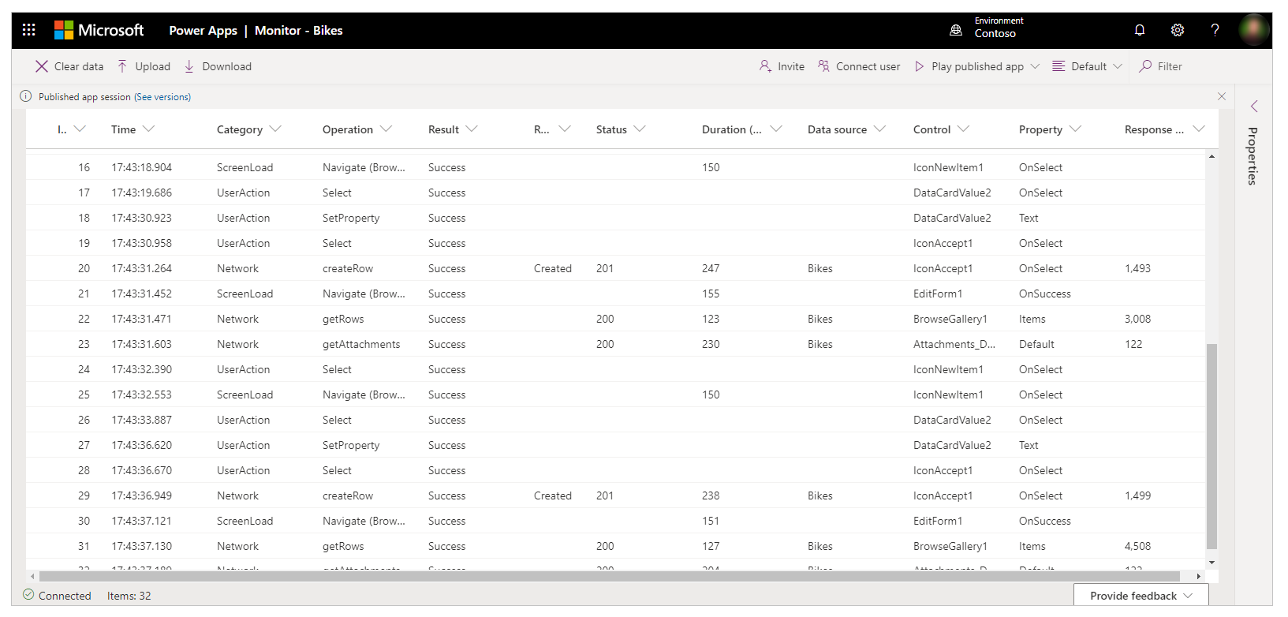

When you select an event in the grid, a panel displays additional details about the event. The panel has four tabs:

* **Details**: Shows a high-level overview of the event that you select. Some of the data might be collapsed in the tree view. You can expand and drill down to view content.

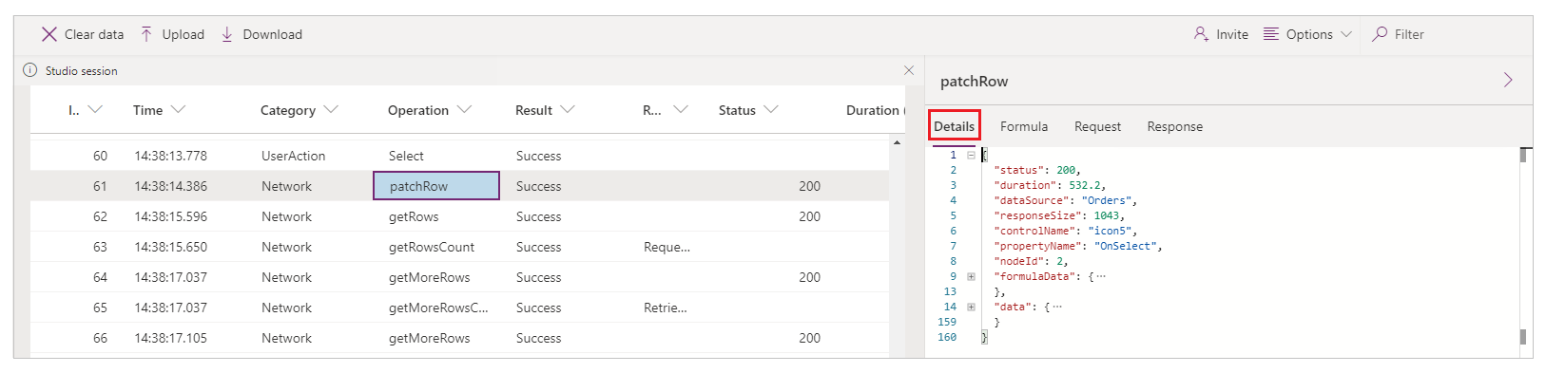

* **Formula**: Shows the related formula from your app for the selected event. The name of the control property triggering the event is displayed on top of the tab and inside the event table.
* **Request**: Shows the HTTP request that was sent.
* **Response**: Shows the HTTP response that was received. You can view the response in JSON format.

[Introducing Monitor to debug apps and improve performance | Microsoft Power Apps](https://powerapps.microsoft.com/en-us/blog/introducing-monitor-to-debug-apps-and-improve-performance/)

### Supported Events

[Overview of Power Apps with Monitor - Power Apps | Microsoft Docs](https://docs.microsoft.com/en-us/powerapps/maker/monitor-overview)

### Offline Analysis

You can **download** the events listed in [Supported events](https://docs.microsoft.com/en-us/powerapps/maker/monitor-advanced#supported-events) for offline analysis. Events can be downloaded in .json or .csv format, and you can share them with others. The .csv files can only be downloaded, not uploaded, but if you download the events in .json format, you can upload them later into Monitor for analysis. You can also attach a trace file to support service requests, which can help speed up getting the solution to your problem.

<https://docs.microsoft.com/en-us/powerapps/maker/monitor-advanced#download-and-upload-trace-files>

### Collect / Analyze logs using Application Insights & Power BI

You can connect your app with [Application Insights](https://docs.microsoft.com/en-us/azure/azure-monitor/app/app-insights-overview), a feature of [Azure Monitor](https://docs.microsoft.com/en-us/azure/azure-monitor/overview). Application Insights includes powerful analytics tools to help you diagnose issues and to understand what users actually do with your app.

You can export your Application Insights data and query results to Power BI for analysis and data presentation.

[Analyze app telemetry using Application Insights - Power Apps | Microsoft Docs](https://docs.microsoft.com/en-us/powerapps/maker/canvas-apps/application-insights)

## Admin Analytics for Power Apps

Analytics for the environment admin is available at the Microsoft Power Platform admin center. The admin reports provide a view into environment level usage, errors, service performance to drive governance, and change management services to users. These reports are available for canvas apps only and not available for model-driven apps.

**Service Performance** report provides details of all standard and custom connectors to understand performance bottlenecks and client versus service API issues. An environment admin will get insights into:

* Connectors used in the environment.
* Best and least performant service and the API service response times.
* Success rates for each service to determine areas that need attention.
* The 50th, 75th, and 90th percentile response times for each service.
* The number of HTTP 500 error codes of connectors indicating issues around the server not responding to calls from the client.
* The number of successful connection requests.

All the service performance KPI's can be filtered with attributes like a specific service or connector, device platform, player version, and country, state, or city to drill down into the specific API.

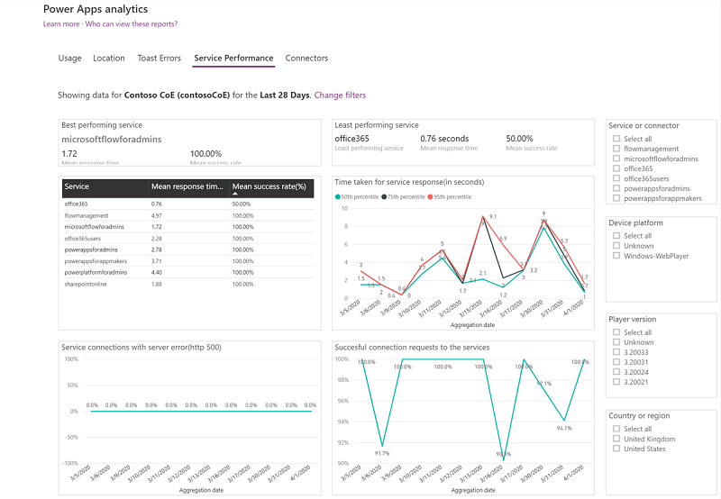

[Administrator analytics and reports for Microsoft Power Apps - Power Platform | Microsoft Docs](https://docs.microsoft.com/en-us/power-platform/admin/analytics-powerapps)

# Resolve

## Startup Issues

[Troubleshooting startup issues for Power Apps - Power Apps | Microsoft Docs](https://docs.microsoft.com/en-us/powerapps/troubleshooting-startup-issues)

# Further Reading

[The importance of thinking about performance - Learn | Microsoft Docs](https://docs.microsoft.com/en-us/learn/modules/testing-performance-checks-powerapps/1-performance)

[Considerations for optimized performance in Power Apps | Microsoft Power Apps](https://powerapps.microsoft.com/en-us/blog/considerations-for-optimized-performance-in-power-apps/?cdn=disable)