Annexure I

A Report
on
Earthquakes 1900 - 2013

SUBMITTED TO SCHOOL OF CSE, LPU

For the partial fulfilment of the
INT 233 - Tableau Project

Under the guidance of
Tanima Thakur

GitHub 
https://github.com/abhikritimoti/Earthquakes-1900-2013.git

Submitted by
Name – Abhikriti Moti
Reg Num – 12007073
Roll Num – 09
Section – KM027

Annexure II

STUDENT'S DECLARATION
I hereby certify that the work which is being done in the project entitled “Earthquakes 1900 - 2013” by “ABHIKRITI MOTI, as per course requirement of INT 233 - Project submitted to SCHOOL OF COMPUTER SCIENCE - LPU, under UNIVERSITY is record of our own work carried out under the supervision of “Tanima Thakur”, LPU.

Abhikriti Moti
Name of the Student
10th APRIL 2023
DATE

Table of Contents

Annexure I 1
Annexure II 2
Introduction 4
Dataset used for the Analysis 4
Basic Understanding of Earthquake Dataset 4
Analysis on the dataset 6
Area Chart 8
Stacked Bar Chart 9
Histograms 10
Scatter Plot 11
Frequency of earthquakes by places - Symbol Maps 12
Earthquake details with total NST - Table 13
Conclusion 14

Earthquakes are one of the most significant natural hazards, causing loss of life and destruction of infrastructure. As earthquakes can occur at any time and in any place, it is important to understand their patterns and characteristics to prepare for potential disasters.

Introduction
In this report, we will explore an earthquake analysis done on Tableau, which provides valuable insights into the distribution and characteristics of earthquakes around the world between the year 1900 and 2013. The analysis focuses on understanding the distribution of earthquakes, their magnitudes, depths, and the relationship between these factors. The insights gained from this analysis can be used to prepare for potential disasters and minimize their impact on human life and infrastructure.

Dataset used for the Analysis
The data used in this analysis is taken from the Kaggle, which contains information on earthquakes worldwide.
https://www.kaggle.com/datasets/ignitedinside/earthquake1990-2013mag6plus

Basic Understanding of Earthquake Dataset
The dataset used in the project contains information on earthquakes that have occurred between 1900 and 2013 with a magnitude of 6 or higher. The dataset includes 8313 rows and 31 fields with the following attributes:
Nst | Number of seismic stations which reported P- and S-arrival times for this earthquake. This number may be larger than Nph if arrival times are rejected because the distance to a seismic station exceeds the maximum allowable distance or because the arrival-time observation is inconsistent with the solution.
Dmin | Horizontal distance from the epicentre to the nearest station (in km). In general, the smaller this number, the more reliable is the calculated depth of the earthquake.
Rmss | In seismology, earthquake RMS stands for Root Mean Square, which is a measure of the amplitude of seismic waves generated by an earthquake. The RMS is calculated by taking the square root of the average of the squared values of the ground motion over a specified time period. This calculation is used to determine the amplitude of the earthquake signal, which can be used to estimate the magnitude of the earthquake, as well as to characterize the seismic waveforms.
Magnitude | Earthquake magnitude is a measure of the size or strength of an earthquake, typically determined by the amount of energy released at the earthquake's source, called the hypocentre or focus. The magnitude of an earthquake is expressed on the Richter scale, which is a logarithmic scale ranging from 0 to 10.
Depth | The depth where the earthquake begins to rupture. This depth may be relative to mean sea-level or the average elevation of the seismic stations which provided arrival-time data for the earthquake location. The choice of reference depth is dependent on the method used to locate the earthquake.
Gap | The gap refers to a section of a fault zone where little or no seismic activity has occurred for an extended period of time, despite the fact that the surrounding areas have experienced frequent earthquakes. Earthquake gaps are considered to be areas where the accumulated strain along a fault has not been released in the form of an earthquake for a significant period of time, leading to the potential for a larger earthquake to occur in the future. The longer the time since the last earthquake in a gap, the greater the potential for a future earthquake of significant magnitude.

Analysis on the dataset

We have analysed the earthquake data using Tableau to visualize the data in different ways. We have used different types of charts and maps to represent the data and extract meaningful insights from it.
We'll create the interactive dashboard using the dataset that contains all the recorded earthquakes with a magnitude of 6 or higher from 1900 to 2013. But first let's explore our dataset by importing the dataset in tableau. As you can see here the first column is time. The timestamp gives us the date and the time then we have the date in which we have the different days when the earthquakes happen, then we have the latitude, the longitude which will allow us to create our map for different places. Next, we have the depth, magnitude, type, NST, rms, dmin, etc.
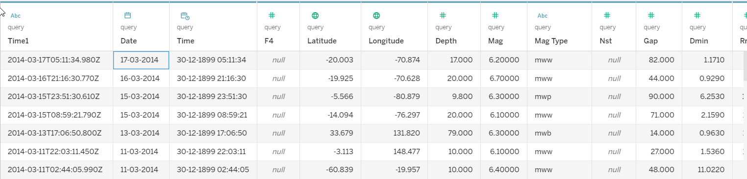
We are going to start by creating our parameters so create parameter and we call it start date and data type will be date, add values from date and as you can see here it automatically selects the minimum and the maximum, and click on OK. Similarly, we'll create another parameter End Date.
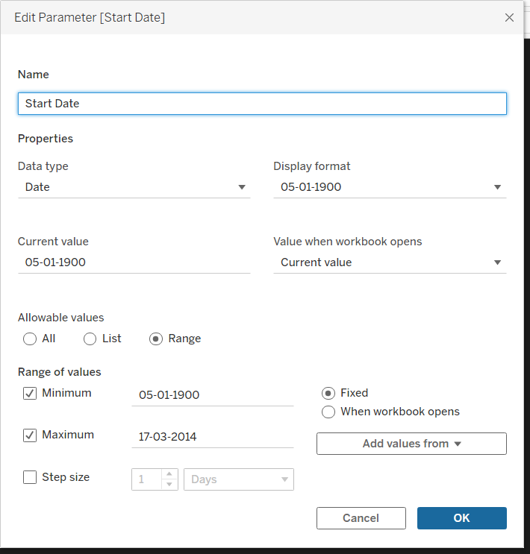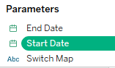
Next, we are going to create KPIs.
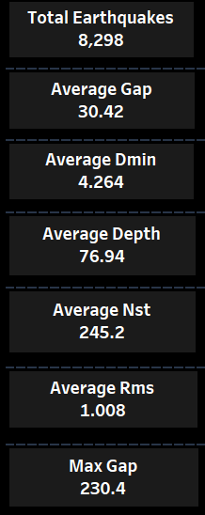

Area Chart
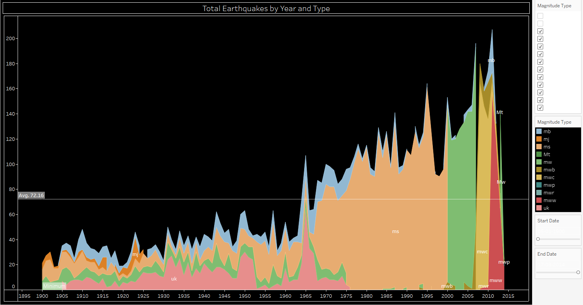
We have created an area chart which represents total earthquakes by year and magnitude type. An area chart showing the total number of earthquakes by year and magnitude type can be a useful tool for understanding trends in seismic activity over time and comparing seismic activity between different regions.
The X-axis of the chart typically represents the years, while the Y-axis represents the total number of earthquakes. The area chart itself is made up of multiple layers or sections, each representing the number of earthquakes for a specific magnitude type. The different magnitude types is color-coded and labelled for easier interpretation.

Stacked Bar Chart
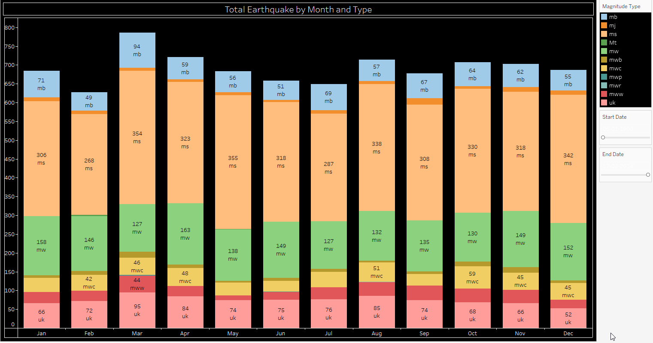
A stacked bar chart is a visual representation of data that uses bars to show the proportion of each category within a larger whole. In this case, the X-axis is the total number of earthquakes in each month, and the categories are the different types of earthquake magnitudes (such as mw, ms, uk, etc).
Each bar in the chart is divided into sections, with each section representing a different magnitude type. The height of each section represents the number of earthquakes of that magnitude type in the given month. The total height of the bar represents the total number of earthquakes in that month. You could compare the proportions of each magnitude type across different months to identify any patterns or trends.

Histograms
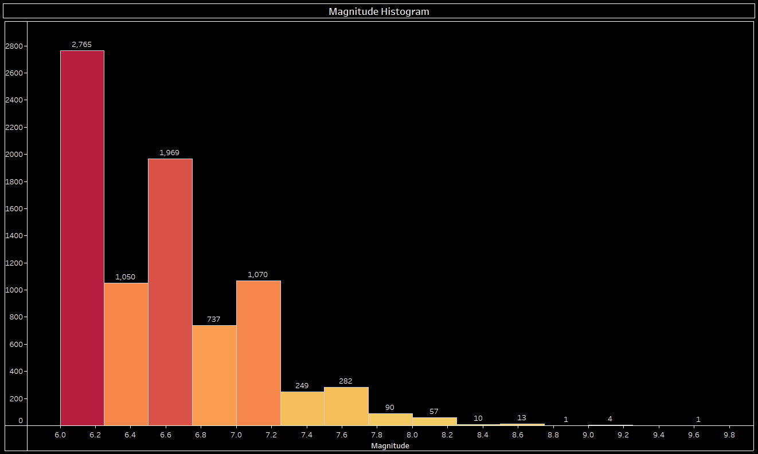
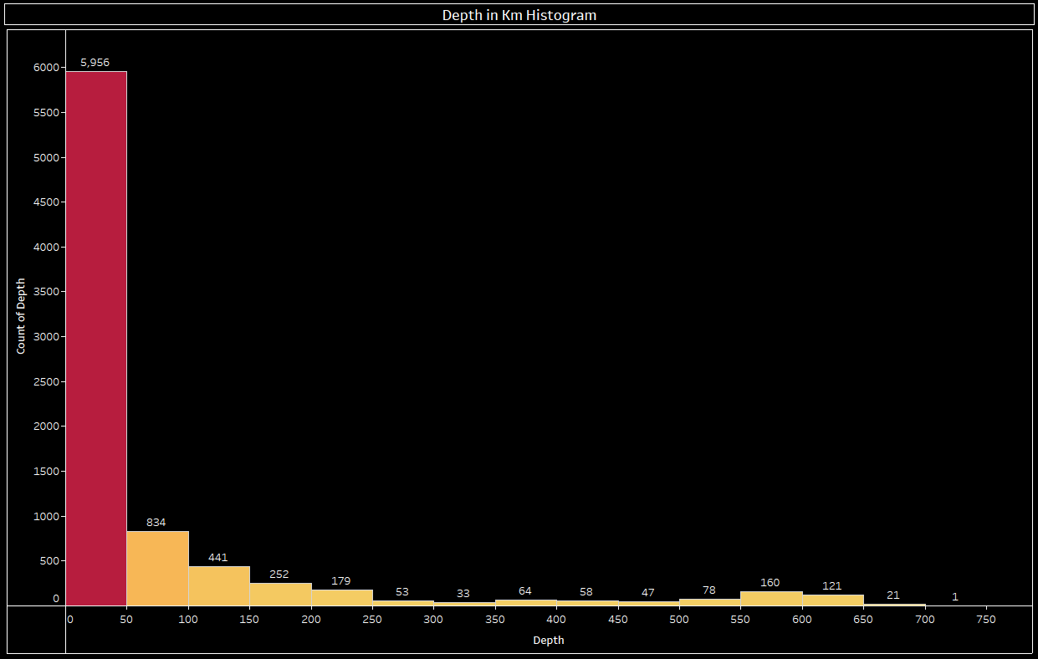
Histograms are a way to visualize the distribution of a dataset. In the case of earthquake magnitudes, in fig. 1, a histogram shows the frequency or count of earthquakes that occurred within a given range of magnitudes. The x-axis typically represent the range of magnitudes, and the y-axis represent the count or frequency of earthquakes within each magnitude range. The histogram shows a high count of earthquakes at both lowest magnitude (6.0), with a dip in the middle, it could indicate a bimodal distribution.
In the fig. 2, The x-axis represent the depth range in km, and the y-axis represent the count or frequency of earthquakes within each depth range. Also we can analyse that most earthquakes occur at depths between 50 and 200 kilometres, with a few deeper earthquakes below 550 kilometres. The distribution of earthquake depths is skewed to the right. The histogram of earthquake depth and count shows a high frequency of earthquakes at shallower depths (i.e., closer to the Earth's surface) and a low frequency of earthquakes at deeper depths, it would be considered a normal or typical distribution.

Scatter Plot
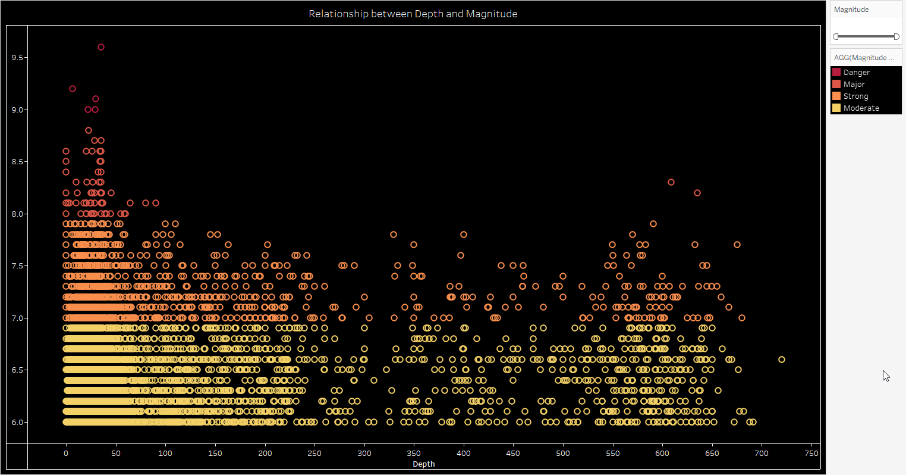
A scatter plot is a useful way to visualize the relationship between two variables, and in this case, the scatter plot show how the depth of an earthquake relates to its magnitude. The x-axis represent the depth of the earthquake in km, and the y-axis would represent the magnitude of the earthquake.
Here we can analyse that the earthquakes of all magnitudes can occur at any depth, and there is no clear pattern of deeper earthquakes being more or less likely to have higher magnitudes. However, it's important to note that this may vary depending on the specific data and the context in which it was collected. In some regions, there may be a correlation between depth and magnitude due to specific geological features or tectonic activity. Additionally, the scatter plot may reveal other patterns or trends, such as clusters of earthquakes occurring at specific depths and magnitudes.

Symbol Maps
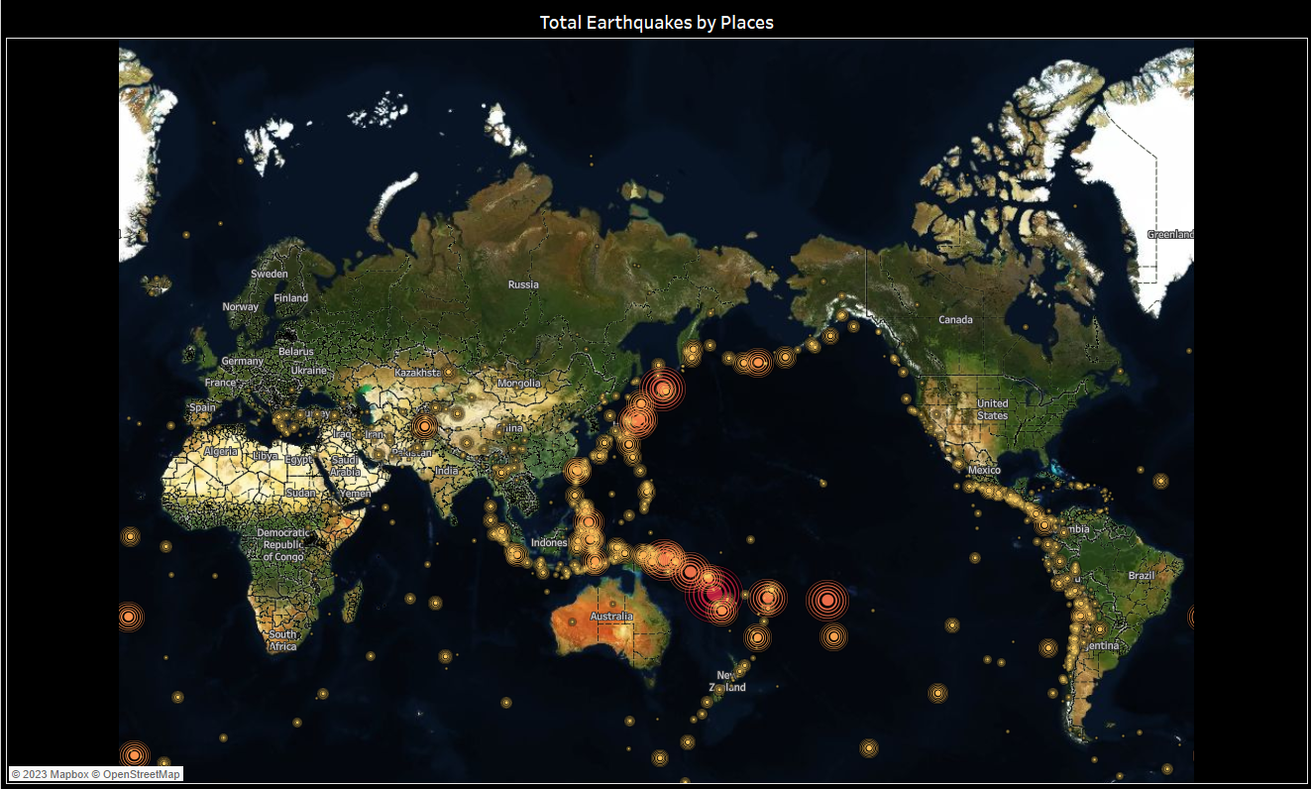
The world map of total earthquakes by places is the visual representation of the frequency and distribution of earthquakes around the world. It shows the total number of earthquakes that have occurred in different regions and countries and provide valuable insights into the overall seismic activity of those areas.
The map provide insights into the potential risks and hazards associated with seismic activity in different regions and countries. Areas with high numbers of earthquakes is more prone to seismic hazards such as ground shaking, landslides, and tsunamis, and may require more stringent building codes and disaster preparedness measures to mitigate these risks.

Table
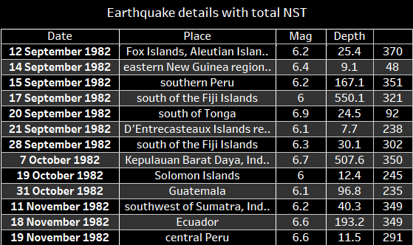
The table shows earthquake details including the place, date, magnitude and total number of seismic stations can provide valuable insights into the distribution and patterns of seismic activity around the world. The total number of seismic stations (NST) is an important metric that measures the number of stations or instruments that have recorded a particular earthquake. It can provide valuable insights into the quality and accuracy of the earthquake data, as well as the level of seismic monitoring in a particular region.

Conclusion

In conclusion, the analysis of earthquakes between 1900 and 2013 with a magnitude of 6 or higher on Tableau has revealed some interesting insights. Firstly, the majority of the earthquakes occurred in the Pacific Ring of Fire, which is an area known for high seismic activity due to tectonic plate movements. Additionally, the analysis also showed that earthquakes with a magnitude of 9 or higher were relatively rare, with only 5 such events occurring during the entire period.
The visualization of earthquake data using Tableau has allowed for a deeper understanding of the impact of these natural disasters on different regions around the world. The data can be used to inform future disaster preparedness and response strategies, as well as to highlight areas that may be more susceptible to earthquakes in the future. Overall, the analysis of earthquake data has proven to be a helpful for gaining insights and understanding into this important phenomenon.

