Automatic Ticket Assignment

Capstone Project

Interim Report

AIML

# Index

Index 2

Team Details 3

Summary of the problem statement, Data and findings 4

Problem Statement 4

Abstract 4

Data & Findings 4

Data provided in format 4

Total Records 4

Data Fields 4

Sample data 4

Distribution of classes 5

Summary of the approach to EDA and Pre-Processing 6

Cleaning processes applied 6

Visualization 6

Word Association 6

Collapsible tree 6

Word Cloud of entire data and top 3 categories 6

Entire Data 6

Charts 6

Bokeh 6

Barchart 6

Decide Model and Model building 7

Model performance - Approaches to improve model 8

Code Snippet 9

Finalized results 10

Link to code and references 11

# Team Details

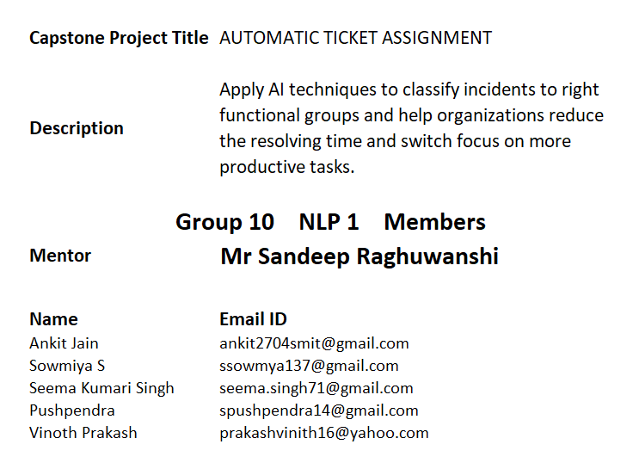

# Summary of the problem statement, Data and findings

## Understanding the Business

IT leverages Incident Management process to ensure there is no disruption to business operations. Any unplanned disruption can cause interruption to business services. Incident management process helps in identification of issues or problems faced by users or operation teams. Manual assignment of incidents is time consuming and requires human intervention. There may be lag in incident resolution due to human errors or if incidents are not routed appropriately. On the other hand, manual assignment also increases the response and resolution times which result in user satisfaction deterioration / poor customer service.

## Background and Objective

To apply techniques and learnings to make ticket assignment more cost-effective, less resolution time so that service desk team can focus on other productive tasks. We are able to see that the current system is capable of assigning 70+% of the tickets correctly. Our target is to automatically classify tickets and directing them to appropriate groups at the earliest, helps in improving the throughput in the ticketing pipeline of an organization.

## Data & Findings Data format CSV

### Total Records 8500

### Data Fields

|  |  |
| --- | --- |
| Short description | A brief overview of the issue faced by the user |
| Description | Detailed description of the issue |
| Assignment group | GRP_0 ~ GRP_73 (total 74 classes of Assignment group) |

### Sample data

| **Short description** | **Description** | **Assignment group** |
| --- | --- | --- |
| login issue | -verified user details.(employee# & manager name)  -checked the user name in ad and reset the password.  -advised the user to login and check.  -caller confirmed that he was able to login.  -issue resolved. | GRP_0 |
| Outlook | received from: hmjdrvpb.komuaywn@gmail.com  hello team,  my meetings/skype meetings etc are not appearing in my outlook calendar, can somebody please advise how to correct this?  kind | GRP_0 |
| cant log in to vpn | received from: eylqgodm.ybqkwiam@gmail.com  hi  i cannot log on to vpn  best | GRP_0 |

### Observations

1. High imbalance seen in data with GRP_0 having 40%+ percent of representation
2. Many groups/classes are with very little representation.
3. Null values:

Short description 8

Description 1

Assignment group 0

1. Very few tickets have non-English descriptions
2. Four columns – Short Description, Description, Caller and Assignment group
3. 74 Assignment groups found - Target classes
4. Caller names in a random fashion (may not be useful for training data)
5. European non-English language also found in the data
6. Email/chat format in description
7. Symbols & other characters in the description
8. Hyperlinks, URLS & few image data found in the description
9. Blanks found either in the short description or description field
10. Few descriptions same as the short description
11. Few words were combined together
12. Spelling mistakes and typo errors are found

# Summary of the approach to EDA and Pre-Processing

### 

### Data Pre-Processing and Cleaning

Below steps have been performed for initial pre-processing and clean-up of data:

1. Dropped the caller field as the data was not found to be useful for analysis
2. Replaced Null values in short description & description with space.
3. Merged Short Description & Description fields for analysis
4. Contraction words found in the merged Description are removed for ease of word modelling
5. Changed the case sensitivity of words to the common one
6. Removed Hashtags and kept the words, Hyperlinks, URLs, HTML tags & non-ASCII symbols from merged fields.
7. Translating all languages (German) to English
8. Tokenization of merged data
9. Removal of Stop words
10. Lemmatization
11. WordCloud created
12. Attempted to do spell check
13. Created Plot to understand the distribution of words
14. Removal of line breaks and tabs (\r\n\t)
15. Removal of special characters
16. Removal of extra spaces
17. Missing value imputation: NLP keyword extraction with Rake < TODO >

## Data Visualization

## 

## Word Cloud

## Grp_0

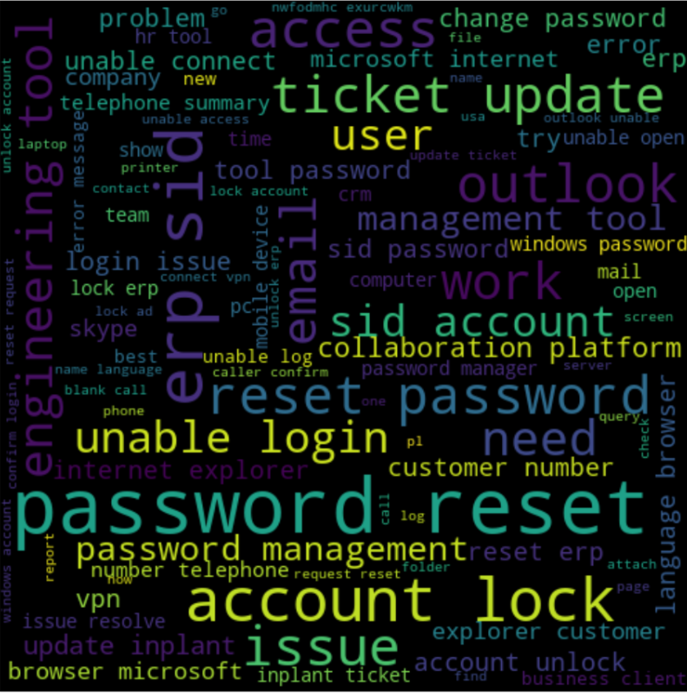

## Data Set

## 

## Charts

TBD

# Decide Model and Model building

TBD

# Model performance - Approaches to improve model

TBD

# Code Snippet

# Finalized results

# Link to code and references