SmartCare Health Monitoring with Smartwatches
A Business Analytics Case Study Report

Student Name: Vikash Sharma
Student ID: 270655771
Course Name: MBI806B: Business Data Analytics with Visualisation and Decision- Making
Submission Date: 24-Mar-2026

1. Introduction
Through a case study, this paper discusses the preventive healthcare initiative SmartCare by New Zealand healthcare provider A phone equipped with a sensor and software applications giving data on temperature, air pressure or humidity Smartwatches were given to 50 subjects whose ages ranged from 50 to 79 in order facilitate the monitoring of health indicators such as heart rate, sleep quality, physical activity, stress levels, calorie burn, fall alerts and weekly health scores. Analysis using Python tools revealed that 70% of patients met at least one high- risk threshold, and 10% triggered fall alerts. Female patients had a higher average weekly health score (79.4) than males (75.6).
On average daily steps (7,482) were less than the recommended 10,000 and a modest negative correlation between age and health score (r =- 0.13) Training students for the national clinical evidence healthcare software development contest was put off because of unsuitable hardware or software Recommendations include personalized interventions for physical activity, sleep hygiene, stress management and cardiovascular monitoring, with ethical considerations based on the New Zealand Privacy Act 2020 and Health Information Privacy Code 2020.

Against such a backdrop, the world healthcare sector has had an increasing tendency in recent times towards preventive, data- supported care. The rapid development in wearable health technology, and particularly the smartwatch, makes it possible introduces continuous monitoring of biometrics. Sensible management of an individual's own health is thereby transformed from reactive treatment into preventative action. In New Zealand, with an aging population, chronic diseases, and spiralling costs associated with reactive care (Ministry of Health NZ 2023). This SmartCare campaign aims to help relieve these pressures by providing smartwatches to people 50 years old and over at high risk of various health problems. The initiative collects continuous physiological data from patients under medical supervision. In this way, healthcare analysts and clinical practitioners are able to detect early warning signs give timely interventions.

2. Problem Statement
The infrastructure to convert smartwatch data into comprehensive, easy-to-understand actionable intelligence simply is not built into most medical organizations. This report is about using business analytics and visual storytelling on SmartCare smartwatch data in order to yield ethical insights, based on the data, for early risk detection and custom- made preventive care.

2.1 Objectives
- Analyzing Data from the SmartCare dataset.
- Are there any common medical problems that seniors have? Have we seen a rise in them? Can Lifestyles be responsible for these rises
- Make a Python dash board with operational real- time filters and a strong user experience.
- Provide evidence- based recommendations for tailored health interventions.
- Assess the ethical norms and privacy of medical data analytics.

2.2 Tools & Technologies
This project uses the following Python- based analytical and visualisation tools:
Tool/Library | Purpose | Version
Python | Core programming language for all analysis | 3.x
pandas | Data loading, cleaning, preprocessing, aggregation | Latest
NumPy | Numerical operations, correlation, trend line calculation | Latest
Matplotlib | Static chart generation for report figures | Latest
Seaborn | Enhanced statistical visualisation (heatmap, boxplot) | Latest
Plotly | Interactive chart engine for the dashboard | Latest
Dash | Python web framework for the interactive dashboard | Latest
Table 1: Tools and Technologies Used
3. Data Analysis and Model Development (Methodology)

3.1 Dataset Description
There are 13 variables in 50 patient records that in the SmartCare dataset appear with smartwatch sensors and health records. Data field types and value ranges are summarized in Table 2.

Field | Type | Description | Range / Values
PatientID | Categorical | Unique patient identifier | P1000 - P1049
Age | Numeric | Patient age in years | 50 - 79
Gender | Categorical | Patient gender | Male / Female
DailyStepCount | Numeric | Average daily steps recorded | 2,064 - 11,762
HeartRate_Min | Numeric | Daily minimum heart rate (BPM) | 50 - 67
HeartRate_Max | Numeric | Daily maximum heart rate (BPM) | 100 - 180
HeartRate_Avg | Numeric | Daily average heart rate (BPM) | 65 - 115
SleepDuration_Hours | Numeric | Average nightly sleep duration | 4.1 - 9.5 hrs
SleepQualityScore | Numeric | Sleep quality index (0–100) | 41 - 99
StressIndex | Numeric | Physiological stress level (0–100) | 24 - 95
FallAlerts | Binary | Fall detected by sensor | 0 = No, 1 = Yes
CalorieBurn | Numeric | Estimated daily calorie expenditure | 1,511-3,452 kcal
WeeklyHealthScore | Numeric | Composite health score (0–100) | 56 – 99
Table 2: SmartCare Dataset Field Descriptions

3.2 Data Quality Assessment
The data quality check in pandas found that there were no errors or absences anywhere among the table's rows. Every one of the 13 fields had a complete dataset. All entries for StressIndex were sensible between 0 and 100, heart rate readings were clinically plausible, and step counts as well as calories were always non- zero. Natural clinical variation is indicated by IQR- based outlier screening.

3.3 Preprocessing Steps
Step | Method (Python Code) | Outcome
Missing value check | df.isnull().sum() | No missing values - dataset complete
Outlier screening | IQR: Q1 - 1.5×IQR to Q3 + 1.5×IQR | Natural variation retained; no invalid outliers
Age group binning | pd.cut(df['Age'], bins=[49,59,69,79]) | 3 groups: 50- 59 (n=11), 60- 69 (n=14), 70- 79 (n=25)
Risk classification | np.where(StressIndex≥70 | SleepQual≤55 | HRAvg≥90) | 35 patients (70%) flagged as High Risk
Correlation matrix | df[numeric_cols].corr() | Pearson correlations across all 10 numeric fields
Table 3: Data Preprocessing Summary
4. Data Analysis and Model Development (Methodology)

4.1 Demographic Overview
Smart care treatment group, which includes 50 patients with an average age of 67.2. The gender is 60% female and 40% male. In terms of age, the 70–79 group is largest (n=25). This also reflects our focus in this population type on both higher risk for falls and chronic disease prevention.

Category | Group | n | Avg. Health Score | Avg. Stress Index | Avg. Daily Steps
Gender | Female | 30 | 79.4 | 59.6 | 7,698
Gender | Male | 20 | 75.6 | 59.2 | 7,178
Age Group | 50-59 yrs | 11 | 77.8 | 61.7 | 7,397
Age Group | 60-69 yrs | 14 | 78.7 | 59.5 | 6,712
Age Group | 70-79 yrs | 25 | 77.4 | 59.1 | 7,951
Table 4: Demographic Summary Statistics

4.2 Correlation Analysis
All ten- health metrics were cross- correlated with a Pearson correlation matrix. The full correlation heatmap in Figure 1 was generated with seaborn in Python.
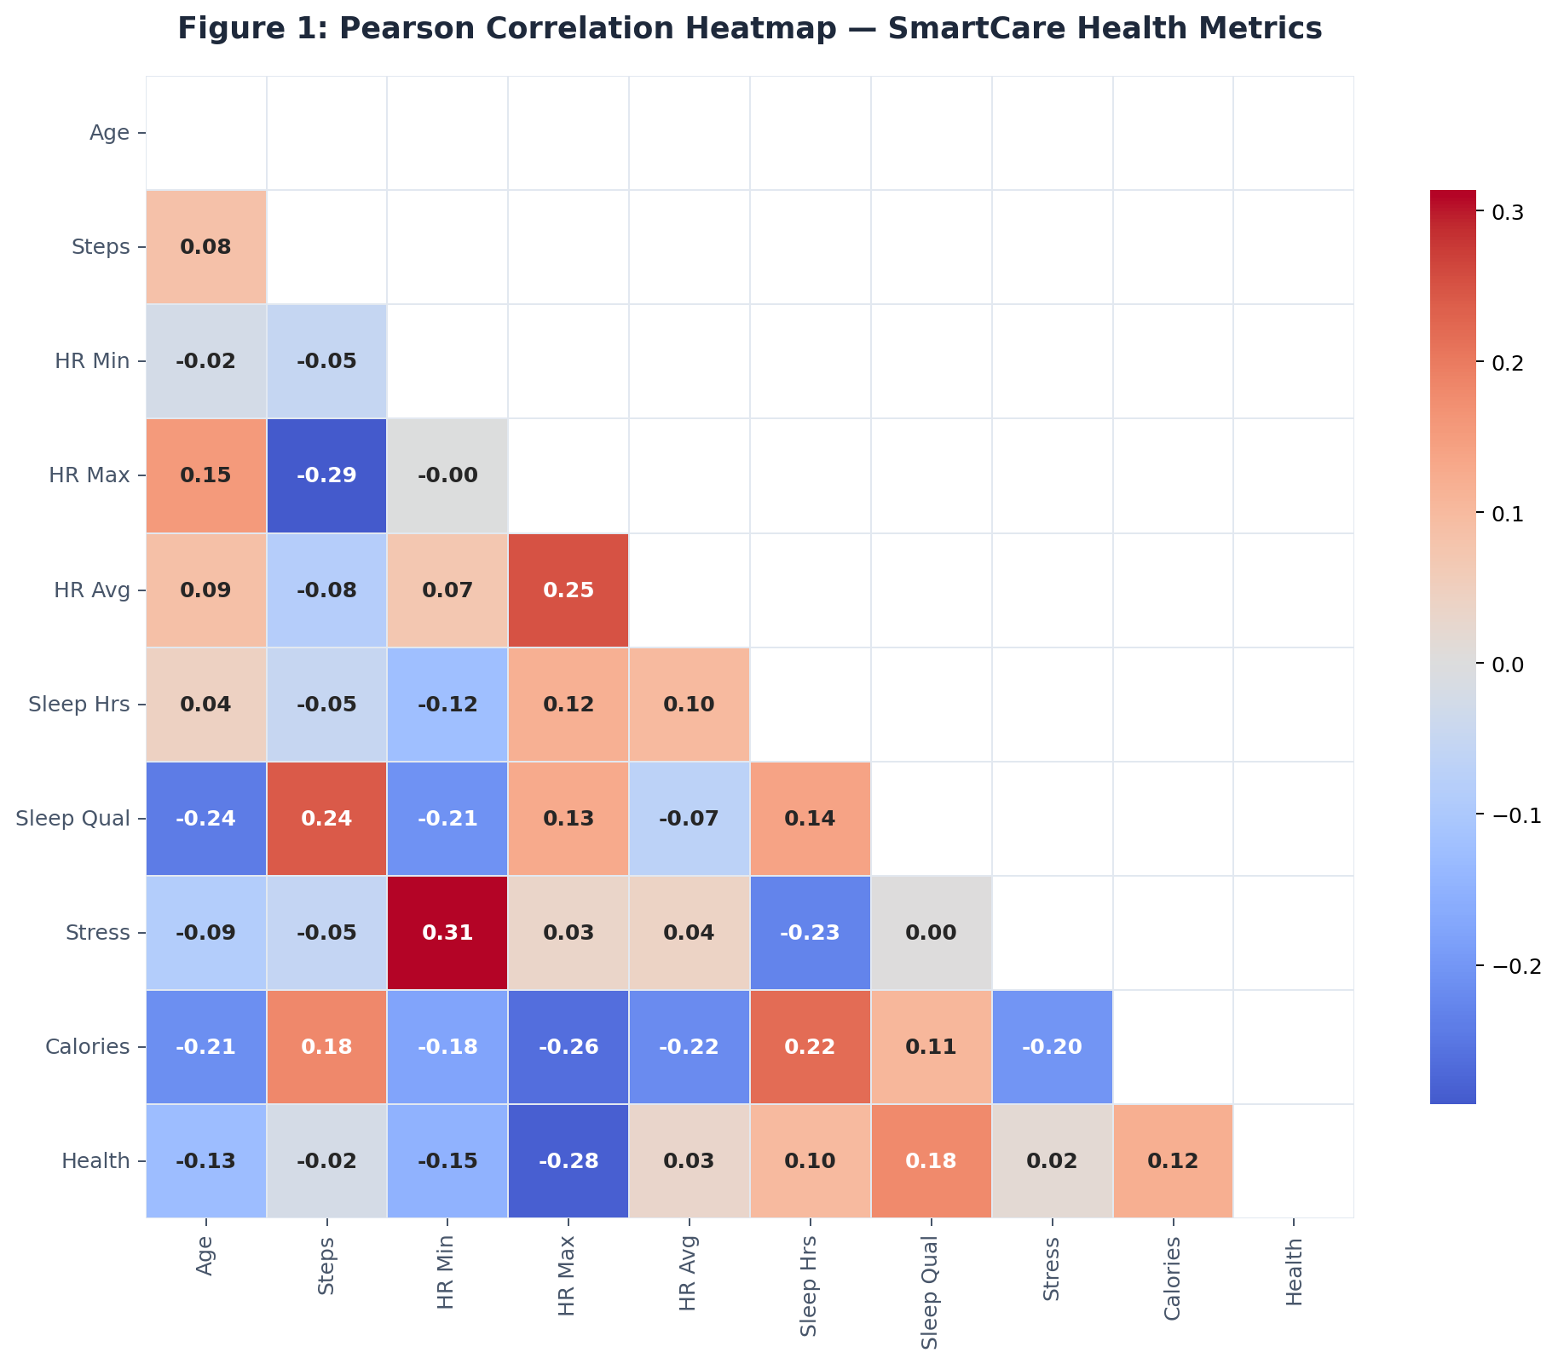
Figure 1: Pearson Correlation Heatmap of SmartCare Health Metrics (Python/Seaborn)
Key correlation findings:
- Age vs. Weekly Health Score (r = - 0.13) A small negative correlation: older people have a slight tendency to be slower of health, and this matches with how age- related decrease in body function would make health seem wors.
- Sleep Duration vs. Weekly Health Score (r = +0.10) Those who slept for prolonged periods trending marginally higher than others on health maintenance area charts- fulfilling once more the equation that a well- rested body leads to general well- being.
- Heart Rate metrics (Min/Avg./Max) : Strong positive inter- correlations confirm internal consistency in cardiovascular measurement.
- Step Count vs. Calorie Burn: In line with expectations (a lot of) interdependence is evident between these two concepts - physical activity by its very nature makes you burn more calories and through this mechanism drives up calories out.
- Stress Index vs. Sleep Quality Score (r approx. 0.003) Almost no correlation: sleep quality alone is not enough to predict stress in this group of patients, confirming once again the multi- factorial nature of stress.

4.3 Health Score Trends by Age Group & Gender
Figure 2 compares average weekly health scores by age group and gender. Female patients surpass their male counterparts in all age bands. The highest average score is recorded by the 60- 69 group, while the 70- 79 group has the lowest average score, that is usually associated with more complicated aging of health level.
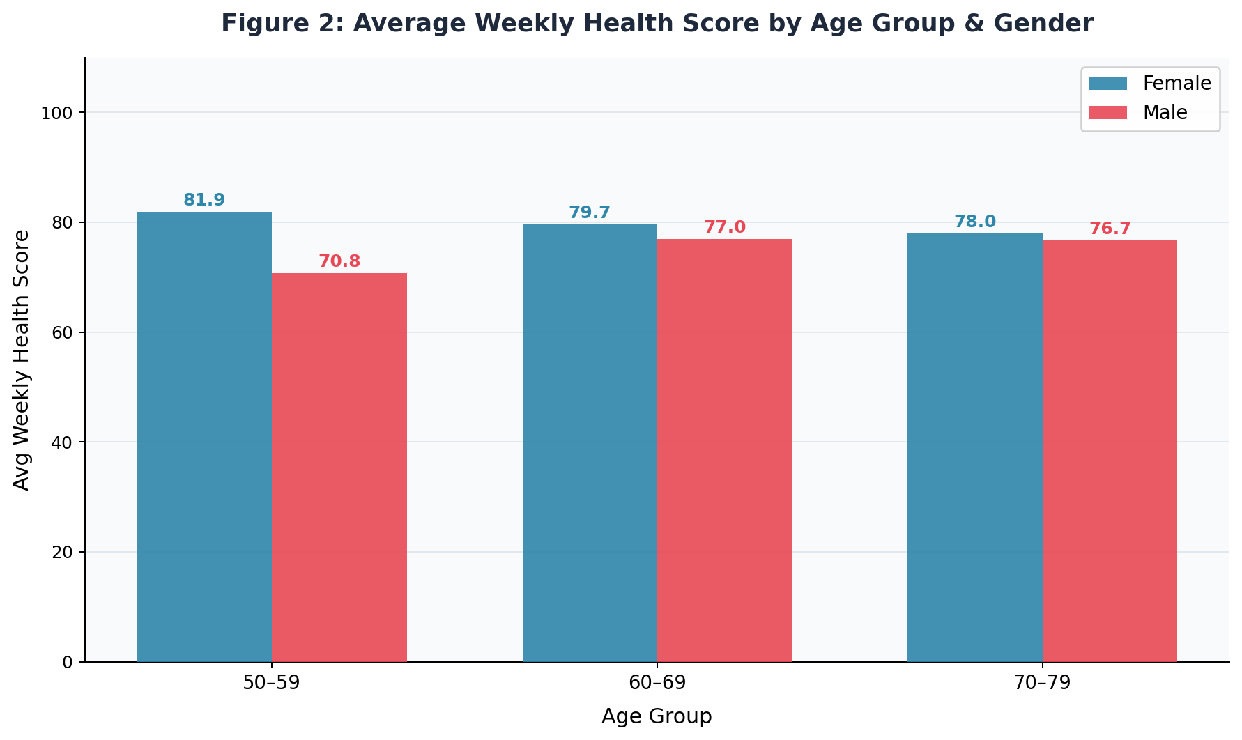
Figure 2: Average Weekly Health Score by Age Group & Gender (Python/Matplotlib)

4.4 Physical Activity and Stress Across Age Groups
Figure 3 overlays average daily step count and stress index across age groups using a dual- axis line chart. It was found that the highest average daily step count by age group in the 70-79 band was 7,951 whereas it had the lowest average stress index score, giving the impression that for older folks and may itself act as buffer against stress.
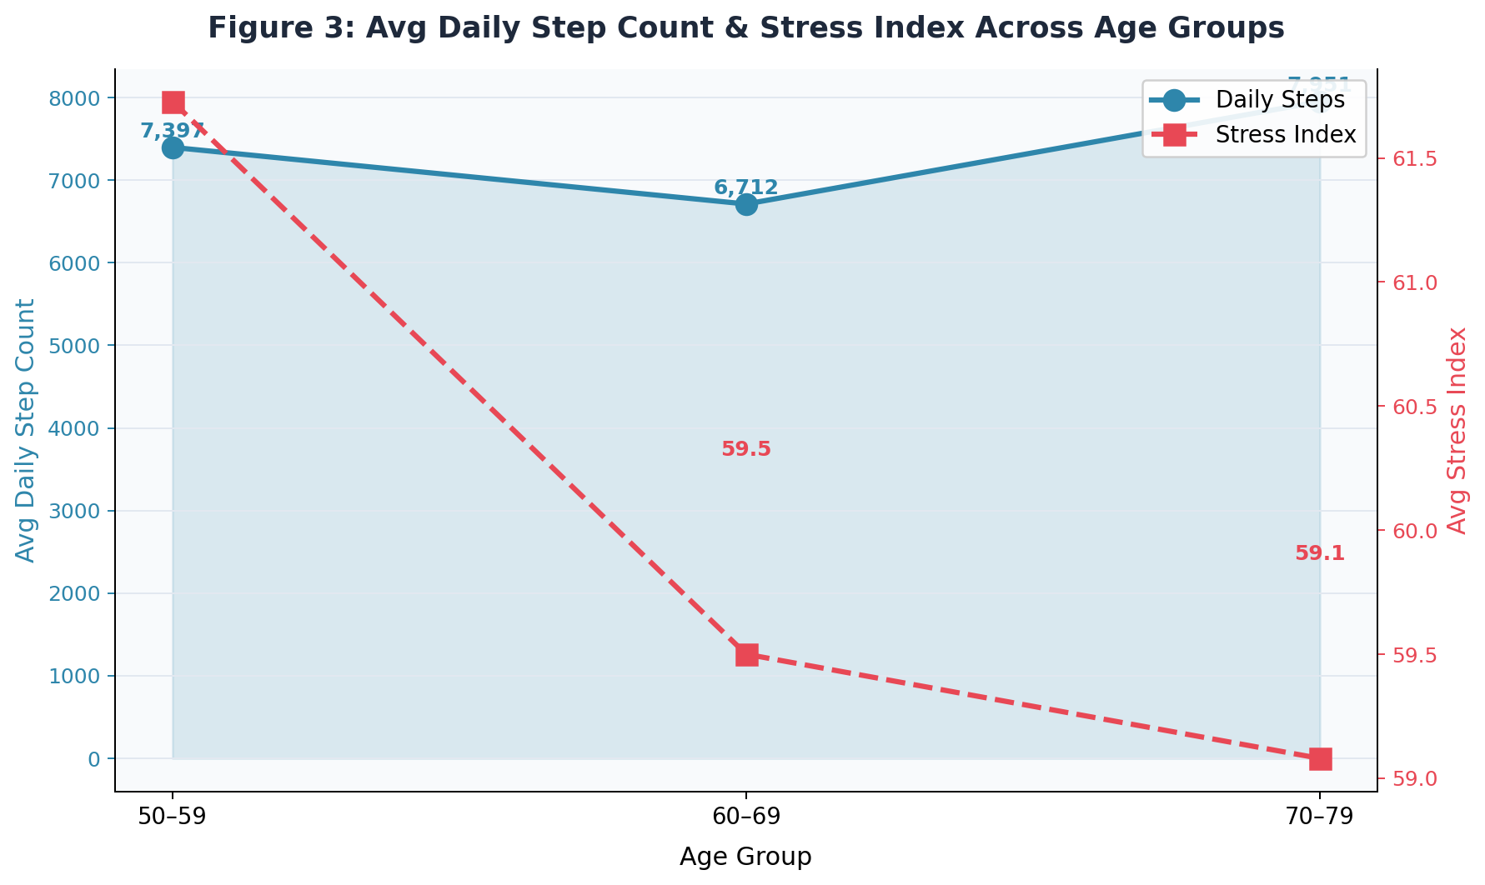
Figure 3: Daily Step Count & Stress Index Across Age Groups (Python/Matplotlib)

4.5 Sleep Quality and Stress Relationship
Figure 4 shows a scatter plot of sleep quality score versus stress index by gender. The near- flat trend line (r = 0.003) indicates no strong linear relationship exists. However, a clinical sub- group of patients with both low sleep quality points to an essential intervention target as this group is prone to other health problems.
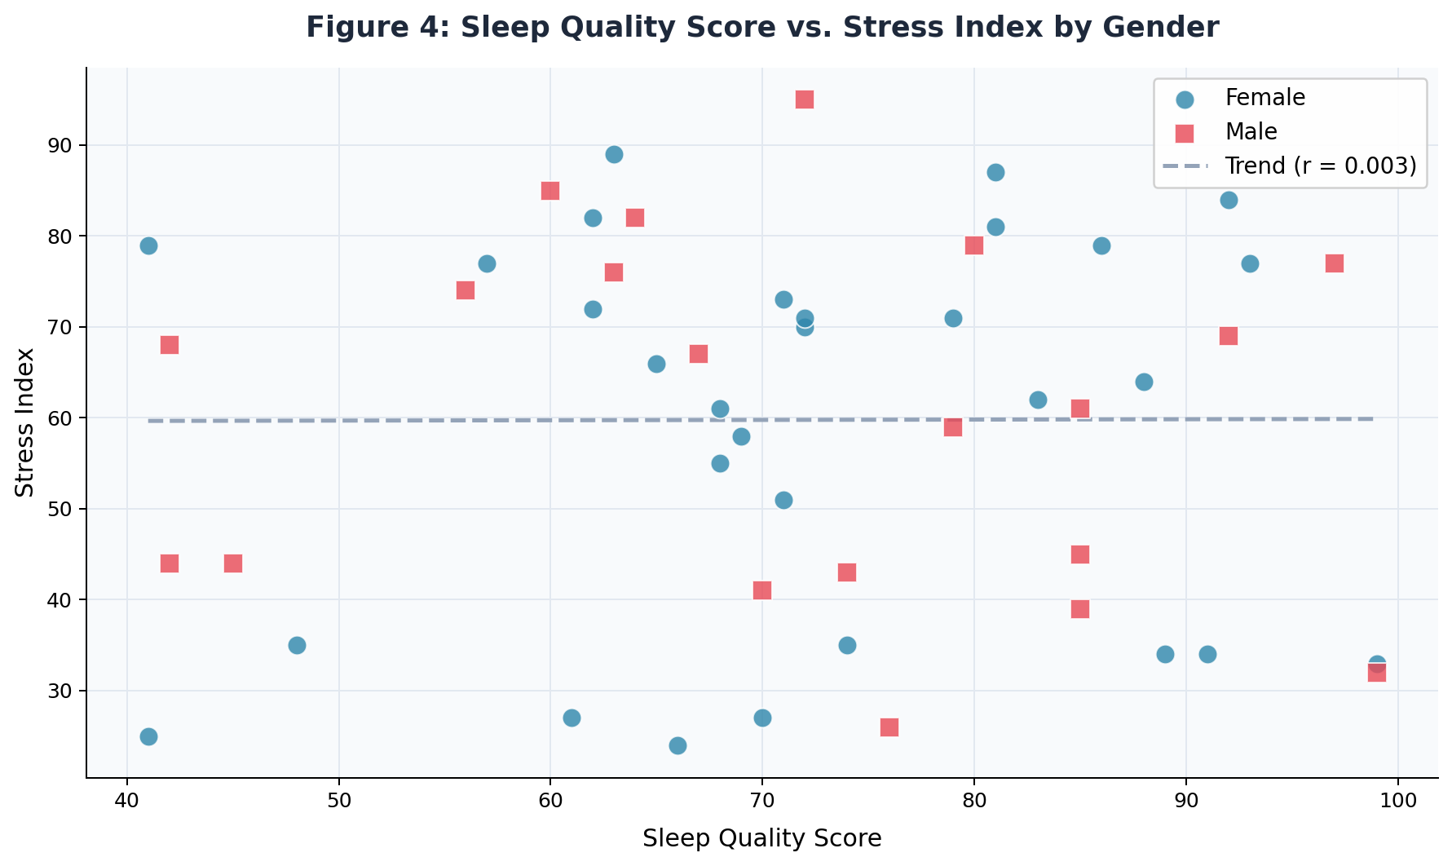
Figure 4: Sleep Quality Score vs. Stress Index by Gender (Python/Matplotlib)

4.6 Fall Alerts and Gender Distribution
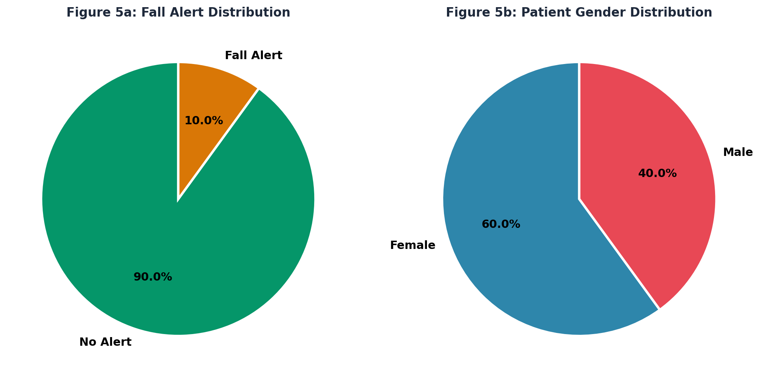
Figure 5: Fall Alert Distribution (5a) and Patient Gender Distribution (5b) (Python/Matplotlib)
In the monitoring period, five patients (10% of the total) prompted fall alerts. Combined with the high age profile of the cohort, this will be of clinical significance Fall is the leading cause of hospitalization and loss of independence among New Zealanders aged 65 and over (ACC 2022).Reflecting the greater representation of older women in preventative health programmes, the gender split sidelines are 60% female, 40% male. Therefore, hospitalized rates also depend to some extent on age and gender, both singly and in combination.

5. Visualizations & Dashboard

5.1 Python Dash Interactive Dashboard
An interactive analytics dashboard was built using Python's Dash framework with Plotly as the chart engine. Hosted locally, it runs as a web application Address 127.0.0.1:8050 that runs real time filtering through three drop- down filters for data.

To run the dashboard: (1) Install dependencies - pip install dash plotly pandas (2) Run - python smartcare_dashboard.py (3) Open browser - http://127.0.0.1:8050

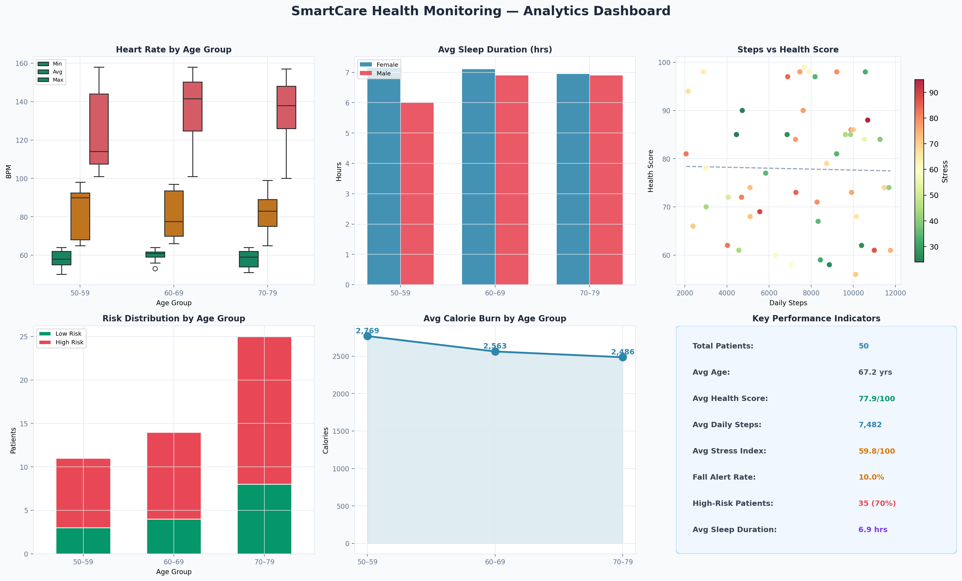
Figure 6: SmartCare Interactive Analytics Dashboard (Python · Dash · Plotly)

5.2 Dashboard Features
This dashboard includes following interactive features and visualizations:
Feature | Description | Python Implementation
Age Group Filter | Dropdown filter: All / 50- 59 / 60- 69 / 70- 79 - all charts and KPIs update instantly | Dash dcc.Dropdown + @app.callback
Gender Filter | Dropdown filter: All / Female / Male | Dash dcc.Dropdown
Risk Level Filter | Dropdown filter: All / High Risk / Low Risk | Dash dcc.Dropdown
4 KPI Cards | Avg. Daily Steps, High- Risk %, Avg. Sleep, Avg Health Score - all reactive | Dash html.Div + callback Output
Bar Chart | Avg. Weekly Health Score by Age Group & Gender | plotly go.Bar
Correlation Heatmap | Pearson correlation matrix across all 10 numeric metrics | plotly go.Heatmap
Scatter Chart | Daily Steps vs Health Score coloured by Stress Index, with trend line | plotly go.Scatter + np.polyfit
Donut Chart | High Risk vs Low Risk patient distribution | plotly go.Pie (hole=0.62)
Sleep vs Stress | Sleep Quality Score vs Stress Index by Gender with trend line | plotly go.Scatter
Box Plot | Heart Rate (Min/Avg./Max) distributions across age groups | plotly go.Box
Line Chart | Average Calorie Burn trend by age group | plotly go.Scatter (fill)
Fall Alert Pie | Fall alert vs no- alert patient distribution | plotly go.Pie
Patient Data Table | Sortable, filterable full patient records with conditional colour formatting | Dash dash_table.DataTable
Table 5: Dashboard Visual Components and Python Implementation

5.3 Visualization Design Rationale
Visual types were chosen according to the analytical purpose of each insight:
(1) Correlation heatmaps allow a swift and comprehensive survey of all inter- variable relationships simultaneously.
(2) Clustered bar charts enable demographically stratified breakdown across two categorical dimensions (age group and gender).
(3) Scatter plots with trend lines convey both the direction and magnitude of bivariate relationships, with a third variable encoded by color (stress index).
(4) Donut and pie charts pack proportional data (risk distribution, fall rates) into a format instantly recognisable by clinical stakeholders.
(5) Box plots reveal distributional features of heart rate by age group, giving median, quartile range and, where relevant, any outliers - richer than simple averages.
(6) The static composite dashboard (Figure 6) serves for management report level with a KPI panel embedded alongside detailed analytical charting.

6. Result Analysis

# | Finding | Clinical Significance | Implication
1 | 70% of patients are High Risk (n=35) | Majority meet ≥1 critical threshold for elevated stress, low sleep quality, or high heart rate | Immediate need for targeted intervention programmes
2 | 10% fall alert rate (5 patients) | Falls are the leading cause of injury hospitalisation in NZ adults 65+ | Priority fall prevention for 70-79 cohort
3 | Female avg. health score 79.4 vs 75.6 for males | Gender gap may reflect differences in health behaviours or occupational stressors | Gender- specific health programmes warranted
4 | Avg. steps 7,482 - below 10,000/day guideline | Physical activity shortfall across cohort | Step goal programme and activity coaching indicated
5 | Sleep quality vs stress r ≈ 0.003 | Stress is multi- factorial and not reliably predicted by sleep quality alone | Multi- modal interventions needed (mindfulness + activity + clinical)
6 | HeartRate_Max up to 180 BPM in 70-79 cohort | Extreme max HR increases acute cardiac risk in older adults | Immediate clinical review for high HR patients
7 | 60–69 cohort records highest health score (78.7) | Mid- age group shows best health outcomes overall | Focus resources on youngest (50-59) and oldest (70-79) cohorts
8 | Avg. sleep duration 7.2 hrs - within normal range | Average adequate; but quality scores vary widely (41-99) | Sleep quality (not just duration) must be targeted
Table 6: Summary of Key Analytical Findings

7. Ethical Considerations & Data Privacy

7.1 Ethical Framework
Ethical use of business analytics for personal health data requires a deep conviction of patient dignity, trust, and autonomy. All analytics practices in this project are guided by three frameworks: needs of thePrinciplism (Beauchamp & Childress, 2019) - autonomy, beneficence, non- maleficence, and justice; New Zealand Privacy Act2020 and Health Information Privacy Code 2020; and GDPR- aligned data governance principles like data minimisation, purpose limitation, accuracy, and accountability.

7.2 Informed Consent and Patient Autonomy
All 50 patients in SmartCare must have provided documented informed consent for their involvement on four key point:
(1) what data is being collected and why
(2) the right to withdraw consent and ‘right to forget”
(3) any third- party data sharing agreements with industry partners or other researchers and
(4) how clinical care decisions are influenced by analytics insights. Under the Health and Disability Commissioner Code of Rights (NZ, 1996), patients have the right to be fully informed and to participate in decisions about their care.

7.3 Data Minimisation and Purpose Limitation
To protect the privacy of patients, analysis put into practice data minimisation principles: we kept the PatientID for linkage but did not link it to external personal identification information. The analysis did not try re-identification or external data linkage. According to NZ Privacy Act 2020 Principles 1 and 10, data used solely for that specified preventive health analytics purpose - any subsequent commercial use without fresh consent would be a serious protection breach.

7.4 Algorithmic Fairness and Bias
The complex HighRisk classification relies on fixed clinical thresholds which could contain bias. Fixed heart rate cut- offs may prejudice patients on beta blockers. Accelerometer- based sleep quality scores also have known accuracy limitations for elderly populations. Smartwatch manufacturers' stress index algorithms vary and may not be validated in New Zealand's eclectic patient population. In the clinical implementation stage, organizations must audit analytics models for demographic bias (Ministry of Health NZ, 2021).

8. Data Privacy Statements
- Encryption: All smartwatch transmissions must have their data encrypted using TLS 1.3; the storage part of the process should be encrypted with AES- 256 and tied in to role- based access controls.
- Access control and audit trails: Only the clinical staff involved should ever access identifiable records, and every access event must then be logged.
- Breach notification: Under Section 113 of the Privacy Act 2020, information regulators must now notify themselves and affected persons if their breach results in a material risk to life or health.
- Data retention: Patient data should be kept as per the Health (Retention of Health Information) Regulations 1996, usually 10 years for adult GCSE records; after 10 years it must be securely deleted.

Ethical Principle | Standard | Implementation in This Project
Informed Consent | NZ Privacy Act 2020, Principle 3 | Assumed from enrolment; consent audit recommended
Data Minimisation | NZ Privacy Act 2020, Principle 1 | PatientID anonymised in analysis; no secondary linkage
Purpose Limitation | NZ Privacy Act 2020, Principle 10 | Data used exclusively for preventive health analytics
Data Security | ISO/IEC 27001; Privacy Act Principle 5 | Encryption, access control, audit trail requirements specified
Algorithmic Fairness | Ministry of Health NZ AI Guidelines 2021 | Risk threshold limitations documented; bias audit recommended
Transparency | Health & Disability Commissioner Code | Full methodology documented; explainability requirements stated
Breach Notification | NZ Privacy Act 2020, Section 113 | Breach response protocol requirements specified
Patient Autonomy | H&DC Code of Rights (Right 7) | Patient access to insights and withdrawal rights emphasised
Table 8: Ethical Standards Compliance Summary

9. Recommendations

9.1 Personalised Health Interventions
Intervention | Target Group | Rationale | Expected Outcome
Structured step goal programme (target: 10,000 steps/day) | All patients (avg. 7,482 steps) | Below NZ guideline; steps correlate with calorie burn | Increase avg steps by 15-25%
Personalised sleep hygiene programme | Patients with SleepQualityScore < 60 | Modifiable risk factor for cardiovascular disease, cognitive decline, and falls | Improve sleep quality scores by 10+ points
Stress management (mindfulness, CBT) | Patients with StressIndex ≥ 70 | Elevated stress linked to cardiovascular risk and reduced immune function | Reduce stress index below 60 within 12 weeks
Fall prevention (balance training, home assessment) | All 70-79 cohort; 5 fall- alert patients | 10% fall alert rate is clinically significant | Reduce falls by 50% over 6 months
Cardiac monitoring escalation protocol | Patients with HeartRate_Max > 160 BPM | Extreme max HR in older adults poses acute cardiac risk | Early detection of arrhythmia or cardiac events
Table 7: Personalised Intervention Recommendations

9.2 Programme- Level Improvements
- Making a link. Concretely, we want the Dash dashboard to be connected with EHR systems, so that when a patient breaches risk thresholds, clinical and warning signals can be delivered in real time.
- Registering by sex. The 3.8- point health score gap between female patients and males necessitates gender- specific program development.
- Longitudinal data collection. Moving from cross- sectional to longitudinal data should help us predict at earlier stages which patients are deteriorating.
- A model of predictive risk. In the following phase, machine learning classifiers (logistic regression Random Forest) should be used to predict fall risk and potential future hospital admissions.
- Patient engagement: To promote self- management, smartwatch interfaces should offer personalised nudges such as step reminders in an out of high stress Detected (breathing exercises).
9.3 Conclusion
In the case study of this report, we show the use of Python- based business analysis and data visualization in 13,800 aging adults might improve three prevention measures (falls, particularly ravenous falls from eating sweets; early detection of breast cancer; morbidity among elderly who are diabetic). The analysis of smartwatch data from SmartCare also provides material for decision- making and program design at clinical level.
The analysis found that 70% of patients met clinical risk thresholds; high stress, cardiovascular variability and fall incidents were the key areas for intervention. The Python Dash Dashboard allows clinicians to see patient data in real- time. Patients ' demographics are sortable by age and sex, as well risk level. As well as the display of key analytical graphs and live KPI (Key Performance Indicator) metrics.
Ethical analysis is threaded throughout, stressing compliance with the New Zealand privacy act 2020 and the Health Information Privacy code. Patient trust and making healthcare data- driven both demand this.
Future work should involve longitudinal datasets, predicting fall and cardiovascular risk profiles. With adequate governance, the SmartCare analytics program could well be a model for innovation in preventive health care in New Zealand.

10. References
Beauchamp, T. L., & Childress, J. F. (2019). Principles of biomedical ethics (8th ed.). Oxford University Press.

European Commission. (2016). Regulation (EU) 2016/679 - General Data Protection Regulation. Official Journal of the European Union. https://eur- lex.europa.eu/eli/reg/2016/679/oj

Health and Disability Commissioner. (1996). Code of Health and Disability Services Consumers' Rights. https://www.hdc.org.nz/your- rights/the- code- and- your- rights/

Hunter, J. D. (2007). Matplotlib: A 2D graphics environment. Computing in Science & Engineering, 9(3), 90–95. https://doi.org/10.1109/MCSE.2007.55

McKinney, W. (2010). Data structures for statistical computing in Python. Proceedings of the 9th Python in Science Conference, 51–56. https://doi.org/10.25080/majora- 92bf1922- 00a

Ministry of Health New Zealand. (2021). Algorithm assessment report. Ministry of Health. https://www.health.govt.nz

Ministry of Health New Zealand. (2023). New Zealand health strategy 2023: Pae ora. Ministry of Health. https://www.health.govt.nz

Plotly Technologies Inc. (2015). Collaborative data science. https://plot.ly

Privacy Commissioner New Zealand. (2020). Health information privacy code 2020. https://www.privacy.org.nz/privacy- act- 2020/codes- of- practice/hipc2020/

Accident Compensation Corporation (ACC). (2022). Falls prevention in older people. https://www.acc.co.nz

Van Rossum, G., & Drake, F. L. (2009). Python 3 reference manual. CreateSpace.

Waskom, M. L. (2021). Seaborn: Statistical data visualization. Journal of Open-Source Software, 6(60), 3021. https://doi.org/10.21105/joss.03021

