There were two problems

* Angular/elements was using the latest version which was 13 that should be point to 7.2.0
  + Command to run npm install [ngx-build-plus@7.0.0](mailto:ngx-build-plus@7.0.0) --save
* Ngx-build-plus was also using the latest version which was 13 that should point to 7.0.0
  + Command to run npm install @angular/elements@7.2.0 –save

Please use the configuration used in

<https://github.com/vikash-verma-profile/Angular-SPFX-Jan2022/tree/main/demo-3>

Few more changes to be done to function it correctly

1.In attached screenshot below line number 18 by default there will be browser you have to change it to npx-build-plus:build

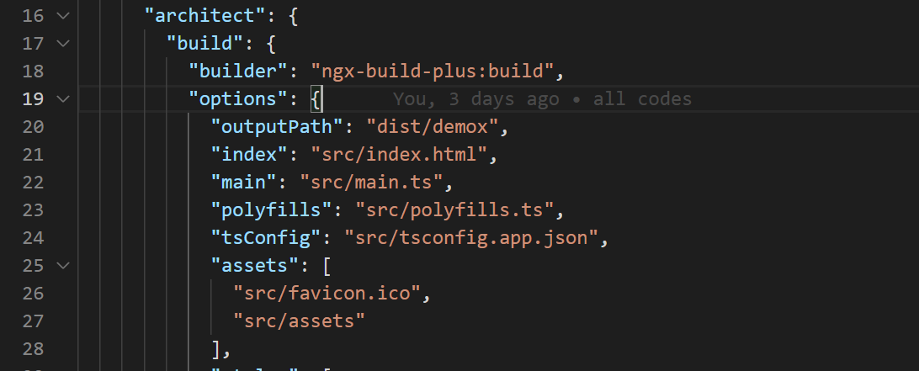

2.In attached screenshot below in line number 11 you have to remove --single-bundle and line number 11 should look like below.

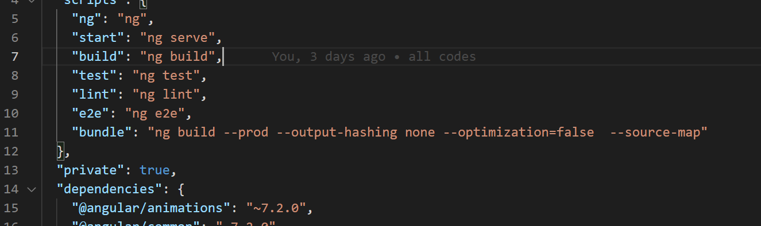

Commands to run after the above config changes: -

1.cd to angular project the run **npm run bundle**

2.cd.. to come out

3.cd to spfx project and run **gulp trust-dev-cert** to support https

3. now run gulp serve. you will able to see your project running.

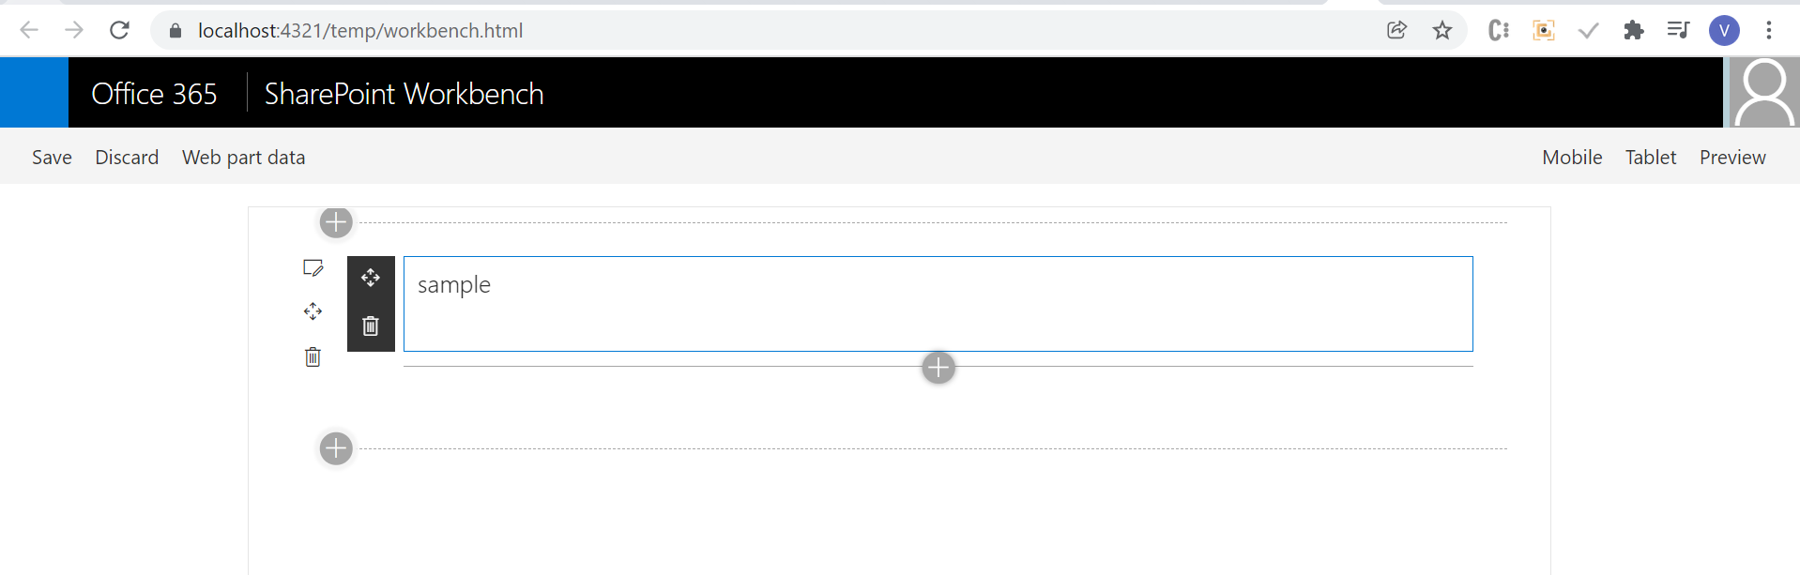

Angular cli version:-

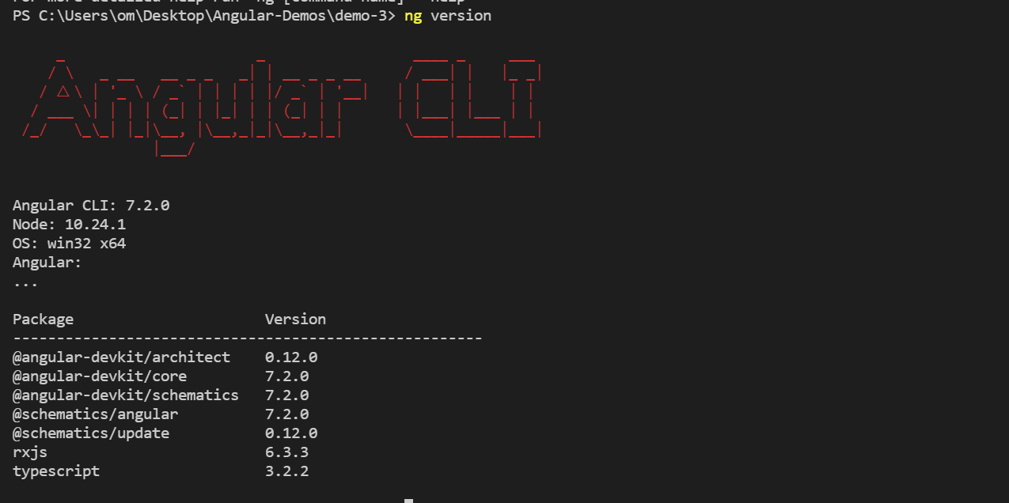

Node -v

