1. Architecture Overview (GCP → Snowflake)
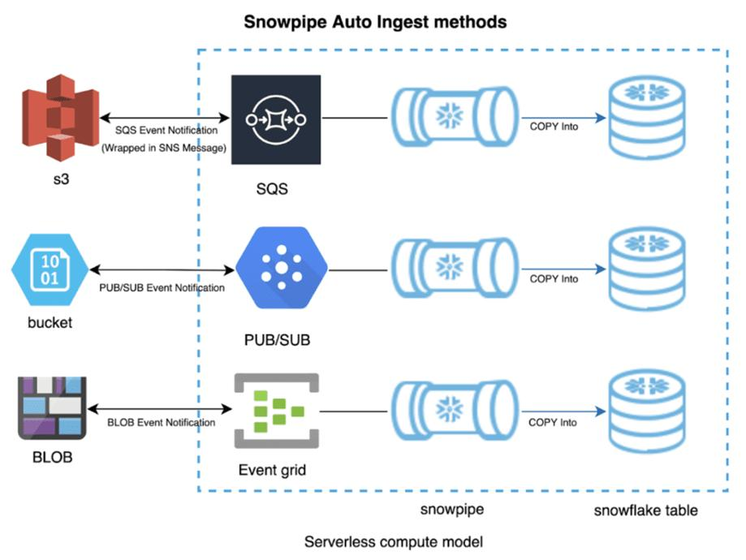
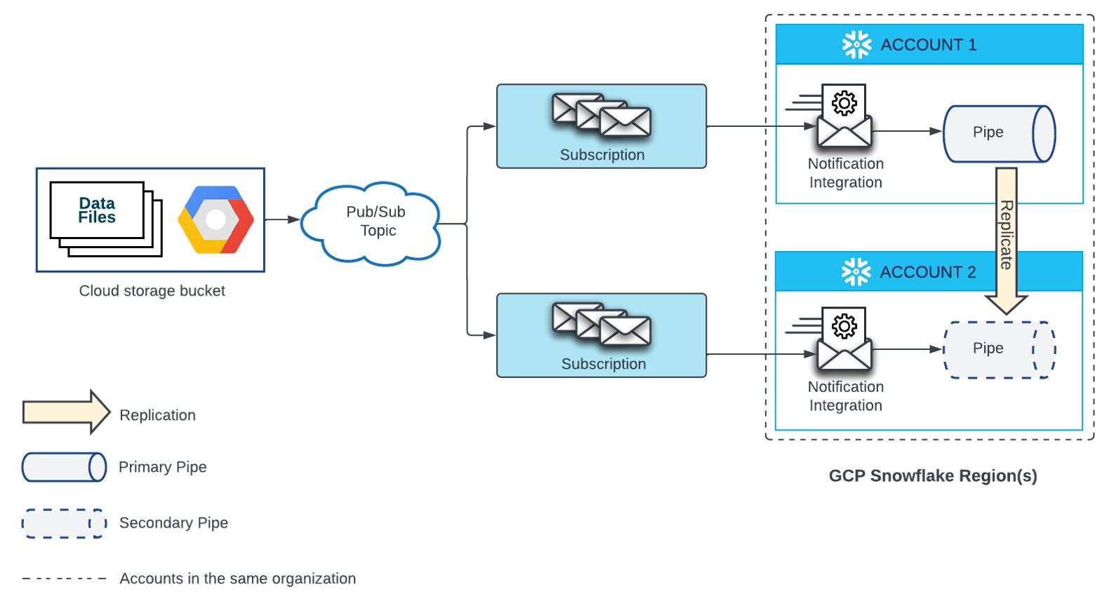
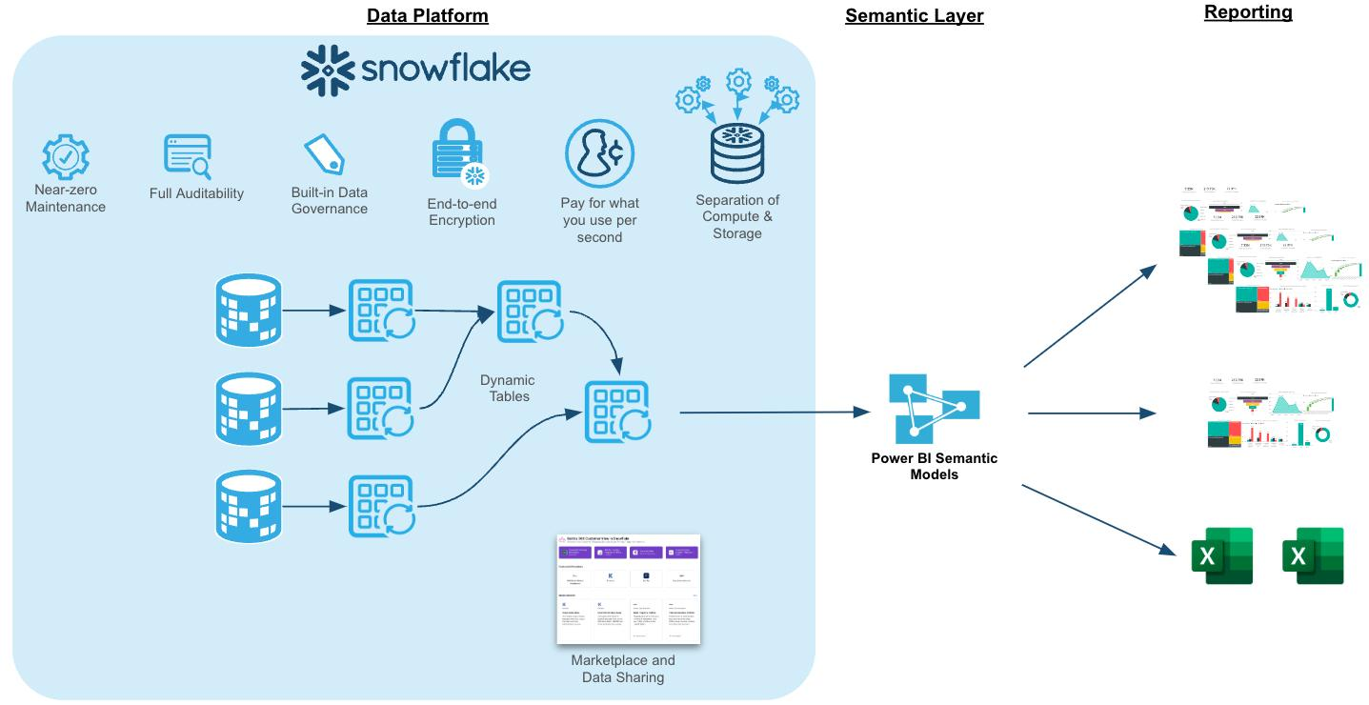
Flow Summary:
- Source system generates files (JSON/CSV)
- Files land in Google Cloud Storage
- Event → Google Cloud Pub/Sub
- Snowpipe auto-ingests into Snowflake
- Streams + Tasks transform data
- BI tools read final tables

2. Step-by-Step Implementation

Step 1: Create GCS Bucket
gsutil mb gs://snowflake-demo-bucket
Upload sample file:
gsutil cp orders.json gs://snowflake-demo-bucket/

Step 2: Create Pub/Sub Topic
gcloud pubsub topics create snowpipe-topic

Step 3: Enable Notification (GCS → Pub/Sub)
gsutil notification create -t snowpipe-topic -f json gs://snowflake-demo-bucket
Now:
Any file uploaded → Pub/Sub event triggered

Step 4: Create Notification Integration in Snowflake
CREATE NOTIFICATION INTEGRATION gcs_notification
TYPE = QUEUE
NOTIFICATION_PROVIDER = GCP_PUBSUB
ENABLED = TRUE
GCP_PUBSUB_SUBSCRIPTION_NAME = 'projects/<project-id>/subscriptions/<sub-name>';

Step 5: Create Storage Integration
CREATE STORAGE INTEGRATION gcs_int
TYPE = EXTERNAL_STAGE
STORAGE_PROVIDER = GCS
ENABLED = TRUE
STORAGE_ALLOWED_LOCATIONS = ('gcs://snowflake-demo-bucket/');
Then:
DESC INTEGRATION gcs_int;
➡ Copy the service account generated by Snowflake
➡ Grant access in GCP IAM (Storage Object Viewer)

Step 6: Create External Stage
CREATE STAGE gcs_stage
URL = 'gcs://snowflake-demo-bucket/'
STORAGE_INTEGRATION = gcs_int
FILE_FORMAT = (TYPE = 'JSON');

Step 7: Create Raw Table
CREATE TABLE raw_orders (
data VARIANT
);

Step 8: Create Snowpipe (Auto Ingest)
CREATE PIPE gcs_pipe
AUTO_INGEST = TRUE
INTEGRATION = gcs_notification
AS
COPY INTO raw_orders
FROM @gcs_stage
FILE_FORMAT = (TYPE = 'JSON');
Now:
File uploaded → Pub/Sub → Snowpipe → Table (automatic)

Step 9: Create Stream (CDC)
CREATE STREAM raw_orders_stream
ON TABLE raw_orders;

Step 10: Create Final Table
CREATE TABLE final_orders (
order_id STRING,
customer STRING,
amount NUMBER
);

Step 11: Create Transformation Task
CREATE TASK transform_task
WAREHOUSE = COMPUTE_WH
SCHEDULE = '1 minute'
AS
INSERT INTO final_orders
SELECT
data:order_id::STRING,
data:customer::STRING,
data:amount::NUMBER
FROM raw_orders_stream;
Start it:
ALTER TASK transform_task RESUME;

3. Sample JSON File
{"order_id":"101","customer":"Vikash","amount":500}
{"order_id":"102","customer":"Rahul","amount":700}

4. End-to-End Flow
- File uploaded → GCS
- GCS triggers → Pub/Sub message
- Snowflake listens via Notification Integration
- Snowpipe executes COPY INTO automatically
- Data lands in RAW table (VARIANT)
- Stream captures new rows
- Task transforms into structured table
- BI / Analytics reads final table

