MODULE 1 — GCP FOUNDATIONS

1. Introduction to Google Cloud Platform
Google Cloud Platform is a suite of cloud services that provides:
- Compute (VMs, Kubernetes)
- Storage (Object, Block)
- Networking (VPC, Load balancing)
- Analytics (BigQuery, Dataflow)
Key Characteristics
- Fully managed services
- Global infrastructure
- Pay-as-you-go pricing
- Strong AI/ML ecosystem

2. GCP Global Infrastructure
Core Components
- Regions → Geographic areas (e.g., us-central1)
- Zones → Data centers within regions
- Multi-region → High availability across regions
Design Principles
- Deploy across multiple zones for HA
- Use regional services for low latency
- Use multi-region storage for critical data

3. GCP Console Walkthrough
What You Can Do
- Create/manage resources
- Monitor usage
- Access logs & metrics
- Manage billing
Key Sections
- Navigation Menu
- Project Selector
- Cloud Shell
- IAM & Admin

4. IAM (Identity & Access Management)

Core Concept
IAM controls WHO can do WHAT on WHICH resource

4.1 IAM Components
Users
- Google accounts (email-based)
Roles
- Collection of permissions
Types:
- Primitive (Owner, Editor, Viewer)
- Predefined (fine-grained)
- Custom (user-defined)
Service Accounts
- Used by applications/services
- Key for automation

4.2 Principle of Least Privilege
- Grant only required access
- Avoid:
  - Owner role
  - Broad permissions
Example
Instead of:
- Storage Admin
Use:
- Storage Object Viewer

4.3 IAM Hierarchy
Organization
↓
Folder
↓
Project
↓
Resources
Key Concept: Inheritance
- Permissions flow downward

5. GCP Resource Hierarchy

Structure
Organization → Folder → Project

Project (Most Important Unit)
- Billing is tied to project
- Resources live inside project

Best Practices
- Separate:
  - Dev / Test / Prod
- Use folders for:
  - Teams
  - Departments

6. GCP Networking Foundations

6.1 VPC (Virtual Private Cloud)
- Global network in GCP
- You define IP ranges
Modes
- Auto mode (default)
- Custom mode (recommended)

6.2 Subnets
- Regional
- Define IP ranges

6.3 Firewall Rules
- Control traffic:
  - Ingress
  - Egress
Example
- Allow SSH (port 22)
- Allow HTTP (port 80)

6.4 Private Service Connect
- Access Google services privately
- Avoid public internet

6.5 VPC Peering
- Connect two VPCs
- Internal communication only

7. Billing & Cost Management

Pricing Models
- Pay-as-you-go
- Sustained use discounts
- Committed use discounts

Budgets & Alerts
- Set monthly budget
- Trigger alerts at thresholds

Cost Optimization
- Stop idle resources
- Use smaller machines
- Use lifecycle policies

8. Cloud Shell & gcloud CLI

Cloud Shell
- Browser-based terminal
- Pre-installed tools
- Temporary VM

gcloud CLI
Common Commands
gcloud init
gcloud config set project PROJECT_ID
gcloud compute instances list

Why CLI?
- Automation
- DevOps pipelines
- Faster operations

MODULE 2 — CLOUD STORAGE (GCS)

1. Cloud Storage (GCS)
Google Cloud Storage
Features
- Object storage
- Highly durable (11 9’s)
- Globally accessible

2. Bucket Structure
Bucket
- Top-level container
- Globally unique name
Object
- File inside bucket

Naming Example
gs://telecom-data-lake/raw/cdr.csv

3. Storage Classes
Class | Use Case
Standard | Frequent access
Nearline | Monthly access
Coldline | Rare
Archive | Long-term

Decision Rule
- Hot data → Standard
- Backup → Nearline
- Archive → Coldline/Archive

4. Lifecycle Rules

Purpose
Automate:
- Storage class changes
- Deletion

Example
- 30 days → Nearline
- 90 days → Coldline
- 365 days → Delete

5. Object Versioning

What It Does
- Keeps old versions of files

Use Cases
- Accidental deletion recovery
- Audit history

6. GCS in Data Engineering

Role of GCS
- Raw data storage
- Landing zone
- Data lake foundation

7. Data Lake Pattern (VERY IMPORTANT)

Medallion Architecture
Bronze → Raw Data
Silver → Cleaned Data
Gold → Business Data

Example (Telecom)
- Bronze:
  - Raw CDR logs
- Silver:
  - Cleaned usage
- Gold:
  - Customer KPIs

8. Partitioning Strategy

Why Partition?
- Faster queries
- Lower cost

Example
/raw/cdr/year=2026/month=04/day=05/

9. Security in GCS

IAM Roles
- Storage Admin
- Storage Object Viewer

Best Practices
- Use service accounts
- Avoid public buckets
- Enable uniform bucket-level access

10. Real-World Architecture
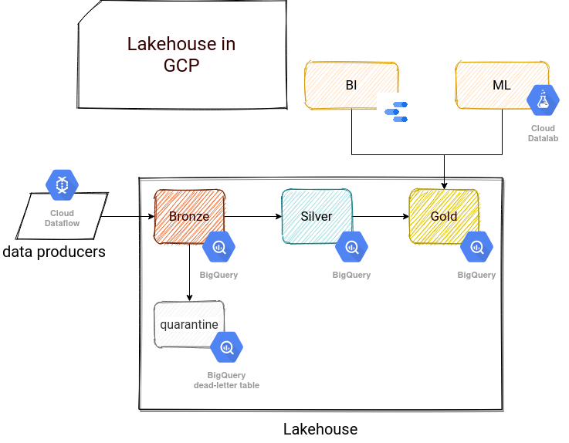
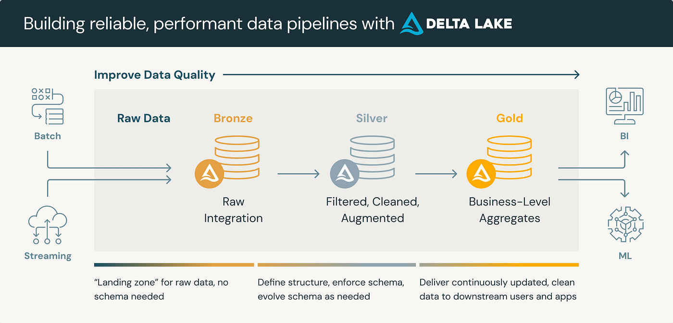
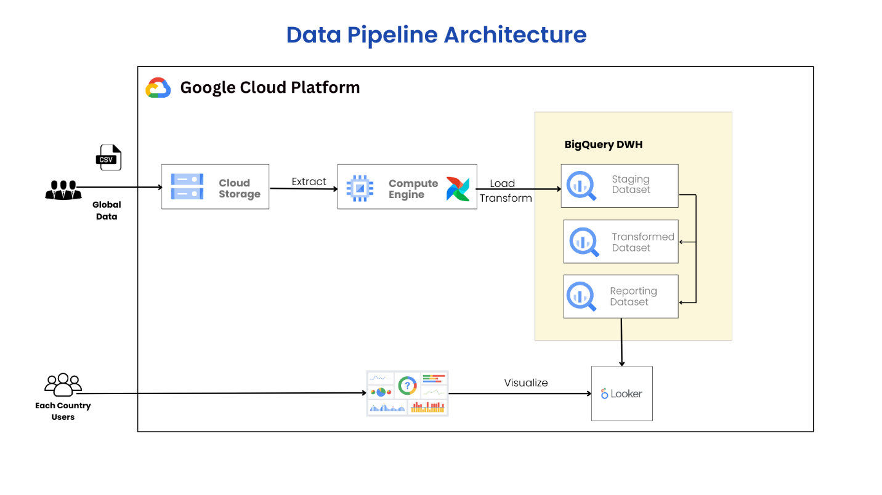

HOW TO STUDY EFFECTIVELY

Step-by-Step Plan
Day 1
- GCP basics + IAM
Day 2
- Networking + Billing
Day 3
- Cloud Shell + CLI
Day 4
- GCS + Storage classes
Day 5
- Data lake + architecture

