Snowflake Architecture, Security & Compute Management – Hands-on Lab

LAB OBJECTIVE
You will:
- Understand **Snowflake architecture in practice
- Configure roles, users, and RBAC
- Create and manage virtual warehouses
- Implement Time Travel, Fail-safe, and Zero Copy Cloning
- Monitor cost and performance

PREREQUISITES
- Snowflake account (trial or enterprise)
- Access to Snowsight UI
- Basic SQL knowledge

ARCHITECTURE OVERVIEW (CONCEPTUAL)
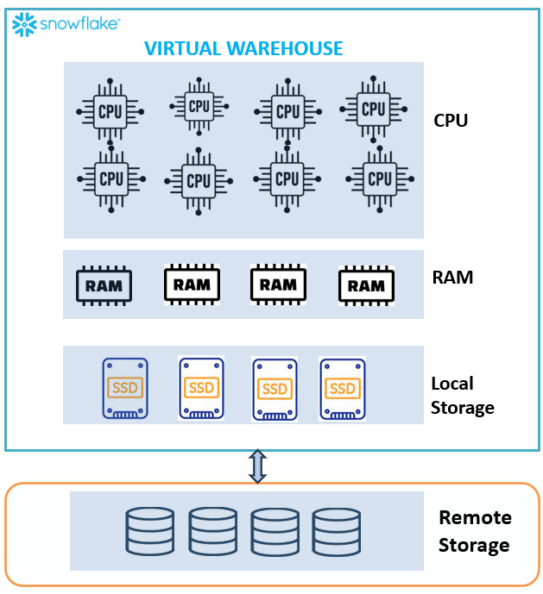
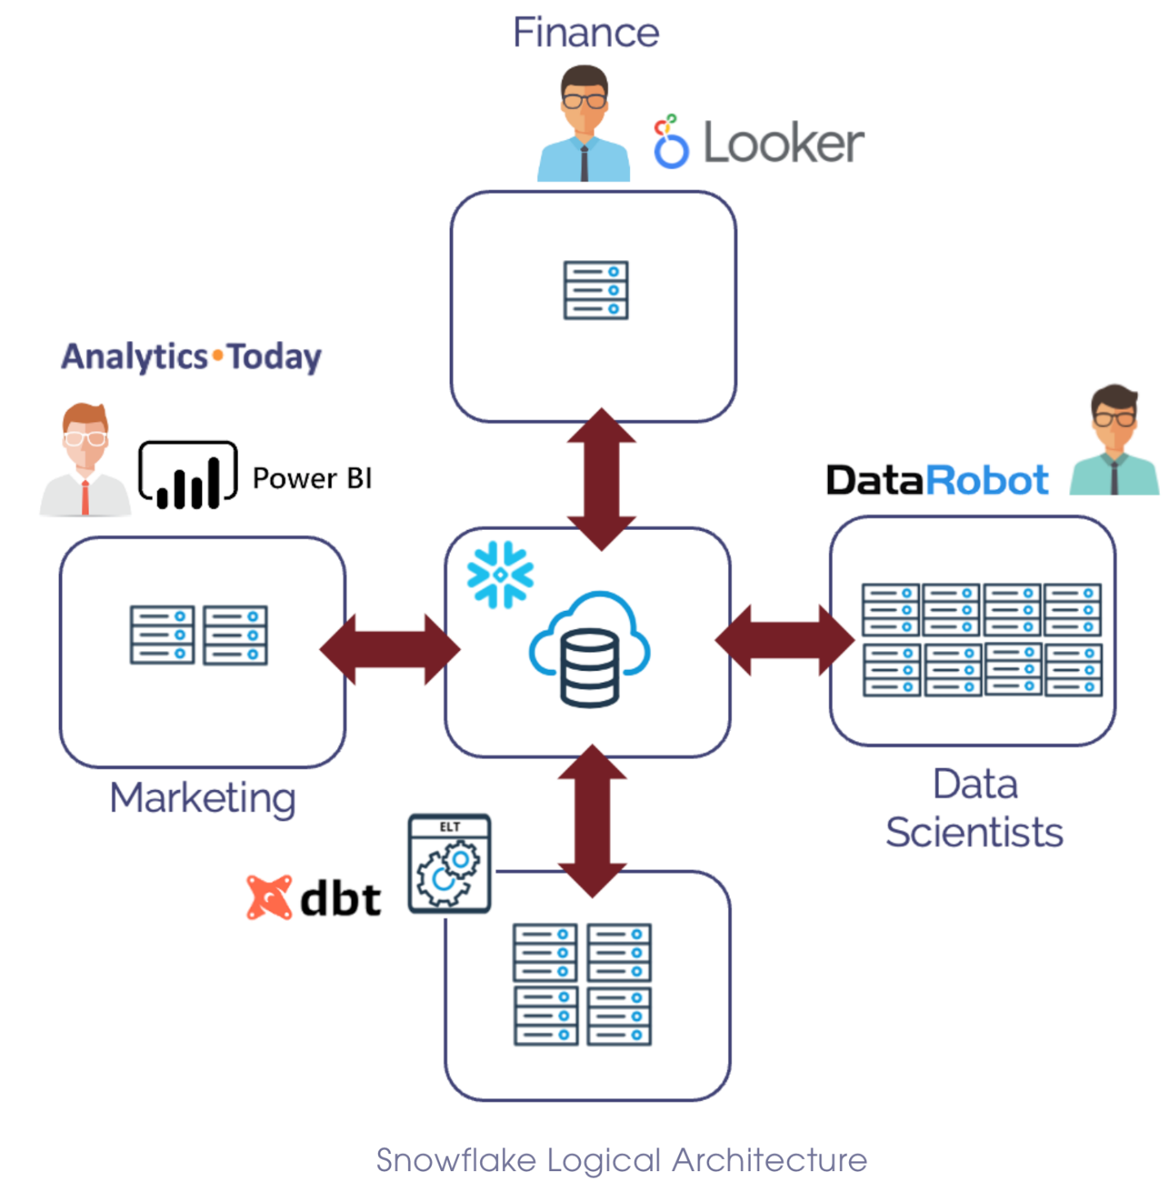
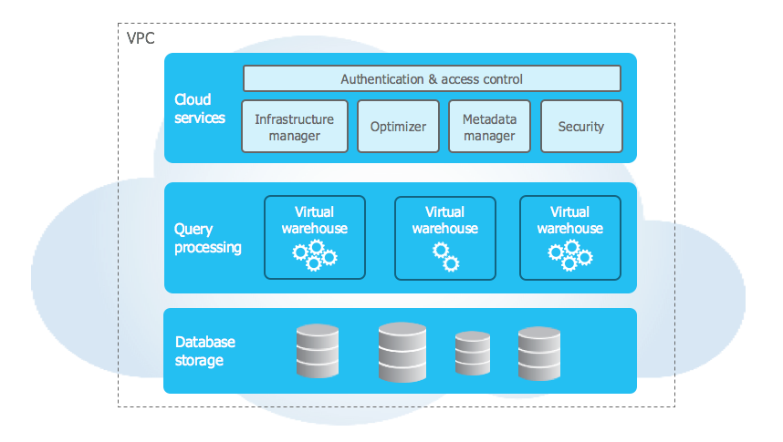

MODULE 1 LAB — SNOWFLAKE ARCHITECTURE & CORE CONCEPTS

LAB 1.1 — Explore Snowflake UI (Snowsight)
Steps
- Login to Snowflake
- Open Snowsight
- Navigate:
  - Data → Databases
  - Warehouses → Compute
  - Activity → Query History

LAB 1.2 — Create Database & Schema
CREATE DATABASE telecom_db;
CREATE SCHEMA telecom_db.raw;

LAB 1.3 — Load Sample Data
CREATE TABLE telecom_db.raw.customers (
customer_id INT,
name STRING,
phone STRING
);
Insert sample data:
INSERT INTO telecom_db.raw.customers VALUES
(1, 'John', '9876543210'),
(2, 'Alice', '9123456780');

LAB 1.4 — Time Travel
Step 1: Delete Data
DELETE FROM telecom_db.raw.customers WHERE customer_id = 1;
Step 2: Recover Data
SELECT * FROM telecom_db.raw.customers AT (OFFSET => -60*5);

LAB 1.5 — Zero Copy Cloning
CREATE TABLE telecom_db.raw.customers_clone CLONE telecom_db.raw.customers;
Verify
SELECT * FROM telecom_db.raw.customers_clone;

LAB 1.6 — Fail-safe (Concept)
- Automatic 7-day recovery (cannot be queried directly)
- Managed by Snowflake

LAB 1.7 — Virtual Warehouse Basics
CREATE WAREHOUSE compute_wh
WITH WAREHOUSE_SIZE = 'XSMALL'
AUTO_SUSPEND = 60
AUTO_RESUME = TRUE;

MODULE 2 LAB — ACCOUNT & ACCESS MANAGEMENT

LAB 2.1 — Create Role
CREATE ROLE analyst_role;

LAB 2.2 — Create User
CREATE USER analyst_user
PASSWORD = 'Password123'
DEFAULT_ROLE = analyst_role;

LAB 2.3 — Grant Role to User
GRANT ROLE analyst_role TO USER analyst_user;

LAB 2.4 — Grant Permissions
GRANT USAGE ON DATABASE telecom_db TO ROLE analyst_role;
GRANT USAGE ON SCHEMA telecom_db.raw TO ROLE analyst_role;
GRANT SELECT ON ALL TABLES IN SCHEMA telecom_db.raw TO ROLE analyst_role;

LAB 2.5 — Test RBAC
Switch Role
USE ROLE analyst_role;
SELECT * FROM telecom_db.raw.customers;

LAB 2.6 — Access Hierarchy
Understand:
Account → Database → Schema → Table

LAB 2.7 — Secure Access Best Practices
- Avoid using ACCOUNTADMIN
- Use custom roles
- Apply least privilege

LAB 2.8 — Snowsight Monitoring
- Query History
- Warehouse usage
- Performance metrics

MODULE 3 LAB — VIRTUAL WAREHOUSES & COMPUTE

LAB 3.1 — Create Warehouse
CREATE WAREHOUSE analytics_wh
WITH WAREHOUSE_SIZE = 'SMALL';

LAB 3.2 — Resize Warehouse
ALTER WAREHOUSE analytics_wh SET WAREHOUSE_SIZE = 'MEDIUM';

LAB 3.3 — Auto Suspend & Resume
ALTER WAREHOUSE analytics_wh
SET AUTO_SUSPEND = 60
AUTO_RESUME = TRUE;

LAB 3.4 — Multi-Cluster Scaling
ALTER WAREHOUSE analytics_wh
SET MIN_CLUSTER_COUNT = 1
MAX_CLUSTER_COUNT = 3
SCALING_POLICY = 'STANDARD';

LAB 3.5 — Warehouse Usage Monitoring
SHOW WAREHOUSES;

LAB 3.6 — Resource Monitor
CREATE RESOURCE MONITOR monitor1
WITH CREDIT_QUOTA = 50
TRIGGERS ON 80 PERCENT DO NOTIFY
ON 100 PERCENT DO SUSPEND;
Assign:
ALTER WAREHOUSE analytics_wh SET RESOURCE_MONITOR = monitor1;

LAB 3.7 — Cost Optimization
Best Practices
- Use smaller warehouses
- Enable auto suspend
- Separate workloads

LAB 3.8 — Performance Optimization
- Use:
  - Proper warehouse size
  - Multi-cluster scaling
  - Query optimization

