Performance & Internal Mechanics

1. Query Result Cache
What it is
- Stores final query results
- Reuses results if:
  - Same query text
  - Same role/session context
  - Underlying data unchanged
Key Points
- No compute cost (zero credits)
- Valid for 24 hours
- Fastest performance layer
Example
SELECT COUNT(*) FROM sales;
Run again → returns instantly from cache

2. Metadata Cache
What it is
- Stores:
  - Table schema
  - Column statistics
  - Partition metadata
Purpose
- Speeds up query planning (optimizer phase)

3. Data Cache (Warehouse Cache)
What it is
- Caches actual data blocks
- Stored at virtual warehouse level
Behavior
- Speeds up repeated queries
- Cleared when:
  - Warehouse is suspended

4. How Caching Works Internally
Execution Flow
- Check Result Cache
- Check Metadata Cache
- Check Data Cache
- Execute query if no cache hit
Key Insight
- Multi-layer caching = major performance boost

5. Cache Invalidation Rules
Action | Effect
INSERT / UPDATE / DELETE | Result cache invalid
DDL (ALTER TABLE) | Metadata cache invalid
Warehouse suspend | Data cache cleared
Time expiry | Result cache expires (24h)

6. Micro-Partitions
Storage Concept
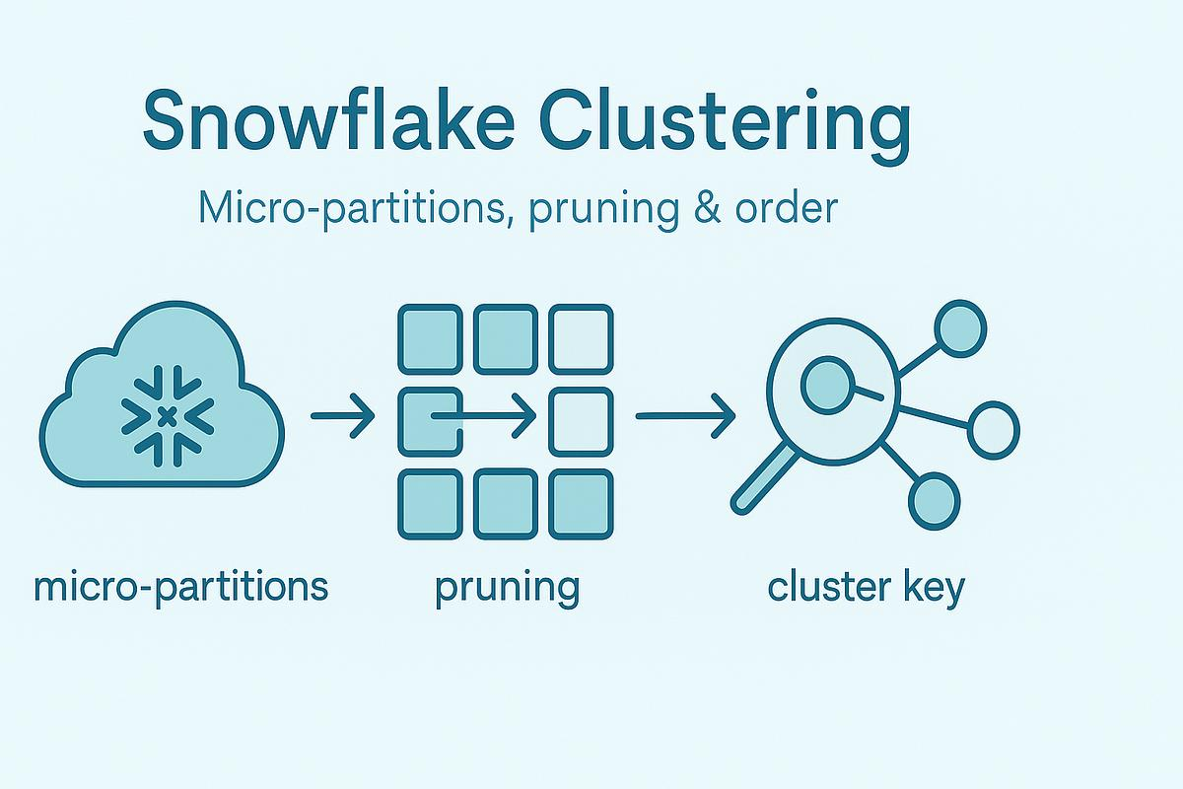
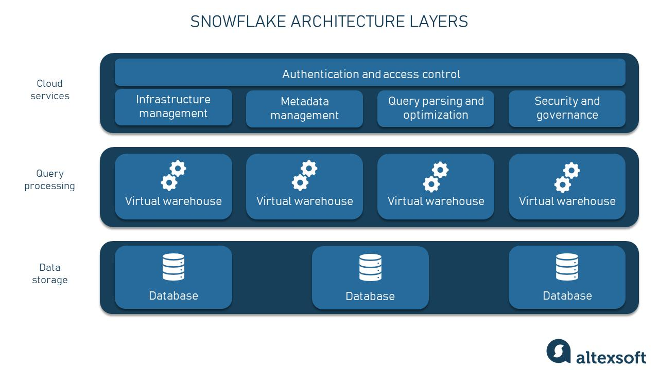
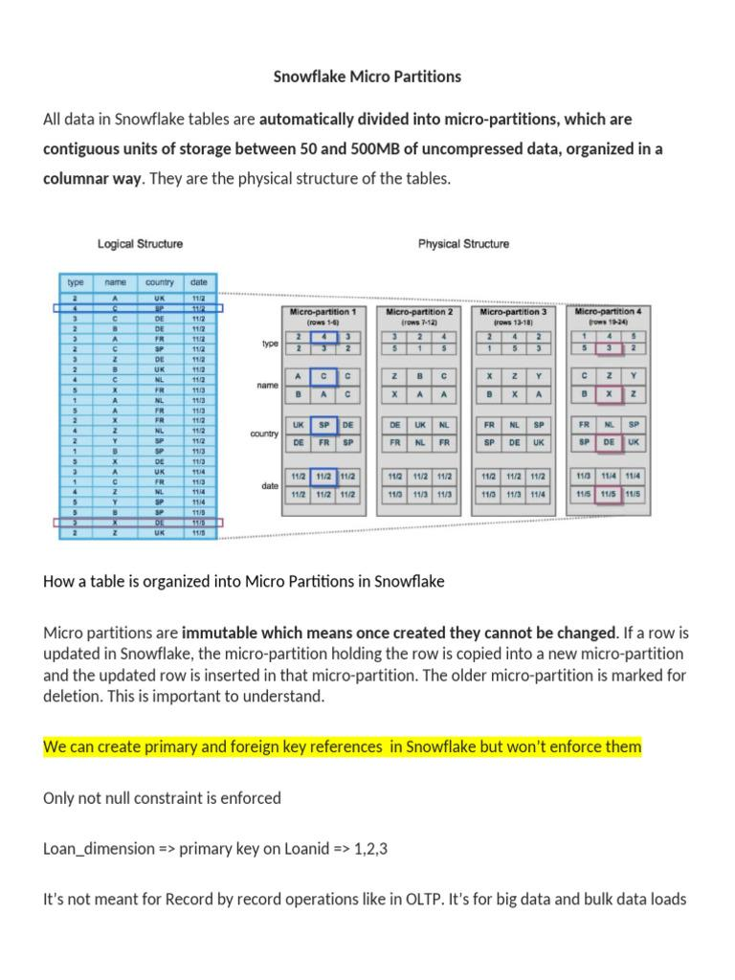
Key Features
- ~16MB compressed units
- Immutable
- Store metadata:
  - Min/max values
  - Distinct count
Why Important
- Enables partition pruning
- Reduces scanned data

7. Clustering Keys
What they do
- Organize data inside micro-partitions
Use Cases
- Large tables
- Frequent filters (date, region)
Benefit
- Better pruning → faster queries

8. Query Performance Optimization
Best Practices
- Avoid SELECT *
- Use filters early
- Use clustering keys
- Reduce joins where possible
- Use appropriate data types

9. Warehouse Tuning Basics
Scaling Types
- Scale Up → Bigger size (compute power)
- Scale Out → Multi-cluster (concurrency)
Tips
- Use auto suspend/resume
- Choose right size
- Monitor credit usage

10. Query Profile Analysis
What it shows
- Execution plan
- Time per step
- Bottlenecks
What to look for
- Scan time
- Join performance
- Partition pruning %

Data Sharing & Governance

1. Secure Data Sharing
Concept
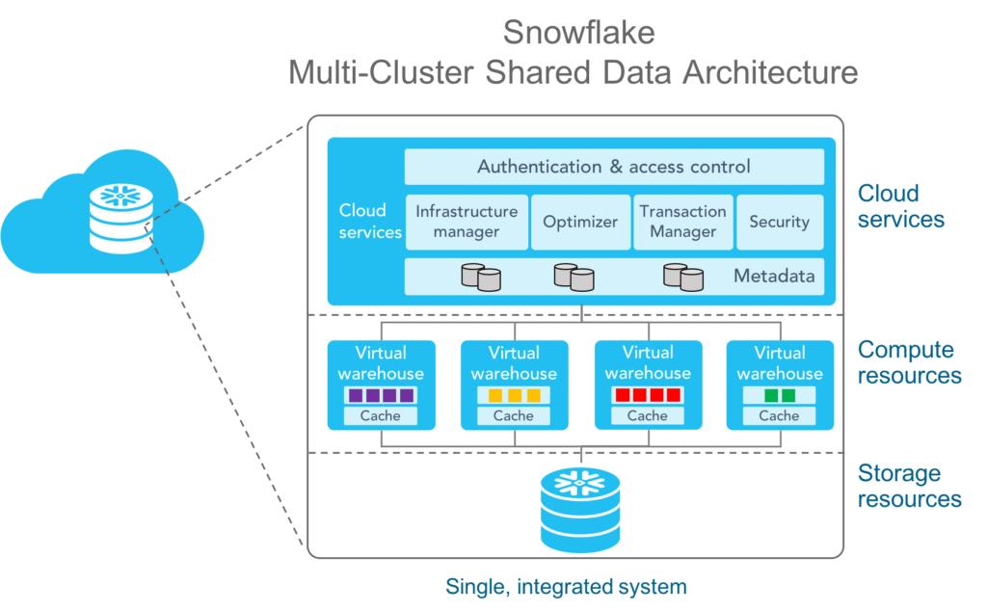
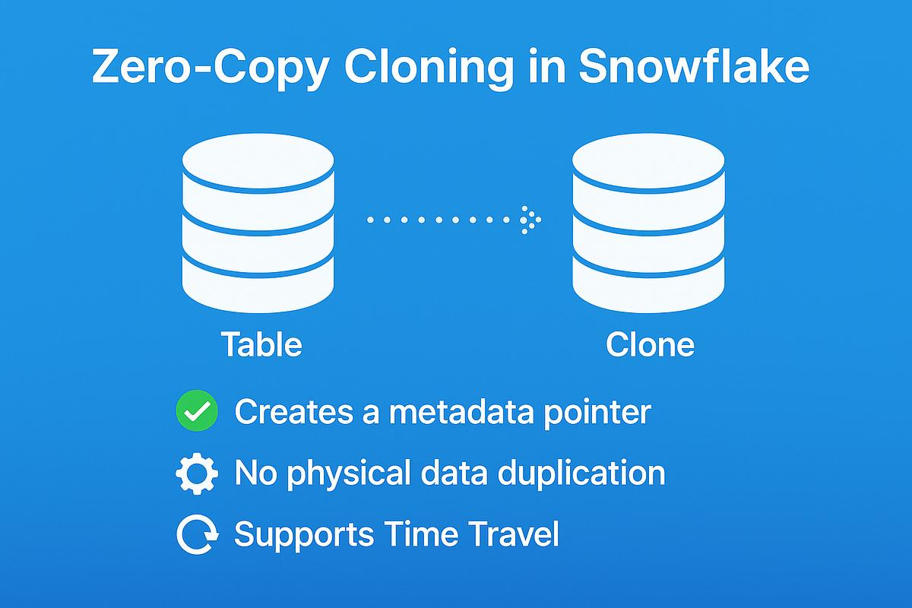
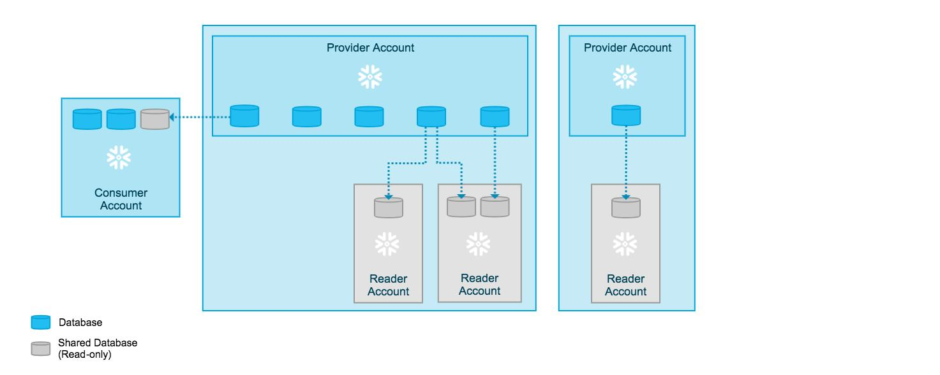
Key Points
- No data duplication
- Real-time access
- Read-only access for consumers

2. Cross-Account Sharing
What it enables
- Share data across:
  - Accounts
  - Regions
  - Clouds
Use Case
- B2B data sharing

3. Data Masking Policies
Purpose
- Protect sensitive data (PII)
Example
- Mask email for non-admin users
Behavior
- Applied dynamically at query time

4. Row Access Policies
What they do
- Restrict access at row level
Example
- Sales team sees only their region

5. Governance Concepts
Core Components
- RBAC (Role-Based Access Control)
- Data lineage
- Auditing
- Data classification

Advanced Concepts

1. Data Sampling
What it is
- Retrieve subset of data
Types
- Random sampling
- Systematic sampling
Use Cases
- Testing
- Faster analysis

2. Container Services (Overview)
What it enables
- Run containerized workloads:
  - ML models
  - APIs
  - Custom apps
Benefit
- Compute close to data

3. Advanced Best Practices
Design
- Use medallion architecture
- Separate compute & storage
- Modular pipelines
Performance
- Partition data
- Optimize queries

4. Cost Optimization
Key Techniques
- Auto suspend warehouses
- Right-size compute
- Avoid full table scans
- Use caching effectively

5. Production Architecture Patterns
Medallion Architecture
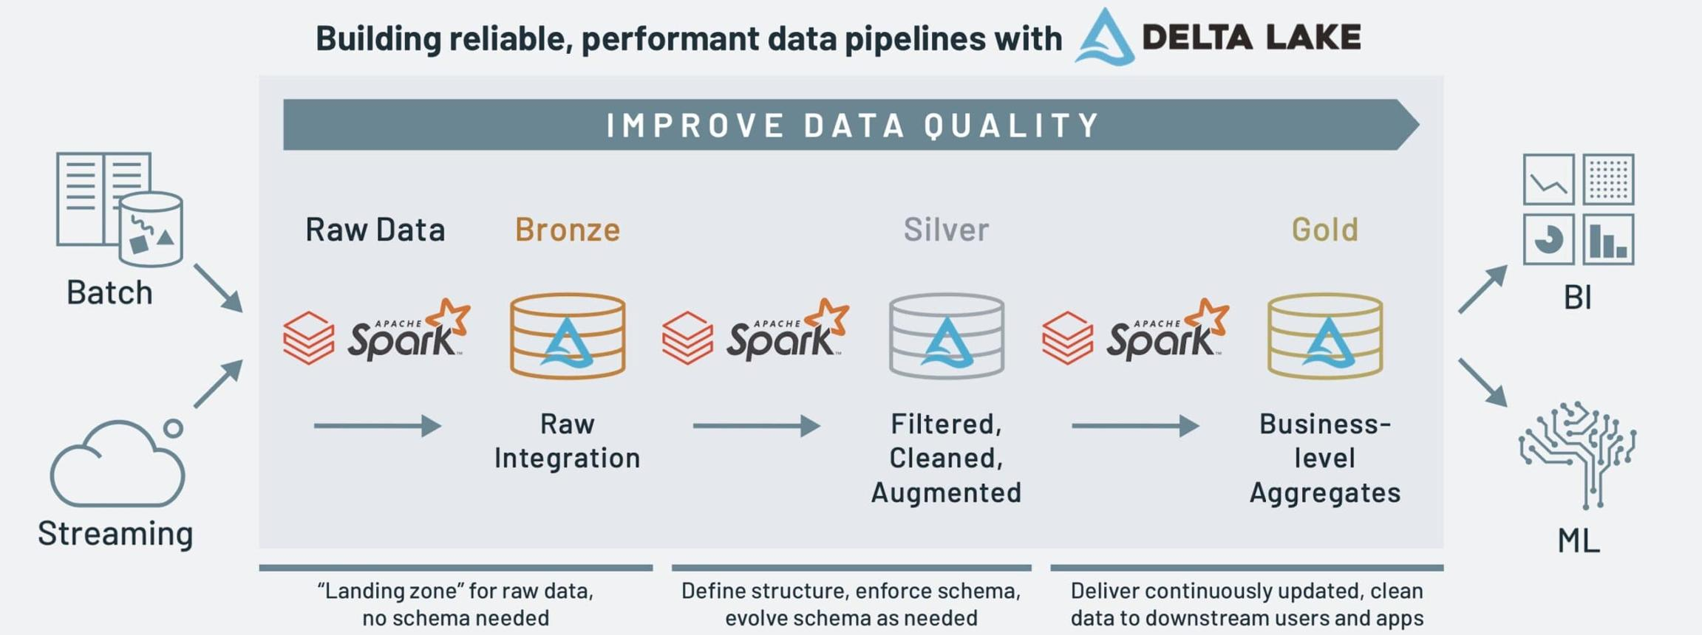
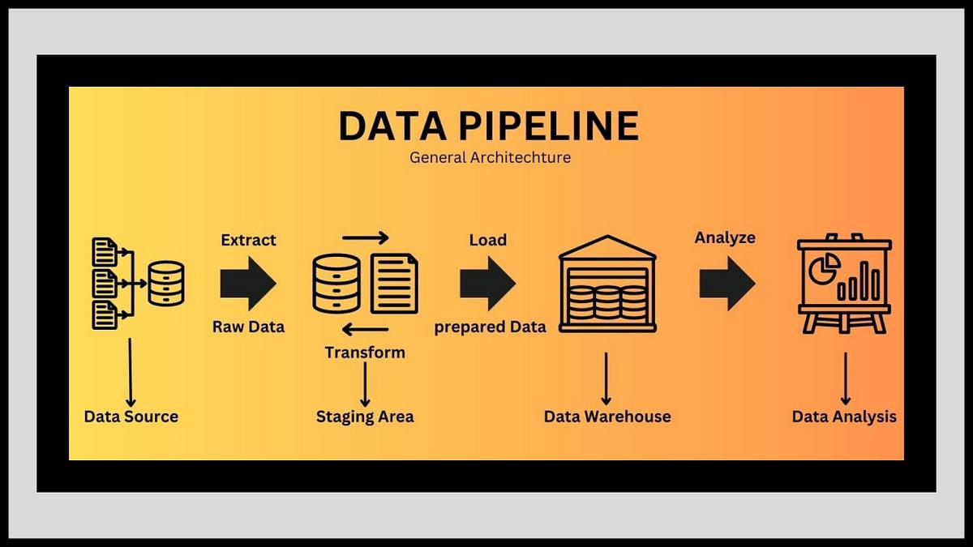
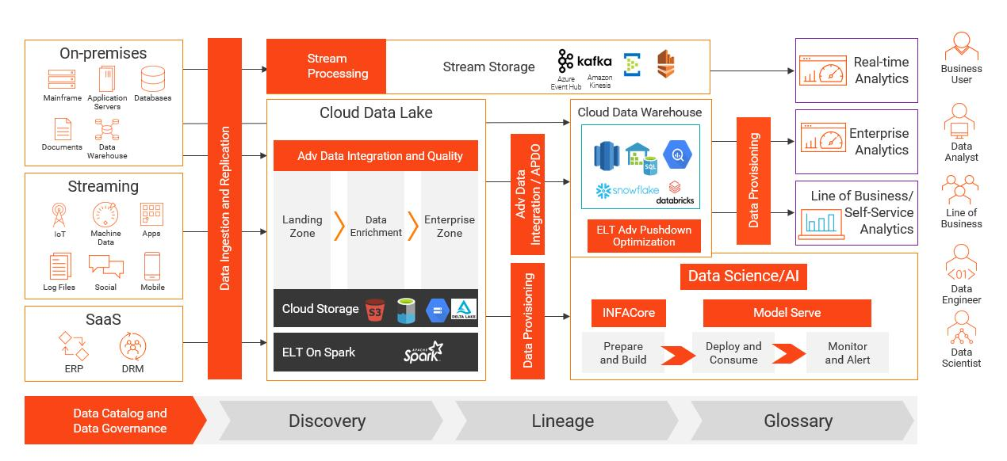
Layers
- Bronze → Raw data
- Silver → Cleaned
- Gold → Aggregated
Why Important
- Scalability
- Data quality
- Reusability

Final Summary
Performance
- Snowflake uses multi-layer caching
- Micro-partitions + clustering = performance core
Governance
- Secure sharing without duplication
- Masking + RLS for security
Advanced
- Focus on:
  - Cost optimization
  - Scalable architecture
  - Real-time + batch balance

