Explained by taking Flight Booking Domin Case Study
1. Lambda Architecture (Batch + Speed Layers)
Lambda has two parallel paths:
- Batch layer for historical data → cleans, enriches, aggregates large volumes.
- Speed layer for real-time/streaming → processes new events with low latency.
- Both feed into a Serving layer (reporting/analytics).
In your lab:
- Batch Layer: ADF → Raw container (CSV/JSON/API batch ingestion) → Databricks → Silver/Gold (aggregates, star schema).
- Speed Layer: Event Hubs → Databricks Structured Streaming → Delta (aircraft telemetry).
- Serving Layer: Power BI on Gold zone.
So the lab is essentially Lambda Architecture: batch ingestion (flight ops, bookings, crew, maintenance) + streaming ingestion (telemetry).

2. Kappa Architecture (Streaming-Only with Replay)
Kappa simplifies by removing the batch layer:
- Everything is ingested as a stream.
- Historical data is reprocessed by replaying the stream through the same pipeline.
- One code path = less complexity.
To run the lab as Kappa:
- Treat even batch CSVs as “mini-streams” (e.g., incremental ingestion using Databricks Autoloader instead of ADF Copy).
- Everything flows through streaming ETL in Databricks (Autoloader + Structured Streaming → Bronze → Silver → Gold).
- No separate ADF batch pipelines needed.

Visual Mapping
Lambda
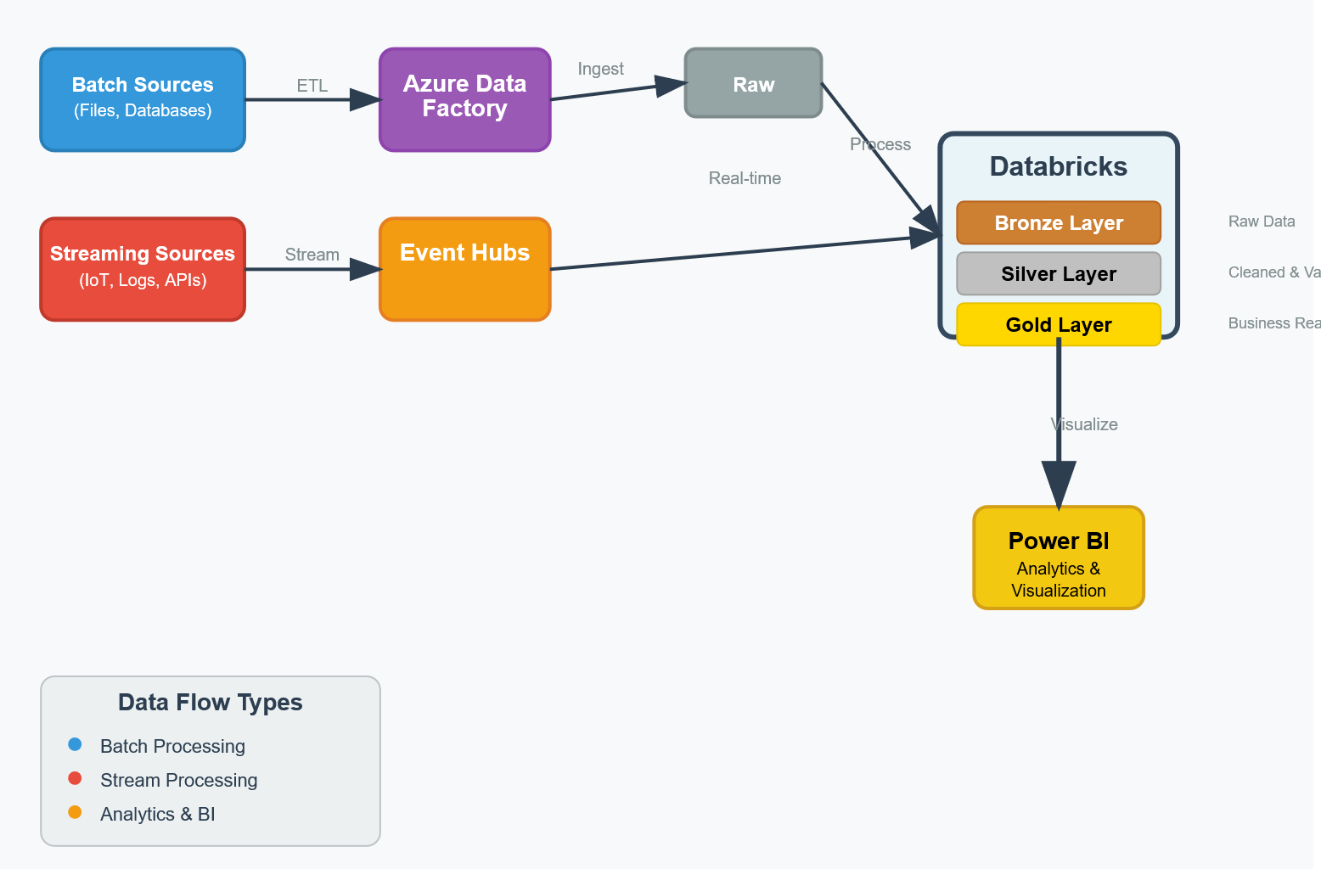
Kappa
