End-to-End Architecture: From Data Ingestion → AI + dbt → Deployment
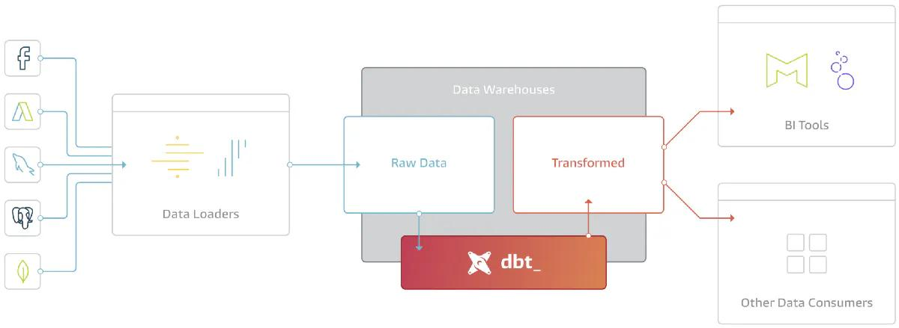
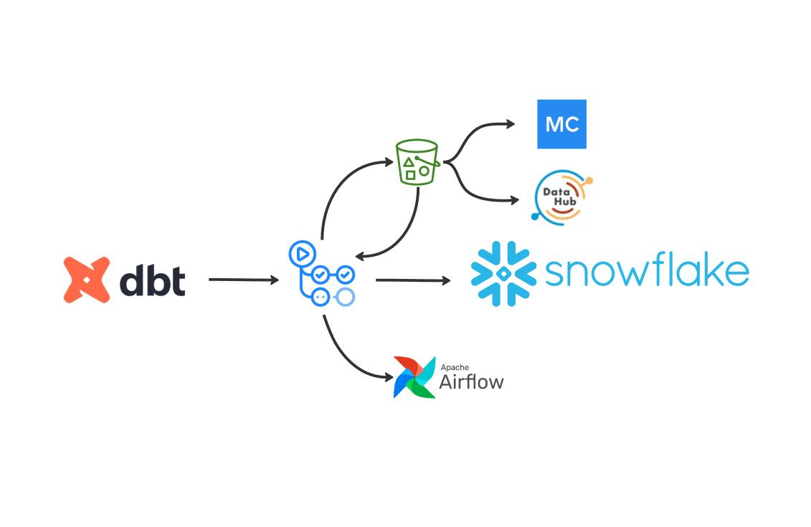
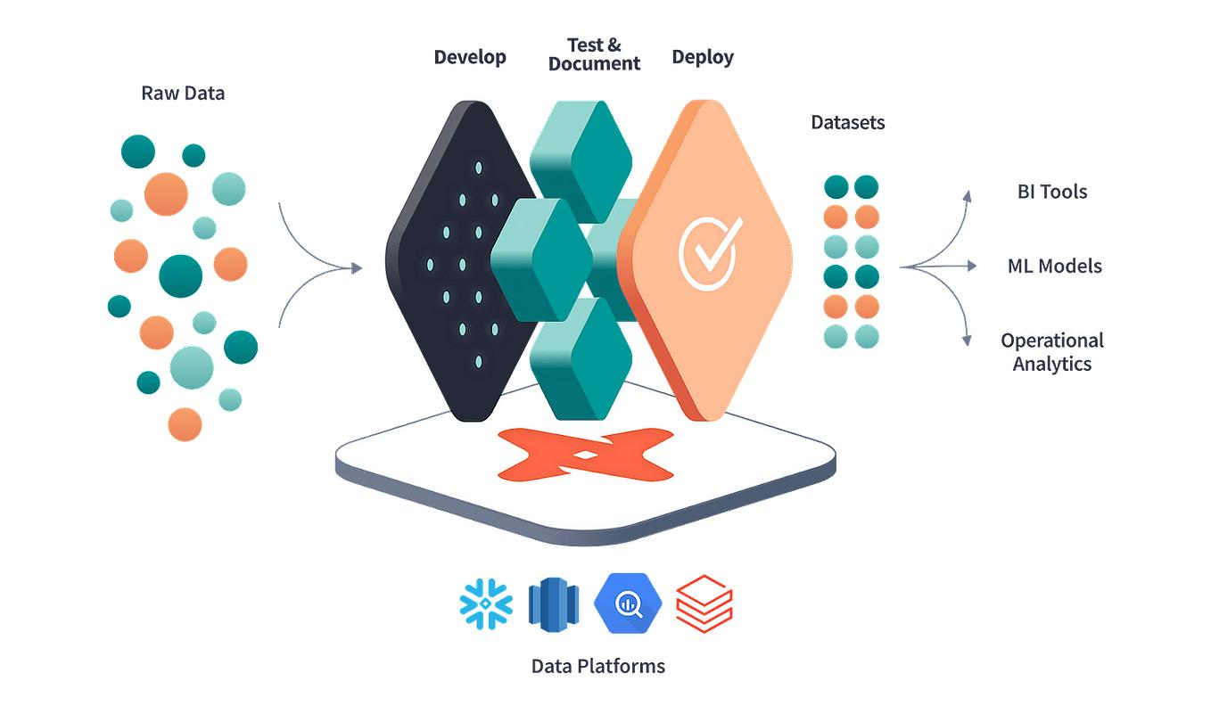

1) Full Pipeline Diagram (Simple View)
[ Data Sources ]
↓
[ Ingestion Layer ]
↓
[ Snowflake (Raw Layer) ]
↓
[ dbt (Transformation Layer) ]
↓
[ Tested Data (Marts Layer) ]
↓
[ AI Layer (NL2SQL / Copilot / Ollama) ]
↓
[ BI / Users / APIs ]
↓
[ Deployment (CI/CD + Scheduler) ]

2) Detailed Architecture (Tool-Level View)
STEP 1: DATA SOURCES
---------------------------------
- E-commerce App (Orders, Users)
- APIs (Payments, Shipping)
- Files (CSV, JSON)
↓
STEP 2: INGESTION
---------------------------------
Tools:
- Azure Data Factory / NiFi / Python Scripts
Action:
- Extract data
- Load into Snowflake
↓
STEP 3: RAW DATA (SNOWFLAKE)
---------------------------------
Tables:
- customers
- products
- orders
Schema:
ECOM_DB.RAW
↓
STEP 4: TRANSFORMATION (dbt)
---------------------------------
Tool:
- dbt Core / dbt Cloud
Layers:
- staging (stg_orders)
- intermediate
- marts (fact_sales, dim_customer)
↓
STEP 5: DATA QUALITY (dbt tests)
---------------------------------
Checks:
- not_null
- unique
- relationships
Tool:
- dbt test
↓
STEP 6: SQL REVIEW (AI + LINT)
---------------------------------
Tools:
- SQLFluff
- Ollama / Copilot
Action:
- Optimize SQL
- Format code
- Detect issues
↓
STEP 7: PRODUCTION TABLES (SNOWFLAKE)
---------------------------------
Schema:
ECOM_DB.PROD
Tables:
- fact_customer_revenue
- dim_customer
- dim_product
↓
STEP 8: AI QUERY LAYER
---------------------------------
Tools:
- Snowflake Cortex Analyst
- Ollama (NL2SQL)
- ChatDB
Users:
- Business Analysts
- Product Managers
↓
STEP 9: BI / CONSUMPTION
---------------------------------
Tools:
- Power BI
- Tableau
- Dashboards
↓
STEP 10: DEPLOYMENT (CI/CD)
---------------------------------
Tools:
- GitHub Actions
- dbt run + dbt test
Flow:
Code → Git → CI/CD → Snowflake PROD
↓
STEP 11: SCHEDULING
---------------------------------
Tools:
- Cron / Airflow / dbt Cloud
Frequency:
- Hourly / Daily runs

3) Real Flow with Your Tools
Development Phase
VS Code
↓
Copilot / Ollama (AI help)
↓
Write SQL + dbt models
↓
SQLFluff (lint & fix)

Build Phase
dbt run
↓
Creates tables in Snowflake

Quality Phase
dbt test
↓
Validates data

Deployment Phase
Git Push
↓
GitHub Actions
↓
dbt run (PROD)
↓
Tables updated in Snowflake

Consumption Phase
Business User
↓
Cortex / NL2SQL
↓
Query Snowflake
↓
Dashboard / Insight

4) Example (E-Commerce Flow)
Step-by-step
- Orders created in app
- Data ingested → Snowflake RAW
- dbt builds:
  - stg_orders
  - dim_customer
  - fact_sales
- dbt tests validate
- CI/CD deploys to PROD
- Business asks:
“Top customers by revenue”
- AI generates SQL
- Snowflake returns result

5) Key Layers Summary
Layer | Purpose
Ingestion | Bring data
Raw | Store original data
dbt | Transform
Tests | Validate
AI | Query
BI | Visualize
CI/CD | Deploy

6) Explanation
“Data flows from source systems into Snowflake, gets transformed and tested by dbt, optimized with AI, and is finally consumed via dashboards or natural language queries—deployed through CI/CD.”

7) Where Each Tool Fits
Tool | Role
Snowflake | Data storage
dbt | Transformation
SQLFluff | Code quality
Ollama / Copilot | AI assistance
Cortex Analyst | NL2SQL
GitHub Actions | Deployment
Power BI | Visualization

8) Final Mental Model
Think of it like:
Raw Data → Clean Data → Trusted Data → AI Access → Business Insights

