AI-Assisted SQL, dbt & Data Modelling
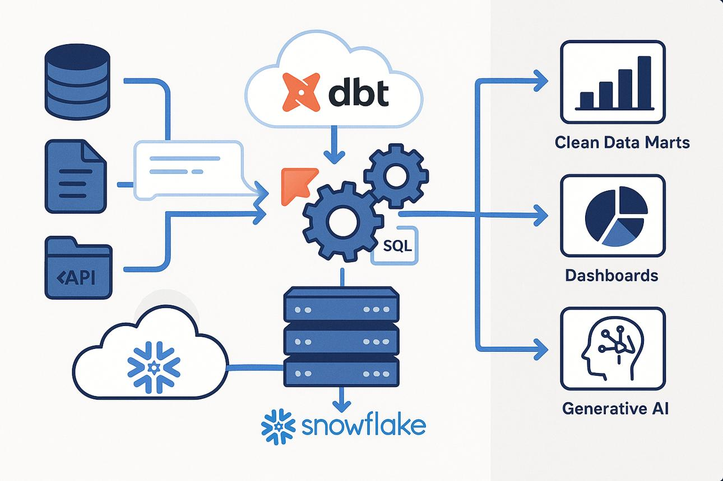
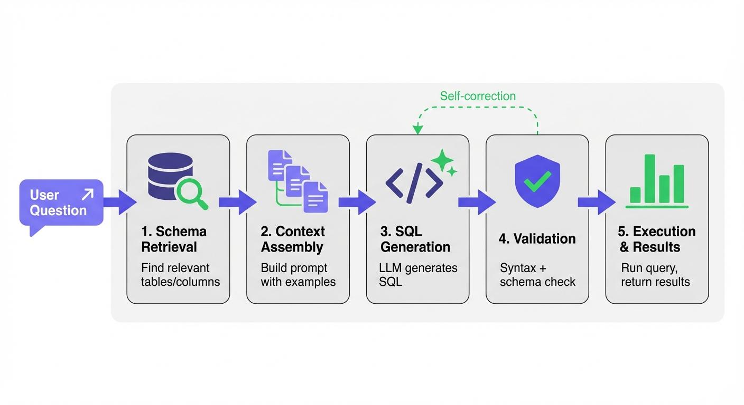
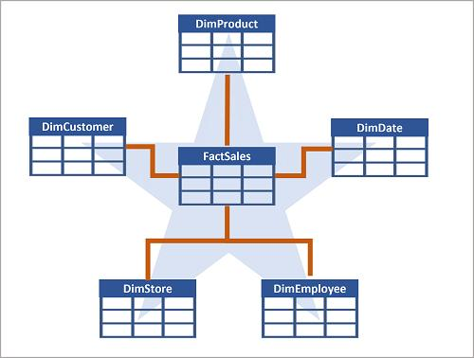

1) Big Picture (How Everything Fits)
End-to-end flow
Raw Data → Warehouse (Snowflake) → dbt Models → Tested Data → AI Query (NL2SQL / Cortex) → Insights
↑
SQL Review Agent
Key idea:
- dbt = clean, structured data
- AI (NL2SQL/Cortex) = easy access to that data
- SQL Review Agent = quality control

2) NL2SQL (Natural Language → SQL)
What to Learn
- Intent detection (aggregation, filter, join)
- Schema grounding (tables, columns)
- Prompt engineering
Core Patterns
- Aggregation → SUM(), COUNT()
- Filtering → WHERE
- Joins → JOIN
- Ranking → ORDER BY + LIMIT
Example
Input:
“Top 5 customers by revenue”
Output SQL:
SELECT customer_id, SUM(amount) AS revenue
FROM orders
GROUP BY customer_id
ORDER BY revenue DESC
LIMIT 5;
Practice Tasks
- Convert 10 business questions into SQL
- Identify incorrect AI-generated SQL
Common Mistakes
- Wrong joins
- Ambiguous questions
- Missing filters

3) Dimensional Modelling (Foundation of Analytics)
Core Concepts
Fact Table
- Metrics (sales, revenue)
Dimension Table
- Context (customer, product)

Star Schema (Preferred)
- Simple joins
- Fast queries
Snowflake Schema
- Normalized
- More complex

Critical Concepts
Grain (MOST IMPORTANT)
Defines what 1 row represents
Surrogate Keys
- Artificial IDs
Slowly Changing Dimensions (SCD)
- Type 1 → overwrite
- Type 2 → history

Practice
Design:
- E-commerce schema
- Banking schema

4) AI-Assisted Modelling
What AI Can Do
- Generate schema from prompt
- Suggest relationships
- Create dbt models
- Auto-document
Example Prompt
“Design a retail sales warehouse”
Output
- fact_sales
- dim_customer
- dim_product

Skills to Build
- Prompt writing
- Validating AI output
- Mapping business → schema

5) dbt (Core of Transformation Layer)
What to Master
1. Models
- SQL files
- Use ref()

2. Layers
Layer | Purpose
stg_ | Clean raw data
int_ | Business logic
fact_/dim_ | Final models

3. Sources
sources:
- name: raw

4. DAG (Lineage)
- Understand dependencies
- Debug pipelines

Practice
- Build 3-layer dbt project
- Create fact + dimension models

6) dbt Model Generation (AI + Manual)
Flow
Prompt → SQL Model → schema.yml → dbt run → Tables
Key Skills
- Writing reusable SQL
- Using ref() properly
- Naming conventions

Exercise
Build:
- stg_orders
- dim_customer
- fact_sales

7) dbt Testing (Data Quality)
Types
Generic Tests
- not_null
- unique
- relationships
- accepted_values
Custom Tests
SELECT * FROM table WHERE amount < 0

Best Practices
- Test primary keys
- Test foreign keys
- Add business rules

Practice
- Create failing dataset
- Run dbt test

8) Snowflake Cortex Analyst (AI Query Layer)
Snowflake Cortex Analyst
What to Learn
- NL → SQL conversion
- Schema dependency
- Prompt clarity

Workflow
User Question → Cortex → SQL → Snowflake → Result

Best Practices
- Use clean dbt models
- Avoid ambiguous prompts

Practice
Ask:
- “Revenue by region”
- “Top products last month”

9) SQL Code Review Agent
Purpose
- Improve SQL quality automatically

What It Checks
1. Performance
- Avoid SELECT *
- Optimize filters
2. Security
- Injection risks
3. Readability
- Formatting

Tools
- SQLFluff
- Claude Code
- GitHub Copilot

Practice
- Take bad SQL → optimize
- Compare execution time

10) Hands-On Capstone (VERY IMPORTANT)
Scenario
Retail Analytics System
Step 1: Raw Tables
- orders
- customers
- products

Step 2: Build dbt Models
- stg_orders
- dim_customer
- dim_product
- fact_sales

Step 3: Add Tests
- not_null
- relationships

Step 4: Optimize SQL
Use AI review agent

Step 5: Query with AI
Use Cortex / NL2SQL

Output
- Clean data models
- Tested pipeline
- AI-powered analytics

