Hands-On Lab: AI-Assisted SQL, dbt & Data Modelling
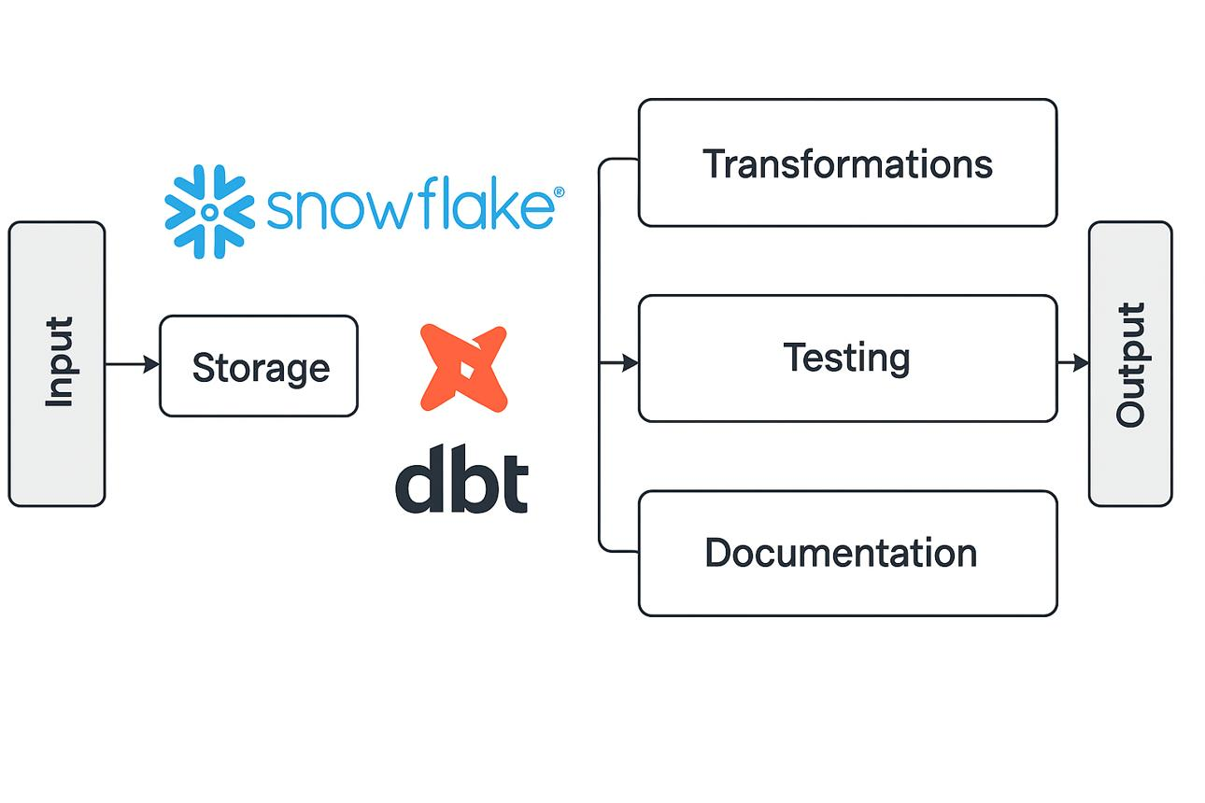
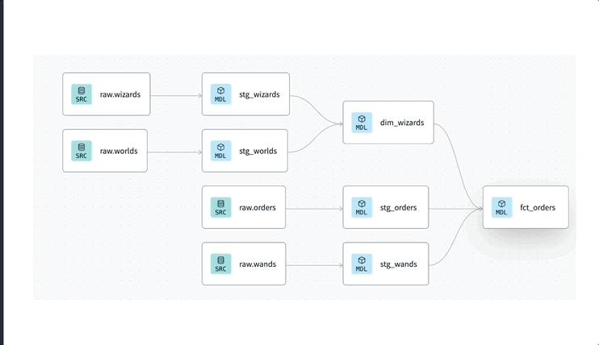
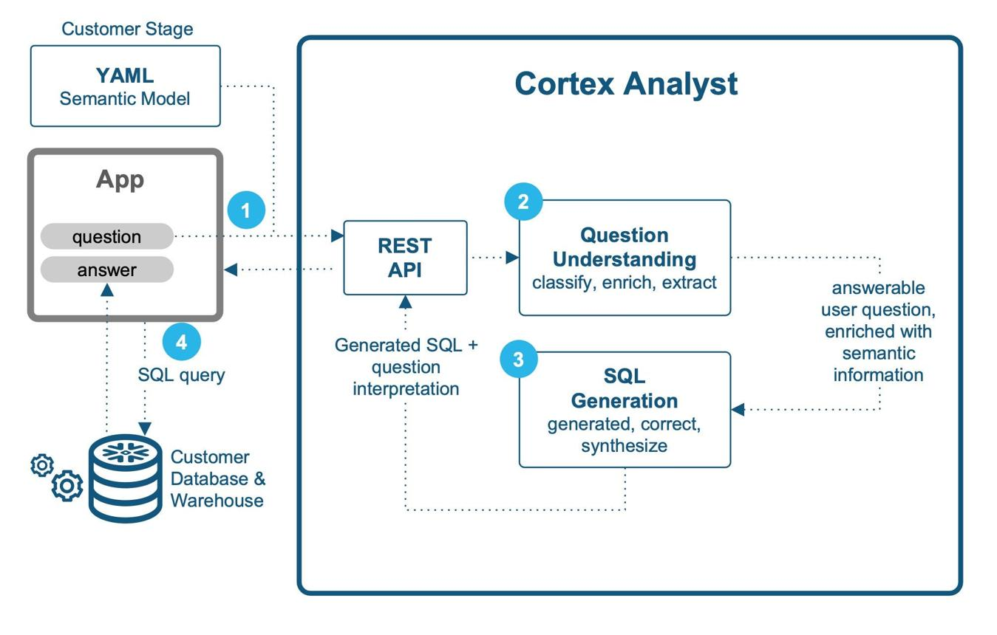
Lab Overview
Scenario
You are building a Retail Analytics System.
Business Questions
- Total revenue by customer
- Revenue by product category
- Top customers

Step 0: Prerequisites
Tools Required
- Snowflake account
- dbt Core installed
- VS Code
- Git
Optional (AI):
- Claude Code
- GitHub Copilot

Step 1: Create Raw Tables in Snowflake
Run this SQL:
CREATE TABLE customers (
customer_id INT,
name STRING,
region STRING
);
CREATE TABLE products (
product_id INT,
product_name STRING,
category STRING
);
CREATE TABLE orders (
order_id INT,
customer_id INT,
product_id INT,
order_date DATE,
amount NUMBER
);

Step 2: Insert Sample Data
INSERT INTO customers VALUES
(1,'Alice','North'),
(2,'Bob','South');
INSERT INTO products VALUES
(101,'Laptop','Electronics'),
(102,'Phone','Electronics');
INSERT INTO orders VALUES
(1001,1,101,'2024-01-01',500),
(1002,2,102,'2024-01-02',300);

Step 3: Initialize dbt Project
dbt init retail_project
cd retail_project
Configure profiles.yml for Snowflake.

Step 4: Define Sources
Create models/sources.yml
version: 2
sources:
- name: raw
database: YOUR_DB
schema: PUBLIC
tables:
- name: customers
- name: products
- name: orders

Step 5: Create Staging Models
models/staging/stg_orders.sql
SELECT
order_id,
customer_id,
product_id,
order_date,
amount
FROM {{ source('raw','orders') }}

models/staging/stg_customers.sql
SELECT
customer_id,
name,
region
FROM {{ source('raw','customers') }}

models/staging/stg_products.sql
SELECT
product_id,
product_name,
category
FROM {{ source('raw','products') }}

Step 6: Create Dimension Models
models/marts/dim_customer.sql
SELECT DISTINCT
customer_id,
name,
region
FROM {{ ref('stg_customers') }}

models/marts/dim_product.sql
SELECT DISTINCT
product_id,
product_name,
category
FROM {{ ref('stg_products') }}

Step 7: Create Fact Model
models/marts/fact_sales.sql
SELECT
o.order_id,
o.customer_id,
o.product_id,
o.order_date,
o.amount
FROM {{ ref('stg_orders') }} o

Step 8: Run dbt Models
dbt run

Step 9: Add Tests
Create models/marts/schema.yml
version: 2
models:
- name: fact_sales
columns:
- name: order_id
tests:
- not_null
- unique
- name: customer_id
tests:
- relationships:
to: ref('dim_customer')
field: customer_id

Step 10: Run Tests
dbt test

Step 11: SQL Code Review (AI)
Bad Query
SELECT * FROM orders
Use AI to improve:
Prompt:
“Optimize this SQL query”
Expected Output
SELECT order_id, customer_id, amount
FROM orders

Step 12: NL2SQL (Cortex Style)
Ask:
“Total revenue by customer”
Generated SQL:
SELECT customer_id, SUM(amount)
FROM fact_sales
GROUP BY customer_id;

Step 13: Optimization Task (Important)
Given Query
SELECT customer_id, SUM(amount)
FROM orders
GROUP BY customer_id;
Improve:
- Use staging table
- Add filters
- Clean structure

Step 14: Expected Outputs
You should now have:
dbt Models
- stg_orders
- dim_customer
- dim_product
- fact_sales

Tests
- not_null
- unique
- relationships

Queries
- Optimized SQL
- NL2SQL queries

Step 15: Folder Structure
models/
staging/
marts/
sources.yml
schema.yml
Step 16: Validation Checklist
- Data loads correctly
- Tests pass
- Queries return correct results
- No duplicates or nulls

