Hands-On Lab: 3-Join Analytics Query → AI Explanation → Optimization → dbt Model → Tests
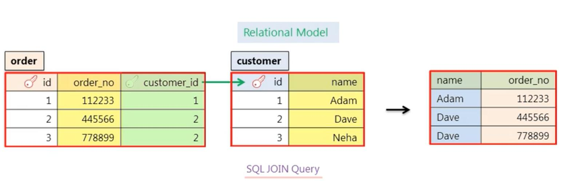
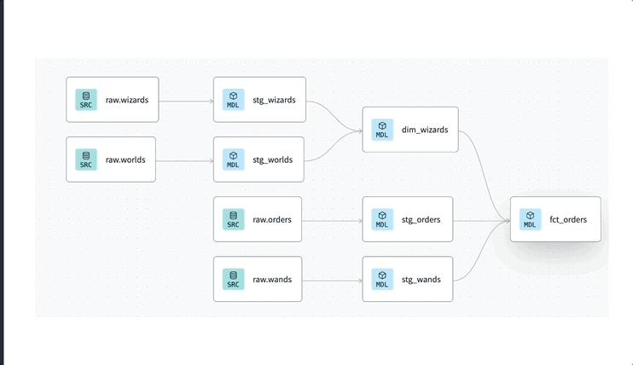
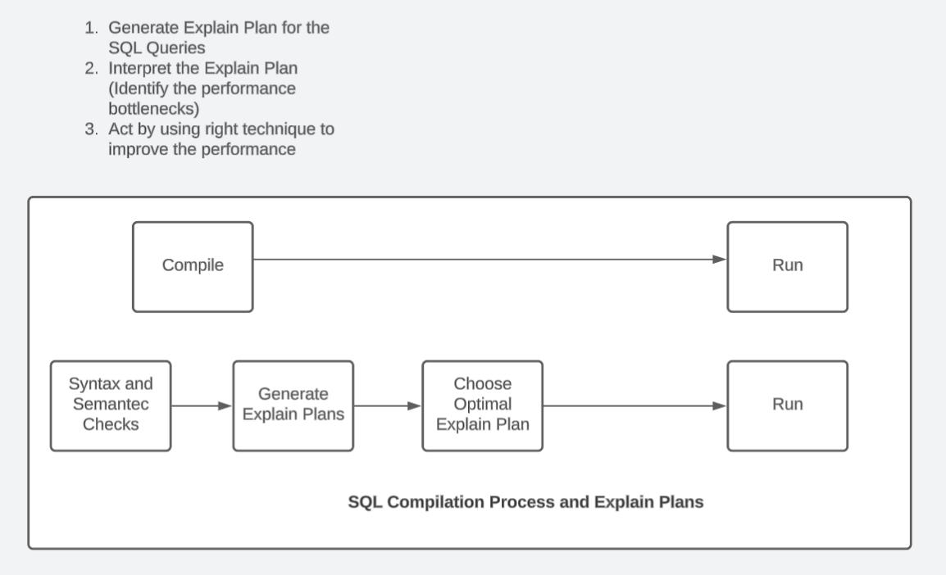

Lab Objective
You will:
- Take a complex 3-table join query
- Use AI (Ollama) to:
  - Explain it in plain English
  - Optimize it
  - Convert it into a dbt model
- Generate 3 dbt tests (with failure cases)

Step 0: Setup (FREE)
Install Ollama
curl -fsSL https://ollama.com/install.sh | sh
Pull model
ollama pull codellama
Test it
ollama run codellama

Step 1: Create Dataset (3 Tables)
CREATE TABLE customers (
customer_id INT,
name STRING,
region STRING
);
CREATE TABLE products (
product_id INT,
product_name STRING,
category STRING
);
CREATE TABLE orders (
order_id INT,
customer_id INT,
product_id INT,
order_date DATE,
amount NUMBER
);

Insert Data (Include some BAD data for testing)
INSERT INTO customers VALUES
(1,'Alice','North'),
(2,'Bob','South');
INSERT INTO products VALUES
(101,'Laptop','Electronics'),
(102,'Phone','Electronics');
INSERT INTO orders VALUES
(1001,1,101,'2024-01-01',500),
(1002,2,102,'2024-01-02',300),
(1003,NULL,101,'2024-01-03',200); -- bad data (NULL)

Step 2: Complex 3-Join Query
SELECT
c.customer_id,
c.name,
p.category,
SUM(o.amount) AS total_revenue,
COUNT(o.order_id) AS total_orders
FROM orders o
JOIN customers c ON o.customer_id = c.customer_id
JOIN products p ON o.product_id = p.product_id
WHERE o.order_date >= '2024-01-01'
GROUP BY c.customer_id, c.name, p.category
ORDER BY total_revenue DESC;

Step 3: AI → Explain Query (Plain English)
Run in Ollama
ollama run codellama
Prompt
Explain this SQL query in simple English:
[PASTE QUERY]
Expected Output
- Joins orders with customers and products
- Filters data from 2024
- Calculates total revenue and number of orders
- Groups by customer and category
- Sorts highest revenue first

Step 4: AI → Optimize Query
Prompt
Optimize this SQL query for performance and best practices:
[PASTE QUERY]
Expected Improvements
- Avoid unnecessary columns
- Add filters early
- Better aliasing

Optimized Query
SELECT
o.customer_id,
c.name,
p.category,
SUM(o.amount) AS total_revenue,
COUNT(*) AS total_orders
FROM orders o
INNER JOIN customers c
ON o.customer_id = c.customer_id
INNER JOIN products p
ON o.product_id = p.product_id
WHERE o.order_date >= DATE '2024-01-01'
GROUP BY o.customer_id, c.name, p.category
ORDER BY total_revenue DESC;

Step 5: SQL Code Linting (Recommended)
sqlfluff fix your_query.sql

Step 6: Convert to dbt Model (AI-Assisted)
Prompt
Convert this SQL into a dbt model using ref() and best practices:
[PASTE OPTIMIZED QUERY]

Output → models/marts/fact_customer_revenue.sql
SELECT
o.customer_id,
c.name,
p.category,
SUM(o.amount) AS total_revenue,
COUNT(*) AS total_orders
FROM {{ ref('stg_orders') }} o
JOIN {{ ref('dim_customer') }} c
ON o.customer_id = c.customer_id
JOIN {{ ref('dim_product') }} p
ON o.product_id = p.product_id
GROUP BY o.customer_id, c.name, p.category

Step 7: Create Supporting Models
stg_orders.sql
SELECT * FROM {{ source('raw','orders') }}
dim_customer.sql
SELECT DISTINCT customer_id, name FROM {{ source('raw','customers') }}
dim_product.sql
SELECT DISTINCT product_id, category FROM {{ source('raw','products') }}

Step 8: Generate dbt Tests (AI)
Prompt
Generate dbt schema.yml tests for this model including not_null, unique, and relationships:

schema.yml
version: 2
models:
- name: fact_customer_revenue
columns:
- name: customer_id
tests:
- not_null
- relationships:
to: ref('dim_customer')
field: customer_id
- name: category
tests:
- not_null
- name: total_revenue
tests:
- not_null

Step 9: Failure Expectations (IMPORTANT)
Because we inserted:
(1003,NULL,101,...)
Expected Failures
Test | Why it fails
not_null(customer_id) | NULL value exists
relationships | No matching customer
business logic | incorrect aggregation

Step 10: Run dbt
dbt run
dbt test

Step 11: Validate Results
Expected
- dbt builds models
- Tests FAIL (due to bad data)

Step 12: Fix Data (Optional Task)
DELETE FROM orders WHERE customer_id IS NULL;
Re-run:
dbt test
→ All PASS

Step 13: Final
You now have:
dbt Models
- stg_orders
- dim_customer
- dim_product
- fact_customer_revenue

AI Outputs
- Query explanation
- Optimized SQL
- dbt model

Tests
- not_null
- relationships
- data validation

