End-to-End Lab: AI-Assisted SQL → Optimization → dbt Model → Tests
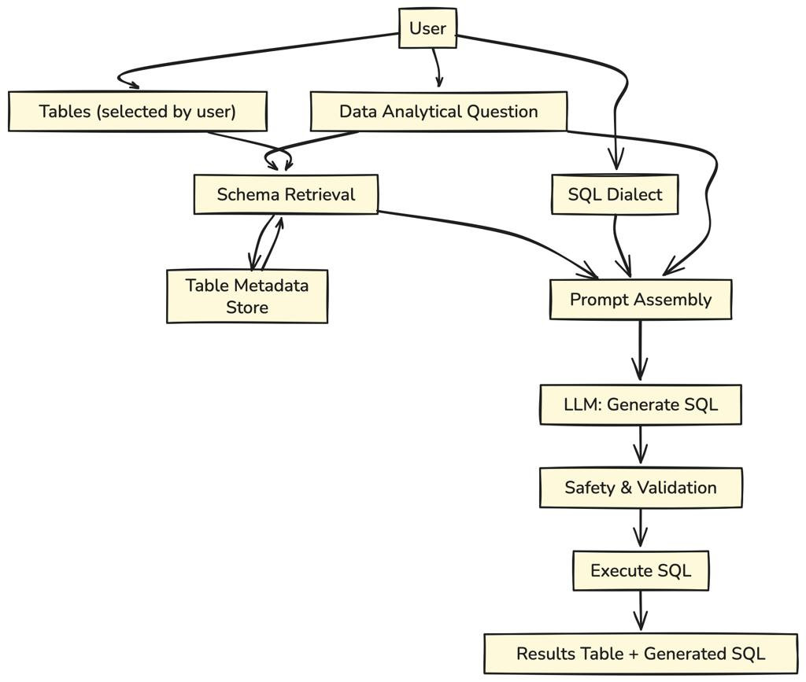

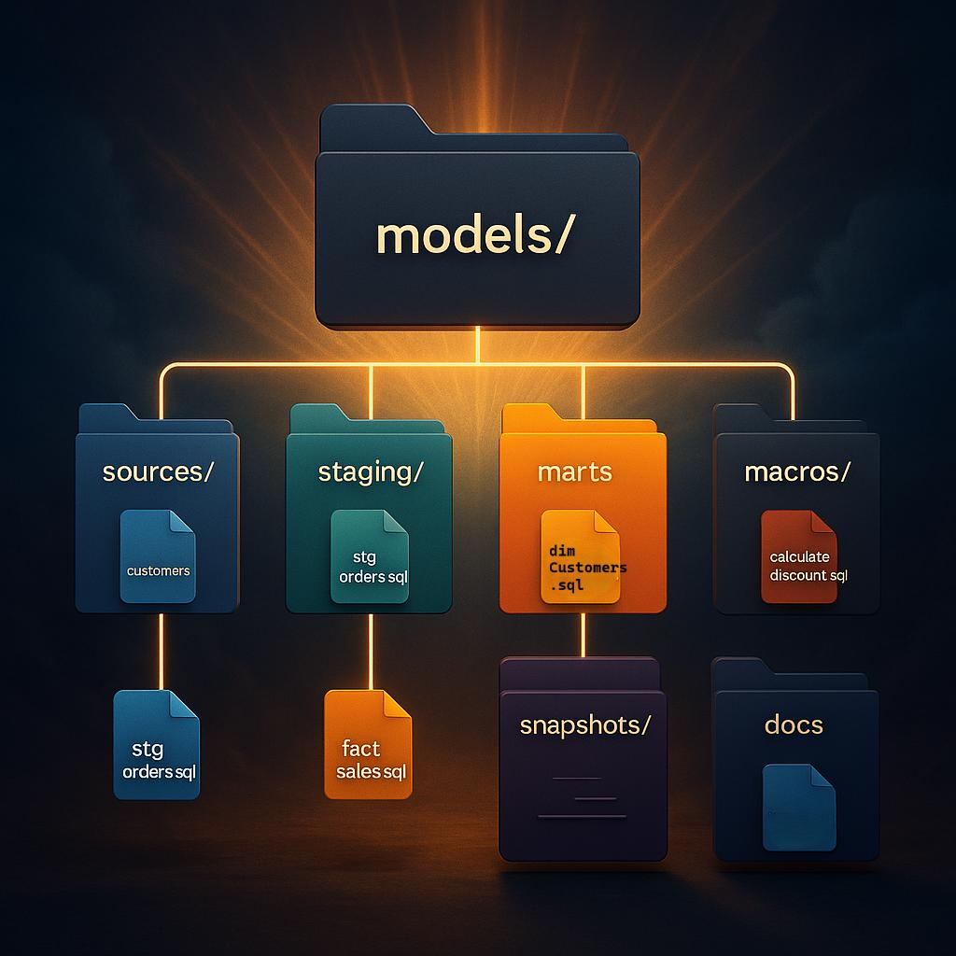

Paid Tool | Open Source Alternative
Claude Code / Copilot | Ollama + Code Llama
Snowflake Cortex Analyst | Ollama (NL2SQL prompts)
dbt Cloud | dbt Core
SQLFluff | SQLFluff
ChatDB / SQLAI | Ollama prompt-based SQL assistant

Lab Objective
You will:
- Take a complex 3-join query
- Use AI to:
  - Explain in plain English
  - Optimize it
  - Convert into dbt model
  - Generate tests
- Deliver:
  - dbt project
  - Tests with failures
  - Optimization report

Step 0: Environment Setup
Install Tools
1. Install Ollama
curl -fsSL https://ollama.com/install.sh | sh
2. Pull Model
ollama pull codellama

3. Install dbt Core
pip install dbt-core dbt-snowflake

4. Install SQLFluff
pip install sqlfluff

Step 1: Create Sample Dataset (3 Tables)
CREATE TABLE customers (
customer_id INT,
name STRING,
region STRING
);
CREATE TABLE products (
product_id INT,
product_name STRING,
category STRING
);
CREATE TABLE orders (
order_id INT,
customer_id INT,
product_id INT,
order_date DATE,
amount NUMBER
);

Insert Data (Include Bad Data)
INSERT INTO customers VALUES
(1,'Alice','North'),
(2,'Bob','South');
INSERT INTO products VALUES
(101,'Laptop','Electronics'),
(102,'Phone','Electronics');
INSERT INTO orders VALUES
(1001,1,101,'2024-01-01',500),
(1002,2,102,'2024-01-02',300),
(1003,NULL,101,'2024-01-03',200); -- BAD DATA

Step 2: Complex 3-Join Query
SELECT
c.customer_id,
c.name,
p.category,
SUM(o.amount) AS total_revenue,
COUNT(o.order_id) AS total_orders
FROM orders o
JOIN customers c ON o.customer_id = c.customer_id
JOIN products p ON o.product_id = p.product_id
WHERE o.order_date >= '2024-01-01'
GROUP BY c.customer_id, c.name, p.category
ORDER BY total_revenue DESC;

Step 3: AI → Explain Query (Ollama)
ollama run codellama
Prompt
Explain this SQL query in simple business terms:
[PASTE QUERY]
Expected Output
- Joins orders with customers and products
- Filters 2024 data
- Calculates revenue and order count
- Groups by customer + category

Step 4: AI → Optimize Query
Prompt
Optimize this SQL query for performance and readability:
[PASTE QUERY]

Optimized Query
SELECT
o.customer_id,
c.name,
p.category,
SUM(o.amount) AS total_revenue,
COUNT(*) AS total_orders
FROM orders o
INNER JOIN customers c
ON o.customer_id = c.customer_id
INNER JOIN products p
ON o.product_id = p.product_id
WHERE o.order_date >= DATE '2024-01-01'
GROUP BY o.customer_id, c.name, p.category
ORDER BY total_revenue DESC;

Step 5: SQL Linting
sqlfluff fix query.sql

Step 6: Generate dbt Model (AI)
Prompt
Convert this SQL into a dbt model using ref() and staging layer:
[PASTE OPTIMIZED QUERY]

Output → models/marts/fact_customer_revenue.sql
SELECT
o.customer_id,
c.name,
p.category,
SUM(o.amount) AS total_revenue,
COUNT(*) AS total_orders
FROM {{ ref('stg_orders') }} o
JOIN {{ ref('dim_customer') }} c
ON o.customer_id = c.customer_id
JOIN {{ ref('dim_product') }} p
ON o.product_id = p.product_id
GROUP BY o.customer_id, c.name, p.category

Step 7: Create Supporting Models
stg_orders.sql
SELECT * FROM {{ source('raw','orders') }}
dim_customer.sql
SELECT DISTINCT customer_id, name FROM {{ source('raw','customers') }}
dim_product.sql
SELECT DISTINCT product_id, category FROM {{ source('raw','products') }}

Step 8: Auto-Generate dbt Tests (AI)
Prompt
Generate dbt schema.yml with 3 tests including not_null, relationships, and business validation

schema.yml
version: 2
models:
- name: fact_customer_revenue
columns:
- name: customer_id
tests:
- not_null
- relationships:
to: ref('dim_customer')
field: customer_id
- name: total_revenue
tests:
- not_null
- name: category
tests:
- not_null

Step 9: Failure Expectations
Because of:
customer_id = NULL
Expected Failures
Test | Failure Reason
not_null(customer_id) | NULL exists
relationships | No matching key
aggregation | incorrect grouping

Step 10: Run dbt
dbt run
dbt test

Step 11: Optimization Report (Deliverable)
Before
- SELECT *
- COUNT(order_id)
- No structure
After
- Selected columns
- COUNT(*)
- Clean joins
- dbt modularization

Step 12: Final Folder Structure
retail_project/
models/
staging/
stg_orders.sql
marts/
dim_customer.sql
dim_product.sql
fact_customer_revenue.sql
schema.yml
sources.yml

Step 13: Optional – NL2SQL Simulation
Prompt
Generate SQL for: "Top customers by revenue"
Deliverables
You now have:
1. dbt Model Folder
2. AI-generated Tests
3. Optimization Report
4. AI-assisted SQL workflow

