E-SHOPPING
Contents
1 Problem Statement 2
2 WIREFRAMES 3
3 Business Requirements: 4
4 Proposed Rest Endpoints to be exposed 5
4.1 Rest APIs: 5
5 Key Rubrics/Expected Deliverables 5
6 Platform 5

Problem Statement
Build a software system which lets user search for a product and purchase it & includes Admin related activities. User can also cancel the order.
Below are the different roles, which need to be supported by above Software System.
- User
- Admin
The scope includes developing the application using dot net core as the backend

WIREFRAMES
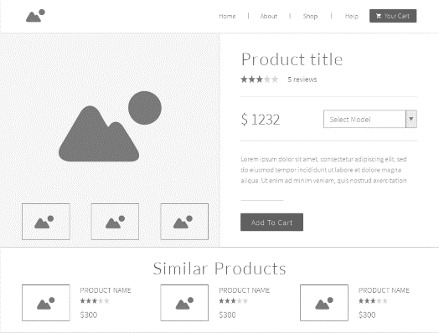
UI needs improvisation and modification as per given use case.
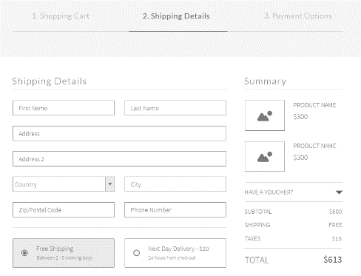
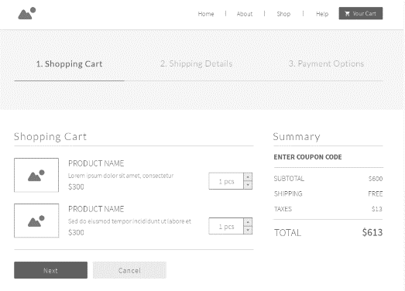
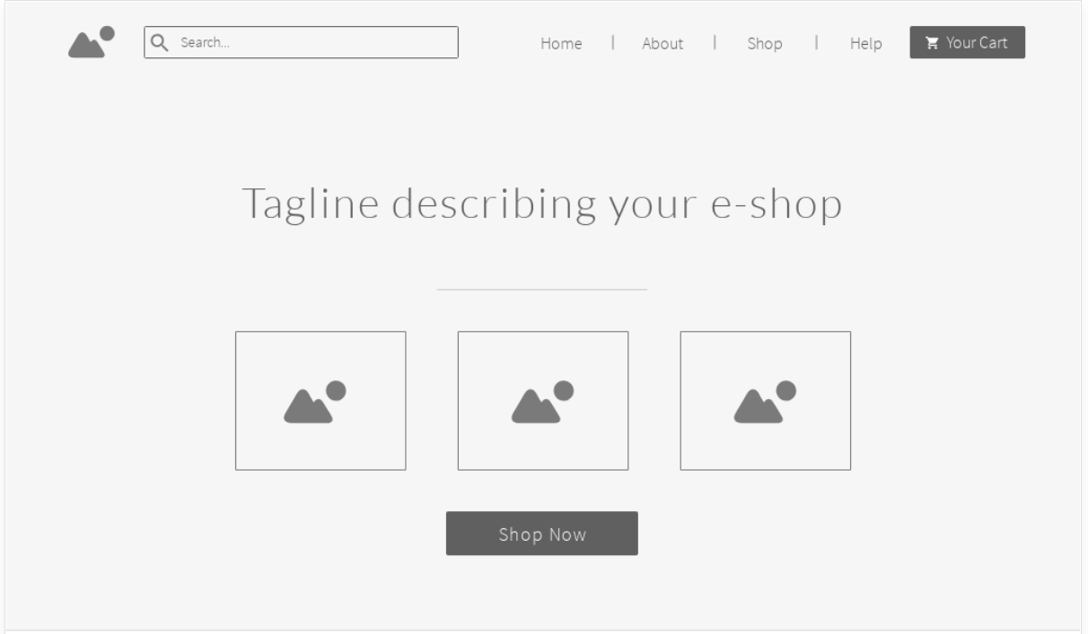

Business Requirements:
As an application developer, develop microservices with below guidelines:
User  Story # | User Story Name | User Story
US_01 | User Mode | - User can search for a Product based on any text  - Each Search result need to display Product details, product Name/image, Price (to & round trip – TBD)  - From Search results, User should be able to select a product and go ahead and complete order Booking by providing below details  - Name and Email ID  - Quantity.  - Address.  - On successful Order Placement, OrderID need to be generated  - With Order ID user should be able to  - view Orders placed,  - Cancel an Order.  - With OrderID view the order details
US_02 | Admin Mode | - Admin shall be able to login/logout.  - There can be pre-defined username/password for Admin.  - Admin shall be able to add/block a product. When product is Blocked, product will not be shown in Search results.  - Admin shall be able to add Inventory of an existing product by specifying below details:  - Product ID  - Admin shall be able to add product with below details: -  - Product name  - Product Description  - Category  - Product discount  - Product MRP  - Product selling price

Proposed Rest Endpoints to be exposed

Rest APIs:
POST | /api/v1.0/eshopping/user/register | New user register
POST | /api/v1.0/ eshopping /admin/login | Admin login
POST | /api/v1.0/ eshopping /catalog/inventory/add | Add Inventory
POST | /api/v1.0/ eshopping /search | Searches for product
POST | /api/v1.0/ eshopping /order/add | Place order
GET | /api/v1.0/ eshopping / order /{OrderID} | Get order details based on orderID
GET | /api/v1.0/ eshopping /order/history/ | Get orders history
DELETE | /api/v1.0/ eshopping / order /cancel/{ OrderID } | Cancel an order

Key Rubrics/Expected Deliverables
As an application developer:
  - Ensure layer project Structure with proper naming conventions and model classes.
  - Use application.json file to maintain all configuration like connection string
  - Implemented the layered structure - Controller, Interface, Service, DAO, Testing, Validation, Security etc
  - Secure all Rest End Points by configuring SSL Certificate for Cloud

Platform

Use above Business Requirements to implement the below.
      - Use Azure to deploy application on cloud.
      - Use Azure SQL Server as a database for the Application.
      - Use Azure Functions and DB to build a backend process for handling requests for E-Shopping App.
      - Use Azure Service to send email after order placement.
Note: Minimum 2APIs (UI+Backend) to be hosted in cloud

