Multi-Layer Outage Investigation
In this capstone lab, you will:
- Analyze a multi-layer outage
- Identify the true root cause
- Validate SLO breach
- Propose a remediation plan
This simulates a real production incident in a cloud-native e-commerce application.

Scenario Overview
Application: Online Retail Platform
Environment: Kubernetes (EKS/AKS/GKE)
Monitoring: Dynatrace Full-Stack Observability
Incident:
- Users report checkout failures
- Checkout page loading slowly
- Orders not completing
- Customer complaints increasing

Architecture Overview
Multi-Layer Stack
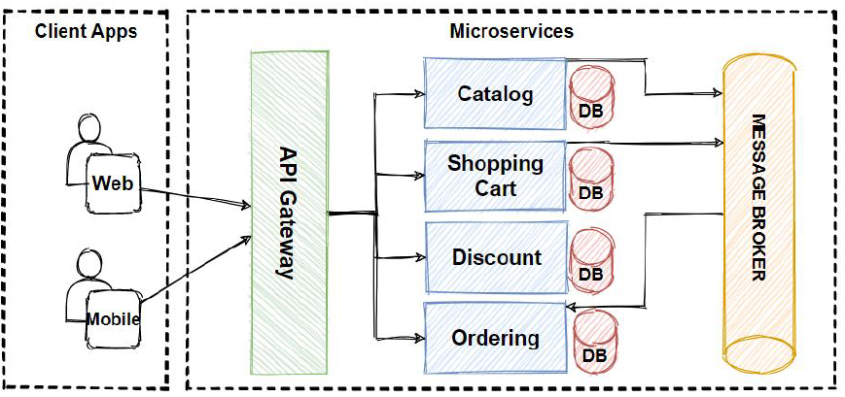

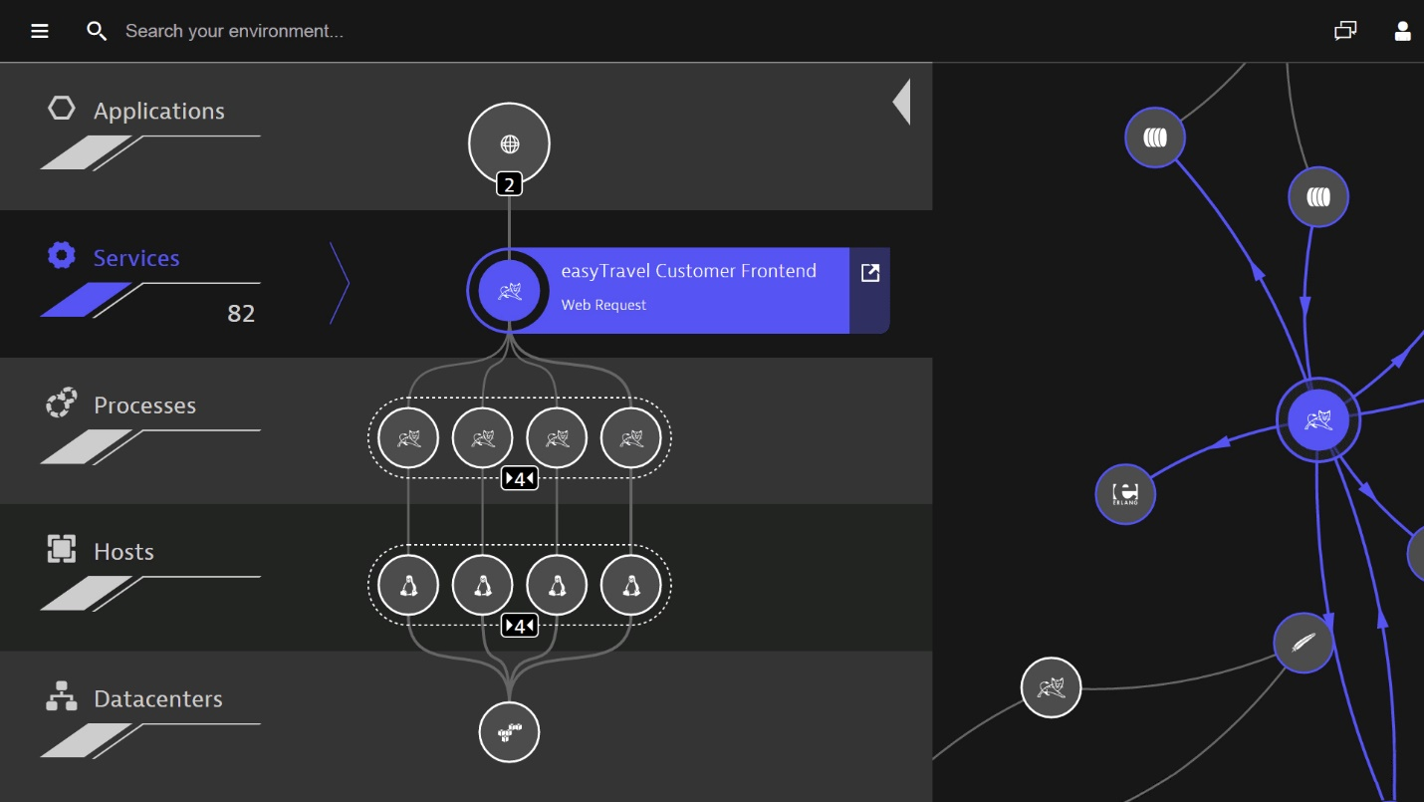
Layers involved:
- Frontend (React/Node.js)
- Checkout Service
- Payment Service
- MySQL Database
- Kubernetes cluster infrastructure

Phase 1 – Analyze the Outage
Step 1 – Open Problems View
Go to:
Observe & Explore → Problems
Identify:
- Active problem
- Severity level
- Impacted services
- Affected users
Expected Observation:
Problem: High failure rate in checkout-service
Severity: CRITICAL
User impact: 65%

Step 2 – Review Problem Card
Examine:
- Root cause entity
- Failure rate spike
- Response time increase
- Timeline view
Look for:
- When did it start?
- Which service is first impacted?

Phase 2 – Multi-Layer Investigation

Layer 1 – Application Layer
Open:
Service → checkout-service
Analyze:
- Response time (p95)
- Failure rate
- Throughput
Observation Example:
- Failure rate increased to 30%
- Response time jumped from 200ms → 3.5s

Layer 2 – PurePath Trace Analysis
Open:
Distributed traces (PurePath)
Find:
- Longest request traces
- External service calls
- Database query timings
Expected Discovery:
Database call taking 2.8 seconds
Multiple retries observed

Layer 3 – Log Correlation
Open:
Related Logs
Search:
severity="ERROR"
Possible log entry:
"Lock wait timeout exceeded; try restarting transaction"
Conclusion:
Database lock contention suspected.

Layer 4 – Infrastructure Layer
Go to:
Kubernetes → Workloads → Database Pod
Analyze:
- CPU usage
- Memory usage
- Pod restarts
- OOMKilled events
Possible Observation:
- CPU 95% sustained
- Memory near limit
- Restart count increased

Layer 5 – Database Metrics
Check:
- Active sessions
- Lock wait time
- Slow query count
Expected:
- Lock wait time spike
- Slow queries increased

Root Cause Identification
Root Cause:
Database lock contention caused by:
- Long-running transaction
OR
- Missing index on orders table
Impact Chain:
Database slowdown
→ Checkout service latency spike
→ Increased retries
→ Failure rate increase
→ SLO breach

Phase 3 – Validate SLO Breach
Step 1 – Open SLO Dashboard
Navigate:
Service → Service Level Objectives
Select:
Checkout Availability SLO

Step 2 – Review Compliance
Expected:
Target: 99.9%
Current: 97.8%
Observe:
- Error budget consumption
- Burn rate spike

Step 3 – Analyze Burn Rate
Burn rate > 5
Meaning:
Monthly error budget consumed in hours
This confirms business impact.

Phase 4 – Propose Remediation Plan
Immediate Remediation (Short-Term)
- Restart affected database pod
- Kill long-running transaction
- Scale database vertically
- Restart checkout pods

Medium-Term Fix
- Add missing DB indexes
- Optimize slow SQL queries
- Reduce transaction locking
- Increase connection pool efficiency

Long-Term Prevention
- Enable auto-adaptive alerting
- Implement burn-rate alerts
- Capacity planning dashboard
- Set proper resource limits in Kubernetes

Automation Recommendation
Create workflow:
Trigger:
Problem: Database CPU > 90%
Action:
- Notify Slack
- Create ServiceNow ticket
- Scale database node group
- Restart affected pods
Add safety controls:
- Production only
- Once per hour
- Severity = CRITICAL

