Lab Module – Integrate Notification Channel (Dynatrace)
This lab teaches how to integrate Dynatrace problem alerts with external systems so incidents automatically reach the right team.
We will configure:
- Slack notification
- ServiceNow incident creation
- PagerDuty escalation
- Generic Webhook integration
- Validation & testing

Architecture Flow
Dynatrace detects problem
→ Sends notification
→ Creates incident / alert
→ Notifies team
→ Enables automation

1. Slack Integration
Slack
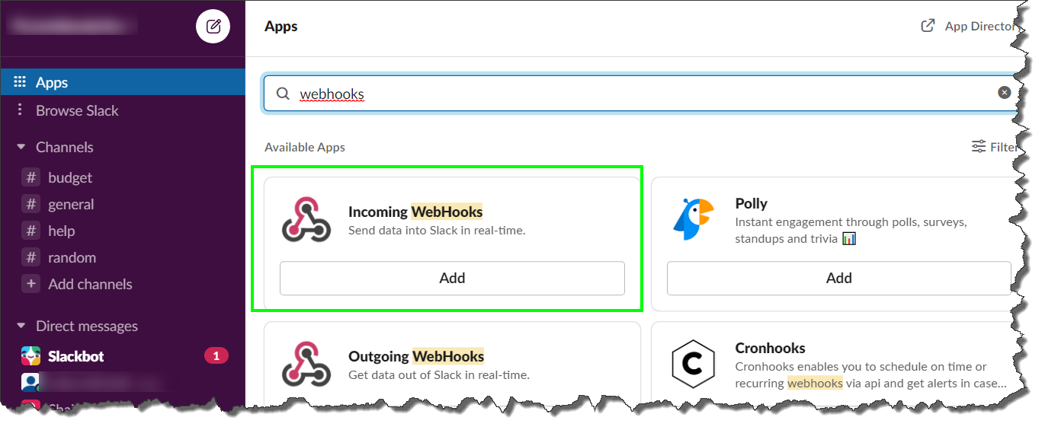
Step 1 – Create Slack Webhook
- Open Slack
- Go to Apps
- Search: Incoming Webhooks
- Add to workspace
- Select channel (e.g., #devops-alerts)
- Copy generated Webhook URL

Step 2 – Configure in Dynatrace
- Go to:
Settings → Integrations → Problem Notifications
- Click: Add notification
- Select Slack
- Paste Webhook URL
- Customize message:
Example template:
Problem: {ProblemTitle}
Severity: {SeverityLevel}
Root Cause: {RootCauseEntity}
Impacted Services: {ImpactedEntities}
Link: {ProblemURL}
- Save

Step 3 – Test Slack Alert
Trigger failure:
http://localhost:3000/orders?error=true
Expected:
- Slack message appears in channel
- Contains root cause & impact details

2. ServiceNow Integration
ServiceNow
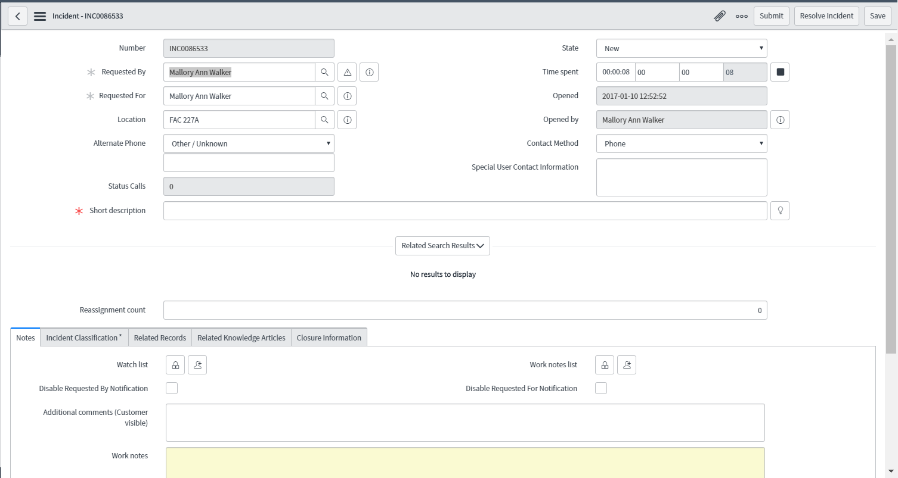
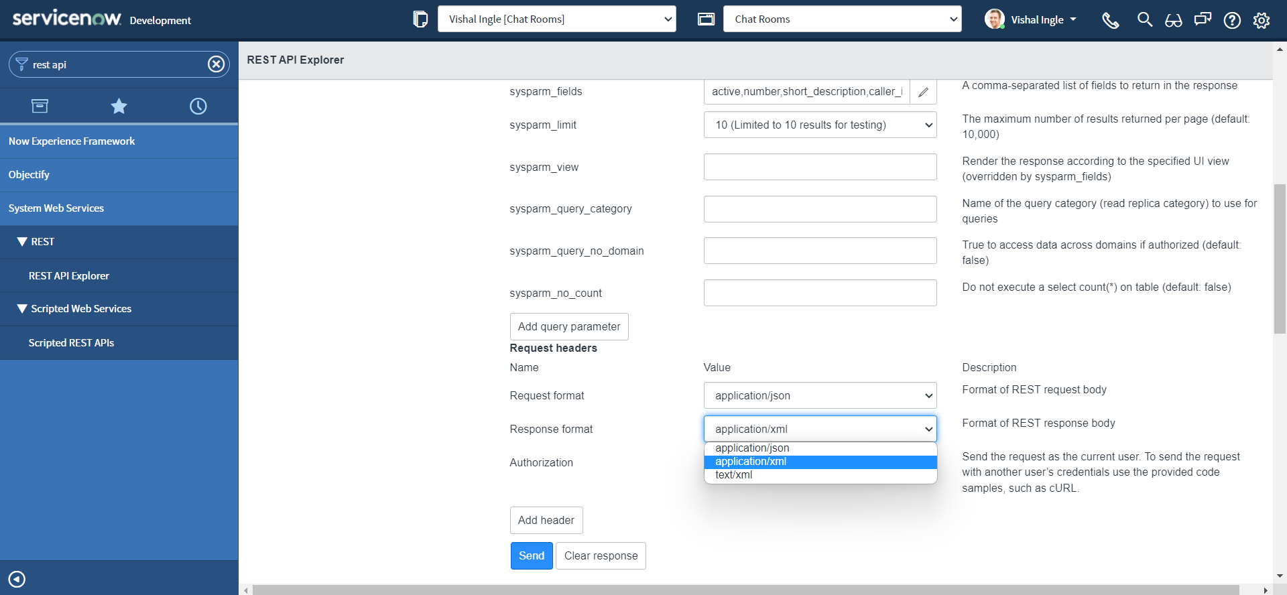
Step 1 – Create API User in ServiceNow
- Login to ServiceNow
- Go to Users → New
- Assign role: itil
- Enable REST API access

Step 2 – Configure Dynatrace
- Settings → Integrations → ServiceNow
- Provide:
  - Instance URL
  - Username
  - Password / OAuth
- Map fields:
Dynatrace Problem → ServiceNow Incident
- Title → Short Description
- Description → Description
- Severity → Impact
- Entity → Configuration Item
- Enable:
Auto-create incident on problem open
- Save

Step 3 – Test
Trigger synthetic failure.
Expected:
- Incident created automatically
- Incident contains:
  - Root cause
  - Severity
  - Direct Dynatrace link

3. PagerDuty Integration
PagerDuty
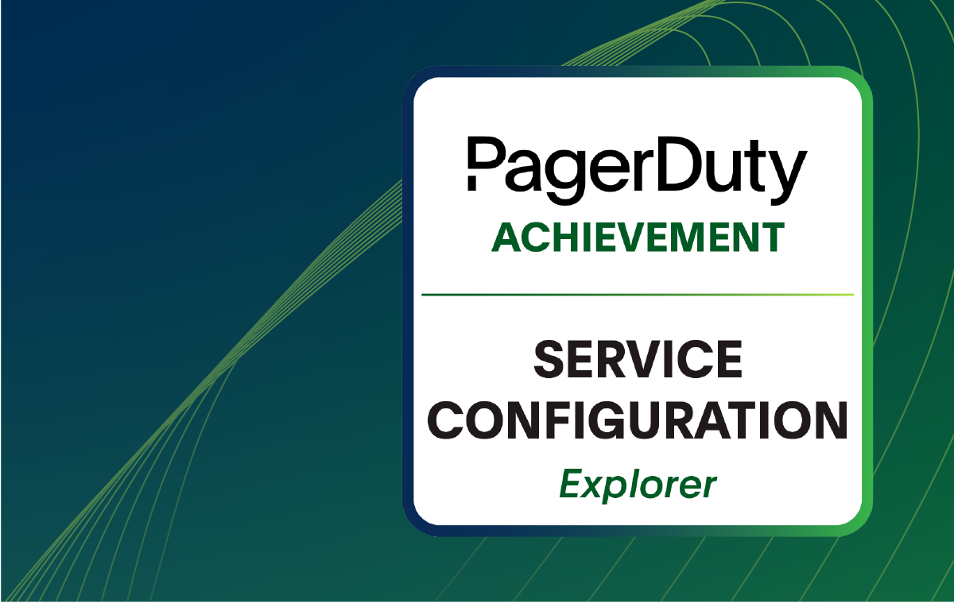
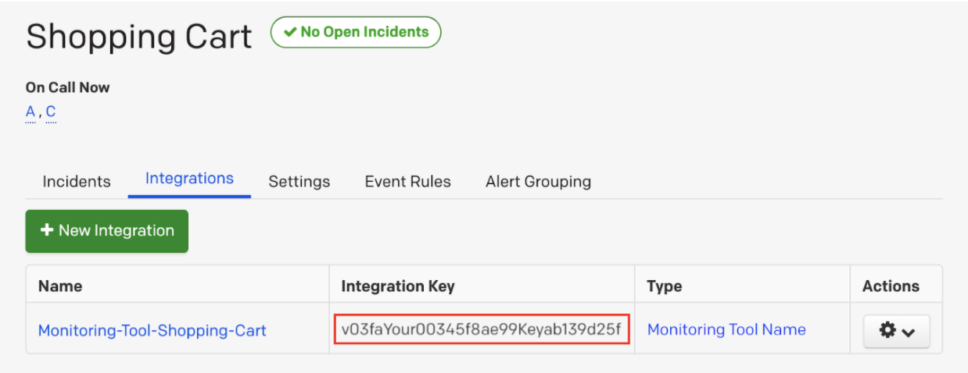
Step 1 – Create PagerDuty Service
- Login to PagerDuty
- Go to Services → New Service
- Select Integration: Events API v2
- Copy Integration Key

Step 2 – Configure Dynatrace
- Settings → Problem Notifications
- Add PagerDuty integration
- Paste integration key
- Choose severity mapping
- Save

Step 3 – Test Escalation
Trigger:
High CPU alert
OR
Error spike
Expected:
- PagerDuty incident created
- On-call engineer notified
- Escalation policy executed

4. Generic Webhook Integration (Advanced)
Used for:
- Custom ITSM tool
- Microsoft Teams
- Internal automation system
- Kubernetes auto-remediation

Step 1 – Add Custom Webhook
- Settings → Problem Notifications
- Add → Webhook

Step 2 – Configure Endpoint
Example:
POST https://your-api/incident
Payload Example:
{
"title": "{ProblemTitle}",
"severity": "{SeverityLevel}",
"rootCause": "{RootCauseEntity}",
"impact": "{ImpactedEntities}",
"link": "{ProblemURL}"
}

Step 3 – Test
Verify:
- Endpoint receives JSON
- Logs show successful POST
- No 400/500 errors

5. Alert Routing Strategy
Best Practice:
Create different notification rules:
Production:
- PagerDuty
- ServiceNow
- Slack #critical
Staging:
- Slack only
Development:
- Email only
Use:
Management Zones to separate environments.

6. Notification Filtering
Avoid alert fatigue.
Configure:
Trigger only when:
- Problem severity = HIGH
- Impacted users > 100
- Service tag = production

7. End-to-End Validation Lab
Students must:
- Create CPU metric alert
- Trigger load
- Confirm Dynatrace problem created
- Confirm Slack message received
- Confirm ServiceNow incident created
- Confirm PagerDuty escalation triggered
- Close problem and verify auto-resolution

8. Troubleshooting Guide
If Slack not receiving:
- Verify webhook URL
- Check firewall rules
- Validate payload format
If ServiceNow not creating:
- Check API user role
- Validate instance URL
- Review logs in Dynatrace
If PagerDuty not escalating:
- Confirm integration key
- Check service escalation policy
- Verify severity mapping

