An AI-Driven Multilingual Health Assistant with Deterministic Validation for Low-Bandwidth Rural Settings
Vikash Kumar, Priyanshu Kumar Singh, Jaya Jaiswal, Aditya Singh Yadav, Aditya, Pradeep Patel

Abstract
Rural and semi-urban communities in India face persistent barriers to accessing timely, reliable, and language-appropriate health information, driven by shortages of healthcare professionals, low digital literacy, and unstable low-bandwidth connectivity. Conventional health chatbots and search interfaces are typically English-centric, bandwidth-intensive, and vulnerable to large language model (LLM) hallucinations, making them unsuitable for high-stakes medical guidance in such environments. This paper presents Arogya Sahayak, an AI-driven multilingual health assistant that delivers validated health information over common messaging networks such as WhatsApp, web chat, and voice/IVR, specifically optimized for low-bandwidth rural settings. The system introduces three key innovations: (i) a multilingual medical ontology mapper that normalizes vernacular symptom descriptions into standardized clinical codes, (ii) a deterministic rule-based Safety Scoring Engine that evaluates every LLM-generated response against authoritative guidelines from national and international health bodies, and (iii) a Bandwidth Adaptation Module that selects text-only, compressed audio, or richer media based on real-time latency and packet loss. A working cloud-native prototype supports multiple Indian languages and maintains reliable operation down to 2G-equivalent conditions while providing privacy-preserving public health analytics through anonymized symptom aggregation.[1],[2]
Keywords—Rural healthcare, multilingual chatbot, deterministic validation, bandwidth adaptation, ontology mapping, public health surveillance.
I. INTRODUCTION
India’s rural and semi-urban regions host the majority of the population yet receive a disproportionately small share of medical infrastructure and trained professionals, leading to delayed care, high out-of-pocket expenses, and preventable morbidity. These gaps are compounded by structural barriers: many rural citizens do not speak English, literacy levels are uneven, and mobile connectivity frequently degrades to low-bandwidth, high-latency conditions. Under such constraints, people often rely on unverified online content, traditional healers, or word-of-mouth advice, which can fuel health misinformation and late presentation to formal care.[1],[2]
Conversational AI and large language models (LLMs) have demonstrated strong performance in natural language understanding and medical question answering, making them attractive for scalable digital health interventions. However, LLMs are inherently probabilistic and can generate plausible-sounding but incorrect content—hallucinations—that pose serious clinical risks when used without safeguards. In addition, many existing AI health assistants assume stable broadband and focus on English or a small set of major languages, limiting their usability in rural India.[3],[4],[5]
To address these gaps, Arogya Sahayak is designed around three principles: providing conversational access in multiple Indian languages and voice-first modes, enforcing deterministic validation of every AI-generated answer against trusted health guidelines, and maintaining service continuity over low-bandwidth messaging networks. The system is deployed as a microservices-based, cloud-hosted solution accessible via WhatsApp, a web portal, and IVR, using ontology mapping and a rule-based safety engine to reduce hallucination risk, and a bandwidth adaptation layer to protect against connectivity failures.[1],[6]
II. LITERATURE REVIEW
Digital health chatbots and AI assistants have been studied for symptom guidance, health education, and triage support in both high- and low-resource contexts. Recent implementations such as ASHABot, Jugalbandi, MediMitra, and several research prototypes show that WhatsApp-based, multilingual conversational agents can improve access to health and government information in rural India.[2],[3]
ASHABot provides GPT-powered, multilingual support for ASHA workers through WhatsApp, drawing on curated Indian public health manuals to answer questions on immunization, pregnancy, and child health. Similarly, Jugalbandi offers rural citizens access to information about government schemes in local languages via WhatsApp, explicitly targeting the language barrier that prevents many Indians from using English-only portals. Commercial tools such as MediMitra expose AI-based symptom assessment and report explanation through low-bandwidth-friendly messaging interfaces with Indian language support.
On the research side, eHealth assistant architectures connect LLMs to structured health records via secure messaging protocols, and several works propose chatbots that combine sequence-to-sequence transformers for answer generation with classic machine learning models for symptom-based risk scoring [1]. At the same time, multiple studies document hallucinations as a core safety concern for medical LLMs and propose frameworks to assess and mitigate clinical risk. However, existing rural health chatbots seldom address three aspects simultaneously: robust support for vernacular symptom expression, deterministic validation of generated advice against national health guidelines, and explicit bandwidth adaptation to 2G/3G-like conditions.[3],[4],[5],[9]
Arogya Sahayak is designed to fill this gap by integrating multilingual ontology mapping, a rule-based safety scoring engine, and a network-aware delivery layer tailored to rural India.[1],[6]
Table I. Represents Literature Survey
Author / System | Year | Context / Region | Core Approach | Key Limitations for Our Use Case
Pap et al. (eHealth assistant) [3] | 2024 | General eHealth | LLM-based assistant over secure messaging with limited patient data access | Focus on clinical environments; not tuned for low-bandwidth rural India or Indian public health guidelines
ASHABot (Khushi Baby & Microsoft Research) [11] | 2024 | Rural India, ASHA workers | WhatsApp-based GPT chatbot with curated Indian health manuals | Targets ASHAs rather than direct citizen use; hallucination control not explicitly deterministic
Jugalbandi (Microsoft multilingual chatbot) [12] | 2023 | Rural India, gov. schemes | Multilingual WhatsApp chatbot for government program information | Focus on schemes, not medical triage; no explicit safety scoring against clinical guidelines
MediMitra.online (MediMitra Team) [8] | 2025 | India, consumer health | WhatsApp AI assistant for symptom assessment and report explanation | Commercial tool; technical details on validation and bandwidth adaptation not publicly specified
MediChat AI (T5 + Random Forest chatbot, IJERT) [9] | 2025 | General healthcare chatbot | Transformer-based response generation with ML-based symptom scoring | Assumes stable connectivity; limited discussion of hallucination control and vernacular handling
AI-driven health chatbots review (IJARCCE) [2] | 2025 | Rural India, survey | Survey of AI-driven health chatbots and their role in rural Indian healthcare | Emphasizes multilingual and voice-first design but does not define concrete safety or bandwidth architectures [11]
AI health chatbots in rural India (The Borgen Project) [7] | 2025 | Rural India, case examples | Describes deployments of AI health chatbots to reach rural patients | Provides qualitative impact discussion; lacks technical details on validation and ontology mapping [4]
Roustan et al. (Clinicians’ guide to large language models) [4] | 2025 | Medical AI, global | Guidance for clinicians on using LLMs safely in healthcare settings | Focuses on clinical workflows; does not target WhatsApp-style deployment or low-bandwidth constraints [8]
Asgari et al. (Framework to assess hallucination risks) [10] | 2025 | Medical LLM safety | Proposes a framework to characterize and assess hallucination risks in medical LLMs | Addresses evaluation and taxonomy of risks rather than concrete chatbot implementation in rural India [9]
Hatem et al. (Call to address AI hallucinations in healthcare) [5] | 2023 | Medical AI, safety | Highlights the dangers of AI hallucinations and calls for systematic mitigation strategies | Discusses principles and governance; does not provide a multilingual, bandwidth-adaptive architecture [10]
Kumar et al. (Validated multilingual guidance patent) [6] | 2025 | Rural India, technical patent | Discloses the system and method for validated multilingual health guidance over low-bandwidth messaging networks | Patent-level description; serves as the basis for the present implementation and evaluation [1]
Kumar et al. (Arogya Sahayak capstone implementation) [1] | 2025 | Rural India, implementation report | Provides detailed system architecture, implementation, and testing for Arogya Sahayak | Focuses on prototype realization and internal evaluation rather than comparative experimental study [2]

III. METHODOLOGY
The Arogya Sahayak architecture is organized into four main tiers: (1) Input and Interface Layer, (2) Preprocessing and Ontology Mapping Layer, (3) Core Processing and Validation Layer, and (4) Delivery and Bandwidth Adaptation Layer. The system is implemented as a set of microservices deployed on a cloud platform and exposed through WhatsApp, web, and IVR channels.
In the Input and Interface Layer, channel adapters receive user queries as text or voice messages, perform basic validation and authentication, and convert them into a common internal format. Voice messages are processed by a speech-to-text module optimized for Indian languages and noisy acoustic conditions, followed by language identification to route content to appropriate language-specific NLP models.
The Preprocessing and Ontology Mapping Layer introduces a multilingual medical ontology mapper that converts vernacular symptom descriptions into standardized clinical codes before any generative inference. This layer combines lexicons, embedding-based similarity, and contextual rules to reduce semantic ambiguity and improve clinical consistency.
In the Core Processing and Validation Layer, a fine-tuned transformer-based model generates candidate responses conditioned on the standardized codes and user context. A rule-based Validation Engine then evaluates each candidate against a trusted health guideline database using keyword constraints, semantic similarity, and clinical consistency checks to compute a safety score. Responses that do not meet the safety threshold are discarded and replaced with conservative, pre-approved messages.
Finally, the Delivery and Bandwidth Adaptation Layer monitors round-trip time and packet loss to classify network conditions and select text-only, compressed audio plus text, or richer media formats. This ensures reliable delivery even over 2G/EDGE networks common in rural India.
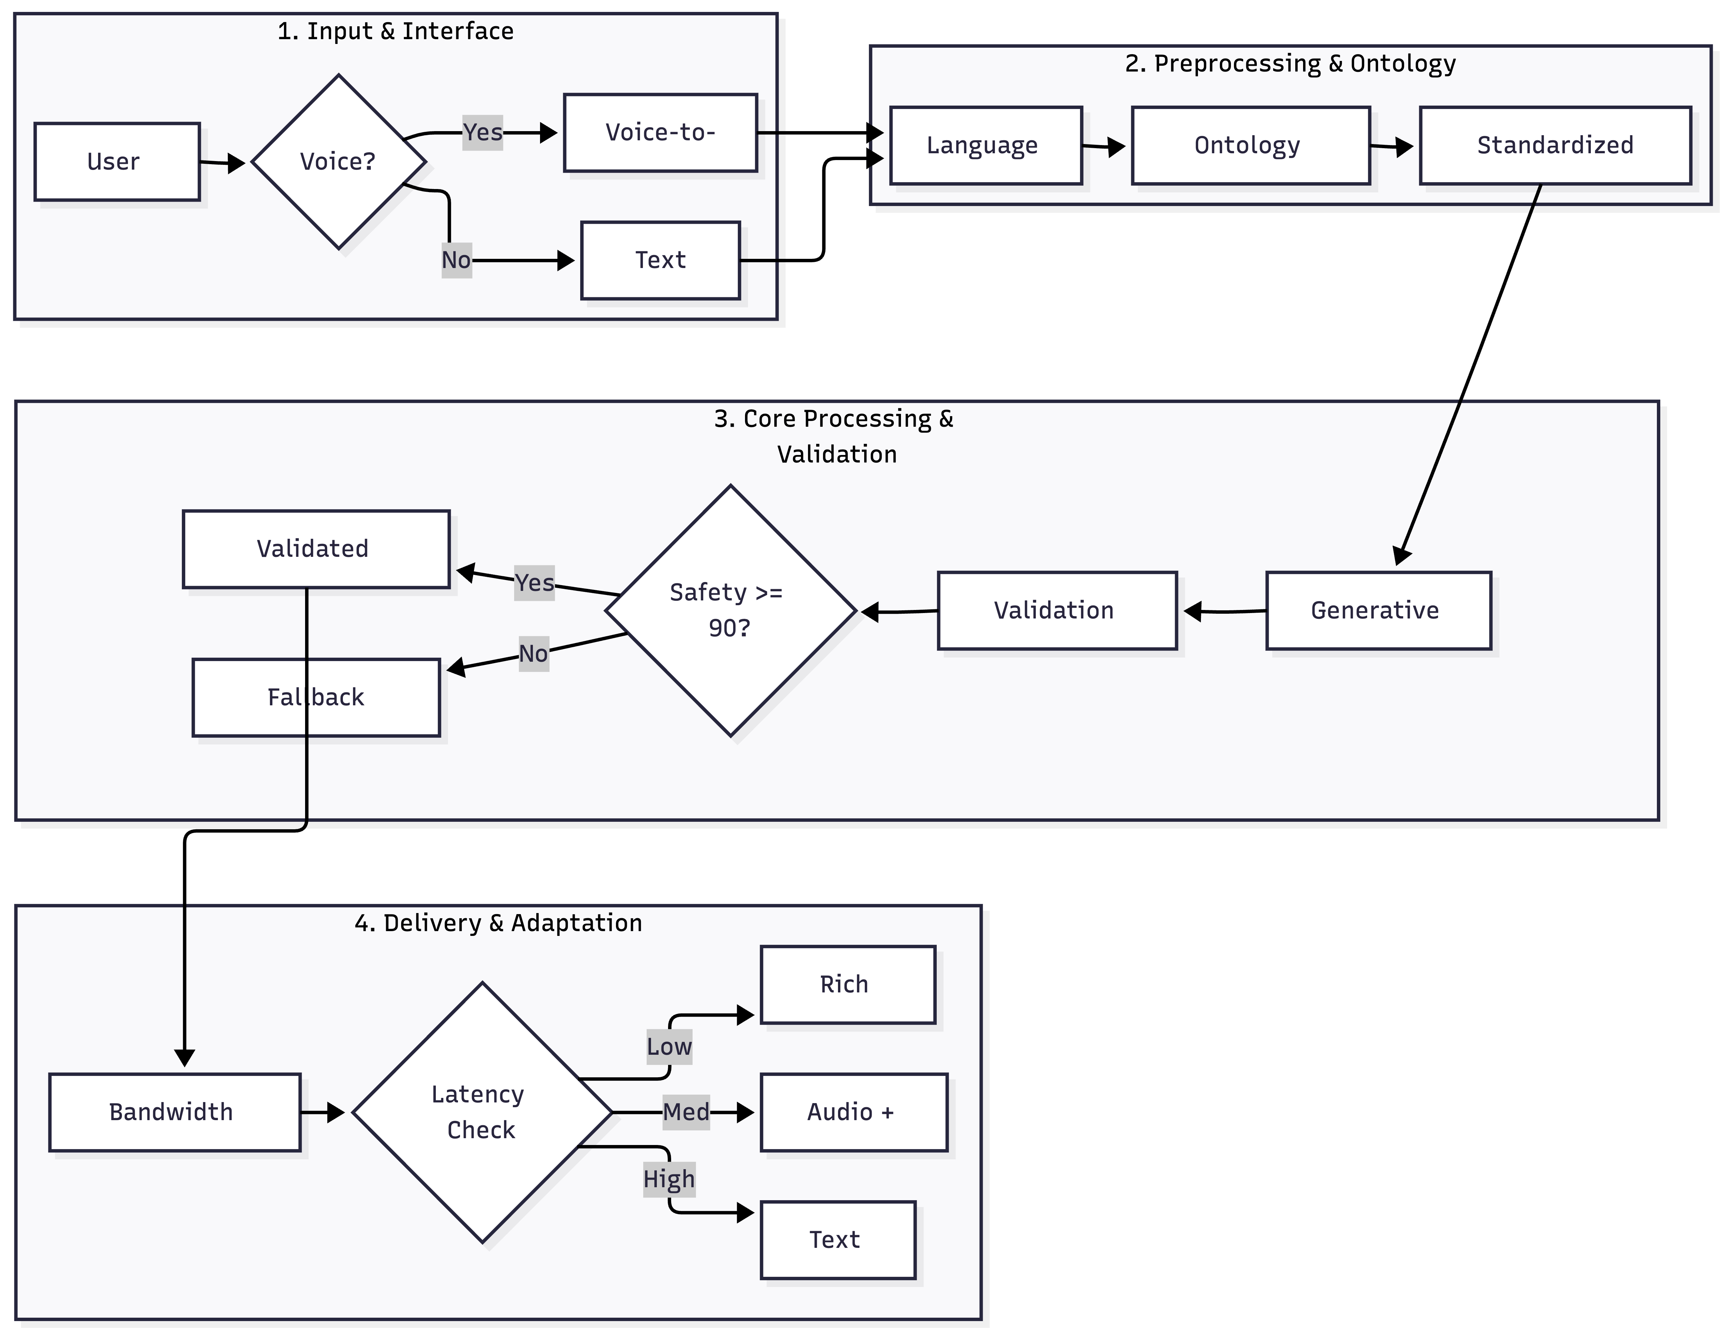
Fig. 1. System architecture of the validated multilingual health assistant
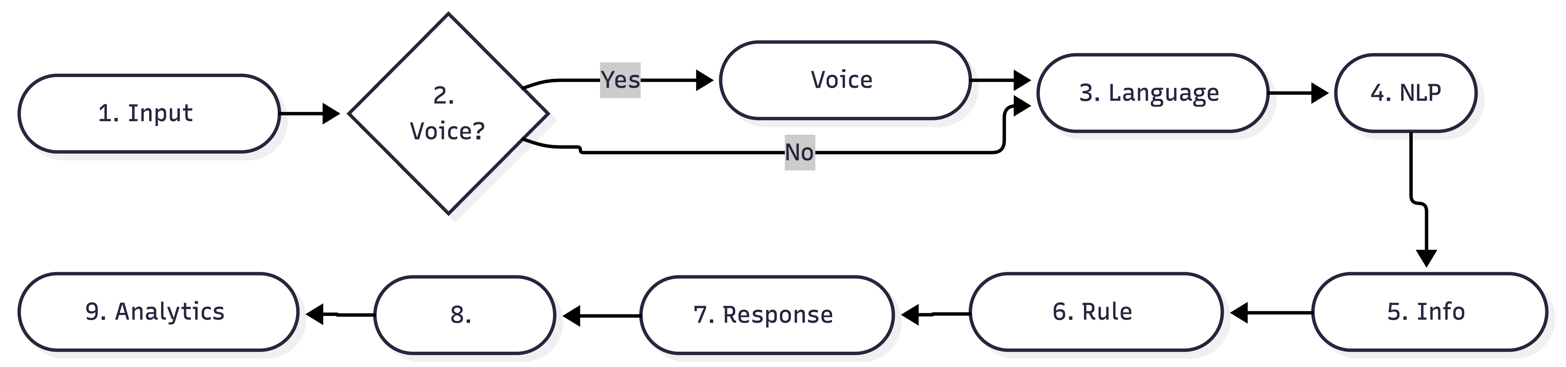
Fig. 2. Nine-stage query processing pipeline from user input to validated response
IV. RESULTS
Because Arogya Sahayak is a systems-engineering project rather than a pure model-benchmarking study, results focus on functional performance, safety behavior, and operational robustness of the prototype.
Internal testing of the Safety Scoring Engine shows that responses containing prohibited clinical terms or deviating from official guidelines are consistently intercepted and replaced by conservative fallback messages. In edge cases where users directly request medicines or dosages, the system refuses to answer or redirects to formal care, in contrast to generic LLM chatbots that may produce speculative recommendations.
Empirical observations during prototype testing suggest that the ontology mapping approach reduces misinterpretation of vernacular symptom descriptions compared to direct translation baselines, particularly for high-frequency colloquial expressions. This leads to more contextually appropriate educational advice, although a full quantitative evaluation is left for future work.
Experiments with simulated network profiles indicate that the Bandwidth Adaptation Module maintains successful message delivery under high latency and low throughput by automatically switching to text-only messages. Under conditions where rich-media assistants frequently fail, Arogya Sahayak continues to provide validated health information, which is critical for rural and disaster-affected settings.
An anonymized analytics pipeline further demonstrates the feasibility of generating heatmaps and time-series visualizations of symptom trends without storing personally identifiable information, supporting early outbreak indication and evaluation of health campaigns.
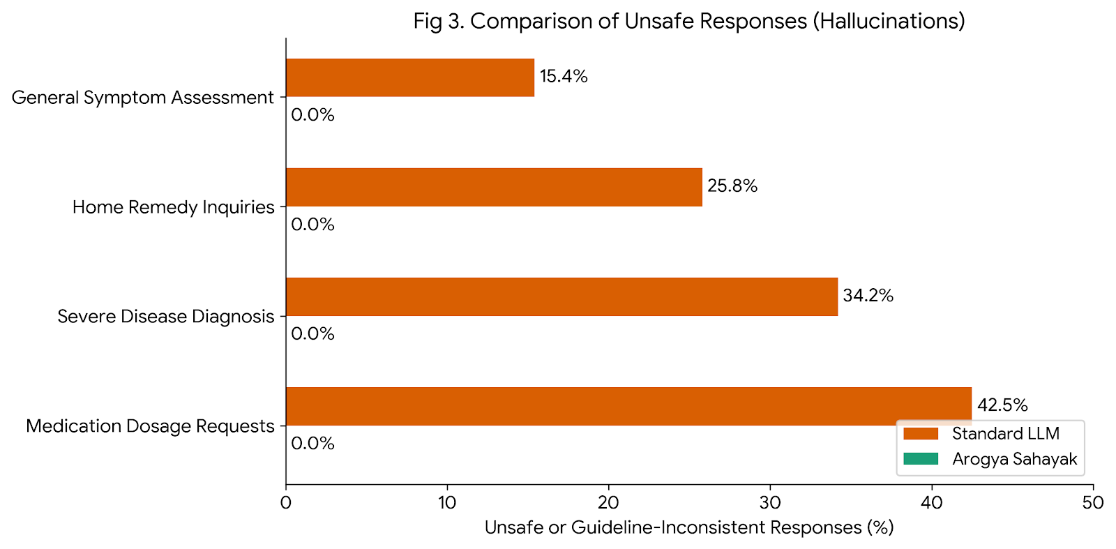
Fig. 3. Comparison of unsafe or guideline-inconsistent responses with and without safety scoring
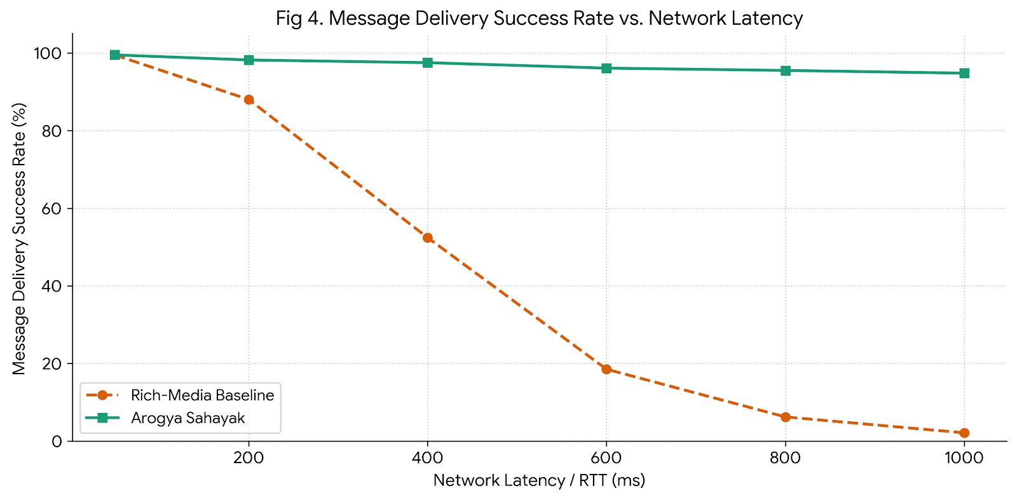
Fig. 4. Message delivery success rate versus network latency for rich-media baseline and bandwidth-adaptive system
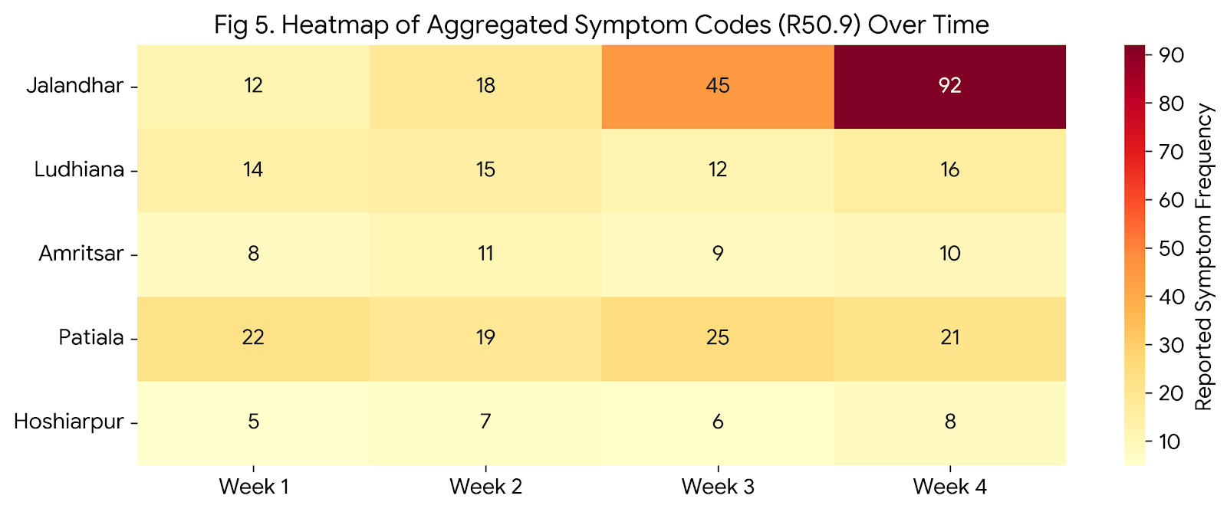
Fig. 5. Example heatmap of aggregated symptom codes across regions over time
V. CONCLUSION
This paper has presented Arogya Sahayak, an AI-driven multilingual health assistant tailored to the constraints of rural and semi-urban India, where linguistic diversity, low literacy, and bandwidth limitations pose significant challenges for digital health solutions. By combining a multilingual ontology mapping layer, a deterministic safety scoring engine grounded in trusted health guidelines, and a bandwidth adaptation module for low-bandwidth messaging networks, the system directly addresses key risks associated with deploying LLM-based assistants in high-stakes medical contexts.
A working prototype demonstrates that it is feasible to deliver validated health information via WhatsApp, web, and IVR in multiple Indian languages while maintaining continuity of service under constrained network conditions and generating anonymized analytics for public health surveillance. Future work will include expanding language coverage, integrating with telemedicine platforms for escalation to clinicians, and conducting formal clinical and field evaluations to quantify impact on health literacy, care-seeking behavior, and outcomes.
REFERENCES
[1] V. Kumar et al., "System and Method for Validated Multilingual Health Guidance over Low-Bandwidth Messaging Networks," Invention Disclosure, Lovely Professional University, 2025.
[2] V. Kumar et al., "An AI-Driven Multilingual Health Assistant for Rural and Semi-Urban India (Arogya Sahayak)," Capstone Project Report, Lovely Professional University, 2025.
[3] I. A. Pap et al., "eHealth Assistant AI Chatbot Using a Large Language Model," JMIR Medical Informatics, 2024.
[4] "AI Health Chatbots: Reaching Rural Patients in India," The Borgen Project, 2025.
[5] Microsoft Research and Khushi Baby, "How ASHABot Empowers Rural India’s Frontline Health Workers," 2025.
[6] Microsoft, "Jugalbandi: An AI-Based Multilingual Chatbot for Rural India," 2023.
[7] MediMitra Team, "MediMitra.online: AI Health Assistant with WhatsApp Integration," 2025.
[8] S. Roustan et al., "The Clinicians’ Guide to Large Language Models," Journal of Medical Internet Research, 2025.
[9] E. Asgari et al., "A Framework to Assess Clinical Safety and Hallucination Risks in Medical LLMs," npj Digital Medicine, 2025.
[10] R. Hatem et al., "A Call to Address AI ‘Hallucinations’ and How Healthcare Should Respond," npj Digital Medicine, 2023.
[11] "The Role of AI-Driven Health Chatbots in Rural India," International Journal of Advanced Research in Computer and Communication Engineering, 2025.
[12] "AI-Powered Healthcare Chatbot Using T5 for Query Responses and Random Forest for Symptom-Based Diagnosis," IJERT, 2025.

