1. Open the web browser and put the URL into address bar to access QRadar Login console.
2. When login screen appears, enter valid user name and password and click on “Login to QRadar”.

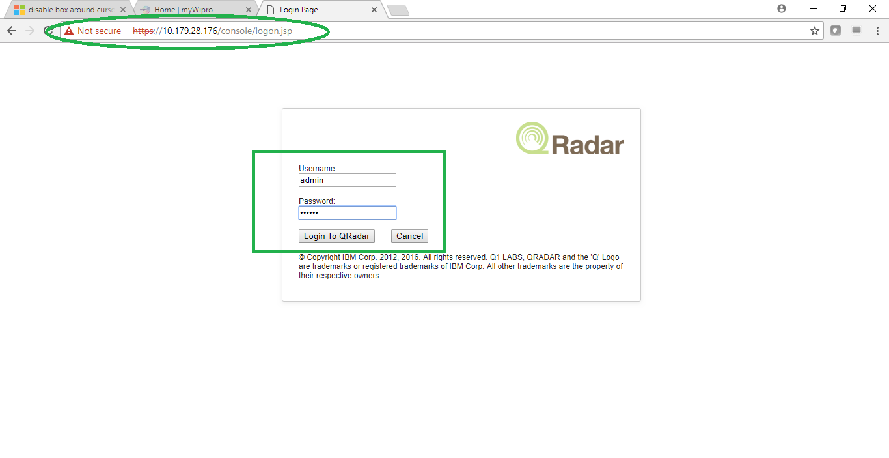

After login you will see the Qradar dashboard tab as below:

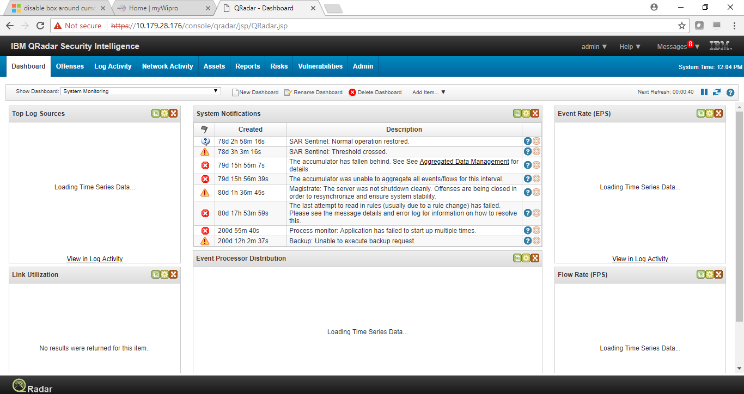

1. To log out of QRadar console, click on drop down box on top-right side of the console as shown:

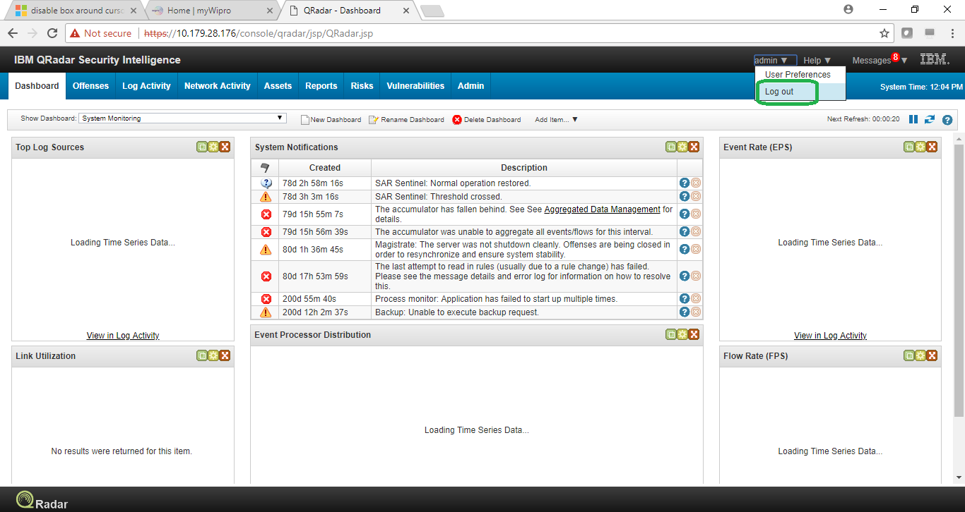

And click on Log out.