1. Click on the “Offenses” tab to see Offenses page.
2. Click on “All Offenses” link” on the left hand side on the page, to see all generated offenses in the console.

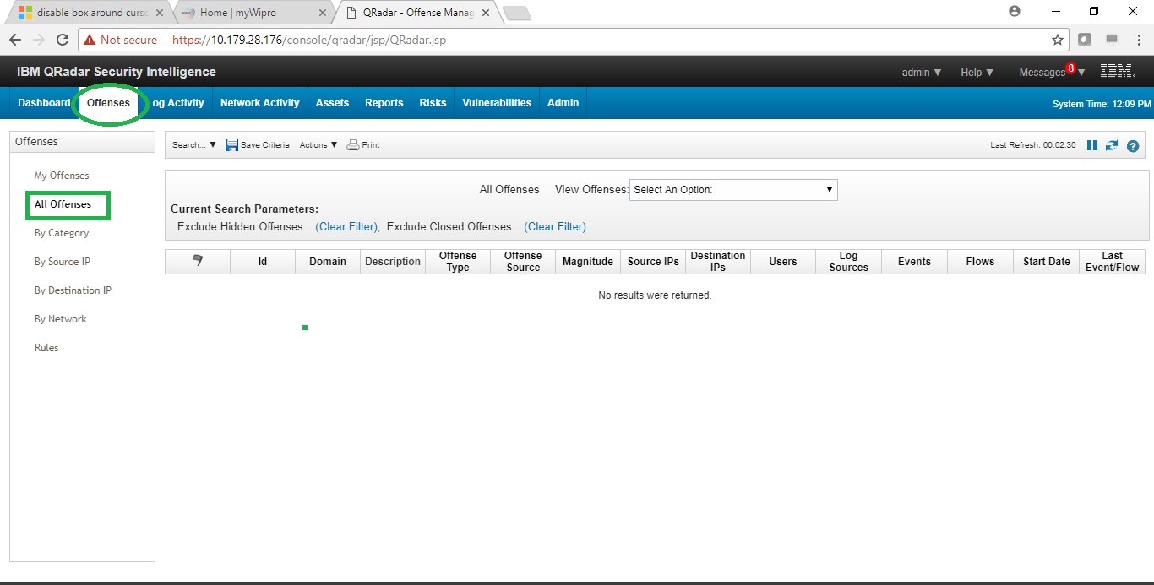

1. Click on “By Category” link to see the offenses grouped by category.

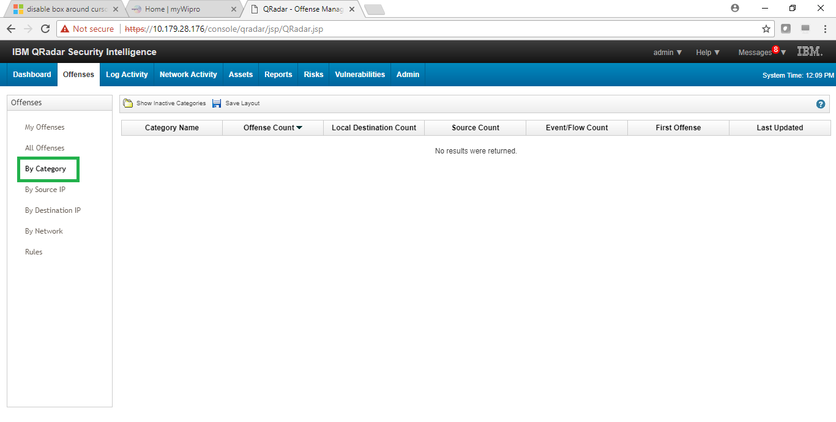

1. Click on “By Source IP” link to see all offenses grouped by source IPs.

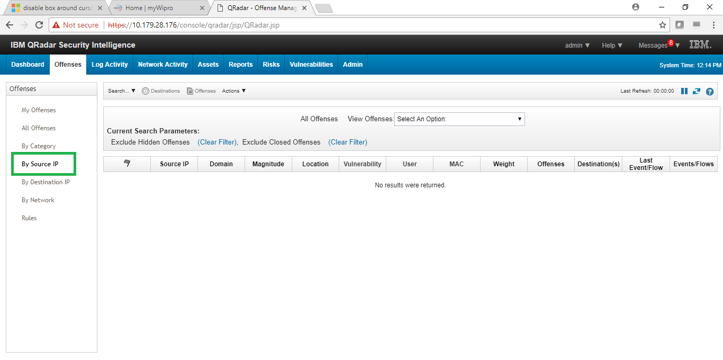

1. Click on “By Destination IP” to see all offenses grouped by destination IPs.

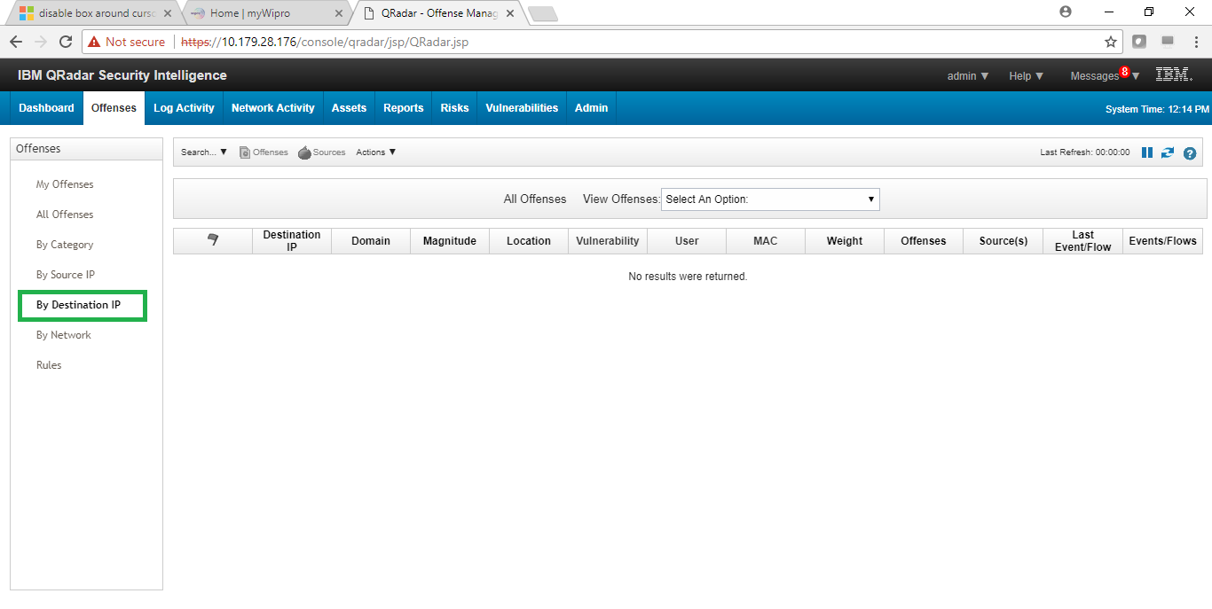

1. Click on “By Network” to see the offenses grouped by Network s as defined in “Network Hierarchy”.

