1. Click on the “Offenses “tab and select “Rules” on the left hand side of the page.
2. Click on the “Display” drop down button and select “Building Blocks” option, to see all building blocks.

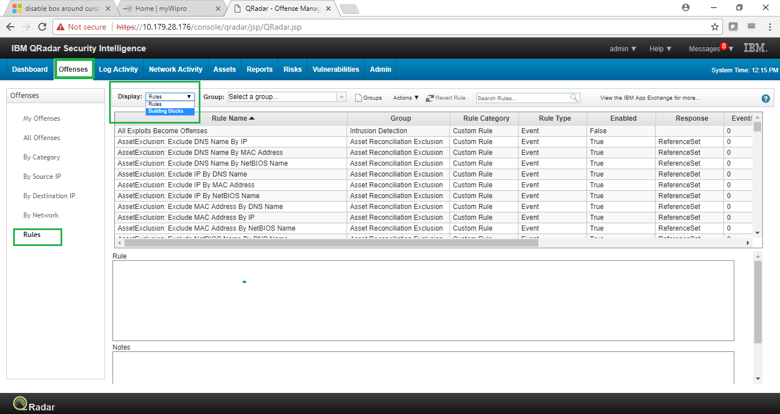

1. Double click on any on the listed building block to see its definition.

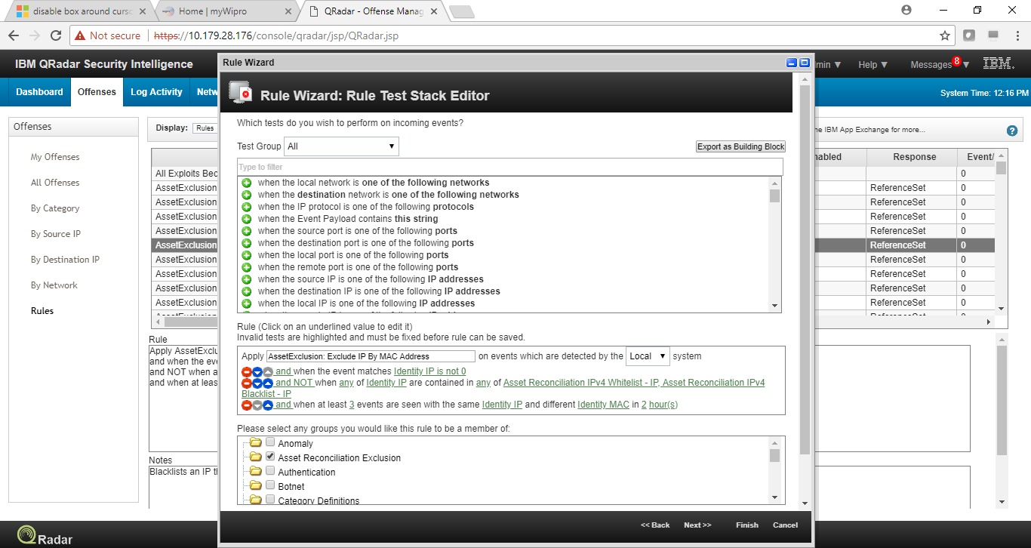

1. Click on “+” sign and “-“sign to add and remove any of the test into/from building block.
2. Select the “underlined” test to add/remove the various test properties.

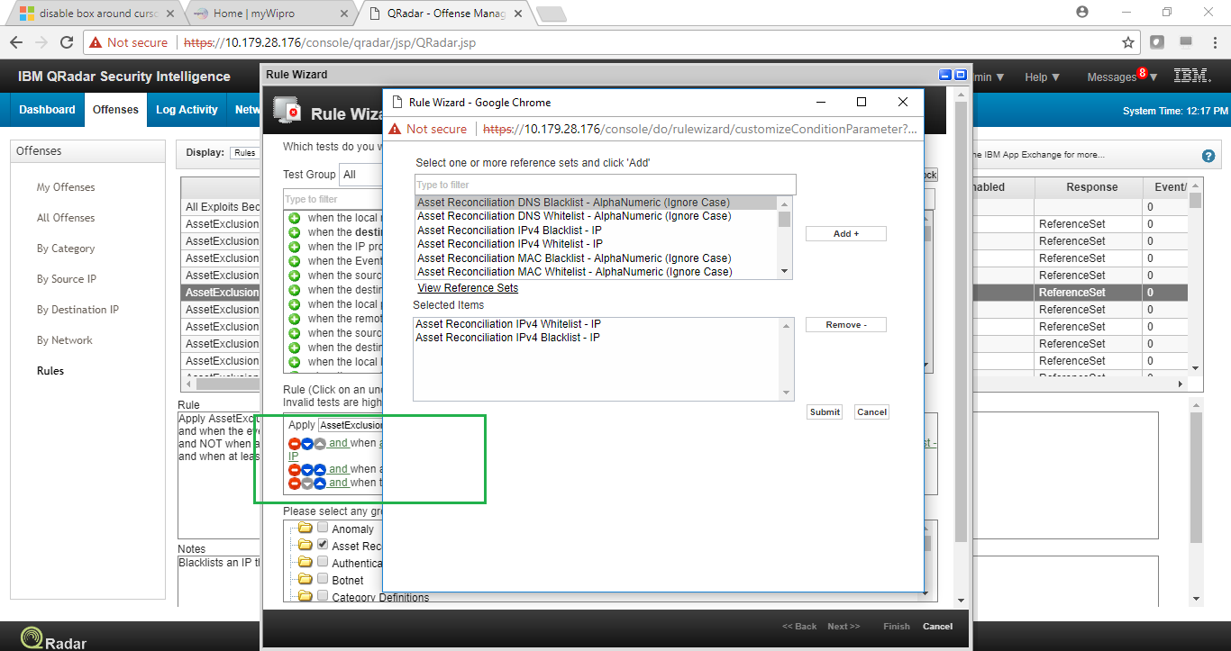

1. Click on the “Offenses “tab and select “Rules” on the left hand side of the page.
2. Click on the “Display” drop down button and select “Rules” option, to see all defined rules.

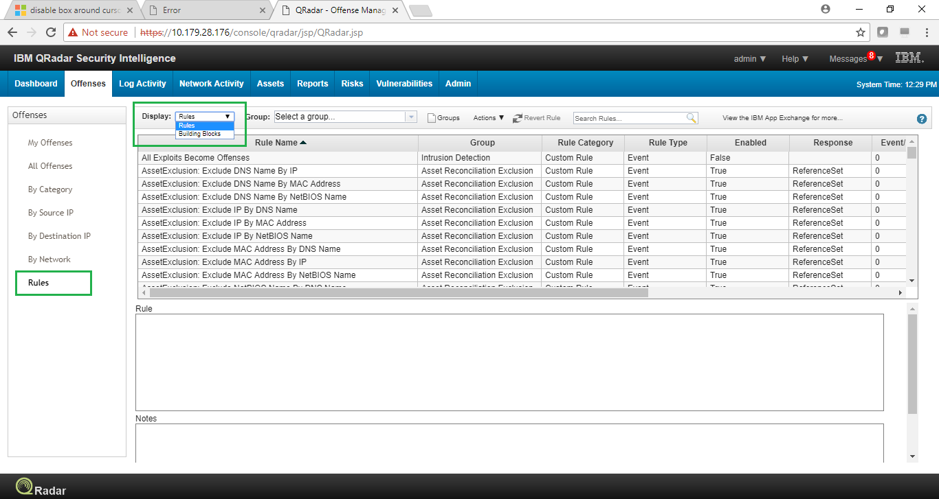

1. Double click on any on the listed building rule to see and modify its definition.

