1. Click on the “Log Activity” tab to see the log activity page.
2. To filter the events, Click on “Add Filter” to select filters for viewing the events.

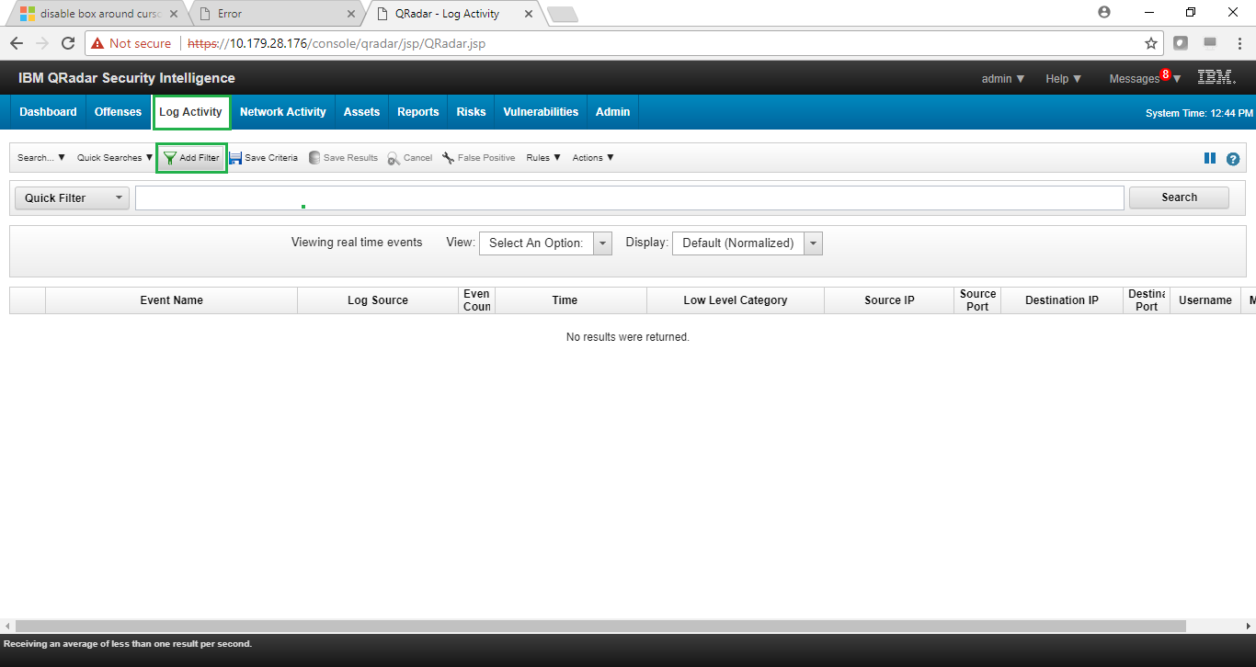

1. Select any of the available filters and specify its value, then click on ‘Add Filter’ button to start filtering the events.

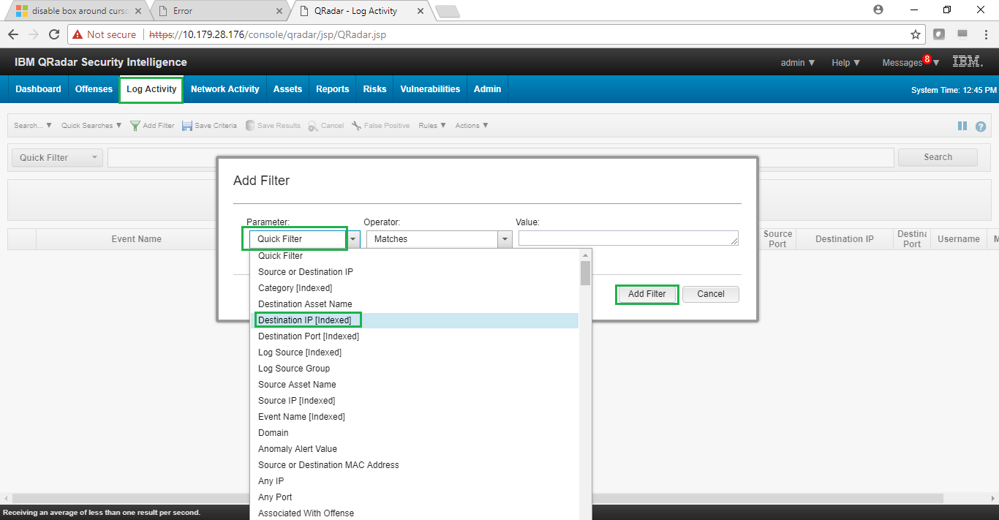

1. Select the time frame for displaying the events for specific time frame. By default real time events are displayed.

