1. Click on the “Network Activity” tab to see the network activity page.

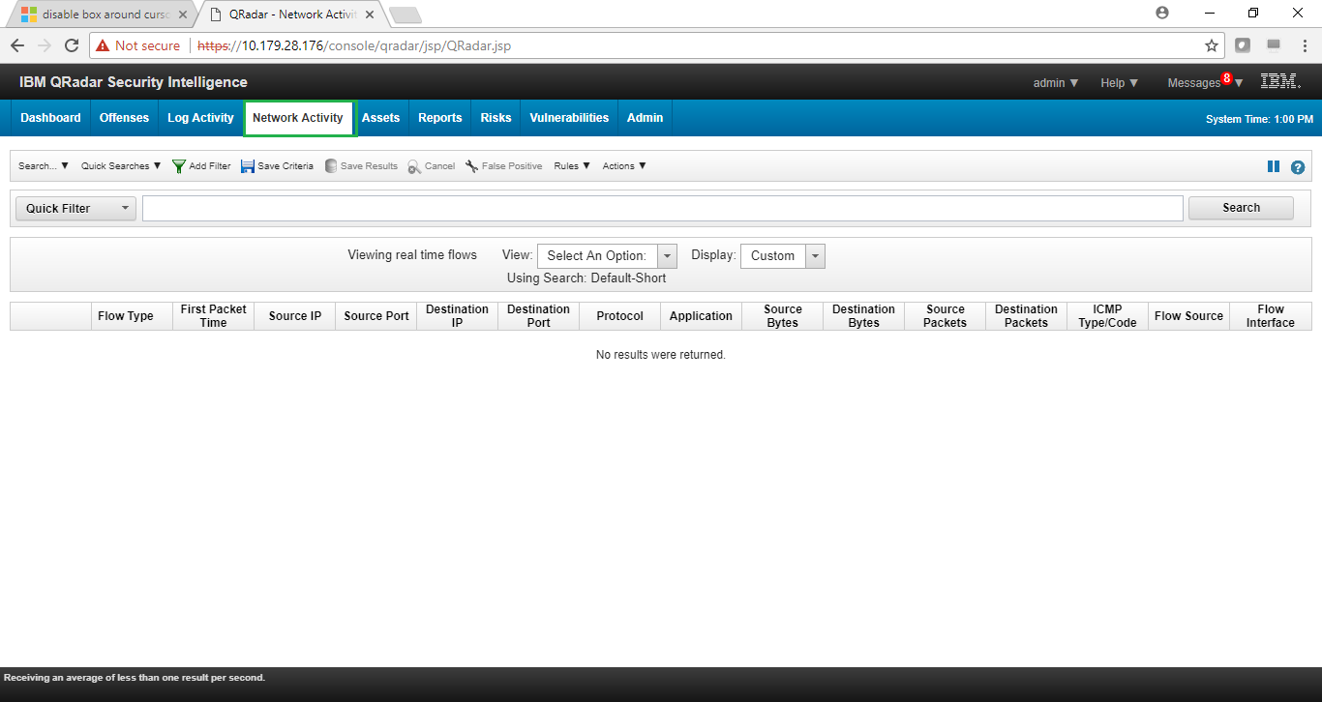

1. Click on the “Add Filter” button and select the filter parameter. Specify the value of the filter parameters and the click on “Add Filter” button to begin the filtration of packets.

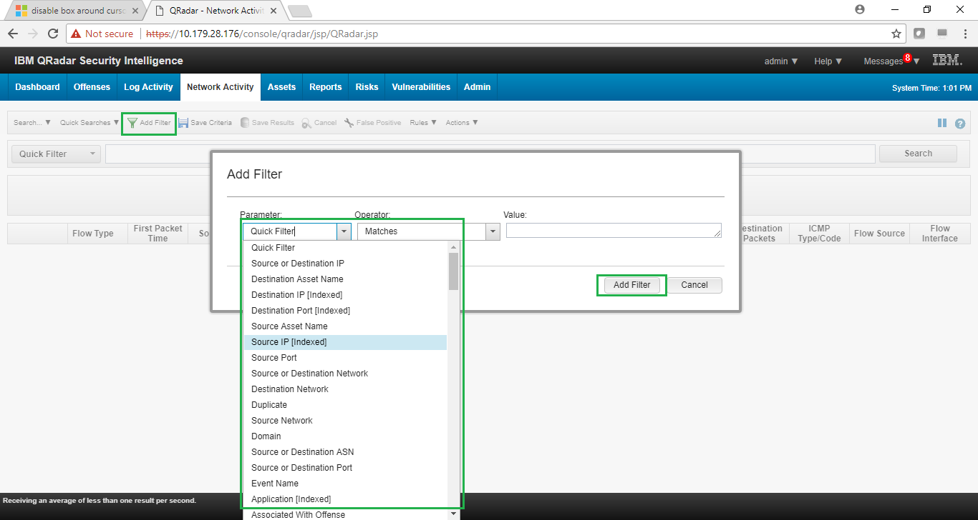

1. Click on the “View” drop down button to select the desired time frame to filter the packets.

