1. To create a new search, Click on the “Network Activity” tab and Select “Search” Drop down button, and click on “New Search”.

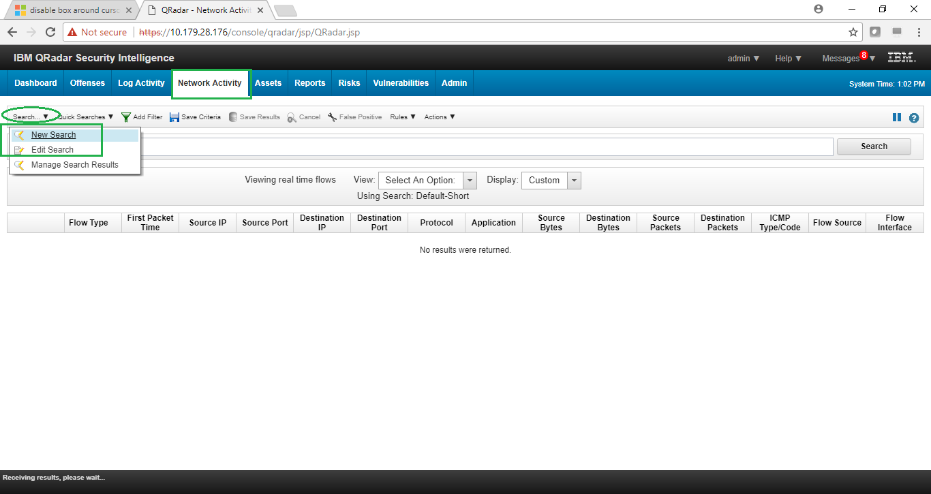

1. Specify the “Time Range” for which you want to search for the packets.

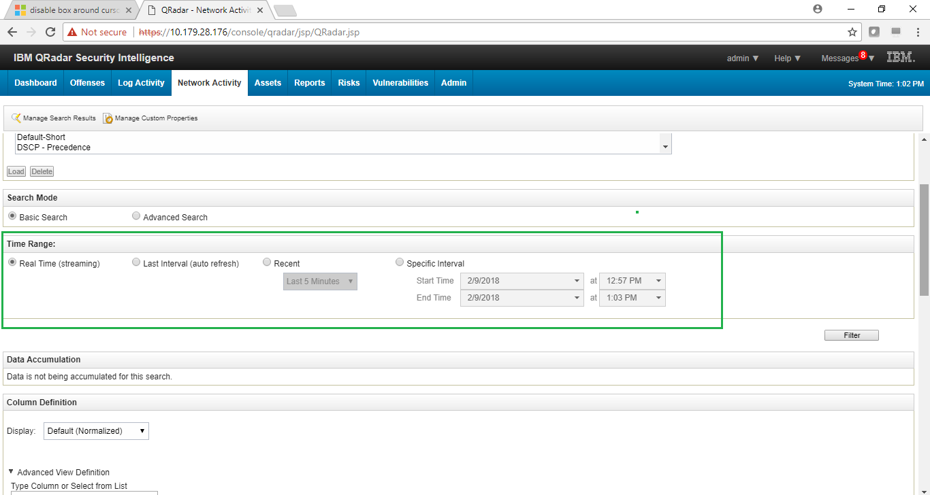

1. Select the normalized columns/fields that you want to display in the search results.

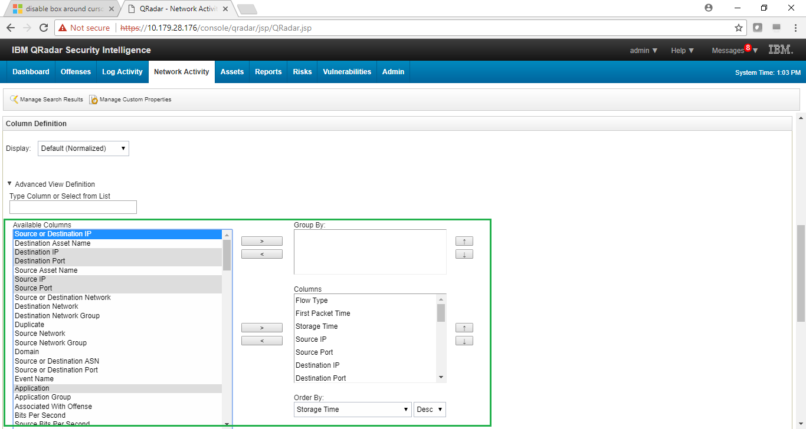

1. Select the “Search Parameters” and specify their value to include filtered packets in the search results. Click on “Add Filter” button and then click on the “Search” button to begin the search.

