1. Click on “Asset” tab to see asset profile page.

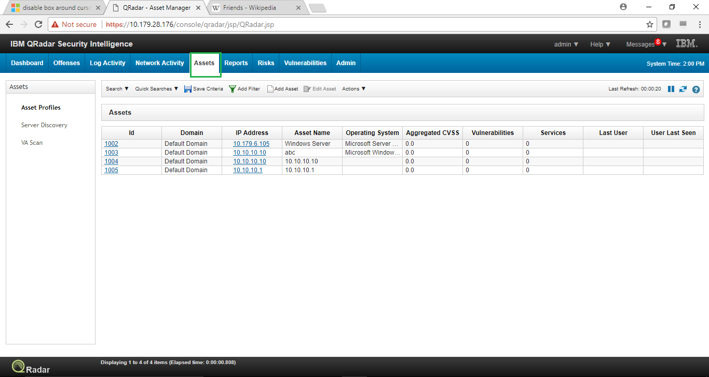

1. Click on “Add Filter” button to filter the desired asset and then click on “OK” button.

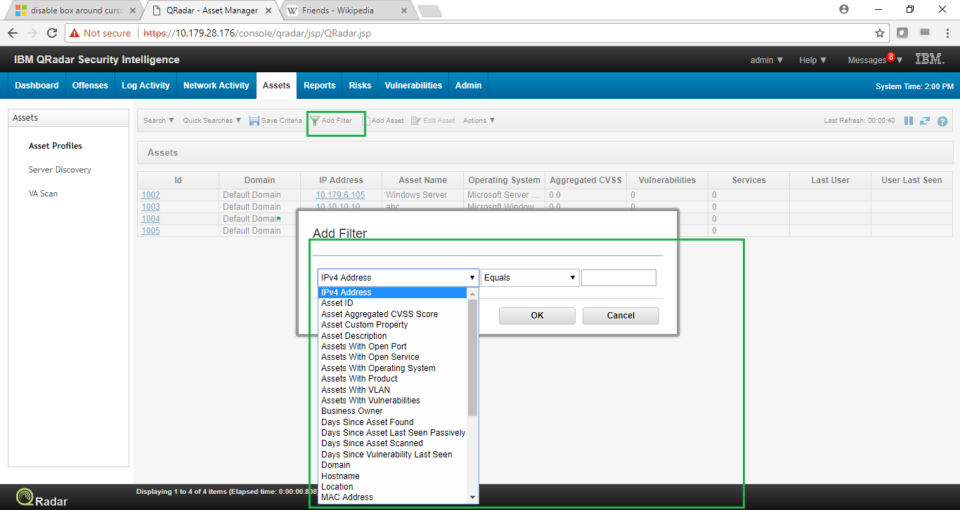

1. To create a new search for the Assets, In the Assets tab, Click on the “Search” drop down button and click on “New Search”.

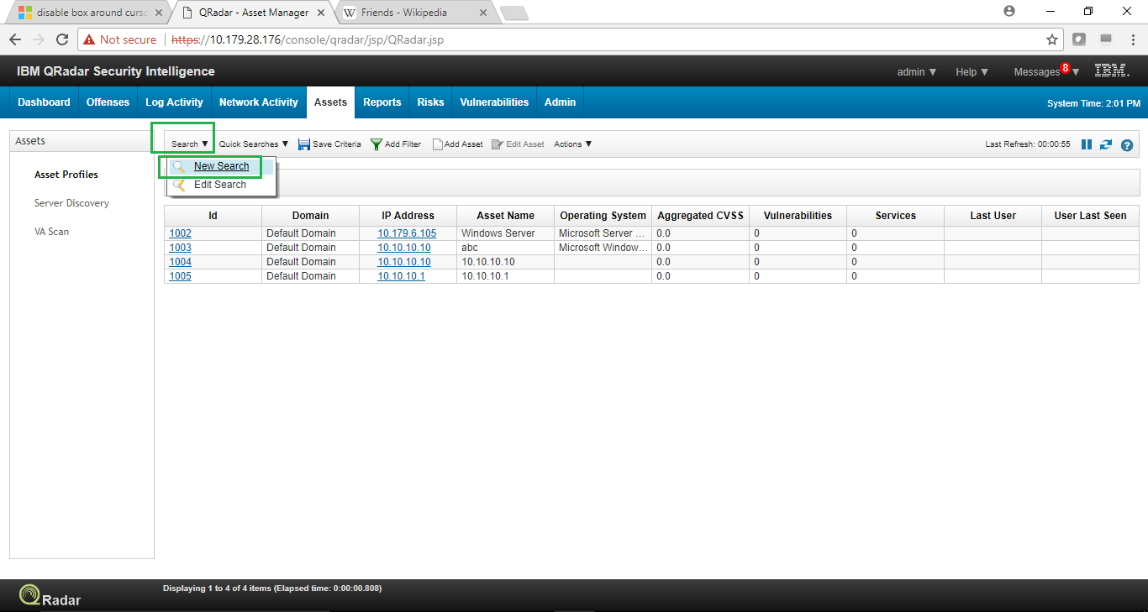

1. Enter the “Column Definition” to specify the columns/Field you would like to see in the search results.

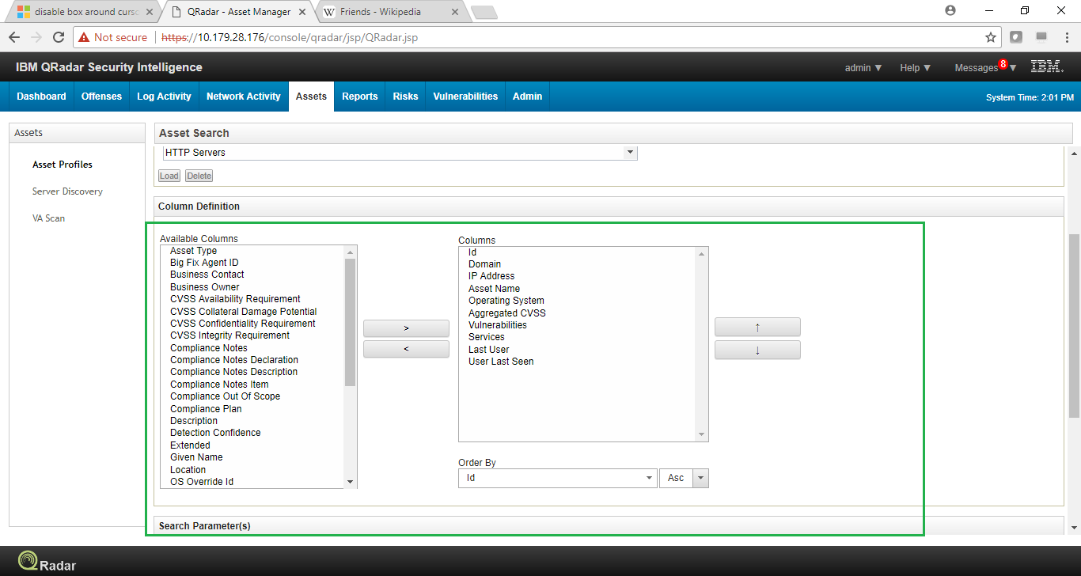

1. Select the “Search Parameters”, specify their values and then click “Add Filter” button.

Then click on “Search” button to begin the search.

