1. Click on “Assets” tab, and then click on “Server Discovery” link on the left hand side of the page.

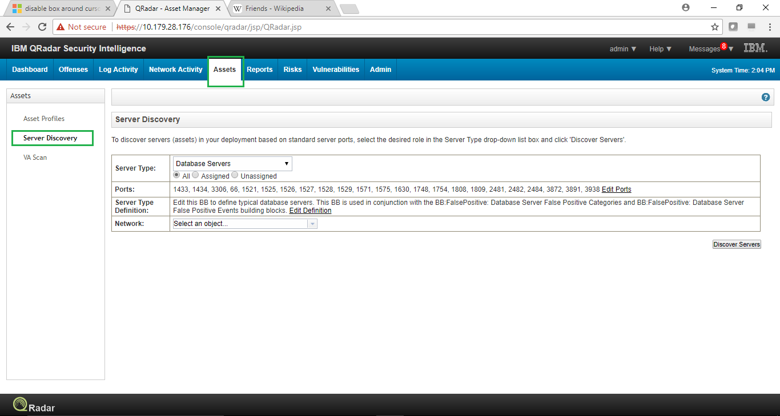

1. Click on “Server Type” drop down button to select the Server/Asset type to be discovered.

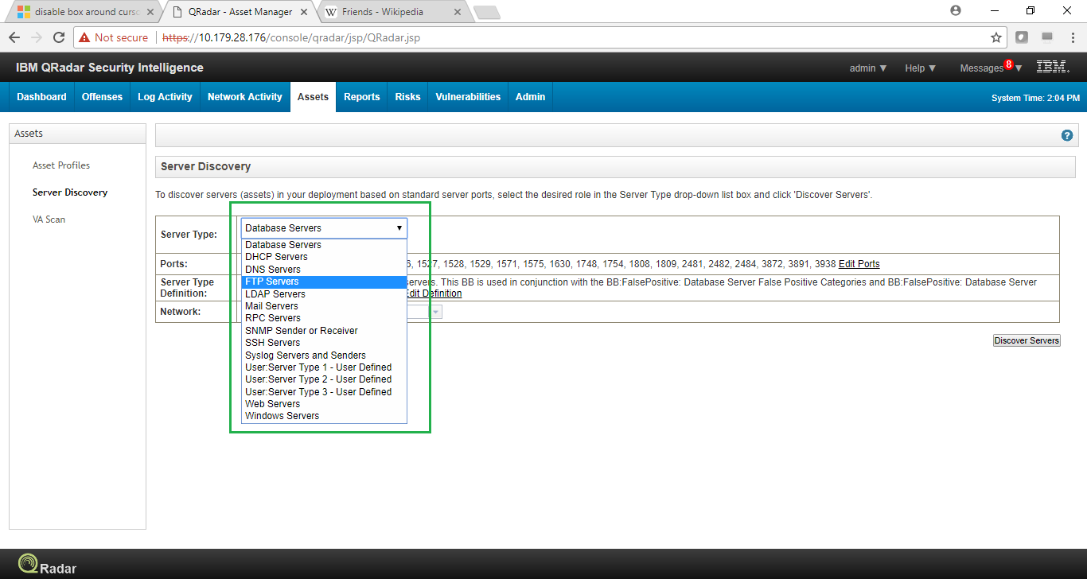

1. Click on “Edit Port” to specify the ports other than standard port for any specific type of server/asset, for discovery.

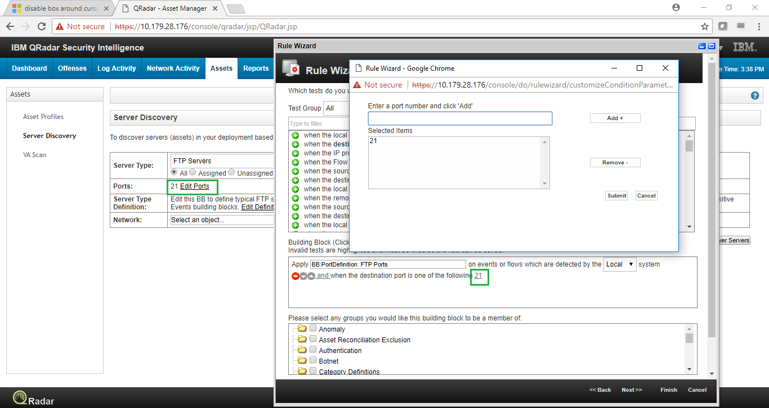

1. Select the “Network” as defined in Network Hierarchy to search for the specified Servers/Assets and then click on “Discover Servers”.

