

*INDUSTRIAL SUMMER TRAINING REPORT*

*On­­­*

**PROJECT “MULTI-PRODUCT E-COMMERCE WEBSITE”**

Submitted on partial fulfilment of the requirements for the award of the degree of

BACHELOR OF ENGINEERING

IN

**COMPUTER SCIENCE & ENGINEERING**



**Submitted to: Mr. Manish Upadhayay**

**(Project Supervisor)**

Submitted By:

Abhijeet Kumar Pandit

UID: 20BCS2049

**Trainer Signature**

Mr. Chandan Singh

**BONAFIDE CERTIFICATE**



**Signature Signature**

**Mr.Mannu Kumar Mr. Chandan Singh**

**PROJECT SUPERVISOR TRAINER**

**ACKNOWLEDGEMENT**

* First of all, I would like to thank the **Almighty** for bestowing his blessings upon me and over the successful completion of my project
* Secondly, I would like to thank and express my heartiest gratitude towards our **Trainer Mrs.Mannu Kumar** who helped and guided me at each and every step in completing my project.
* Without their guidance, I shall not have succeeded in my project successfully.
* Finally, I would like to thank **“Adityapur Auto Cluster”** for giving such fortunate opportunity to showcase talent through this project and I have gained a lot of knowledge about DJANGO framework,JAVASCRIPT, SQL throughout the making of this project.

**DECLARATION**

I, the students of branch “**Bachelor of Computer Science & Engineering**”, **session: 2020-2024**, RVS College Of Engineering And Technology, hereby declare that the work presented in this project report entitled as **“MULTI-PRODUCT E-COMMERCE WEBSITE”** is the outcome of my own work, is bonafide and correct to the best of my knowledge and this work has been carried out taking care of Engineering ethics.

**Signature of Project Supervisor Signature of Trainer**

**Mr. Manish Upadhayay Mr. Chandan Singh**

**LIST OF ABBREVIATIONS**

* Django
* Python
* BootStrap
* CSS - Cascading Style Sheets
* JS – JavaScript
* HTML - HyperText Markup Language
* DB – Database

**Content**

**1. INTRODUCTION ABOUT Adityapur Auto Cluster** 6

**2. DETAILS OF THE INTERNSHIP** 6

**3. Introduction & Purpose of Project** 6-7

**4. TECHNOLOGY OVERVIEW** 7-11

4.1 PYTHON: 7

4.2 DJANGO : 7-8

4.3 Database: 8

4.4 SQLITE: 8-9

4.5 HTML: 9-10

4.6 Web Page: 10

4.7 CSS: 10

4.8 JavaScript: 10

4.8.1 Features Of JavaScript: 11

4.9 Bootstrap: 11

4.10 Microsoft Visual Studio: 11

**5. Results And Discussion** 12-31

Master Page 12-17

HomePage 18-23

Registration Page 24-25

LoginPage 26-27

Models.py 28-31

**6. References** 32

**1.INTRODUCTION ABOUT Adityapur Auto Cluster**

 Adityapur Auto Cluster (AAC) : a movement by the Adityapur Small Industries Association (ASIA) & Industrial Infrastructure Upgradation Scheme (IIUS). SPV i.e. Special purpose Vehicle also called as AAC , is registered under the Companies Act 1956 under section 25 as a non profit organization, with a financial grant from the Government of India and Government of Jharkhand. It is the 1st largest auto cluster in Eastern India.

**2. DETAILS OF THE INTERNSHIP**

Here at Adityapur Auto Cluster in Jamshedpur, Jharkhand. I got a marvellous opportunity to work as a Web Development Intern in the DJANGO framework, creating Web Forms with the PYTHON language that are considered to be a very light and secure framework to work upon. This offline physical internship boosted my skills enormously and imparted a vast amount of knowledge, wisdom, and soft skills along with exposure to the corporate world, which will surely prove to be very helpful in the near future.

**3. Introduction & Purpose of Project**

In this project, I have created and designed 1 useful login page and 1 useful registration page templates with various features and functionalities already installed within so that the developer can directly add these to their web application (either personal or professional). This Login Page is more than just a simple template; it also includes several predefined functions, allowing developers to spend less time working and more time playing.

First of all, after you are successfully logged in, if you have to show various production lists of a company or to show employees' shift records or any other data, then the developer doesn’t have to suffer much. The solution is just a few steps away. The backend coding has already been done. You just have to provide the Server Name, User Id, Password, Table and Database Name .In other databases, these templates can be used, but you have to make certain changes in the backend coding.

**4. TECHNOLOGY OVERVIEW**

The technology selected for implementing the project **“MULTI-VENDOR E-COMMERCE WEBSITE”** is PYTHON,DJANGO Framework,SQLITE3, Oracle, HTML, CSS, JS, Bootstrap Framework. The development was done in a ‘windows’ environment using Microsoft Visual Studio.

**4.1 PYTHON**

Python is an interpreted, object-oriented, high-level programming language with dynamic semantics. Its high-level built in data structures, combined with dynamic typing and dynamic binding, make it very attractive for Rapid Application Development, as well as for use as a scripting or glue language to connect existing components together. Python's simple, easy to learn syntax emphasizes readability and therefore reduces the cost of program maintenance. Python supports modules and packages, which encourages program modularity and code reuse. The Python interpreter and the extensive standard library are available in source or binary form without charge for all major platforms, and can be freely distributed.

**4.2 DJANGO**

Django is a high-level Python web framework that encourages rapid development and clean, pragmatic design. Built by experienced developers, it takes care of much of the hassle of web development, so you can focus on writing your app without needing to reinvent the wheel. It’s free and open source.

Ridiculously fast.

Django was designed to help developers take applications from concept to completion as quickly as possible.

Reassuringly secure.

Django takes security seriously and helps developers avoid many common security mistakes.

Exceedingly scalable.

Some of the busiest sites on the web leverage Django’s ability to quickly and flexibly scale.

**4.3 Database**

A database is an application that stores the organized collection of records. It can be accessed and manage by the user very easily. It allows us to organize data into tables, rows, columns, and indexes to find the relevant information very quickly. Each database contains distinct API for performing database operations such as creating, managing, accessing, and searching the data it stores. Today, many databases available like MySQL, Sybase, Oracle, MongoDB, PostgreSQL, SQLITE,SQL Server, etc. In this project, I have used SQLITE and Oracle.

**4.4 SQLITE**

SQLite is an in-process library that implements a [self-contained](https://www.sqlite.org/selfcontained.html), [serverless](https://www.sqlite.org/serverless.html), [zero-configuration](https://www.sqlite.org/zeroconf.html), [transactional](https://www.sqlite.org/transactional.html) SQL database engine. The code for SQLite is in the [public domain](https://www.sqlite.org/copyright.html) and is thus free for use for any purpose, commercial or private. SQLite is the [most widely deployed](https://www.sqlite.org/mostdeployed.html) database in the world with more applications than we can count, including several [high-profile projects.](https://www.sqlite.org/famous.html)

SQLite is an embedded SQL database engine. Unlike most other SQL databases, SQLite does not have a separate server process. SQLite reads and writes directly to ordinary disk files. A complete SQL database with multiple tables, indices, triggers, and views, is contained in a single disk file. The database [file format](https://www.sqlite.org/fileformat2.html) is cross-platform - you can freely copy a database between 32-bit and 64-bit systems or between [big-endian](http://en.wikipedia.org/wiki/Endianness) and [little-endian](http://en.wikipedia.org/wiki/Endianness) architectures. These features make SQLite a popular choice as an [Application File Format](https://www.sqlite.org/appfileformat.html). SQLite database files are a [recommended storage format](https://www.sqlite.org/locrsf.html) by the US Library of Congress. Think of SQLite not as a replacement for [Oracle](http://www.oracle.com/database/index.html) but as a replacement for [fopen()](http://man.he.net/man3/fopen)

SQLite is a compact library. With all features enabled, the [library size](https://www.sqlite.org/footprint.html) can be less than 750KiB, depending on the target platform and compiler optimization settings. (64-bit code is larger. And some compiler optimizations such as aggressive function inlining and loop unrolling can cause the object code to be much larger.) There is a tradeoff between memory usage and speed. SQLite generally runs faster the more memory you give it. Nevertheless, performance is usually quite good even in low-memory environments. Depending on how it is used, SQLite can be [faster than direct filesystem I/O](https://www.sqlite.org/fasterthanfs.html).

SQLite is [very carefully tested](https://www.sqlite.org/testing.html) prior to every release and has a reputation for being very reliable. Most of the SQLite source code is devoted purely to testing and verification. An automated test suite runs millions and millions of test cases involving hundreds of millions of individual SQL statements and achieves [100% branch test coverage](https://www.sqlite.org/testing.html#coverage). SQLite responds gracefully to memory allocation failures and disk I/O errors. Transactions are [ACID](http://en.wikipedia.org/wiki/ACID) even if interrupted by system crashes or power failures. All of this is verified by the automated tests using special test harnesses which simulate system failures. Of course, even with all this testing, there are still bugs. But unlike some similar projects (especially commercial competitors) SQLite is open and honest about all bugs and provides [bugs lists](http://www.sqlite.org/src/rptview?rn=1) and minute-by-minute [chronologies](http://www.sqlite.org/src/timeline) of code changes.

The SQLite code base is supported by an [international team](https://www.sqlite.org/crew.html) of developers who work on SQLite full-time. The developers continue to expand the capabilities of SQLite and enhance its reliability and performance while maintaining backwards compatibility with the [published interface spec](https://www.sqlite.org/c3ref/intro.html), [SQL syntax](https://www.sqlite.org/lang.html), and database [file format](https://www.sqlite.org/fileformat2.html). The source code is absolutely free to anybody who wants it, but [professional support](https://www.sqlite.org/prosupport.html) is also available.

The SQLite project was started on [2000-05-09](https://www.sqlite.org/src/timeline?c=2000-05-29+14:26:00). The future is always hard to predict, but the intent of the developers is to support SQLite through the year 2050. Design decisions are made with that objective in mind.

We the developers hope that you find SQLite useful and we entreat you to use it well: to make good and beautiful products that are fast, reliable, and simple to use. Seek forgiveness for yourself as you forgive others. And just as you have received SQLite for free, so also freely give, paying the debt forward.

**4.5 HTML**

* HTML stands for Hyper Text Markup Language
* HTML is the standard markup language for creating Web pages
* HTML describes the structure of a Web page
* HTML consists of a series of elements
* HTML elements tell the browser how to display the content

**4.6 Web Page:** A web page is a document which is commonly written in HTML and translated by a web browser. A web page can be identified by entering an URL. A Web page can be of the static or dynamic type.

**4.7 CSS**

* CSS stands for Cascading Style Sheets
* CSS describes how HTML elements are to be displayed on screen, paper, or in other media
* CSS saves a lot of work. It can control the layout of multiple web pages all at once
* CSS is a widely used language on the web.

**4.8 JavaScript**

JavaScript (js) is a light-weight object-oriented programming language which is used by several websites for scripting the webpages. It is an interpreted, full-fledged programming language that enables dynamic interactivity on websites when applied to an HTML document. It was introduced in the year 1995 for adding programs to the webpages in the Netscape Navigator browser. Since then, it has been adopted by all other graphical web browsers. With JavaScript, users can build modern web applications to interact directly without reloading the page every time. The traditional website uses js to provide several forms of interactivity and simplicity.

Although, JavaScript has no connectivity with Java programming language. The name was suggested and provided in the times when Java was gaining popularity in the market.

***4.8.1 Features of JavaScript***

* All popular web browsers support JavaScript as they provide built-in execution environments.
* JavaScript follows the syntax and structure of the C programming language. Thus, it is a structured programming language.
* JavaScript is a weakly typed language, where certain types are implicitly cast (depending on the operation).
* JavaScript is an object-oriented programming language that uses prototypes rather than using classes for inheritance.
* It is a light-weighted and interpreted language.
* It is a case-sensitive language.
* JavaScript is supportable in several operating systems including, Windows, macOS, etc.
* It provides good control to the users over the web browsers.

**4.9 Bootstrap**

* Bootstrap is a free front-end framework for faster and easier web development
* Bootstrap includes HTML and CSS based design templates for typography, forms, buttons, tables, navigation, modals, image carousels and many other, as well as optional JavaScript plugins
* Bootstrap also gives you the ability to easily create responsive designs

**4.10 Microsoft Visual Studio**

Microsoft Visual Studio is an integrated development environment from Microsoft. It is used to develop computer programs, as well as websites, web apps, web services and mobile apps.

Visual Studio dev tools & services make app development easy for any developer, on any platform & language.

**5. Results And Discussion**

**Master page**

<!DOCTYPE html>

{% load static %}

<html lang="en">

  <head>

    <!-- Required meta tags -->

    <meta charset="utf-8" />

    <meta name="viewport" content="width=device-width, initial-scale=1" />

    <script

      src="https://kit.fontawesome.com/4dafb3b10e.js"

      crossorigin="anonymous"

    ></script>

    <!-- Bootstrap CSS -->

    <link

      href="https://cdn.jsdelivr.net/npm/bootstrap@5.0.0-beta1/dist/css/bootstrap.min.css"

      rel="stylesheet"

      integrity="sha384-giJF6kkoqNQ00vy+HMDP7azOuL0xtbfIcaT9wjKHr8RbDVddVHyTfAAsrekwKmP1"

      crossorigin="anonymous"

    />

    <!--Owl Carousel CSS-->

    <link rel="stylesheet" href="{% static 'app/css/owl.carousel.min.css' %}" />

    <!--FontAwesome CSS-->

    <link rel="stylesheet" href="{% static 'app/css/all.min.css' %}" />

    <!--Custom CSS-->

    <link rel="stylesheet" href="{% static 'app/css/style.css' %}" />

    <title>ShoppingX | {% block title %} {% endblock title %}</title>

  </head>

  <body>

    <nav class="navbar navbar-expand-lg navbar-dark bg-primary">

      <div class="container">

        <a class="navbar-brand" href="/">ShoppingX</a>

        <button

          class="navbar-toggler"

          type="button"

          data-bs-toggle="collapse"

          data-bs-target="#navbarSupportedContent"

          aria-controls="navbarSupportedContent"

          aria-expanded="false"

          aria-label="Toggle navigation"

        >

          <span class="navbar-toggler-icon"></span>

        </button>

        <div class="collapse navbar-collapse" id="navbarSupportedContent">

          <ul class="navbar-nav me-auto mb-2 mb-lg-0">

            <li class="nav-item">

              <a class="nav-link active" aria-current="page" href="/">Home</a>

            </li>

            <li class="nav-item dropdown">

              <a

                class="nav-link dropdown-toggle text-white"

                href="#"

                id="electronicsDropdown"

                role="button"

                data-bs-toggle="dropdown"

                aria-expanded="false"

              >

                Electronics

              </a>

              <ul class="dropdown-menu" aria-labelledby="electronicsDropdown">

                <li>

                  <a class="dropdown-item" href="{% url 'mobile' %}">Mobile</a>

                </li>

                <li><a class="dropdown-item" href="#">Laptop</a></li>

              </ul>

            </li>

            <li class="nav-item dropdown">

              <a

                class="nav-link dropdown-toggle text-white"

                href="#"

                id="fashionDropdown"

                role="button"

                data-bs-toggle="dropdown"

                aria-expanded="false"

              >

                Fashion

              </a>

              <ul class="dropdown-menu" aria-labelledby="fashionDropdown">

                <li><a class="dropdown-item" href="#">Top Wear</a></li>

                <li><a class="dropdown-item" href="#">Bottom Wear</a></li>

              </ul>

            </li>

          </ul>

          <form class="d-flex">

            <input

              class="form-control me-2"

              type="search"

              placeholder="Search"

              aria-label="Search"

            />

            <button class="btn btn-light" type="submit">

              <i class="fa-solid fa-magnifying-glass"></i>

            </button>

          </form>

          <div>

            <ul class="navbar-nav me-auto mb-2 mb-lg-0">

              {% if request.user.is_authenticated %}

              <li class="nav-item dropdown mx-2">

                <a

                  class="nav-link dropdown-toggle text-white"

                  href="#"

                  id="profileDropdown"

                  role="button"

                  data-bs-toggle="dropdown"

                  aria-expanded="false"

                >

                  {{request.user.username|capfirst}}

                </a>

                <ul class="dropdown-menu" aria-labelledby="profileDropdown">

                  <li>

                    <a class="dropdown-item" href="{% url 'profile' %}"

                      >Profile</a

                    >

                  </li>

                  <li>

                    <a class="dropdown-item" href="{% url 'orders' %}"

                      >Orders</a

                    >

                  </li>

                  <li>

                    <a class="dropdown-item" href="{% url 'passwordchange' %}"

                      >Change Password</a

                    >

                  </li>

                  <li>

                    <a class="dropdown-item" href="{% url 'logout' %}"

                      >Logout</a

                    >

                  </li>

                </ul>

              </li>

              <li class="nav-item mx-2">

                <a href="{% url 'showcart' %}" class="nav-link text-white"

                  ><span class="badge bg-danger">{{totalitem}}</span> Cart

                </a>

              </li>

              {% else %}

              <li class="nav-item mx-2">

                <a href="{% url 'login' %}" class="nav-link text-white"

                  >Login</a

                >

              </li>

              <li class="nav-item mx-2">

                <a

                  href="{% url 'customerregistration' %}"

                  class="nav-link text-white"

                  >Registration</a

                >

              </li>

              {% endif %}

            </ul>

          </div>

        </div>

      </div>

    </nav>

    {% block banner_slider %} {% endblock banner_slider %} {% block livesale %}

    {% endblock livesale %} {% block main-content %} {% endblock main-content %}

    {% block payment-gateway %} {% endblock payment-gateway %}

    <!-- Start Footer -->

    <footer class="container-fluid bg-dark text-center p-2 mt-5">

      <small class="text-white"

        >Copyright &copy; 2021 || Designed By vikashmundari ||

      </small>

      <img

        src="{% static 'app/images/payment.png' %}"

        alt=""

        srcset=""

        class="img-fluid"

        height="2px"

      />

    </footer>

    <!-- End Footer -->

    <!-- Jquery -->

    <script

      src="https://code.jquery.com/jquery-3.5.1.min.js"

      integrity="sha256-9/aliU8dGd2tb6OSsuzixeV4y/faTqgFtohetphbbj0="

      crossorigin="anonymous"

    ></script>

    <!-- Bootstrap Bundle with Popper -->

    <script

      src="https://cdn.jsdelivr.net/npm/bootstrap@5.0.0-beta1/dist/js/bootstrap.bundle.min.js"

      integrity="sha384-ygbV9kiqUc6oa4msXn9868pTtWMgiQaeYH7/t7LECLbyPA2x65Kgf80OJFdroafW"

      crossorigin="anonymous"

    ></script>

    <script src="{% static 'app/js/owl.carousel.min.js' %}"></script>

    <script src="{% static 'app/js/all.min.js' %}"></script>

    <script src="{% static 'app/js/myscript.js' %}"></script>

  </body>

</html>

**Home page**

{% extends 'app/base.html' %}

{% load static %}

{% block title %}Home{% endblock title %}

{% block banner_slider %}

<!--Banner Slider-->

 <div id="carouselExampleControls" class="carousel slide" data-bs-ride="carousel">

  <div class="carousel-inner">

    <div class="carousel-item active">

      <img src="{% static 'app/images/banner/b1.jpg' %}" class="d-block w-100" alt="...">

    </div>

    <div class="carousel-item">

      <img src="{% static 'app/images/banner/b2.jpg' %}" class="d-block w-100" alt="...">

    </div>

    <div class="carousel-item">

      <img src="{% static 'app/images/banner/b3.jpg' %}" class="d-block w-100" alt="...">

    </div>

    <div class="carousel-item">

      <img src="{% static 'app/images/banner/b4.jpg' %}" class="d-block w-100" alt="...">

    </div>

  </div>

  <a class="carousel-control-prev" href="#carouselExampleControls" role="button" data-bs-slide="prev">

    <span class="carousel-control-prev-icon" aria-hidden="true"></span>

    <span class="visually-hidden">Previous</span>

  </a>

  <a class="carousel-control-next" href="#carouselExampleControls" role="button" data-bs-slide="next">

    <span class="carousel-control-next-icon" aria-hidden="true"></span>

    <span class="visually-hidden">Next</span>

  </a>

</div>

<!-- End Banner Slider -->

{% endblock banner_slider %}

{% block livesale %}

<!-- Live Sale Section -->

<div class="container">

  <div class="row bg-danger text-center p-5 text-white border-bottom shadow">

    <h1>SALE IS LIVE NOW</h1>

    <span>5% Instant Discount on Axis Bank Credit and Debit Card</span>

    <small class="fw-lighter">Term and Condition Applied (For details visit Bank's official Website)</small>

  </div>

</div>

<!-- End Live Sale Section -->

{% endblock livesale %}

{% block main-content %}

<!-- 1st Product Slider -->

<div class="m-3">

 <h2>ShoppingX Bottom Wear</h2>

 <!-- Slider 1 -->

 <div class="owl-carousel" id="slider1">

  {% for b in bottomwears %}

    <a href="{% url 'product-detail' b.id %}" class="btn"><div class="item"><img src="{{b.product_image.url}}" alt="" height="300px"><span class="fw-bold">{{b.title}}</span><br><span class="fs-5">Rs. {{b.discounted_price}}</span></div></a>

  {% endfor %}

 </div>

</div>

<!-- End 1st Product Slider -->

<!-- Payment Info Section -->

<div class="container my-5">

 <div class="row">

  <div class="col-sm-3">

   <div class="card mb-3">

     <div class="card-body">

     <img src="{% static 'app/images/payavail/cc.jpg' %}" alt="" srcset="" class="img-fluid">

     </div>

   </div>

  </div>

  <div class="col-sm-3">

   <div class="card mb-3">

     <div class="card-body">

      <img src="{% static 'app/images/payavail/upi.jpg' %}" alt="" srcset="" class="img-fluid">

     </div>

   </div>

  </div>

  <div class="col-sm-3">

   <div class="card mb-3">

     <div class="card-body">

      <img src="{% static 'app/images/payavail/nb.jpg' %}" alt="" srcset="" class="img-fluid">

     </div>

   </div>

  </div>

  <div class="col-sm-3">

   <div class="card mb-3">

     <div class="card-body">

      <img src="{% static 'app/images/payavail/bj.jpg' %}" alt="" srcset="" class="img-fluid">

     </div>

   </div>

  </div>

 </div>

</div>

<!-- End Payment Info Section -->

<!-- 2nd Product Slider -->

<div class="mx-3">

 <h2>ShoppinglyX Top Wear</h2>

 <!-- Slider 2 -->

 <div class="owl-carousel" id="slider2">

  {% for tp in topwears %}

    <a href="{% url 'product-detail' tp.id %}" class="btn"><div class="item"><img src="{{tp.product_image.url}}" alt="" height="300"><span class="fw-bold">{{tp.title}}</span><br><span class="fs-5">Rs. {{tp.discounted_price}}</span></div></a>

  {% endfor %}

 </div>

</div>

<!-- End 2nd Product Slider -->

<!-- 3rd Product Slider -->

<div class="mx-3">

 <h2>ShoppinglyX Mobile</h2>

 <!-- Slider 3 -->

 <div class="owl-carousel" id="slider3">

  {% for m in mobiles %}

    <a href="{% url 'product-detail' m.id %}" class="btn"><div class="item"><img src="{{m.product_image.url}}" alt="" height="300"><span class="fw-bold">{{m.title}}</span><br><span class="fs-5">Rs. {{m.discounted_price}}</span></div></a>

  {% endfor %}

 </div>

</div>

<!-- End 2nd Product Slider -->

{% endblock main-content %}

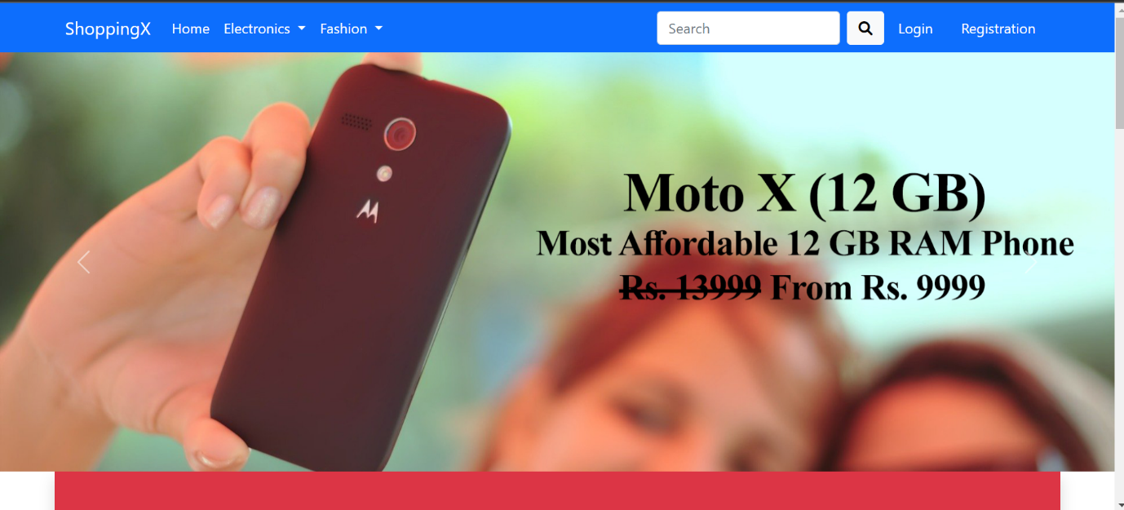

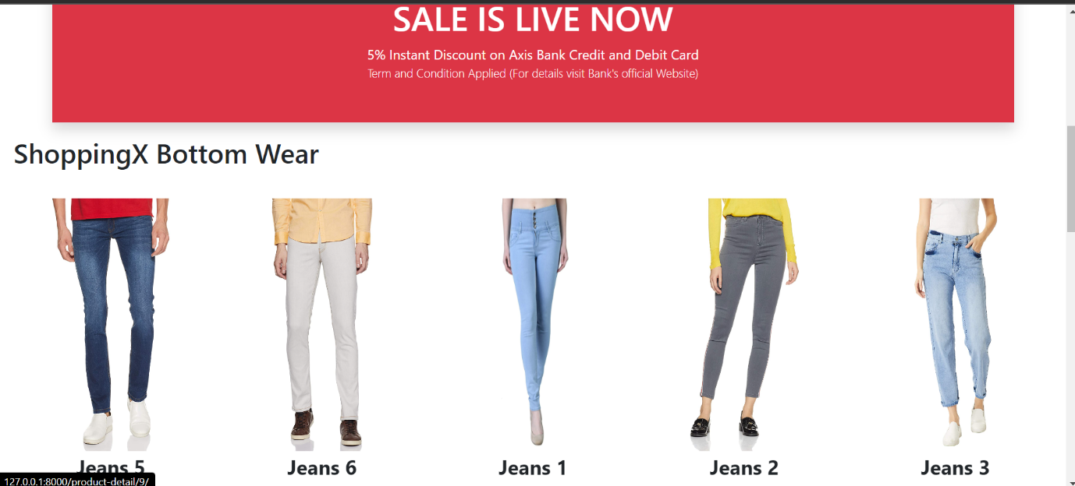

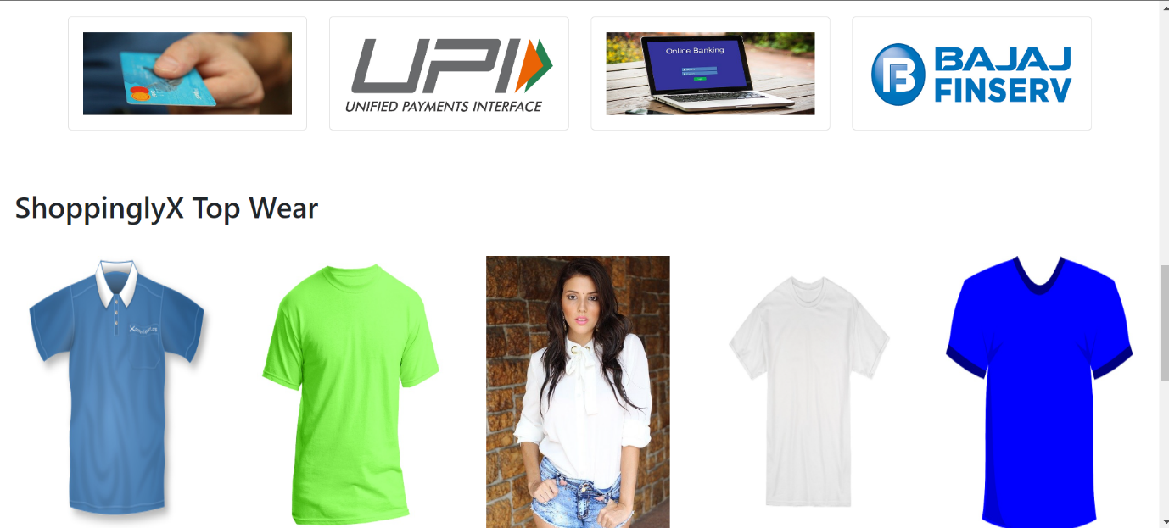

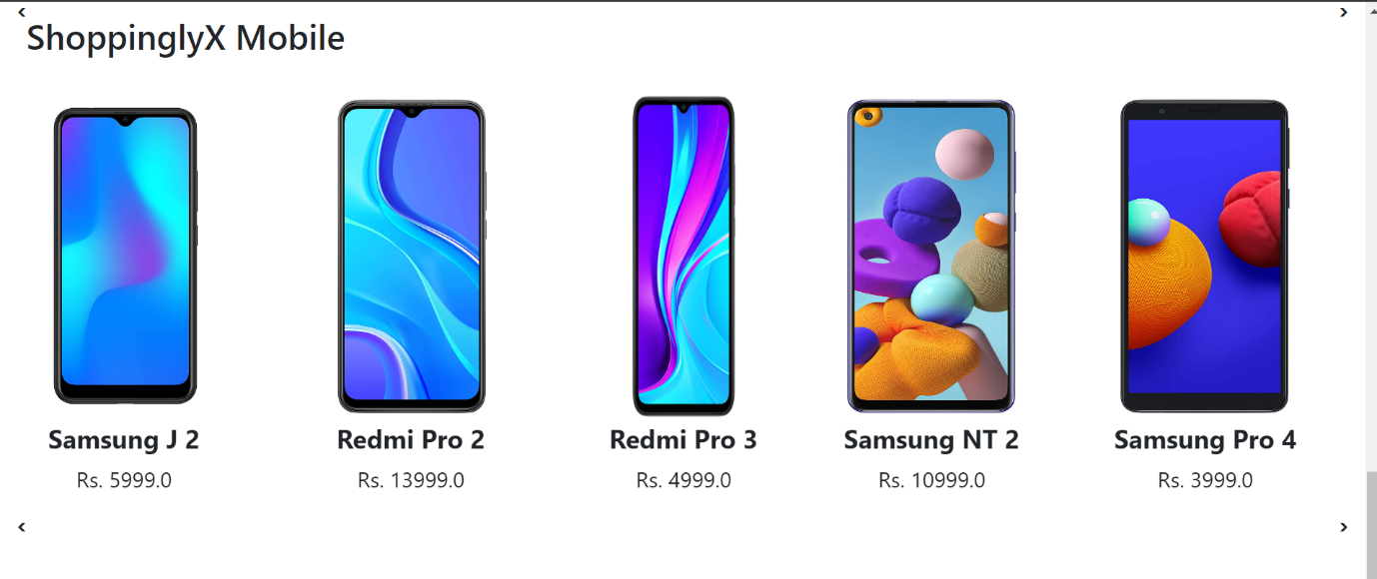

**Registration page**

{% extends 'app/base.html' %}

{% load static %}

{% block title %}Customer Registration{% endblock title %}

{% block main-content %}

<div class="container">

 <div class="row my-3">

  <div class="col-sm-6 offset-sm-3">

   <h3>Customer Registration</h3>

   <hr>

   <form action="" method="post" novalidate class="shadow p-5">

    {% if messages %}

    {% for message in messages %}

     <p {% if message.tags %} class="alert alert-{{message.tags}} mb-5" {% endif %}>{{message}}}</p>

    {% endfor %}

    {% endif %}

     {% csrf_token %}

     {% for fm in form %}

      <div class="form-group mb-3">

      {{fm.label_tag}} {{fm}} <small class="text-danger">{{fm.errors|striptags}}</small>

      </div>

     {% endfor %}

     <input type="submit" value="Submit" class="btn btn-primary">

     <br>

     <div class="text-center text-primary fw-bold"><small>Existing User ? <a href="{% url 'login' %}" class="text-danger">Login Now</a> </small></div>

     {% if form.non_field_errors %}

      {% for error in form.non_field_errors %}

       <p class="alert alert-danger my-3">{{error}}</p>

      {% endfor %}

     {% endif %}

    </form>

  </div>

 </div>

</div>

{% endblock main-content %}

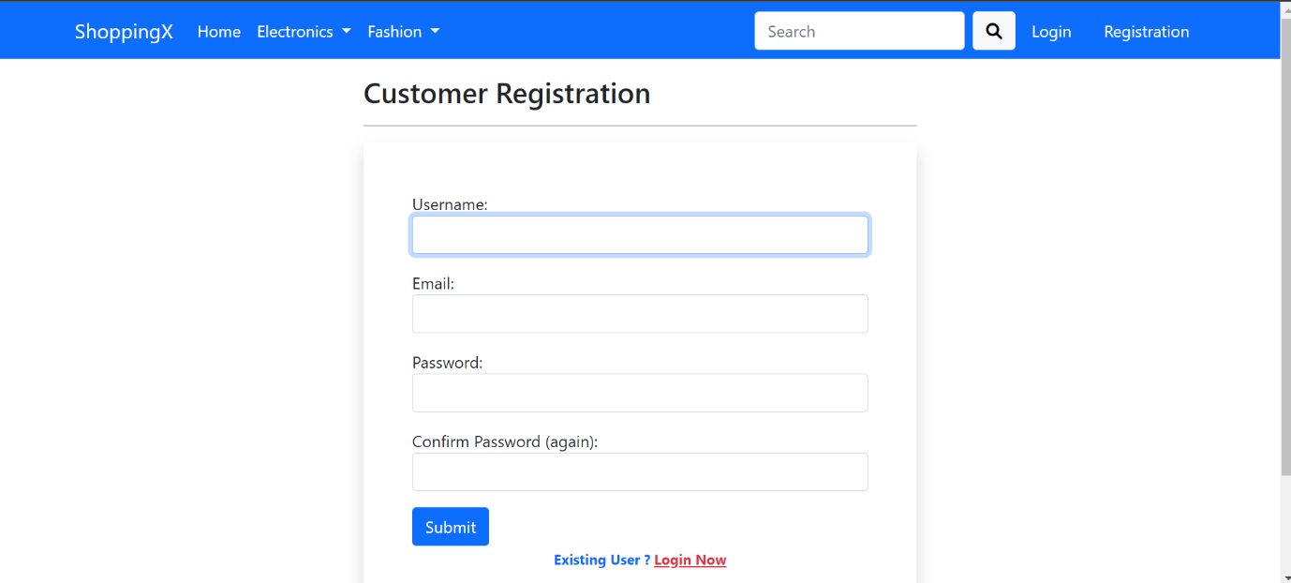

**Login page**

{% extends 'app/base.html' %}

{% load static %}

{% block title %}Login{% endblock title %}

{% block main-content %}

<div class="container">

 <div class="row my-3">

  <div class="col-sm-6 offset-sm-3">

   <h3>Login</h3>

   <hr>

   <form action="" method="post" novalidate class="shadow p-5">

     {% csrf_token %}

     {% for fm in form %}

      <div class="form-group">

      {{fm.label_tag}} {{fm}} <small class="text-danger">{{fm.errors|striptags}}</small> <br>

      </div>

     {% endfor %}

     <small><a href="{% url 'password_reset' %}">Forgot Password ?</a></small> <br>

     <input type="submit" class="btn btn-primary mt-4" value="Login">

     <br>

     <div class="text-center text-primary fw-bold"><small>New to ShoppinglyX ? <a href="{% url 'customerregistration' %}" class="text-danger">Create an Account</a> </small></div>

     {% if form.non_field_errors %}

      {% for error in form.non_field_errors %}

       <p class="alert alert-danger my-3">{{error}}</p>

      {% endfor %}

     {% endif %}

    </form>

  </div>

 </div>

</div>

{% endblock main-content %}

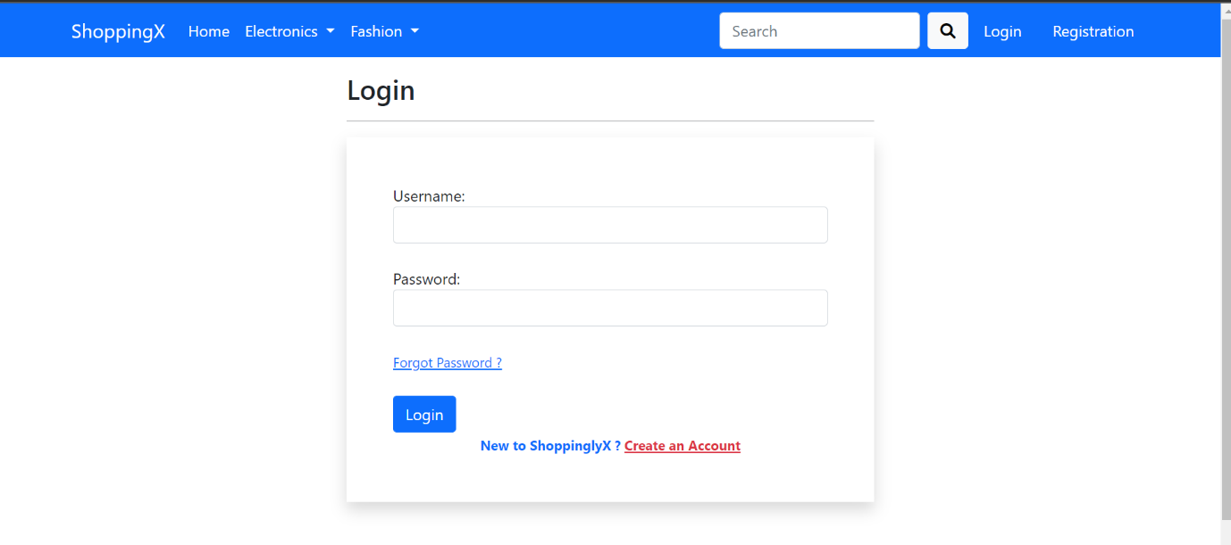

**Models.py**

from django.db import models

from django.contrib.auth.models import User

from django.core.validators import MaxValueValidator, MinValueValidator

STATE_CHOICES = (

  ('Andaman & Nicobar Islands','Andaman & Nicobar Islands'),

  ('Andhra Pradesh','Andhra Pradesh'),

  ('Arunachal Pradesh','Arunachal Pradesh'),

  ('Assam','Assam'),

  ('Bihar','Bihar'),

  ('Chandigarh','Chandigarh'),

  ('Chhattisgarh','Chhattisgarh'),

  ('Dadra & Nagar Haveli','Dadra & Nagar Haveli'),

  ('Daman and Diu','Daman and Diu'),

  ('Delhi','Delhi'),

  ('Goa','Goa'),

  ('Gujarat','Gujarat'),

  ('Haryana','Haryana'),

  ('Himachal Pradesh','Himachal Pradesh'),

  ('Jammu & Kashmir','Jammu & Kashmir'),

  ('Jharkhand','Jharkhand'),

  ('Karnataka','Karnataka'),

  ('Kerala','Kerala'),

  ('Lakshadweep','Lakshadweep'),

  ('Madhya Pradesh','Madhya Pradesh'),

  ('Maharashtra','Maharashtra'),

  ('Manipur','Manipur'),

  ('Meghalaya','Meghalaya'),

  ('Mizoram','Mizoram'),

  ('Nagaland','Nagaland'),

  ('Odisha','Odisha'),

  ('Puducherry','Puducherry'),

  ('Punjab','Punjab'),

  ('Rajasthan','Rajasthan'),

  ('Sikkim','Sikkim'),

  ('Tamil Nadu','Tamil Nadu'),

  ('Telangana','Telangana'),

  ('Tripura','Tripura'),

  ('Uttarakhand','Uttarakhand'),

  ('Uttar Pradesh','Uttar Pradesh'),

  ('West Bengal','West Bengal'),

)

class Customer(models.Model):

 user = models.ForeignKey(User, on_delete=models.CASCADE)

 name = models.CharField(max_length=200)

 locality = models.CharField(max_length=200)

 city = models.CharField(max_length=50)

 zipcode = models.IntegerField()

 state = models.CharField(choices=STATE_CHOICES, max_length=50)

 def __str__(self):

  # return self.user.username

  return str(self.id)

CATEGORY_CHOICES = (

 ('M', 'Mobile'),

 ('L', 'Laptop'),

 ('TW', 'Top Wear'),

 ('BW', 'Bottom Wear'),

)

class Product(models.Model):

 title = models.CharField(max_length=100)

 selling_price = models.FloatField()

 discounted_price = models.FloatField()

 description = models.TextField()

 brand = models.CharField(max_length=100)

 category = models.CharField( choices=CATEGORY_CHOICES, max_length=2)

 product_image = models.ImageField(upload_to='productimg')

 def __str__(self):

  return str(self.id)

class Cart(models.Model):

 user = models.ForeignKey(User, on_delete=models.CASCADE)

 product = models.ForeignKey(Product, on_delete=models.CASCADE)

 quantity = models.PositiveIntegerField(default=1)

 def __str__(self):

  return str(self.id)

  # Below Property will be used by checkout.html page to show total cost in order summary

 @property

 def total_cost(self):

   return self.quantity * self.product.discounted_price

STATUS_CHOICES = (

  ('Accepted','Accepted'),

  ('Packed','Packed'),

  ('On The Way','On The Way'),

  ('Delivered','Delivered'),

  ('Cancel','Cancel')

)

class OrderPlaced(models.Model):

 user = models.ForeignKey(User, on_delete=models.CASCADE)

 customer = models.ForeignKey(Customer, on_delete=models.CASCADE)

 product = models.ForeignKey(Product, on_delete=models.CASCADE)

 quantity = models.PositiveIntegerField(default=1)

 ordered_date = models.DateTimeField(auto_now_add=True)

 status = models.CharField(max_length=50,choices=STATUS_CHOICES,default='Pending')

  # Below Property will be used by orders.html page to show total cost

 @property

 def total_cost(self):

   return self.quantity * self.product.discounted_price

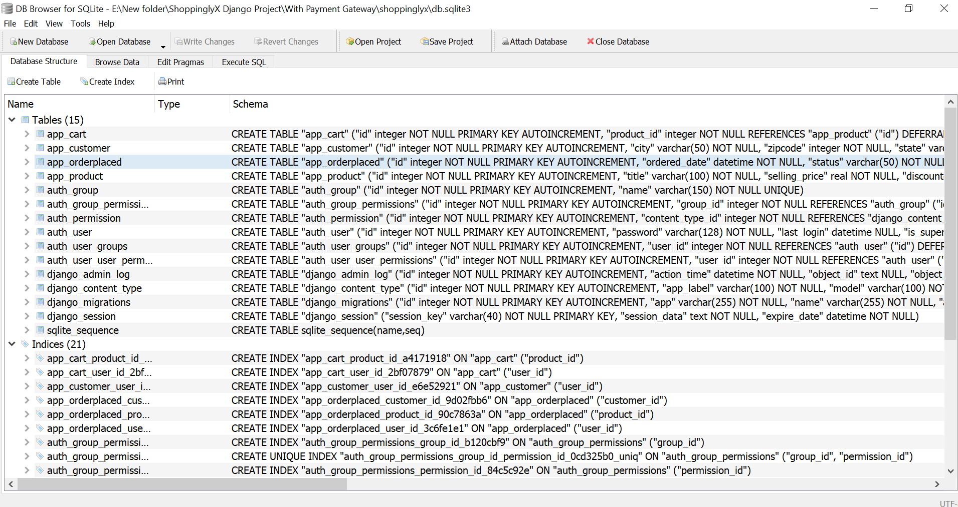

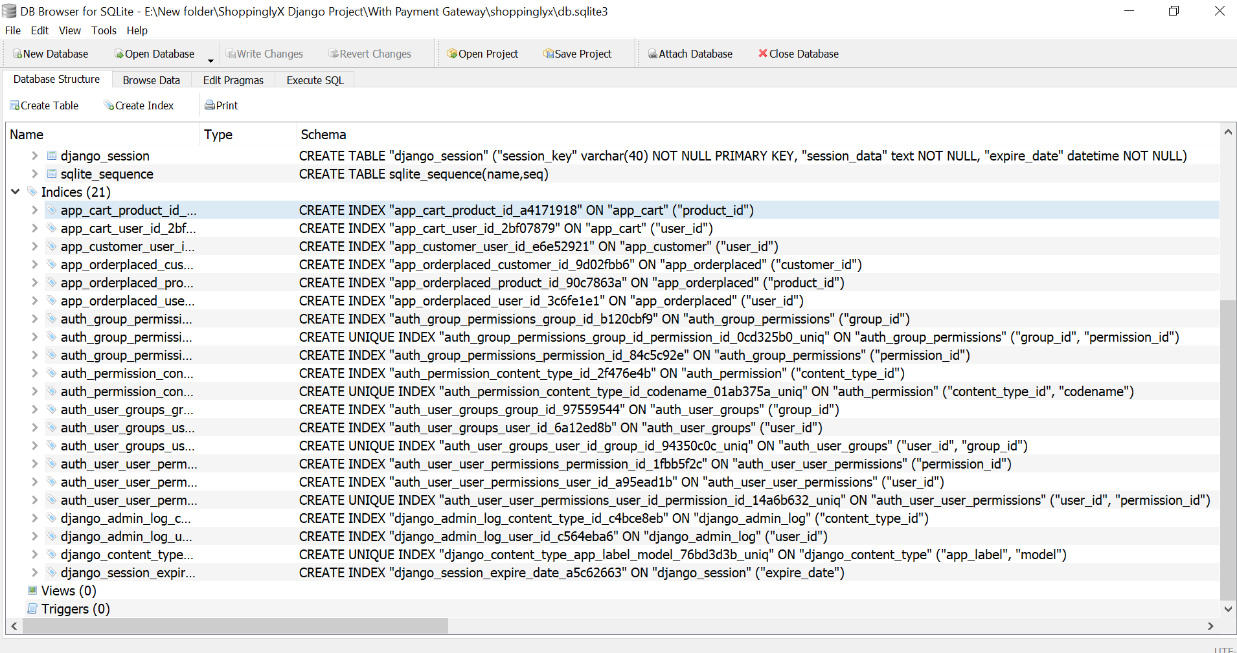

**6. References**

**1.** https://www.w3schools.com/python/default.asp

**2.** https://stackoverflow.com/

**3.** https://docs.djangoproject.com/en/4.1/

**4.** https://www.w3schools.com/js/default.asp

**5.** https://getbootstrap.com/

**6.** https://www.sqlite.org/docs.html