**A Project Report**

**On**

**BLOGGING WEBSITE**

**Submitted by:**

**VIKASH SHARMA, 63**

**VISHNU SINGH YADUVANSHI,64**

**UMESH KUMAR, 57**

**VASHUDEV PANDEY, 62**

**VANISHA KUMARI, 61**

**UMESH RAGHAV,58**

**UTKARSH TIWARI, 59**

**UTKARSH YADAV, 60**

**Supervisor:**

Mr. Dhirendra prasad Yadav

Assistant professor

**Department of Computer Engineering & Application**

**Gla university, Mathura**



**GLA University, Mathura - 281406**

Date of Submission in 28/05/2022

**DECLARATION**

We ***Vikash Sharma, bca 2021, 63; Vishnu Singh yaduvanshi, bca 2021, 64; Vasudev Pandey, bca 2021, 62; Umesh Kumar, bca 2021, 57; vanisha Kumari, bca 2021, 61; Umesh Raghav, bca 2021, 58; Utkarsh Tiwari, bca 2021, 59; Utkarsh Yadav, bca 2021, 60*** hereby declare that the work presented in this project report entitled **“BLOGGING WEBSITE”** is an authentic record of our own work carried out under supervision of **Mr. Dhirendra prasad Yadav.**

**S.NO NAME ROLL NO. SIGNATURE**

1. **Vikash Sharma 63**
2. **Vishnu yaduvanshi 64**
3. **Umesh Kumar 57**
4. **Vanisha Kumari 61**
5. **Umesh Raghav 58**
6. **Vashudev Pandey 62**
7. **Utkarsh Tiwari 59**
8. **Utkarsh Yadav 60**

**CERTIFICATE**

This is to certify that the above statement made by the students are correct to the best of my knowledge and belief.

Date: 25/05/2022

Place: Mathura

**SUPERVISOR SIGNATURE**

Mr. Dhirendra prasad Yadav

**Contents**

|  |  |  |
| --- | --- | --- |
| **Certificate & Declaration** | | **ii** |
|  |
| Table of Contents | | **iii** |
| 1. **Introduction, Motivation and Objective** | | **v** |
| **2.Project Description and Work done** | | **vi** |
| **3.Geotagged Images of Students at the place of**   1. **work** | | **vii** |
| **4.Findings and Conclusion** | | **viii** |
| **5.Bibliography/ References** | | **ix** |

**Chapter - 1**

**Introduction, Motivation and Objective**

**Introduction:**

A blog is a discussion or informational website published on the world wide web consisting of discrete, often informal diary- style text entries.

Posts are typically displayed in reverse chronological order so that the most recent post appears first, at the top of the webpage**.**

We create this blogging website where users can upload

And delete blog posts related new technology.

We also create an admin panel where users can manage the posts add, delete, edit the posts.

Examples of blogging site:

Blogger -

Blogger is an American online content management system which enables multi-user blogs with time-stamped entries. Pyra Labs developed it before being acquired by Google in 2003. Google hosts the blogs, which can be accessed through a subdomain of blogspot.com.

**Motivation:**

As the technology is increasing day by day and the new fields is introducing in the computer science.

Ex: Data science, AI/ML, Blockchain etc.

Let's look at the top 10 most popular and free blog platforms. -

- WordPress.com.

- Blog.com.

- Blogger.

- Type Pad Micro.

- Tumblr.

- Posterous Spaces.

- Weebly.

- LiveJournal.

**Objective:**

The main objective of this website is to provide the knowledge about new technologies introducing day by day.

Here users can find the posts related to new technologies.

**Chapter - 2**

**Description and Work done**

The project divides into four modules

Home page:

In this page we show the blogs and this is the front page of the website.

About page:

this page shows the description of the website and about the team members.

Contact:

this is the contact page where user can contact with us by sending the mail

Login:

this is the login page of website from where admin can enter in dashboard section and manage their posts

dashboard:

when user enters the username and password correctly it enters in dashboard where he/she can manage their posts.

Tools and technologies used:

we also use different technologies for making this website like-

* Html, CSS, JavaScript (frontend)

**HTML**provides the *basic structure* of sites, which is enhanced and modified by other technologies like CSS and JavaScript.

**CSS** stands for Cascading Style Sheets. This programming language dictates how the HTML elements of a website should actually appear on the frontend of the page.CSS is used to control *presentation, formatting, and layout*.

**JavaScript** is a more complicated language than HTML or CSS, and it wasn't released in beta form until 1995. Nowadays, JavaScript is supported by all modern web browsers and is used on almost every site on the web for more powerful and complex functionality.

* python programming language(backend)

Python is a full-stack language. It is used in backend development while its frameworks are used in frontend development. A Python program can be written in MAC OS and the same program can run in Linux, therefore Python is also a cross-stage language.

* flask framework

Flask is a web application framework written in Python. Armin Ronacher, who leads an international group of Python enthusiasts named Pocco, develops it. Flask is based on Werkzeug WSGI toolkit and Jinja2 template engine. Both are Pocco projects.

* MySQL database

MySQL is an open source relational database management system. For WordPress sites, that means it helps you store all your blog posts, users, plugin information, etc. It stores that information in separate “tables” and connects it with “keys”, which is why it's relational.

* local production server xampp

XAMPP has the ability to **serve web pages on the World Wide Web**. A special tool is provided to password-protect the most important parts of the package. XAMPP also provides support for creating and manipulating databases in MariaDB and SQLite among others.

* flask mail services

A web-based application is often required to have a feature of sending mail to the users/clients. Flask-Mail extension makes it very easy to set up a simple interface with any email server. At first, Flask-Mail extension should be installed with the help of pip utility.

**Work done:**

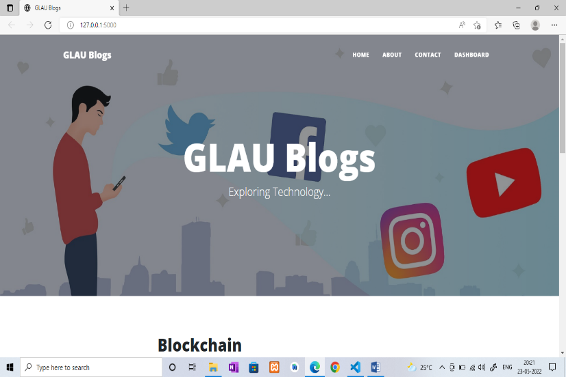

This is the home page of website from here we can go on contact page, about page, and dashboard.

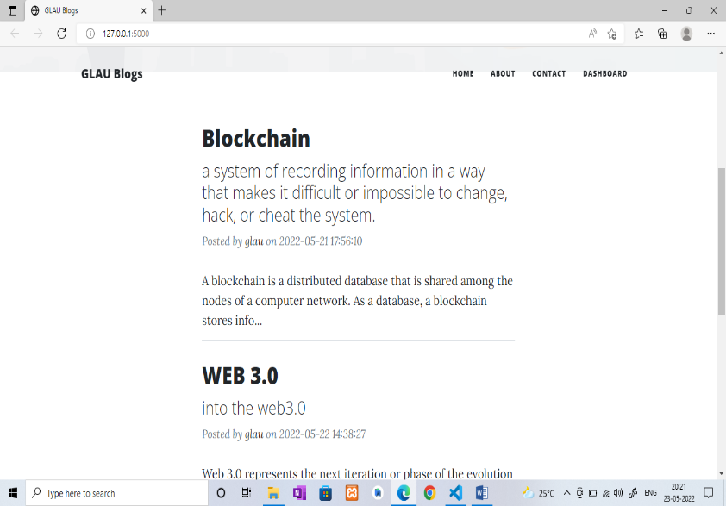

These are the blog posts on clicking these posts we go on posts page to read full post.

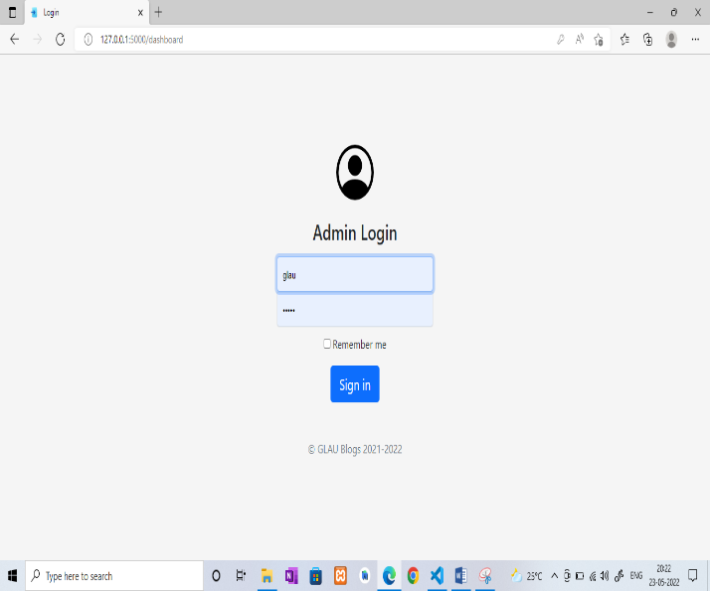

This is the login page, if user wants to manage their posts they can go on dashboard by filling correct username and password.

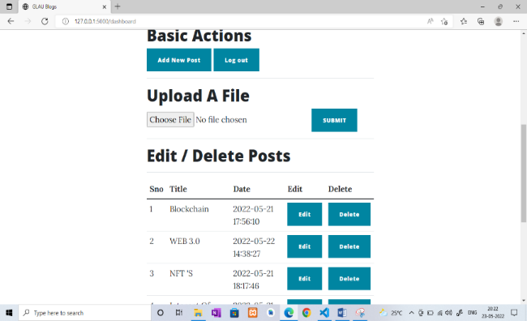

This is the dashboard from here admins can manage their posts or create new posts.

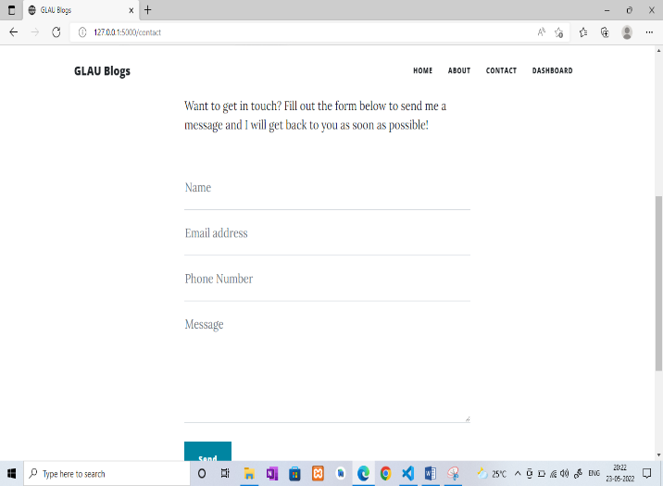

This is the contact page users can directly contact with us by sending email

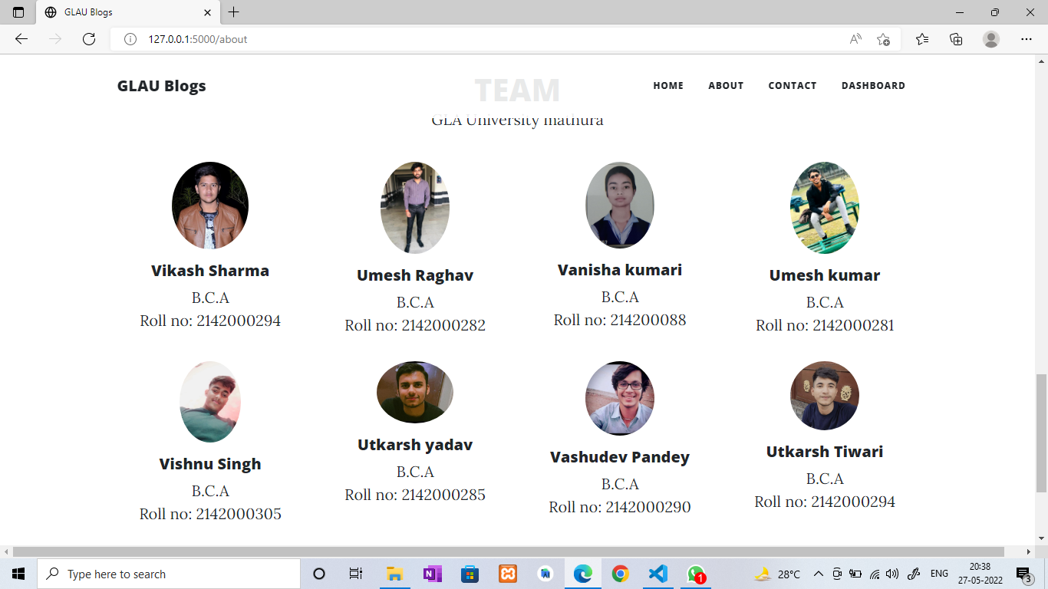

This is the about us page of our website here is the details of team members

And about this website and gla university.

**Chapter - 3**

**Geotagged Images of Students at the place of work**

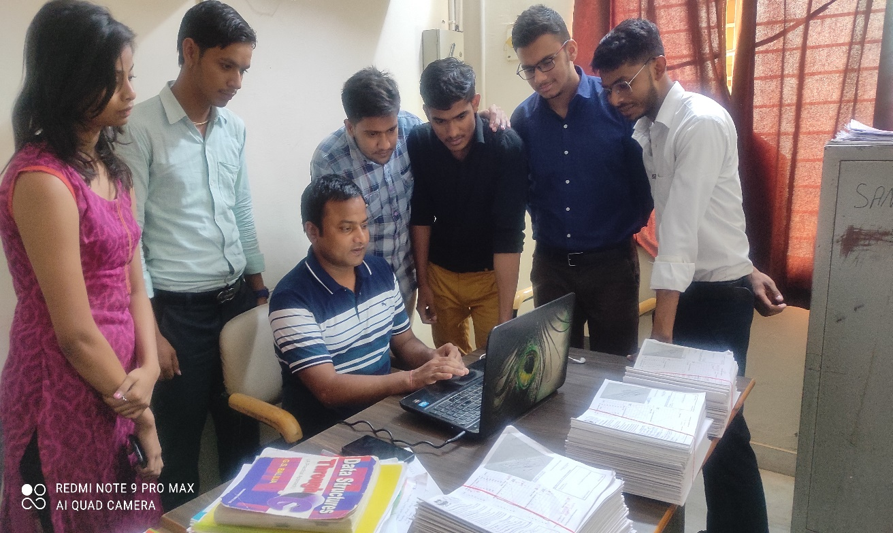

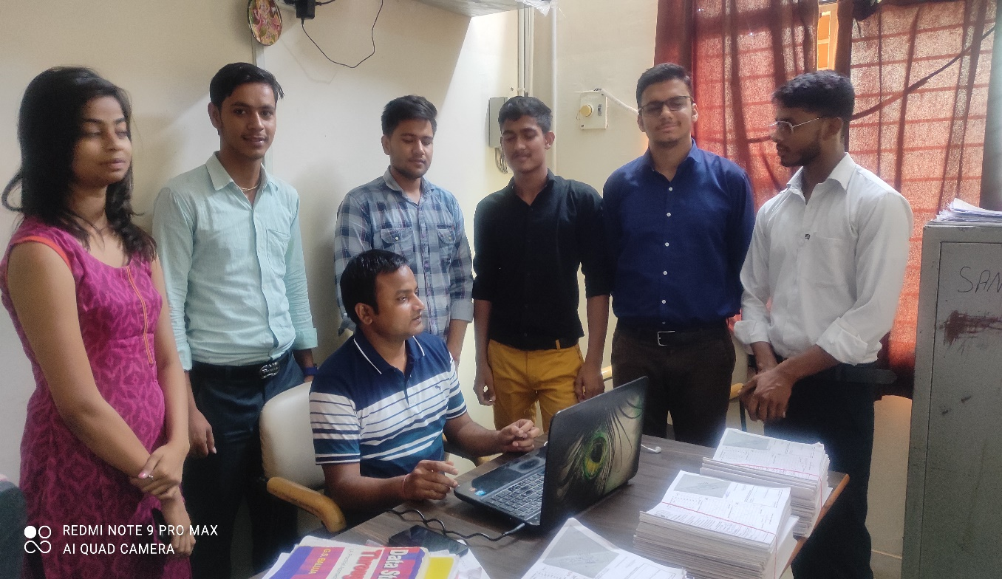

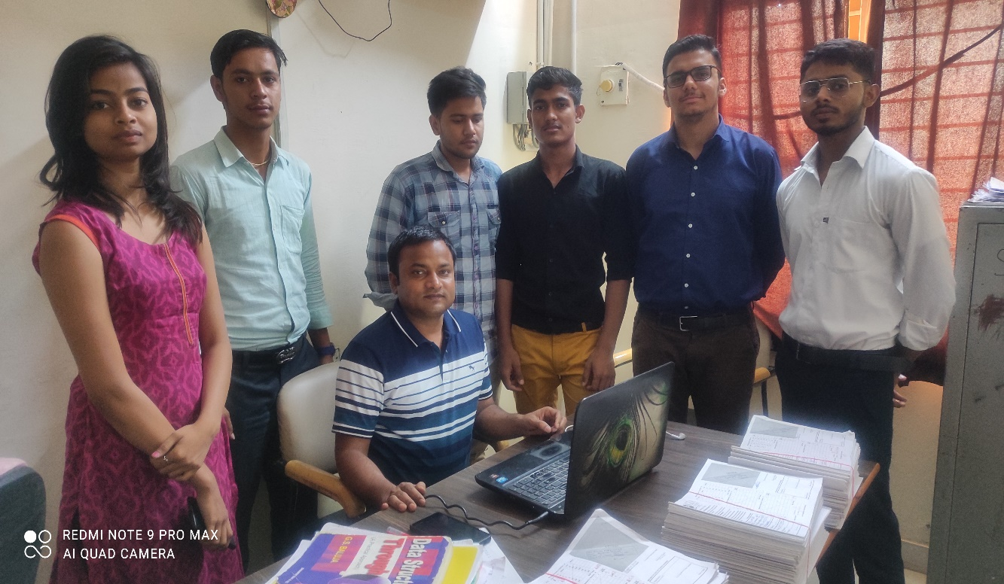

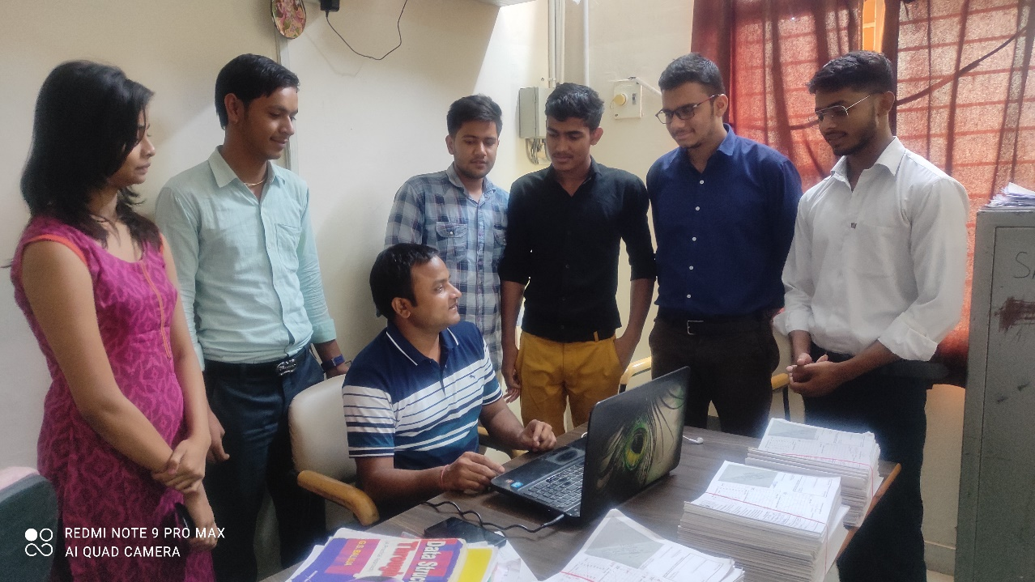

**Chapter - 4**

**Findings and Conclusion**

* If students use this website they should be much aware about new fields of computer science.
* Students should be able to see events happening in the university in the single platform
* an opportunity to inspire people and make them see how great your brain is.
* Students can also write their views of different topics and enhance their knowledge.

**Bibliography/ References**

* [**Welcome to Flask — Flask Documentation (2.1.x) (palletsprojects.com)**](https://flask.palletsprojects.com/en/2.1.x/)
* [**3.10.4 Documentation (python.org)**](https://docs.python.org/3/)
* [**Python Programming Language - GeeksforGeeks**](https://www.geeksforgeeks.org/python-programming-language/)