

**Running an Intelligent Analytical System on AWS**

**Using AWS Services & Solutions in AWS Marketplace**

*Overview*

# Disclaimer:

1. The AWS Marketplace Fusion Solution showcased in this document is solely meant as a tutorial, *but with given additional customizations, it can be used for production use cases*.
2. Technologies used in this Solution can be replaced by other equivalent technologies as needed for business reasons.
3. All data used in this Solution is machine generated and fictitious.
4. For setting up this AWS Marketplace Fusion Solution, prior knowledge of the technologies used in the Solution and familiarity with Amazon AWS Cloud is recommended.
5. For most of the components, we used the region **US West (Oregon)**, but you can change it as per your choice.

**Table of Contents**

[**1.** **Introduction** 4](#_Toc468268834)

[**2.** **Business Use Case** 4](#_Toc468268835)

[**3.** **Project Details** 5](#_Toc468268836)

[**4.** **Architecture Diagram** 8](#_Toc468268837)

[**5.** **Data Model Diagram** 9](#_Toc468268838)

[**6.** **How to use the project documents?** 11](#_Toc468268839)

[**7.** **Appendix** 12](#_Toc468268840)

1. **Introduction**

The Intelligent Analytical System is a complete end-to-end predictive analytical solution. It is completely built on the AWS platform with fast data processing capability, scalability, reliability, an accurate predictive analysis, and a connected application. It leverages AWS Services and third-party solutions from AWS Marketplace.

The Intelligent Analytical System consists of 3 projects, including a prerequisite setup. The projects must be followed sequentially to setup, configure, and execute the end-to-end processes.

After completion of these 3 projects, the user will achieve these:

1. Create an AWS Account. do initial setup before installation, and configure various AWS products.
2. Install and configure several components from AWS marketplace, which are used to build this Solution.
3. Generate the required datasets and initiate the data pipeline.
4. Use a machine learning model for predictive analysis and create a predictive dashboard for visualization.
5. Use a mobile app to get mobile notifications based on the predictive analysis.

To understand what this Solution is meant to achieve, let us look at a particular business use case.

1. **Business Use Case**

*Note: This scenario was developed for the finance sector, but can be applied to other industries.*

These days, a lot of people make their living as a stock trader. However, stock trading is not a simple job. A good stock trader has to keep an eye on every piece of information that can possibly impact the stock prices of a company. But this is exceedingly difficult for a stock trader who does not want to sit in front of a computer to monitor prices around the clock.

In such situations, the stock trader could face the following issues:

* Have limited access to information about external factors, which could impact the stock prices of a company.
* Be limited to non-real time analytics and non-elastic systems.
* Be handicapped by a lack of backend predictive analytics.

But with the advancement of technology, one can overcome all these difficulties by building a robust analytics system.

The Intelligent Analytical System you will build using these guides makes all of these possible:

* With minimum setup of a sophisticated analytics system, a stock trader will be able to see how even a small piece of information impacts the stock price. For example, a storm forecast in the area of a manufacturing plant of a company could potentially impact the customer delivery timeline of a company, which in turn could directly impact revenue and stock prices.
* However, by predicting the occurrence of a storm using machine learning techniques, the trader now has access to this information beforehand, and has the choice to sell that company’s stock in advance before its price goes down.
* Thus, predictive analytics saves the trader significant losses by helping make more informed decisions.

1. **Project Details**

Here is a high-level overview of the project details.

All documents can be found in the following Git repository:

**Document 1 — Prerequisites**

Before starting Project 1, you must have an AWS Account and the necessary setup. The **Prerequisites** document will guide you through the following:

* + - * Create and login to an AWS account.
      * Create Identity and Access Management (IAM) Users.
      * Assign policies to the user or role.
      * Generate Private keys.
      * Manage an EC2 instance – Start up and Shut Down an EC2 instance

The **Prerequisites** document is targeted for Developers, DevOps, and IT Managers who will set up the system.

The Prerequisites Document can be found in the Git repository:

*Prerequisites.pdf*

**Documents 2 and 3 — Project 1: Step-by-Step Deployment Guide— Parts 1 and 2**

These two documents will guide you in detail through all the steps required to install and configure the components for building this system.

**Target audience:** This project requires a basic familiarity with AWS services and is specifically targeted at technology managers, cloud managers, or DevOps personnel who provision the system.

You will find these two documents in the Git repository:

1. *Step by Step Deployment Guide-Part1.pdf*
2. *Step by Step Deployment Guide-Part2.pdf*

**Document 4 — Project 2: Building a Data Pipeline**

The Project 2 document will guide you through the steps for generating the data required for the end-to-end data flow and for the required analytic and machine learning. It will also walk you through setting up the data flow processes through various components, like Amazon S3, Amazon Redshift, MySQL, and ATTUNITY CloudBeam.

**Target audience:** Project 2’s guide, “Building a Data Pipeline,” includes all the steps required to process the data and details about the data flow through the system. It therefore requires basic familiarity with AWS services and is specifically targeted at developers and data scientists. The Project 2 guide is saved in the Git repository under this name:

*Step by Step Guide for Data Pipeline from AWS Marketplace.pdf*

**Document 5 — Project 3: Machine Learning, Reporting, and BYOD**

Project 3 will guide you on how to use machine learning techniques for predictive analysis, using R, and then depicting the results and price trends on a predictive dashboard using TIBCO Spotfire. It will also guide you on how to receive alerts of your predictions on a mobile app using Kony Mobile Fabric.

**Target audience:** The first part of Project 3 requires basic familiarity with the concepts of machine learning and data visualization. This project is specifically targeted at developers and data scientists. The second part of Project 3, which includes mobile app development, is also aimed at front-end/mobile app developers.

The Project 3 guide is saved in the Git repository under this name:*Machine Learning and, Reporting .pdf*

1. **Architecture Diagram**

The following level 1 solution architecture diagram shows the components you will use to build this Solution, as well as the overall data flow processes.

The technologies used in this flow are as follows:

* SoftNAS Cloud Standard
* ATTUNITY CloudBeam
* TIBCO Spotfire
* Kony Mobile Fabric
* TREND Micro Security
* Amazon Redshift
* Git
* Apache Tomcat
* Apache Maven
* Amazon VPC

C:\Users\Abhinandan\Desktop\Diagram\Level 1 aws_marketplace_immersion_project_HLA.png

1. **Data Model Diagram**

The Data Model Diagram will help you understand the schema of datasets used in this Solution.

Following is the list of datasets:

1. Company Master
2. Company Product
3. Company Announcements
4. Stock Data
5. Weather Storm Data
6. Weather Data Incremental
7. Weather Prediction

**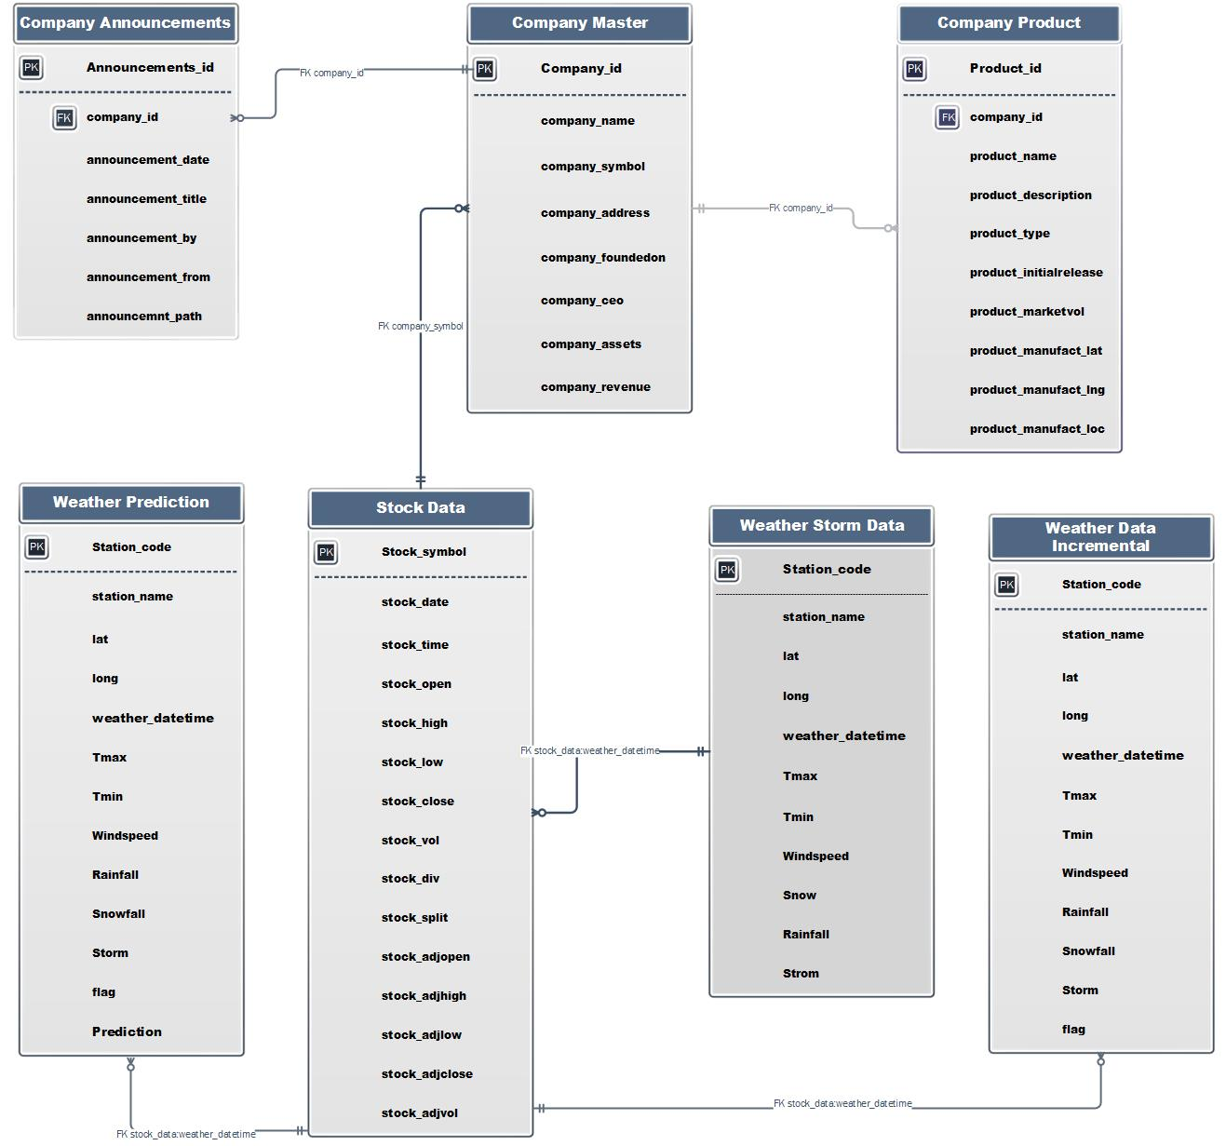**

1. **How to use the project documents**

This document serves as an overview for all 3 projects. You should execute the documents in the following order,

1. Prerequisites

2. Project 1 - part 1

3. Project 1 - part 2

4. Project 2

5. Project 3The sequence in terms of actual documents (found in the Git repository) are as follows:

1. *Prerequisites.pdf*
2. *Step by Step Deployment Guide-Part1.pdf*
3. *Step by Step Deployment Guide-Part2-.pdf*
4. *Step by Step guide forData Pipeline from AWS Marketplace.pdf*
5. *Machine Learning and, Reporting and BYODpdf*

Recommendation: Return to this document — and this list — after completing every step to find the correct next step.

1. **Appendix**
2. The following table shows cost estimates for running AWS marketplace products used in this Solution. These are estimates as of Oct, 2016 and are subject to change. This is just a guideline, not actuals.

|  |  |  |
| --- | --- | --- |
| Components Name | EC2 Servers | EC2 Charges Hourly |
| SoftNAS | m3.xlarge | $1.616/hr. |
| ATTUNITY CloudBeam | m4.large | $2.646/hr. |
| TIBCO Spotfire | m4.large | $2.646/hr. |
| Kony Mobile Fabric | t2.large | $0.104/hr. |
| TREND Micro Security | m4.large | $1.62/hr. |
| AWS RedShift | NA | $0.250/hr. |

1. The following are the links for Amazon Marketplace components. You can use the links provided to find out more details about each one:

|  |  |
| --- | --- |
| **Component Name** | **EC2 Server Type** |
| SoftNAS | <https://aws.amazon.com/marketplace/pp/B00PJ9FGVU?qid=1475145771249&sr=0-2&ref_=srh_res_product_title> |
| ATTUNITY CloudBeam | <https://aws.amazon.com/marketplace/pp/B00LBH6GCC?qid=1475145807428&sr=0-3&ref_=srh_res_product_title> |
| TIBCO Spotfire | <https://aws.amazon.com/marketplace/pp/B00PB74KYY?qid=1475145882225&sr=0-9&ref_=srh_res_product_title> |
| Kony Mobile Fabric | Developer: <https://aws.amazon.com/marketplace/pp/B010TV3U2E?qid=1475145908555&sr=0-2&ref_=srh_res_product_title>  Express: <https://aws.amazon.com/marketplace/pp/B010PHCVO0?qid=1475145908555&sr=0-1&ref_=srh_res_product_title> |
| TREND Micro Security | <https://aws.amazon.com/marketplace/pp/B01AVYHVHO?qid=1475145958660&sr=0-2&ref_=srh_res_product_title> |

1. Here is the information about which components could be installed and configured using the Amazon CloudFormation. This list is also subject to change.

|  |  |  |
| --- | --- | --- |
| Components Name | Cloud Formation Available | Difficulty Level |
| SoftNAS | Yes | High |
| ATTUNITY CloudBeam | Yes | High |
| TIBCO Spotfire | Yes | High |
| Kony Mobile Fabric | Yes | Medium |
| TREND Micro Security | Yes | High |
| AWS RedShift | Yes | Low |
| Apache Tomcat | No | NA |
| Apache Maven | No | NA |