ALTEC_CR2 Project Setup

- Extract soa_client.zip from TC11.2 base to SOA Client folder location.

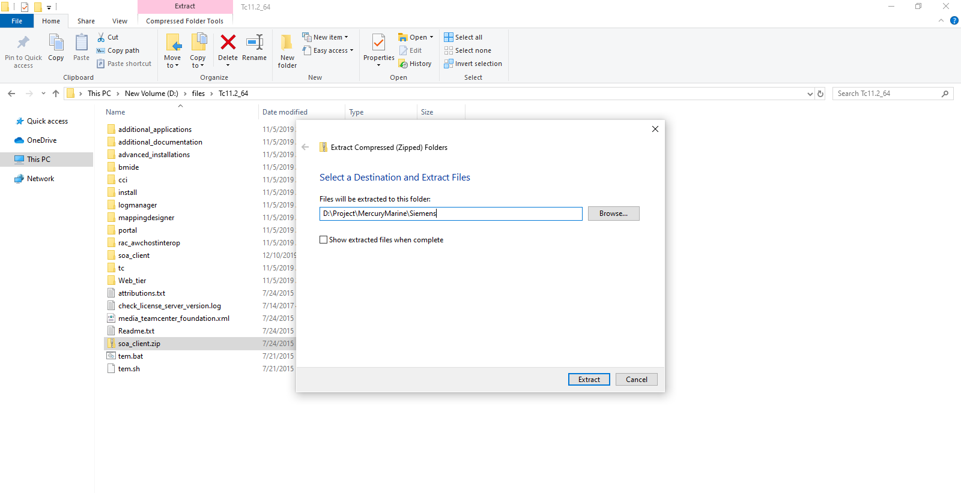

- Extract soa_client.zip from TC11.4.3 patch to SOA Client folder location.

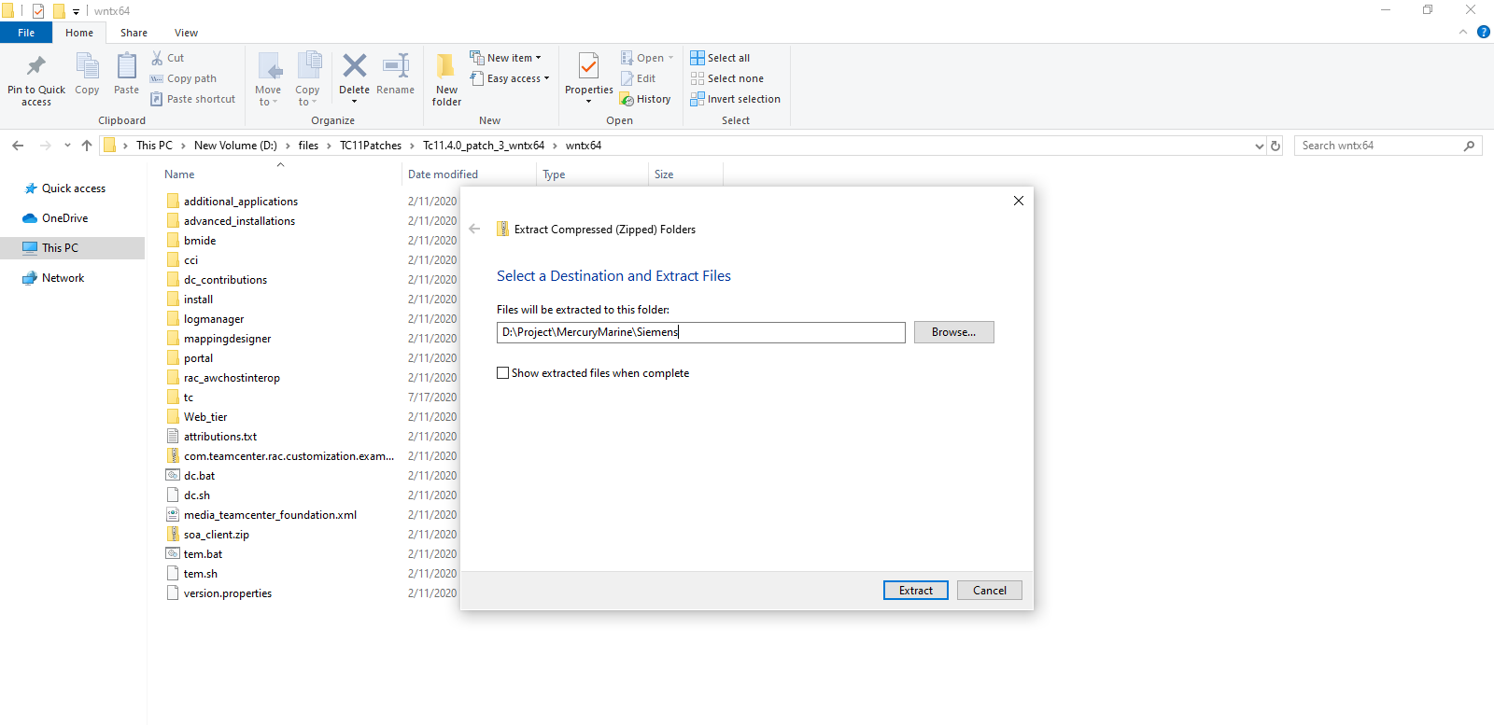

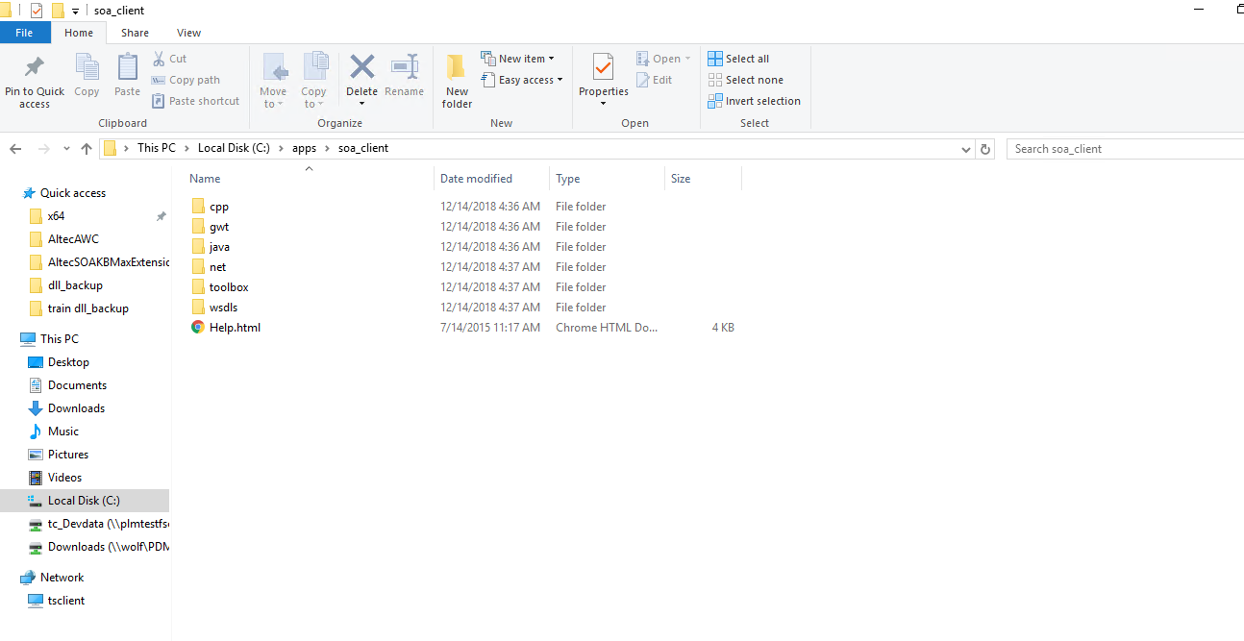

- Add highlighted lines to “bmide.bat” file.

- Import “ALTEC_CR2” project in bmide.

- Add values to project properties as shown below.

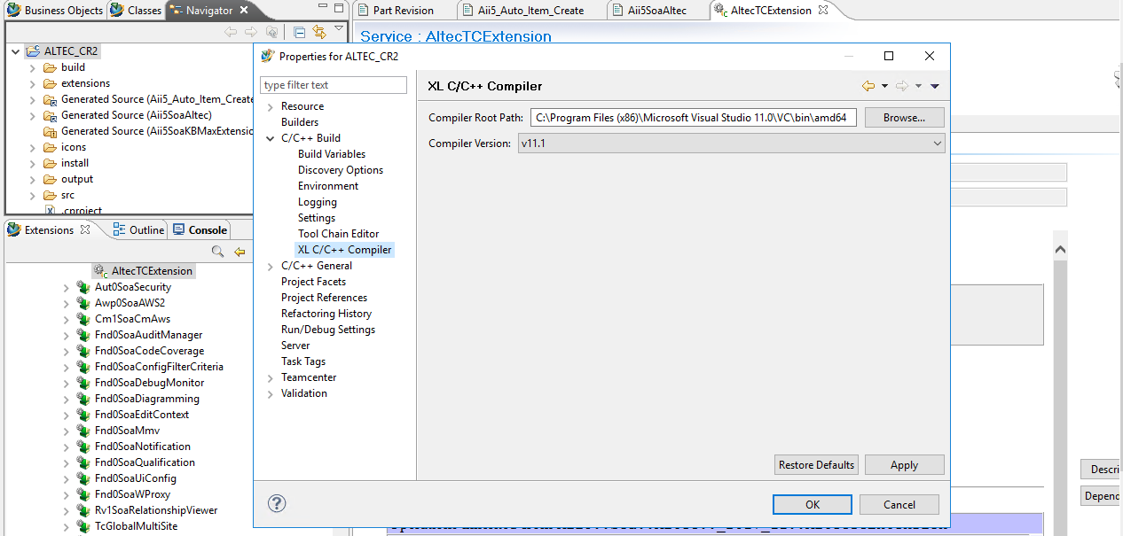

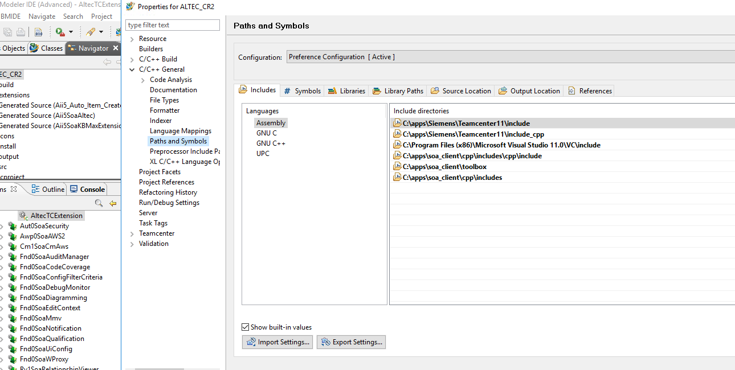

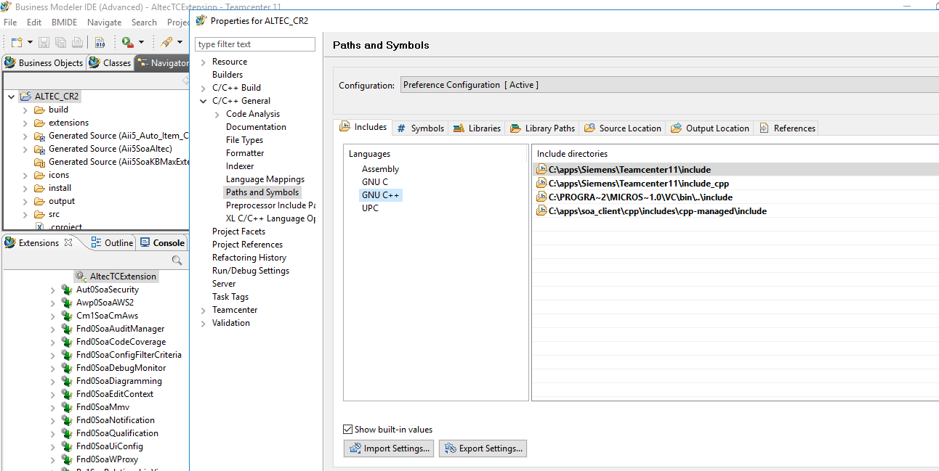

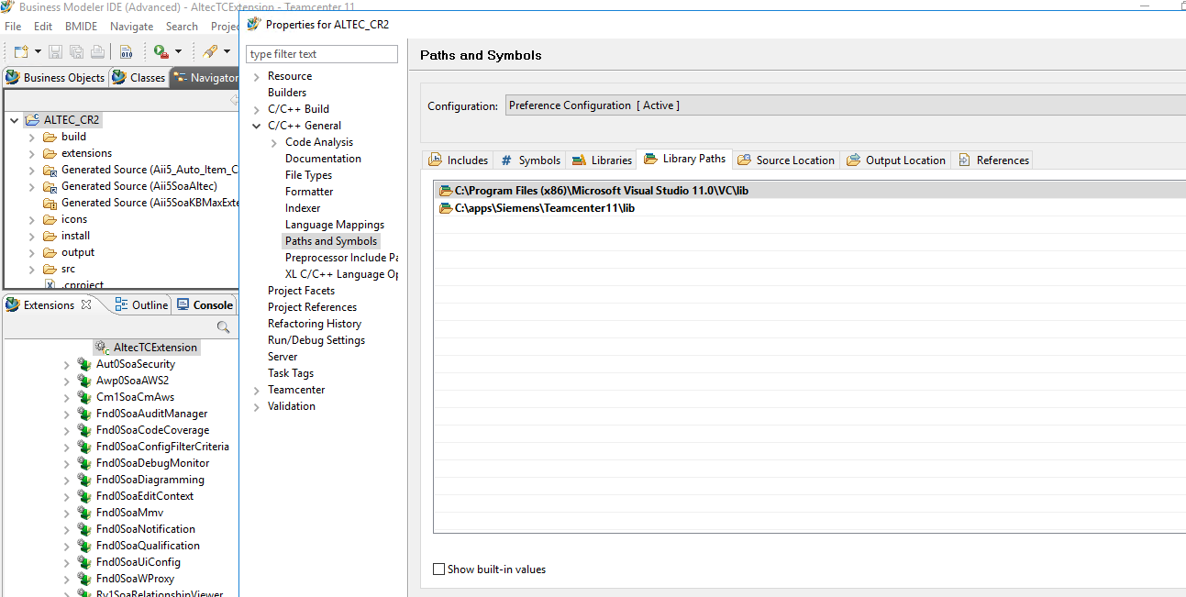

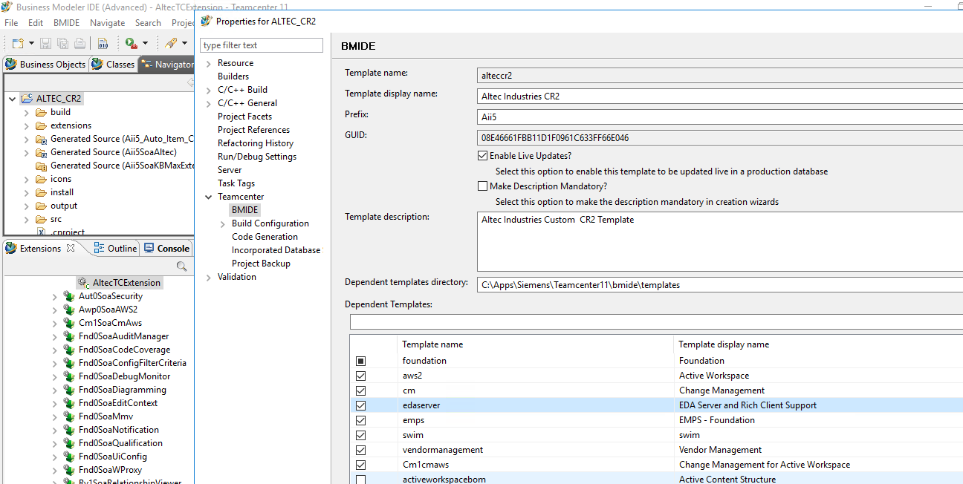

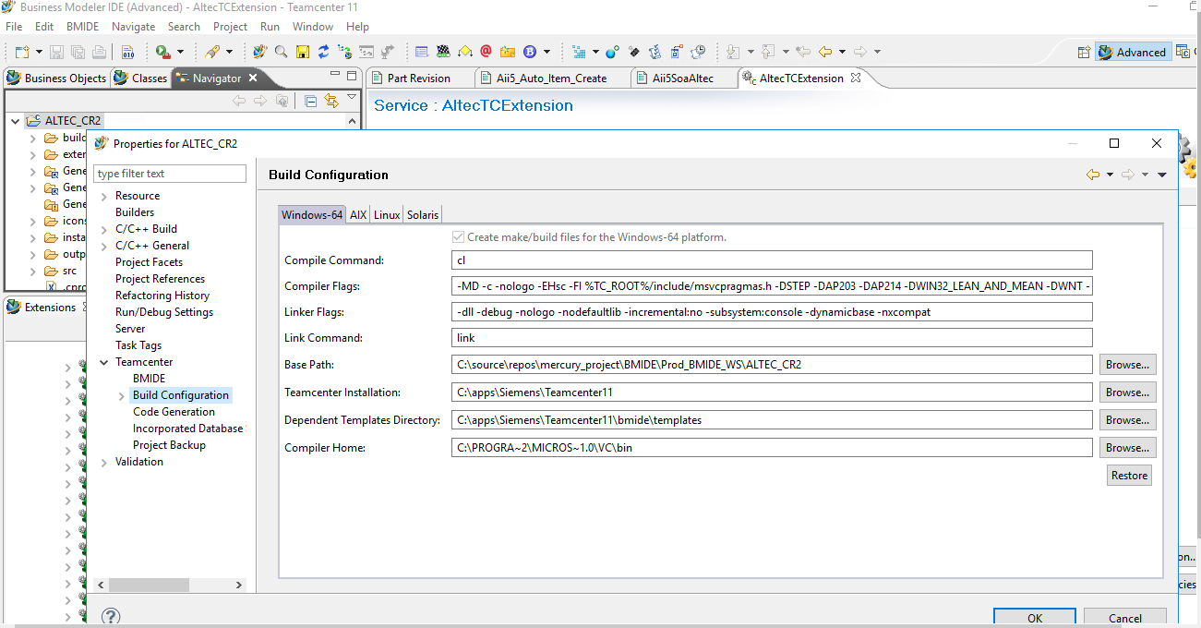

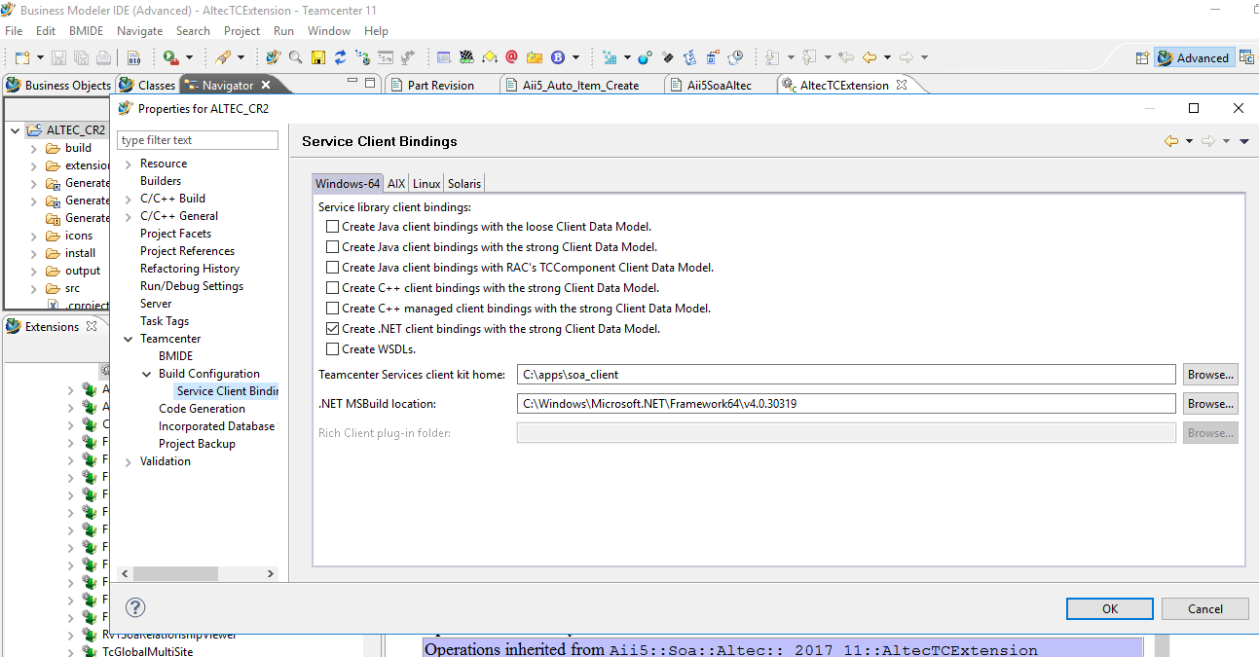

- Modify the “makefile.wntx64” with highlighted values as shown below.

- Make sure that Teamcenter lib folder contains “libsoaaltec.lib” file. If Teamcenter lib folder doesn't contains “libsoaaltec.lib” file, it will throw error during “Build Project”.

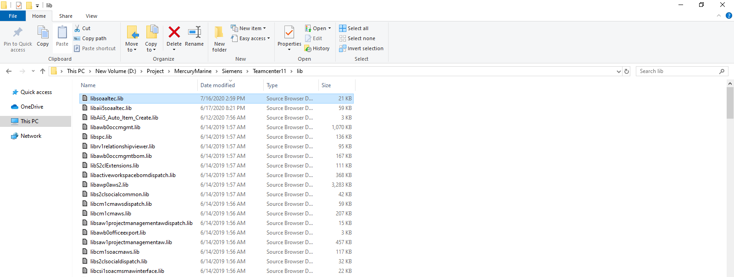

- Build the project and check it gets built successfully.

