Step 1: Create Visual Studio project “AltecSOAKBMaxExtension” and add properties as shown below

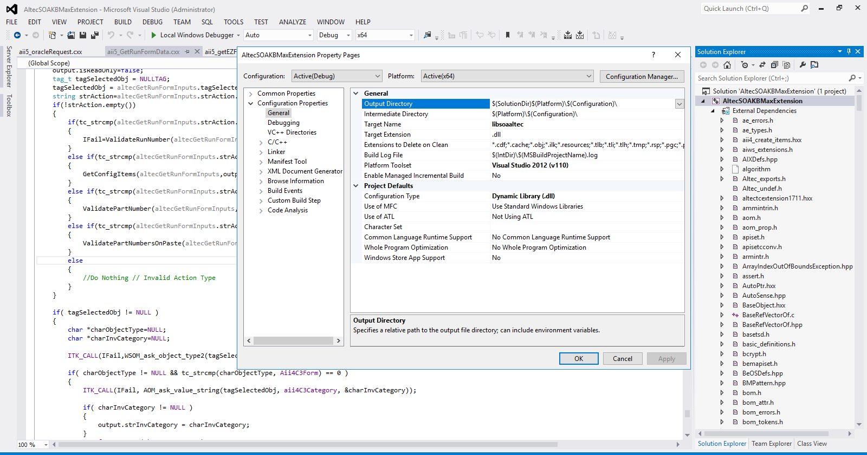

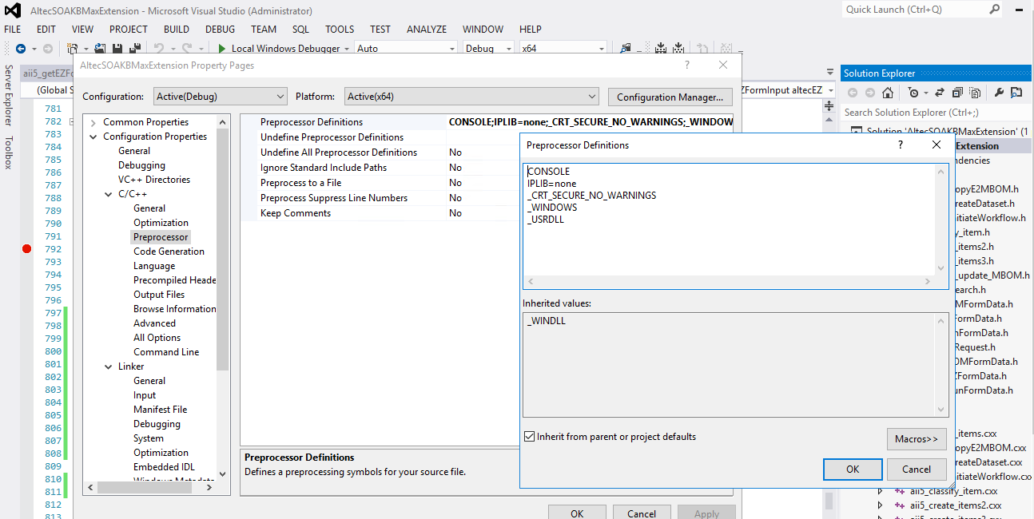

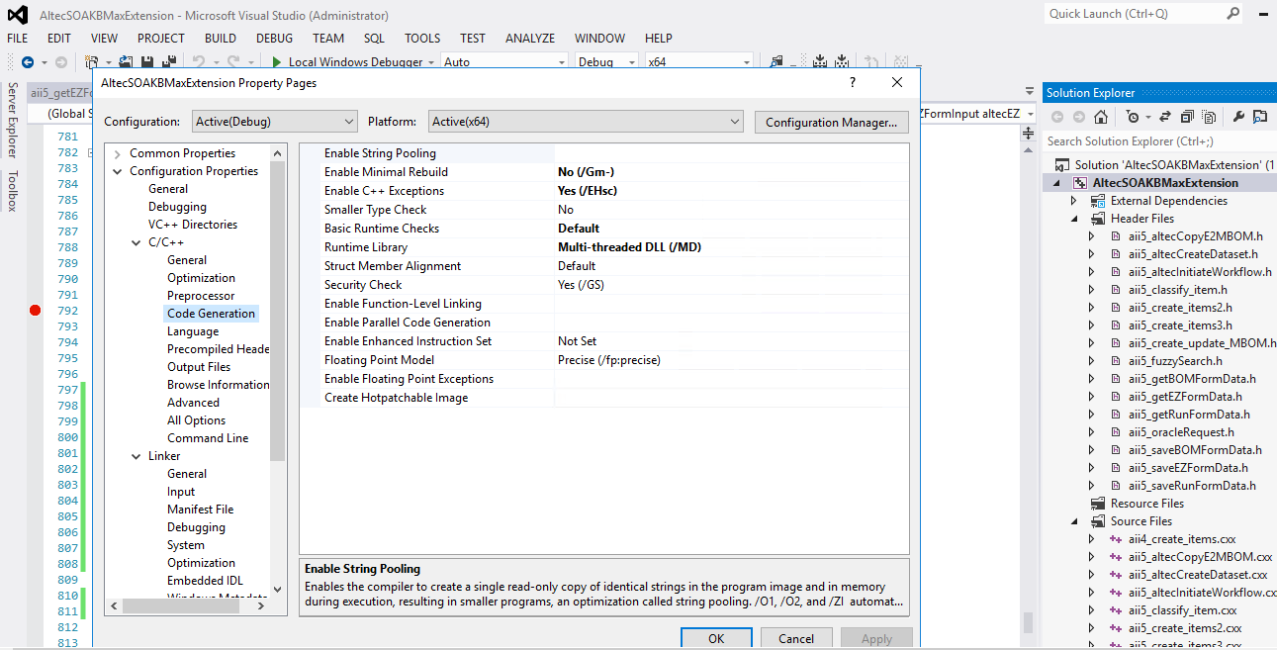

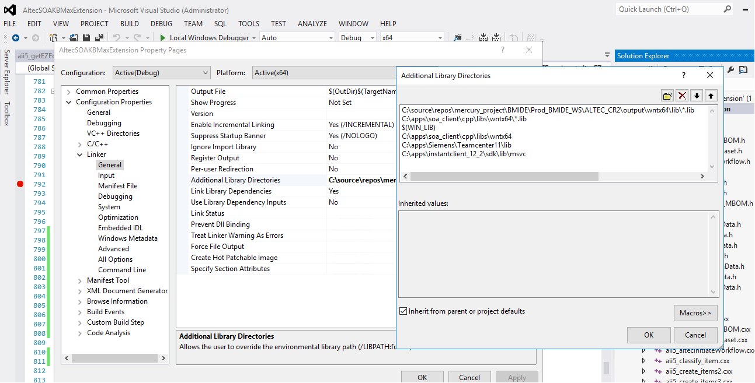

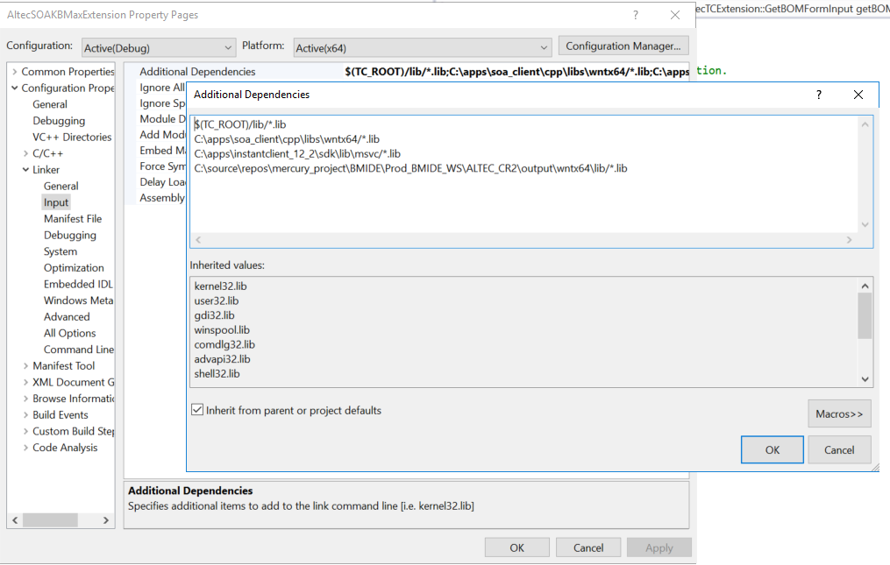

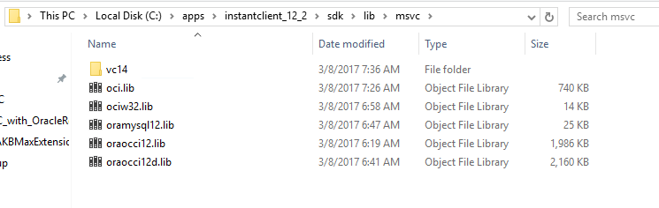

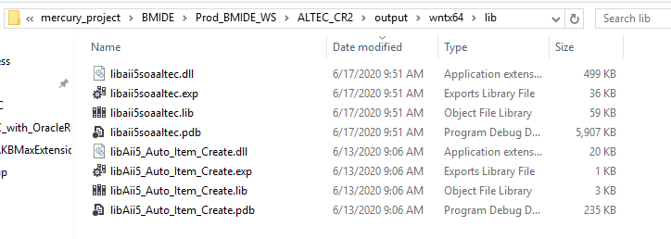

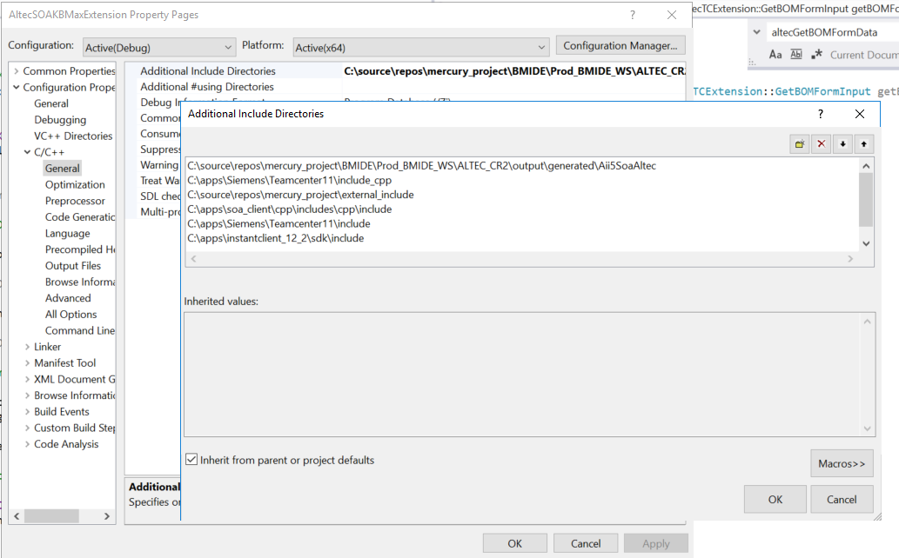

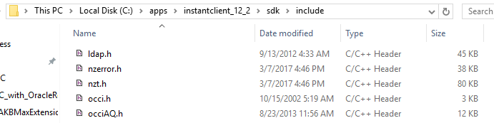

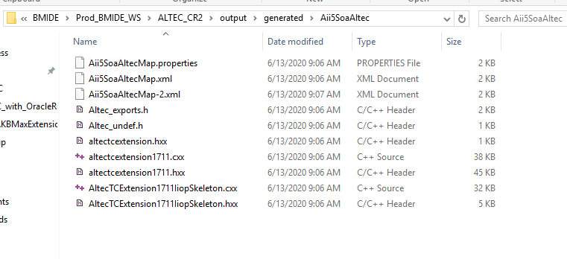

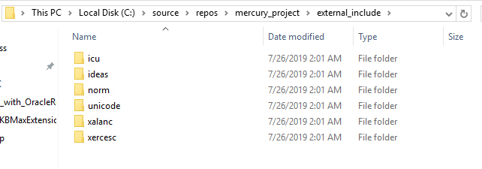

Step 2: Using “EXTERN_DLL” keyword, extern the soa service function.

Step 3: Write the business logic in “altecGetBOMFormData” function and build the project.

Step 4: Copy dll and pdb files and paste them in Teamcenter bin folder.

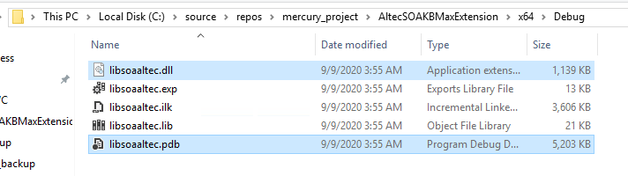

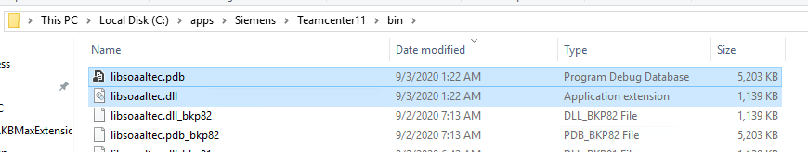

Step 5: Copy lib file and paste it in Teamcenter lib folder.

