SpringBoot RabbitMQ Integration

SRabbitMQis an AMQP messaging broker and it is the most popular open source and cross-platform message broker.
RabbitMQ is also a way to exchange the data between different platform applications such as a message sent from Netapplication can be read by a Node.js application orJava application.
The RabbitMQ is built on Erlang general-purpose programming language and it is also used by WhatsApp for messaging.

What is AMQP?
The Advanced Message Queuing Protocol (AMQP) is an open standard application layer protocol for message-oriented and the features of AMQP are message orientation, queuing, routing (including point-to-point and publish-and-subscribe), reliability and security.
It was developed by JPMorgan and iMatix Corporation. AMQP was designed with the following main characteristics as goals:
- Security
- Reliability
- Interoperability
- Standard
- Open
RabbitMQ is lightweight and easy to deploy on available premises and it supports multiple messaging protocols. RabbitMQ can be deployed in distributed and federated configurations to meet high-scale, high-availability requirements.
Following is the pictorial representation of how RabbitMQ will act as a mediator between sender and consumer in our applications.
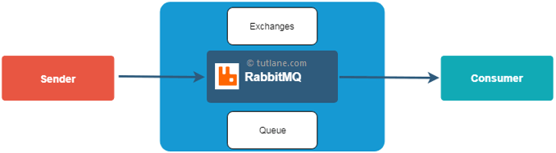

What is Erlang?
Erlang is a general-purpose programming language and runtime environment.
Erlang has built-in support for concurrency, distribution and fault tolerance. Erlang is used in several large telecommunication systems from Ericsson.
In rabbitmq,

when producer creates a message that will not directly sent to a queue, instead first the message will be send to exchanges, then after that a routing agent reads and sends it to the appropriate queue with help of header attributes, bindings, and routing keys.
RabbitMQ Exchange Types
In rabbitmq, we have a four type of Exchanges are available to route the message in different ways.
Following are the different type of exchanges available in rabbitmq.
- Direct
- Fanout
- Topic
- Headers

RabbitMQ Direct Exchange
In rabbitmq, direct exchange will deliver a messages to the queues based on the message routing key. In direct exchange, the message is routed to the queues whose binding key exactly matches with the routing key of the message.
Following is the pictorial representation of message flow in rabbit direct exchange.

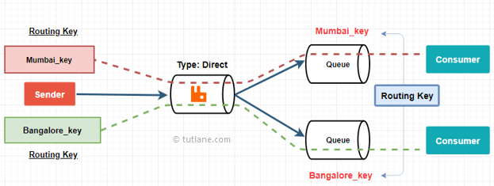
RabbitMQ Fanout Exchange
In rabbitmq,fanout exchange will route messages to all of the queues that are bound to it
Following is the pictorial representation of message flow in rabbitmq fanout exchange.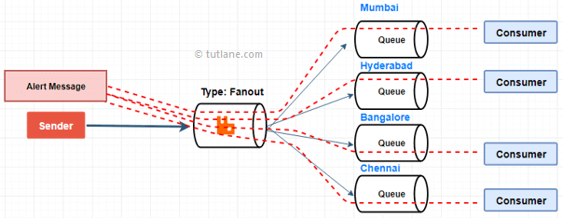

RabbitMQ Topic Exchange
In rabbitmq, topic exchange will perform a wildcard match between the routing key and the routing pattern specified in the binding to publish a messages to queue.
Following is the pictorial representation of message flow in rabbitmq topic exchange.

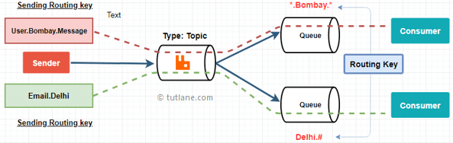

RabbitMQ Headers Exchange
In rabbitmq, headers exchanges will use the message header attributes for routing.
Following is the pictorial representation of message flow in rabbitmq headers exchange.

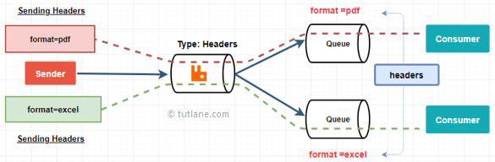

Producer: Application that sends the messages.
- Consumer: Application that receives the messages.
- Queue: Buffer that stores messages.
- Message: Information that is sent from the producer to a consumer through RabbitMQ.
- Connection: A TCP connection between your application and the RabbitMQ broker.
- Channel: A virtual connection inside a connection. When publishing or consuming messages from a queue - it's all done over a channel.
- Exchange: Receives messages from producers and pushes them to queues depending on rules defined by the exchange type. To receive messages, a queue needs to be bound to at least one exchange.
- Binding: A binding is a link between a queue and an exchange.
- Routing key: A key that the exchange looks at to decide how to route the message to queues. Think of the routing key like an address for the message.
- AMQP: Advanced Message Queuing Protocol is the protocol used by RabbitMQ for messaging.
- Users: It is possible to connect to RabbitMQ with a given username and password. Every user can be assigned permissions such as rights to read, write and configure privileges within the instance. Users can also be assigned permissions for specific virtual hosts.
- Vhost, virtual host: Provides a way to segregate applications using the same RabbitMQ instance. Different users can have different permissions to different vhost and queues and exchanges can be created, so they only exist in one vhost.

Step 1 – Install Erlang

$wget https://packages.erlang-solutions.com/erlang-solutions_1.0_all.deb
$sudo dpkg -i erlang-solutions_1.0_all.deb

Now, you can install erlang package on your system using the following command. This will install all of its dependencies as well.

$sudo apt-get update
$sudo apt-get install erlang erlang-nox

Step 2 – Install RabbitMQ Server

After installing requirements, now enable RabbitMQ apt repository on your system. Also you need to import rabbitmq signing key on your system.

$echo 'deb http://www.rabbitmq.com/debian/ testing main' | sudo tee /etc/apt/sources.list.d/rabbitmq.list
$wget -O- https://www.rabbitmq.com/rabbitmq-release-signing-key.asc | sudo apt-key add -

After that update apt cache and install RabbitMQ server on your system...,

$sudo apt-get update
$sudo apt-get install rabbitmq-server

Step 3 – Manage RabbitMQ Service

After completing installations, enable the RabbitMQ service on your system. Also, start the RabbitMQ service. Use one the below methods sysvinit for older systems or systemctl for the latest operating system.

Using Systemctl –
sudo systemctl enable rabbitmq-server
sudo systemctl start rabbitmq-server
sudo systemctl stop rabbitmq-server

Step 4 – Create Admin User in RabbitMQ

By default rabbitmq creates a user named “guest” with password “guest”. You can also create your own administrator account on RabbitMQ server using following commands. Change password with your own password.

$sudo rabbitmqctl add_user admin password
$sudo rabbitmqctl set_user_tags admin administrator
$sudo rabbitmqctl set_permissions -p / admin ".*" ".*" ".*"

Step 5 – Setup RabbitMQ Web Management Console

RabbitMQ also provides and web management console for managing the entire RabbitMQ. To enable web management console run following command on your system. The web management console helps you for managing RabbitMQ server.

$sudo rabbitmq-plugins enable rabbitmq_management

RabbitMQ dashboard starts on port 15672. Access your server on the port to get dashboard. Use the username and password created in step 4

