**Conditionals in Java**

In Java, conditionals allow programs to make decisions based on certain conditions. These conditions are usually based on logical expressions that evaluate to either true or false. Java supports several types of conditional statements:

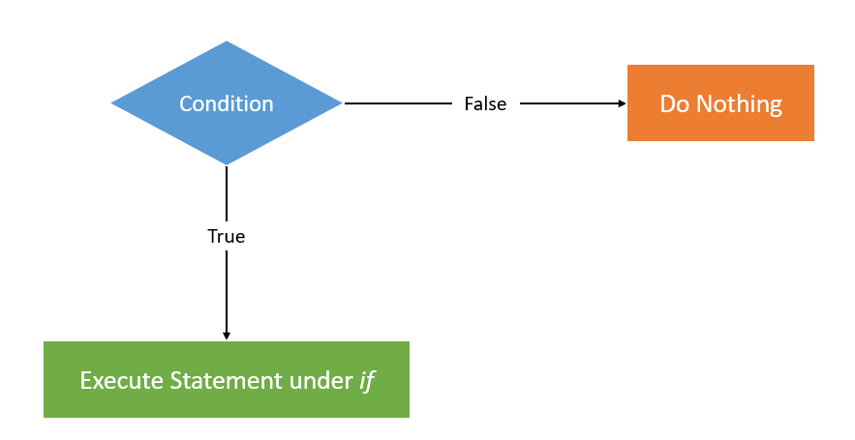

**Types of Conditional Statement:**

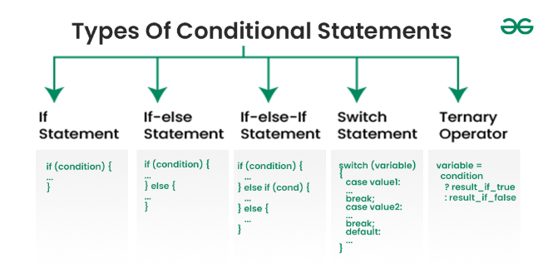

**1. if Statement**

The if statement is the simplest form of conditional statement. It executes a block of code only if a given condition is true.

**Syntax:**

if (condition) {

// Code to be executed if the condition is true

}

**Example:**

int number = 10;

if (number > 0) {

System.out.println("The number is positive.");

}

In this example, the message "The number is positive" will be printed only if the condition number > 0 is true.

**2. if-else Statement**

The if-else statement provides an alternative block of code that will be executed if the condition is false.

**Syntax:**

if (condition) {

// Code to be executed if the condition is true

} else {

// Code to be executed if the condition is false

}

**Example:**

int number = -5;

if (number > 0) {

System.out.println("The number is positive.");

} else {

System.out.println("The number is negative or zero.");

}

Here, if number > 0 is false, the message "The number is negative or zero" will be printed.

**3. if-else-if Ladder**

The if-else-if ladder is used to test multiple conditions. If the first condition is false, it checks the next condition, and so on.

**Syntax:**

if (condition1) {

// Code to be executed if condition1 is true

} else if (condition2) {

// Code to be executed if condition2 is true

} else {

// Code to be executed if all conditions are false

}

**Example:**

int score = 75;

if (score >= 90) {

System.out.println("Grade: A");

} else if (score >= 80) {

System.out.println("Grade: B");

} else if (score >= 70) {

System.out.println("Grade: C");

} else {

System.out.println("Grade: F");

}

In this case, the output would be "Grade: C" because score >= 70 is true.

**4. Nested if**

A nested if is an if statement inside another if statement. This allows you to check multiple conditions.

**Syntax:**

if (condition1) {

if (condition2) {

// Code to be executed if both condition1 and condition2 are true

}

}

**Example:**

int number = 15;

if (number > 0) {

if (number % 2 == 0) {

System.out.println("The number is positive and even.");

} else {

System.out.println("The number is positive but odd.");

}

}

In this case, the number is positive but odd, so the output will be "The number is positive but odd."

**5. switch Statement**

The switch statement is used to execute one block of code out of many based on the value of an expression. It is a more efficient alternative to using multiple if-else-if statements when testing against specific values.

**Syntax:**

switch (expression) {

case value1:

// Code to be executed if expression == value1

break;

case value2:

// Code to be executed if expression == value2

break;

// You can have any number of case statements

default:

// Code to be executed if none of the cases match

}

**Example:**

java

Copy code

int day = 3;

switch (day) {

case 1:

System.out.println("Monday");

break;

case 2:

System.out.println("Tuesday");

break;

case 3:

System.out.println("Wednesday");

break;

default:

System.out.println("Invalid day");

}

In this example, since day == 3, the output will be "Wednesday."

**6. Conditional (Ternary) Operator**

The ternary operator (? :) is a shorthand for if-else and can be used to evaluate a condition and return one of two values.

**Syntax:**

condition ? value1 : value2;

**Example:**

int number = 10;

String result = (number > 0) ? "Positive" : "Negative";

System.out.println(result);

In this case, since number > 0 is true, the output will be "Positive."

Key Points to Remember:

* **if** is used when you need to check a single condition.
* **if-else** is used when you have two possible outcomes.
* **if-else-if** is for multiple conditions.
* **switch** is preferred when checking multiple values for a single variable.
* **Ternary operator** is a compact way of writing simple if-else conditions.

These conditionals allow Java programs to branch and execute different code based on runtime conditions, making the language versatile for decision-making tasks.