log = LogisticRegression(C=2, max_iter=100)

raf = RandomForestClassifier(min_samples_leaf=10, min_samples_split=20,random_state=100)

#Ensemble Technique

from sklearn.ensemble import VotingClassifier

Ens = VotingClassifier( estimators= [('Log',log),('raf',raf)], voting = 'hard')

Ens= Ens.fit(X_train , y_train)

Ens

#Accuracy

y_pred1 = Ens.predict(X_test)

en=Ens.score(X_test, y_test)

print('Accuracy score= {:.2f}'.format(Ens.score(X_test, y_test)))



#Confusion Matrix

from sklearn.metrics import classification_report, confusion_matrix

from mlxtend.plotting import plot_confusion_matrix

print('\n')

print("confusion matrix")

print('\n')

CR=confusion_matrix(y_test, y_pred1)

print(CR)

print('\n')

fig, ax = plot_confusion_matrix(conf_mat=CR,figsize=(10, 10),

show_absolute=True,

show_normed=True,

colorbar=True)

plt.show()

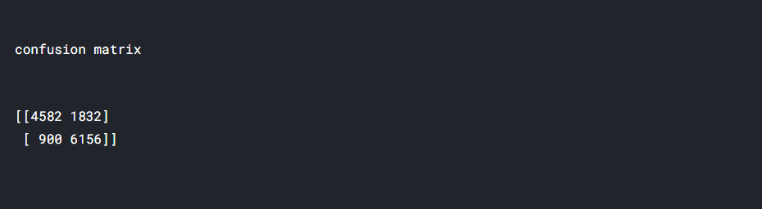

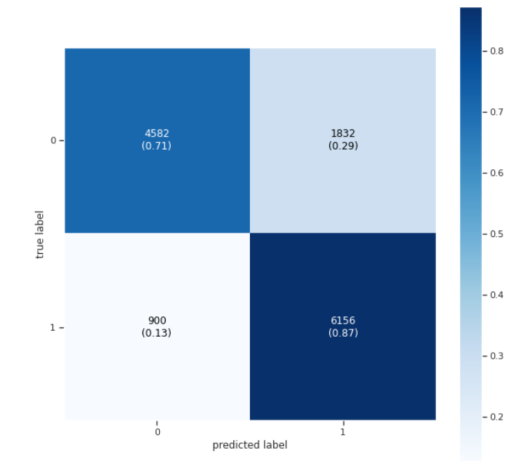

from prettytable import PrettyTable

x = PrettyTable()

print('\n')

print("Comparison of all algorithm results")

x.field_names = ["Model", "Accuracy"]

x.add_row(["LogisticRegression Algorithm", round(lr,2)])

x.add_row(["Random Forest Algorithm", round(rf,2)])

x.add_row(["Ensemble Modelling", round(en,2)])

print(x)

print('\n')

Comparison of all algorithm results

+------------------------------------+------------------------------- +

| Model | Accuracy |

+------------------------------------+------------------------------- +

| Logistic Regression Algorithm | 0.8 |

| Random Forest Algorithm | 0.79 |

| Ensemble Modelling | 0.8 |

+------------------------------------+------------------------------- +