FRONT-END DEVELOPMENT - ASSIGNMENT 2
Student Details
Student Name: A. Vikash
Year: 2nd year
College Code:
College Name: A M Jain college
Department: computer science with AI
Semester: 4th semester
Roll No: 24AI018
NMID:
Date: 1/03/2026
PROJECT TITLE: Event Registration Page Styling using CSS

1. Problem Statement
This assignment focuses on improving the visual appearance of an event registration webpage created using HTML. Initially, the page contained only basic structure and functionality. By applying CSS styling, the webpage layout is enhanced to make it more attractive, readable, and user-friendly.

2. Objective
The objective of this assignment is to apply CSS styling techniques to enhance the design and layout of the event registration page and improve readability and user experience.

3. Requirements
3.1 Apply Global Styling: Apply background, font styling, spacing, and alignment.
3.2 Style Event Title and Description: Improve heading appearance with colors and spacing.
3.3 Design Event Information Section: Style event details using a table layout.
3.4 Enhance Registration Form Layout: Use card layout with padding and shadows.
3.5 Style Fieldsets and Legends: Improve visual appearance with borders and highlights.
3.6 Improve Input Elements: Style input boxes, dropdowns, and text areas.
3.7 Button Styling: Design submit and reset buttons with hover effects.
3.8 Style Participants Table: Add borders, alternate row colors, and hover effect.
3.9 Style Declaration Section: Proper spacing and alignment for checkbox.
3.10 Footer Design: Centered footer with background color.

4. CSS Concepts Used
Selectors
Box Model
Typography
Colors and Backgrounds
Borders and Shadows
Transitions and Hover Effects
Table Styling
Form Styling

5. Implementation Steps
1. Create the HTML structure for the event page.
2. Link CSS file to the HTML document.
3. Apply global styles to body and layout.
4. Style header section.
5. Design event information table.
6. Style registration form elements.
7. Add button styles and hover effects.
8. Style participants table.
9. Design footer section.

6. Output
Attach screenshots of the styled webpage including form, table, and footer.
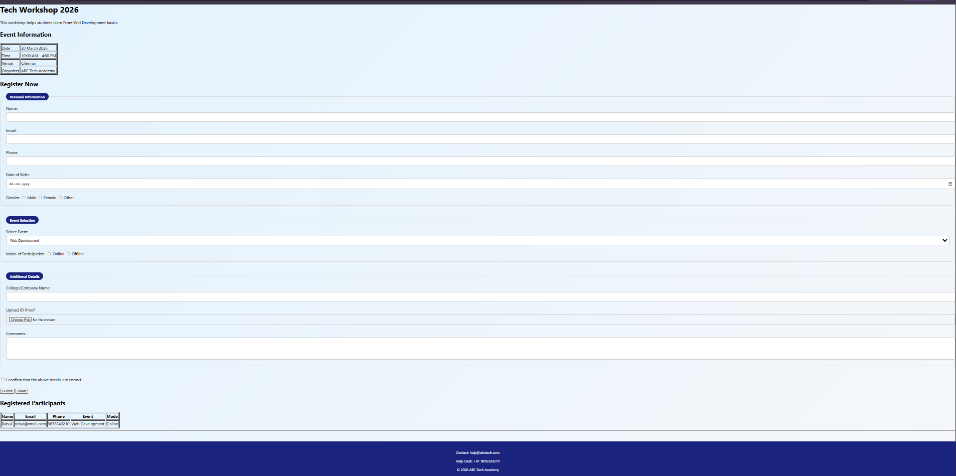

7. Learning Outcome
This assignment helped in understanding CSS styling, layout design, and improving webpage presentation.

8. Conclusion
The event registration webpage was successfully enhanced using CSS to create a visually appealing and user-friendly interface.

