1.Print the names of the employees who have highest no of  leaves.

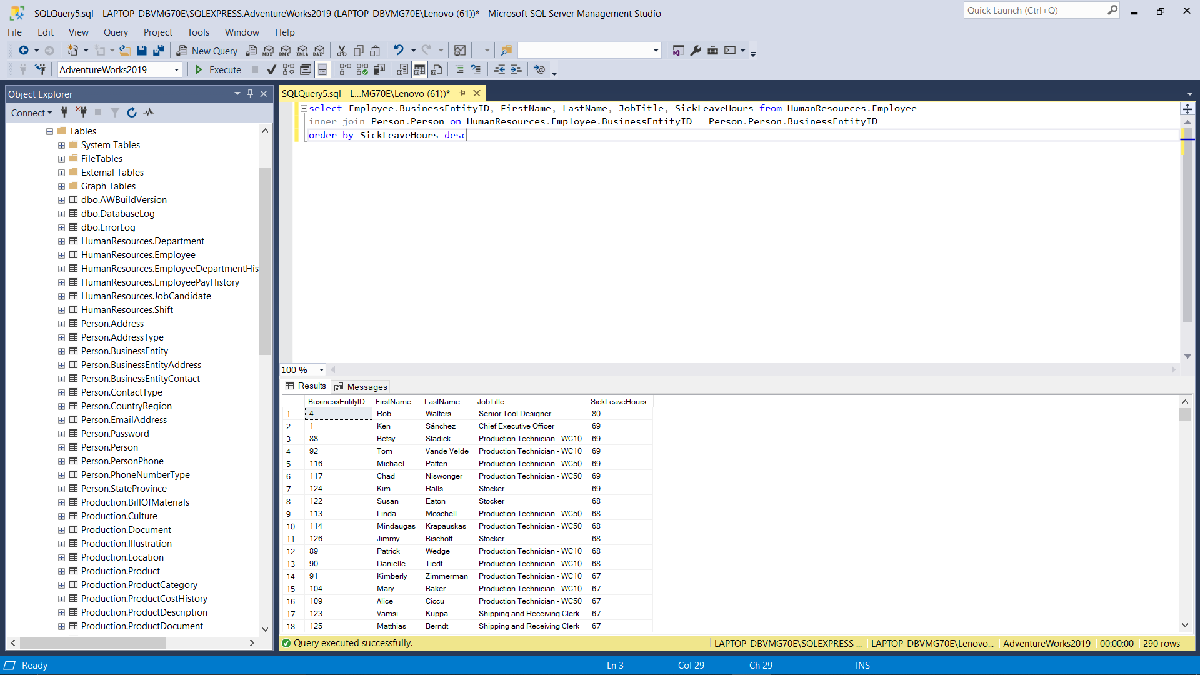

2. Print the names of the employees that took the second highest leaves

 get the 2nd highest no of leaves.

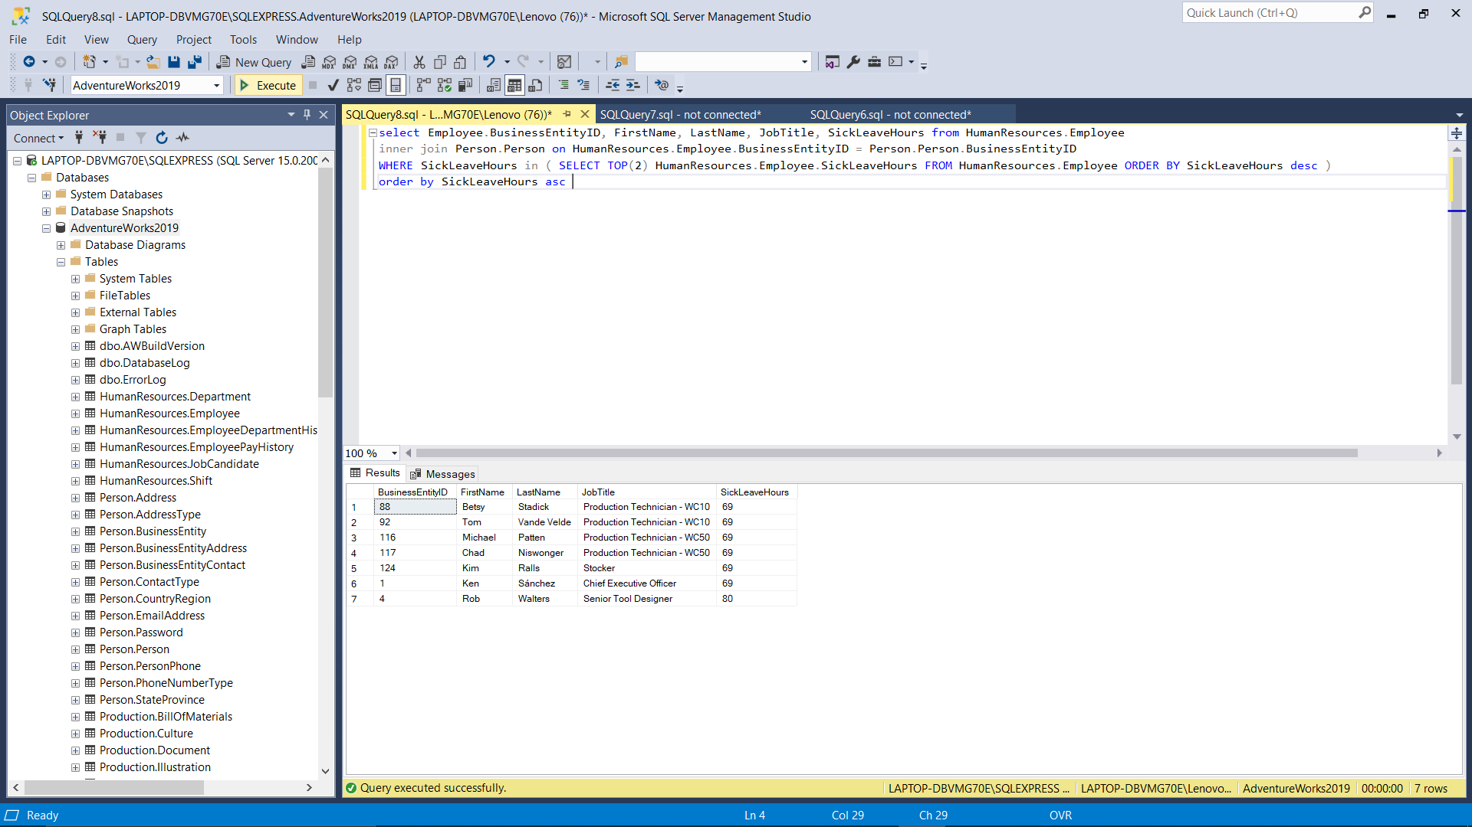

3.Print n th THTHth highest salary

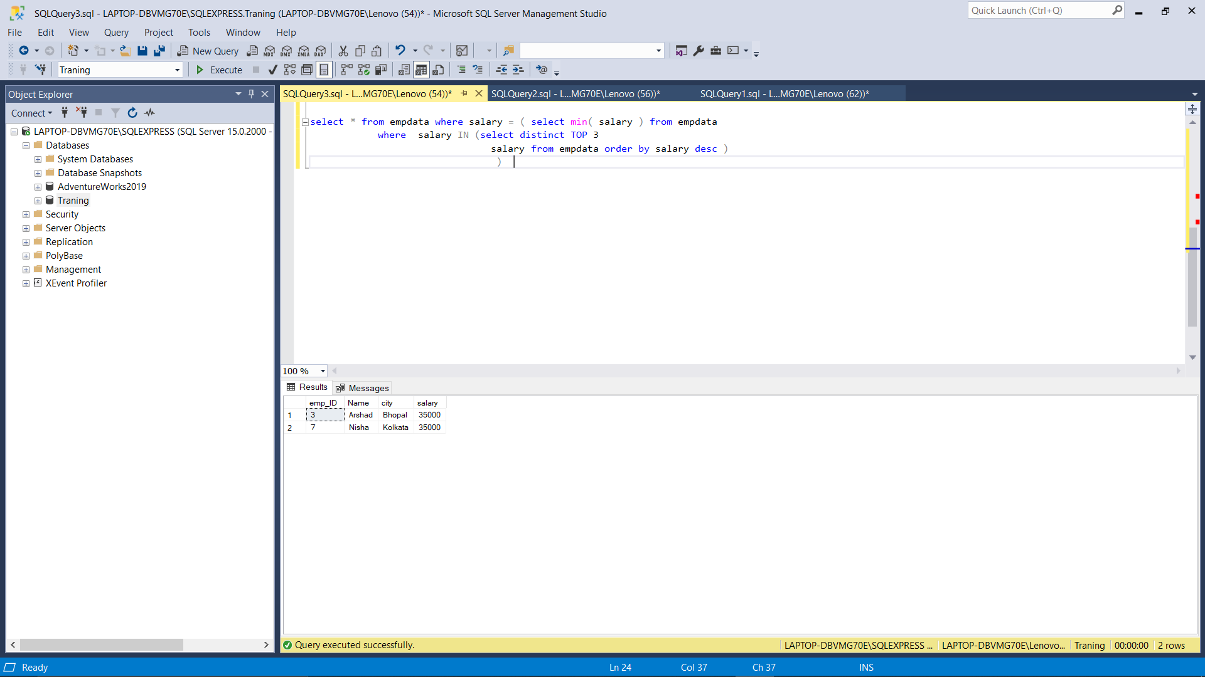

1.Print Name of the employee, Department name, StartDate, EndDate - Ordered by Employee, StartDate ascending

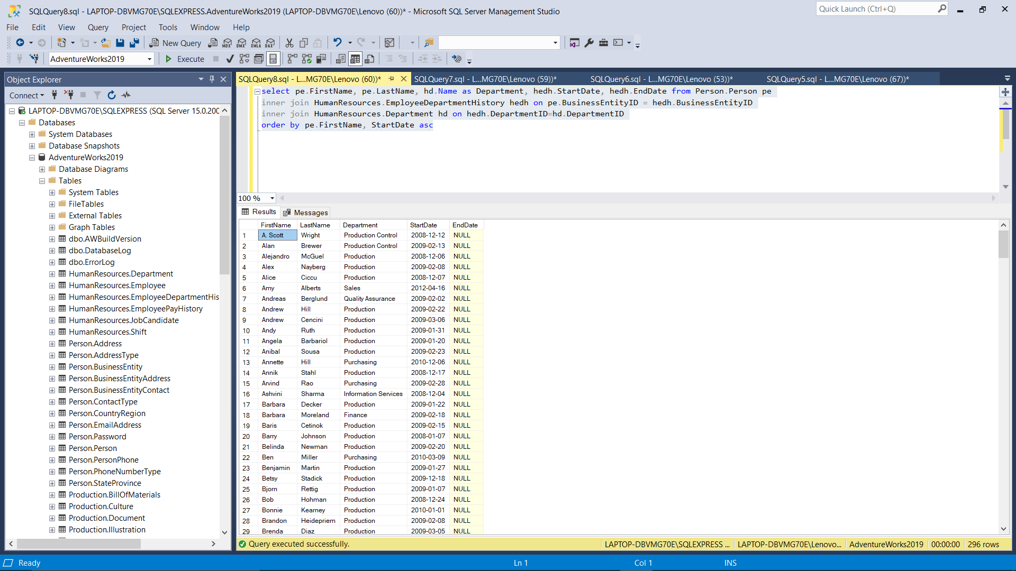

2. Print the Employees that are assigned to more than one department

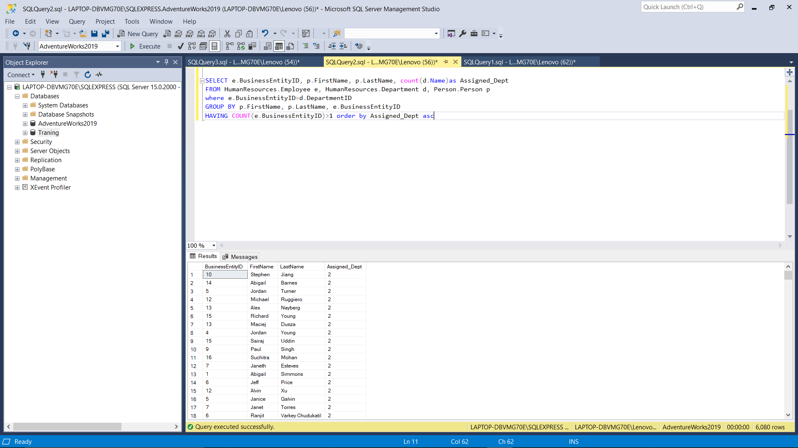

3.Print the number of employees that are not assigned to any deparment.

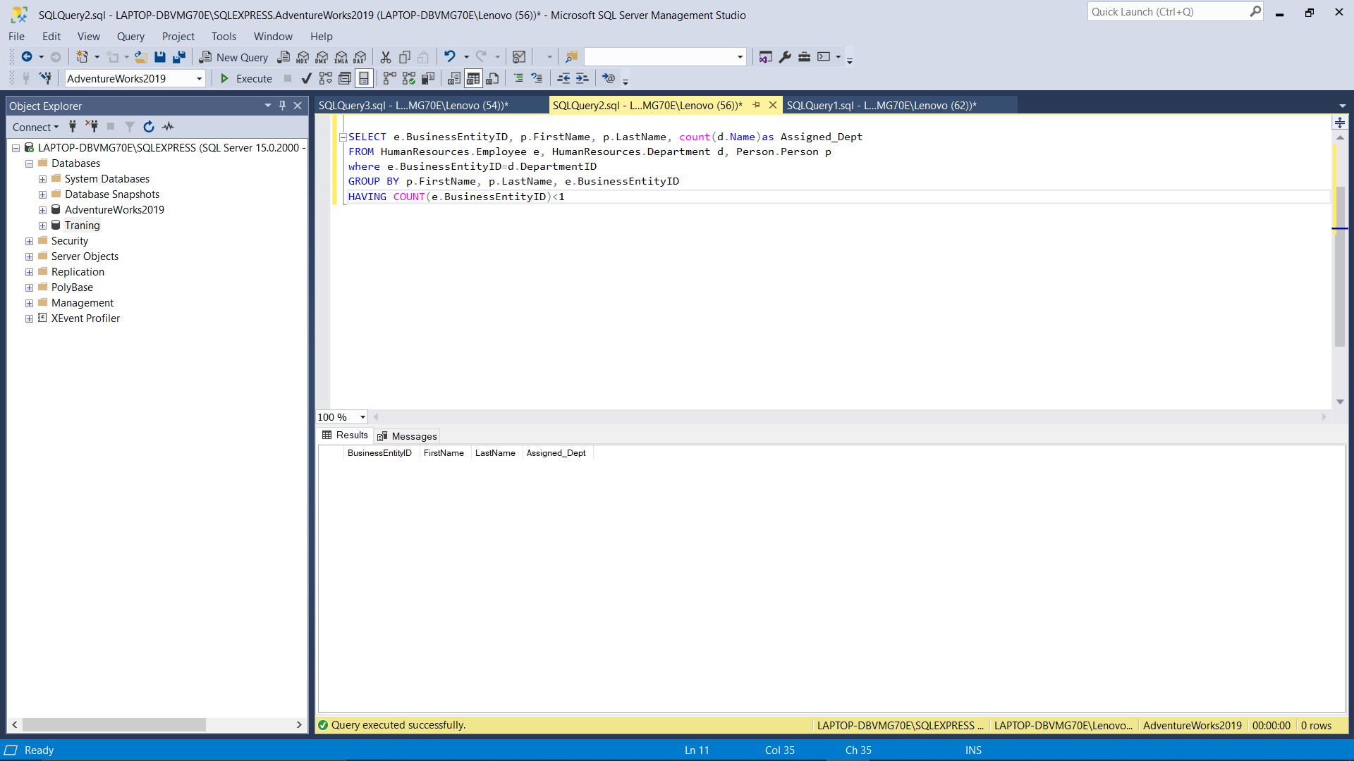

4.Print the number of employees by their shift [ Number of employees working day, evening, and night ]

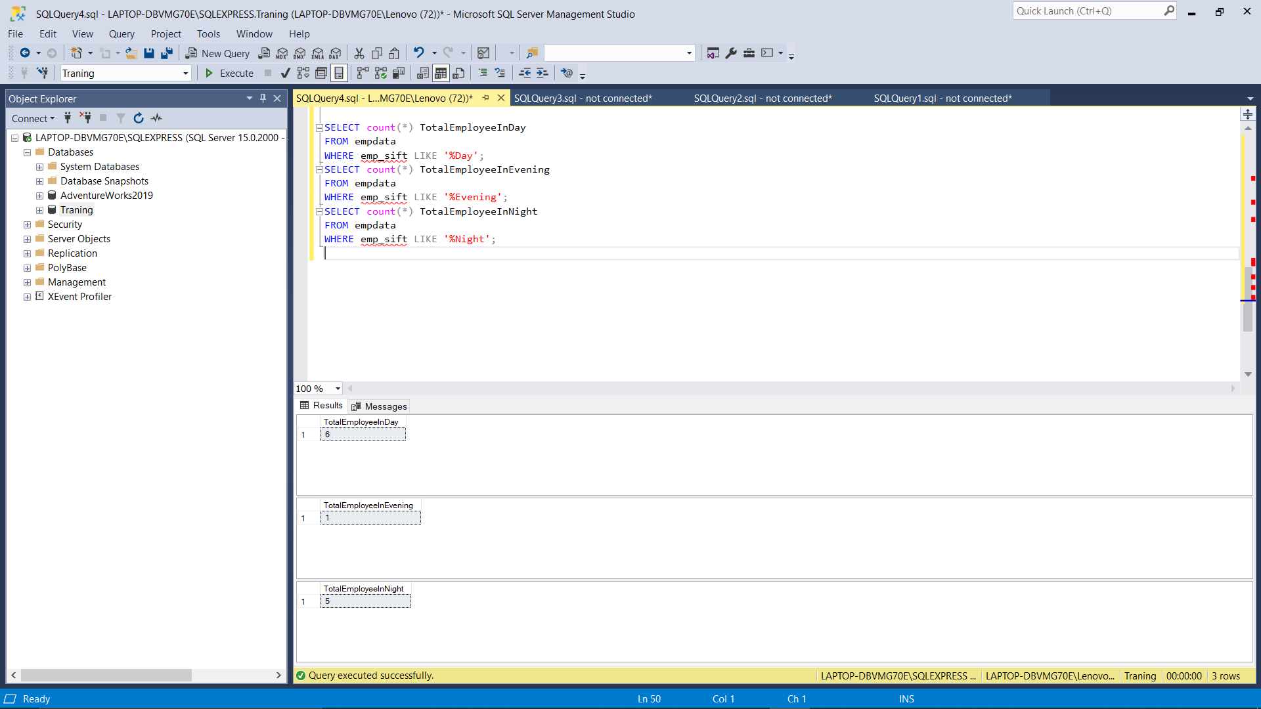

5.Print Number of Emplyoees  by CountryRegionName

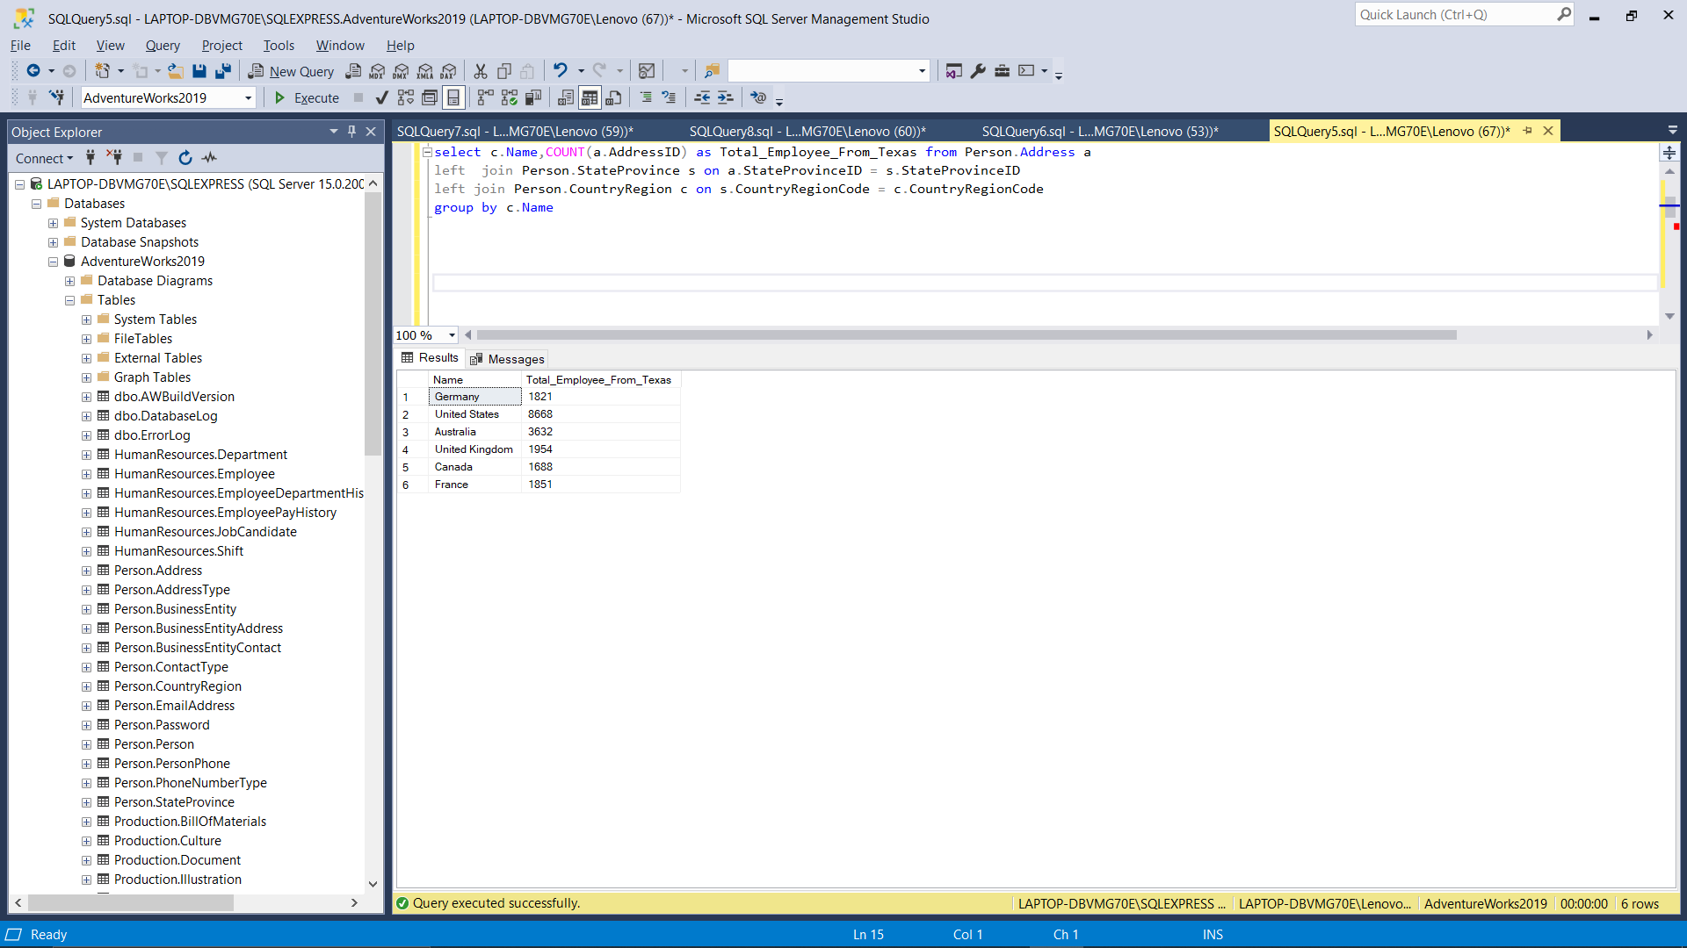

6.Print the name of the CoutryRegion with the highest number of employees

0 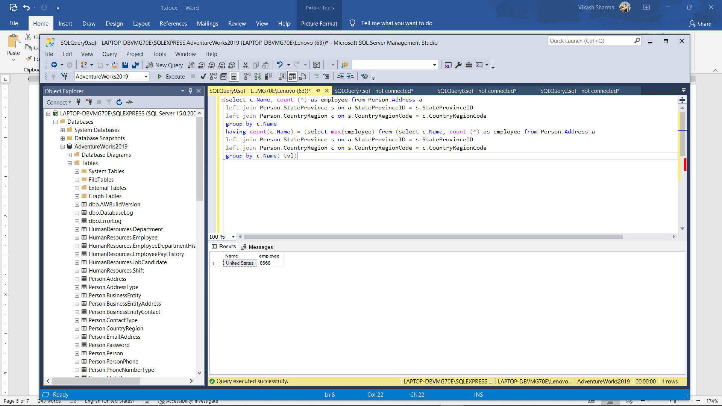

1. Print the employee with their Home address detail

First Name, Last name, AddressType = Home, Line1, Line2, City, State ( I want the name of the state here ), Postal Code and Country

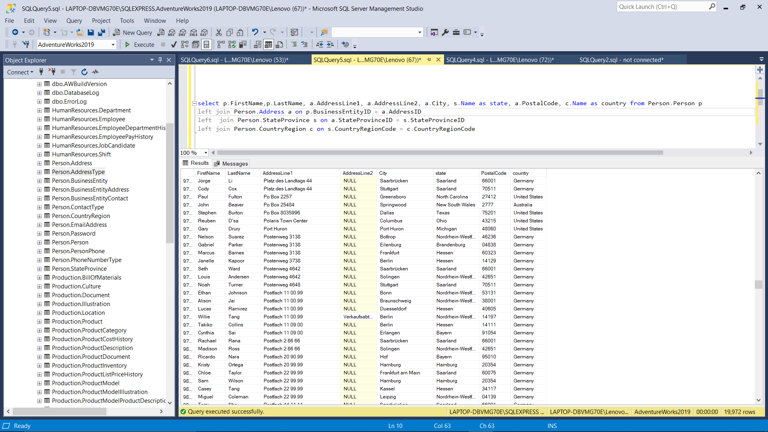

2. Print the number of employees that don't have shipping address

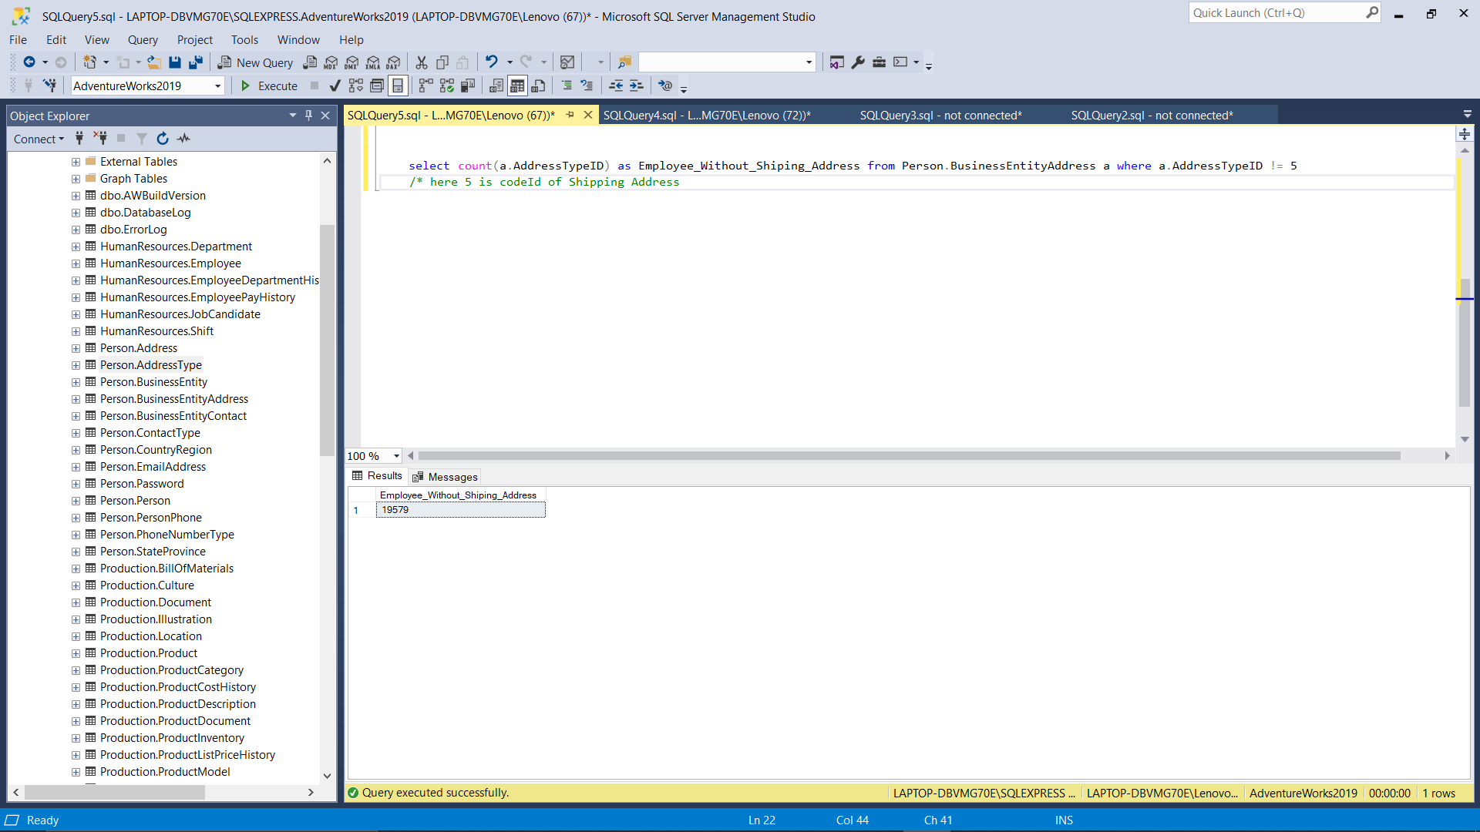

3. Print the number of employees that have Home + Billing addresses

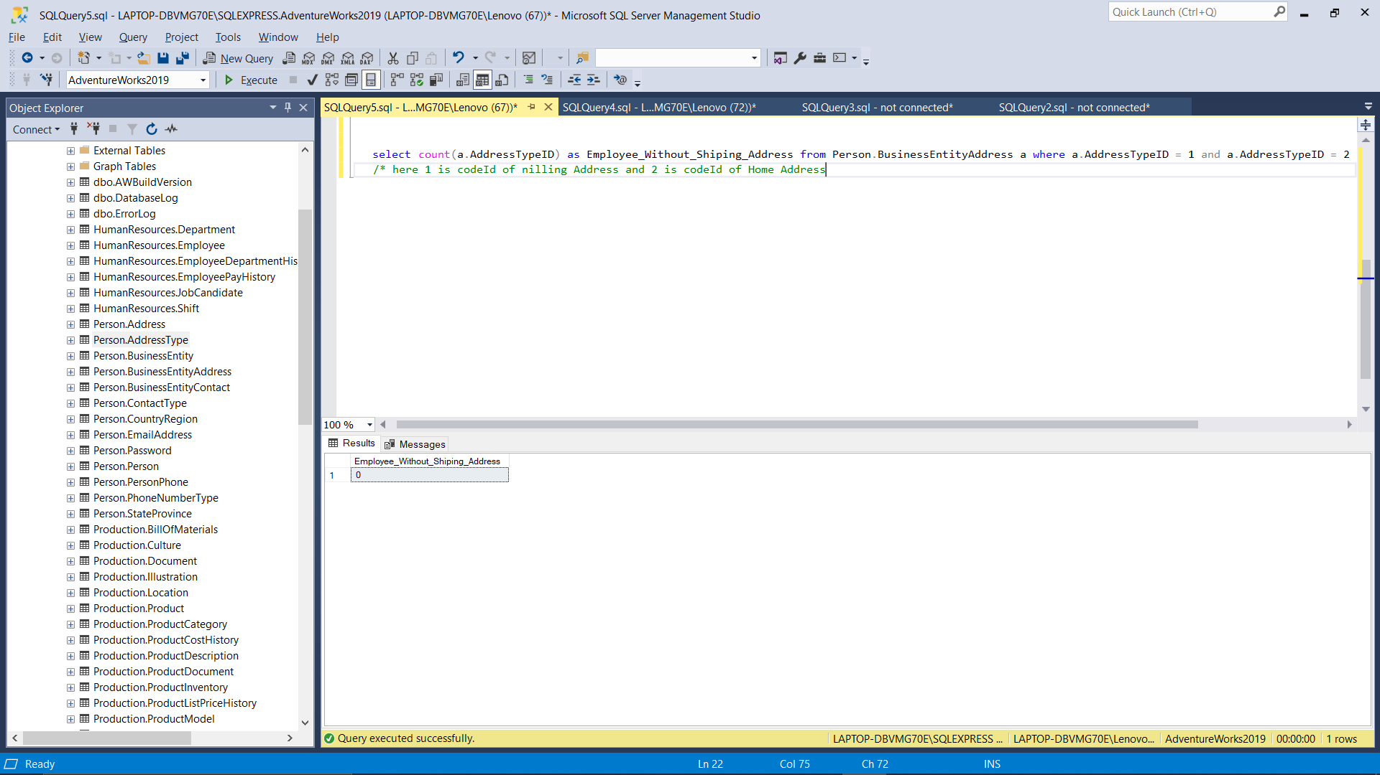

4. Print the count of employees that are living in Texas state.

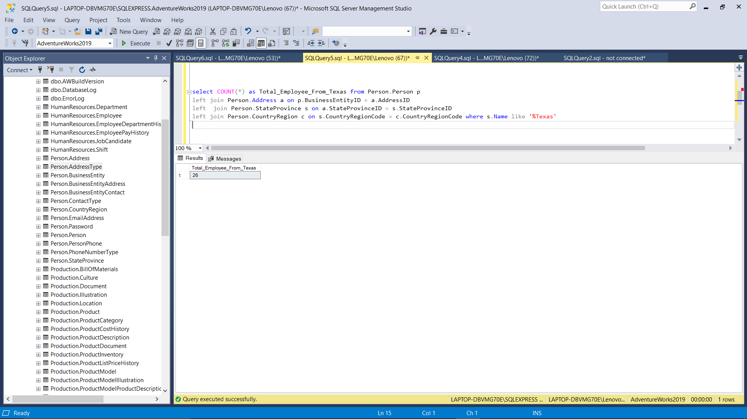

1. Get the customers and their Sale value ( total due )

2. Get the names of the salespersons that did the highest sale

3. Number of sales by Online vs non-online

4. Number of sales by their status

5. Print the number of customers by Product

6. Print the most popular product

7. Print the products by their revenue.