1. How do you check whether a string contains a substring
2. How do you validate an email in JavaScript
3. How do you get the current url with JavaScript

Ans:- **window.location.href** and **document.URL**

1. **location** object in javascript

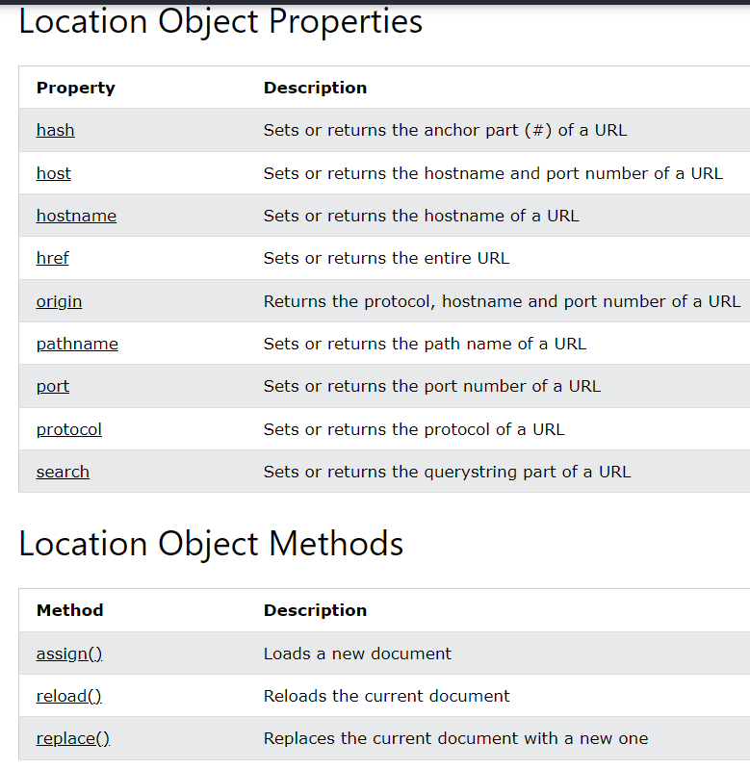

1. **document** object in javascript

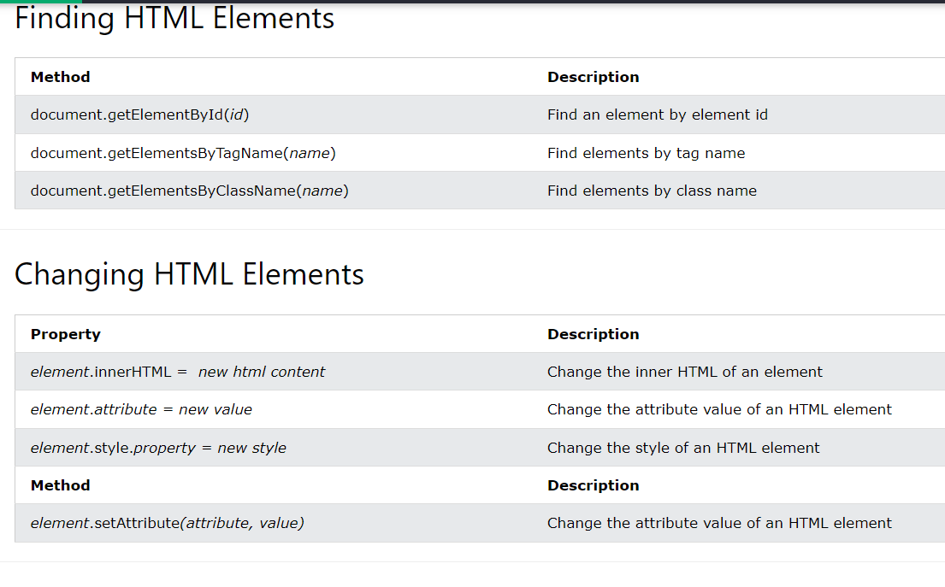

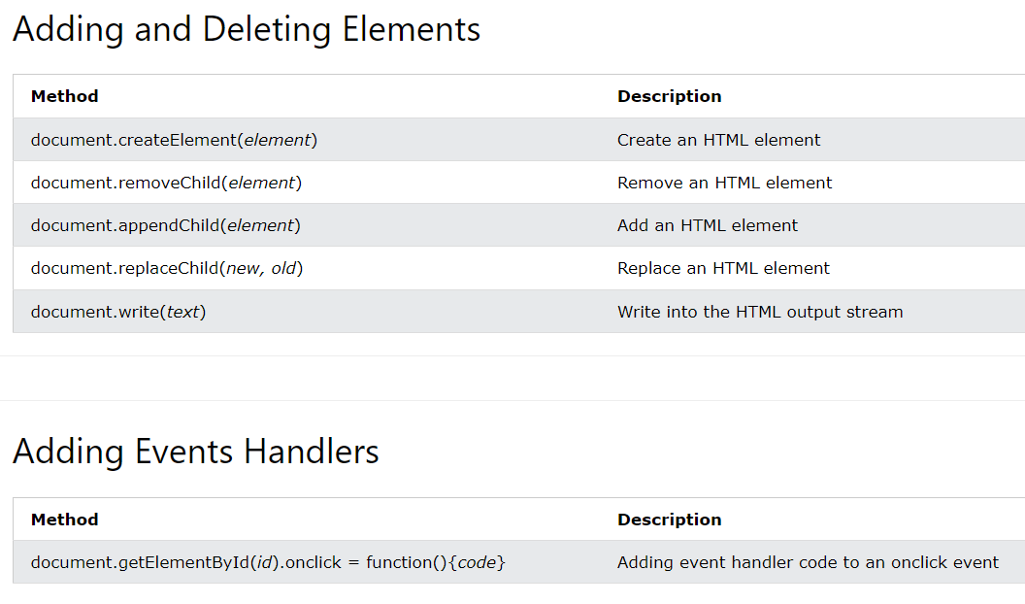

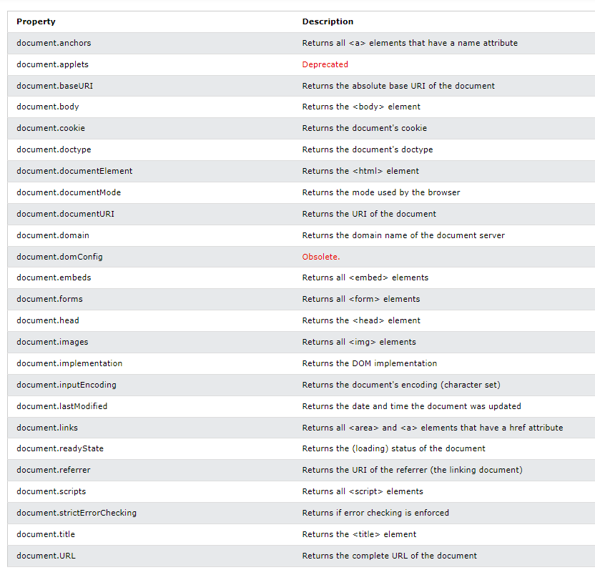

1. How do get query string values in JavaScript

**let params = new URLSearchParams('q=node&page=2');**

**params.get('q'); // 'node'**

**params.get('page'); // '2'**

1. How do you check if a key exists in an object
2. How do you test for an empty object
3. How do you make first letter of the string in an uppercase
4. How do you display the current date in JavaScript
5. How do you compare two date objects
6. How do you check if a string starts with another string
7. How do you trim a string in JavaScript
8. How do you add a key value pair in JavaScript
9. Is the '!--' notation represents a special operator
10. What is the way to find the number of parameters expected by a function
11. What is a polyfill
12. How do you generate random integers
13. Can you write a random integers function to print integers within a range
14. How do you search a string for a pattern
15. What would be the result of 1+2+'3'
16. How do you convert date to another timezone in JavaScript
17. promise code
18. async/await code
19. promise using async and await
20. How to convert string to title case with JavaScript
21. How do you determine two values same or not using object
22. How do you copy properties from one object to other
23. How do get the timezone offset from date
24. How do you convert character to ASCII code
25. How do you combine two or more arrays
26. How do you return all matching strings against a regular expression
27. How do you trim a string at the beginning or ending
28. How to remove all line breaks from a string
29. What happens with negating an array
30. What happens if we add two arrays
31. How do you map the array values without using map method
32. How do you rounding numbers to certain decimals
33. What is the easiest way to convert an array to an object
34. What are the placeholders from console object
35. Is it possible to add CSS to console messages
36. What is the purpose of dir method of console object
37. Is it possible to debug HTML elements in console
38. How do you display data in a tabular format using console object
39. How do you verify that an argument is a Number or not
40. Explain what is a callback function and provide a simple example
41. Write a recursive function to calculate multiplication of numbers? Example:4x3x2x1
42. Write a function to find a non-repetitive characters in a string?
43. Write a program reverse each word in the given sentence?
44. Write a project to check if an object is an array or not?
45. Write a program check if a number is an integer or not?
46. Write a function to delete duplicate number from an array?
47. Write a function to reverse a given string?
48. Find the sum of all elements\numbers of a given array?
49. Find a word in a sentence
50. How to convert an object into array in JavaScript?
51. How to convert an array to object in JavaScript?