*The outline* of our major course started with Algorithmic Thinking and for the last few sessions we have been working on our project of building games using **GDevelop 5** an open-source application. One of the games created by this application is called ***Forrest Gump***. 

*This game* has a player called FG (Forrest Gump), with some of its special features, and yes there are few challenges faced by the player during the gaming time. A player fully utilizes the screen space by navigating with the help of some keys. In the game the player gets a total of 3 minutes to win the game. There is a simple challenge that the player has to escape from getting hit/touched by the ball when FG is on the ground.

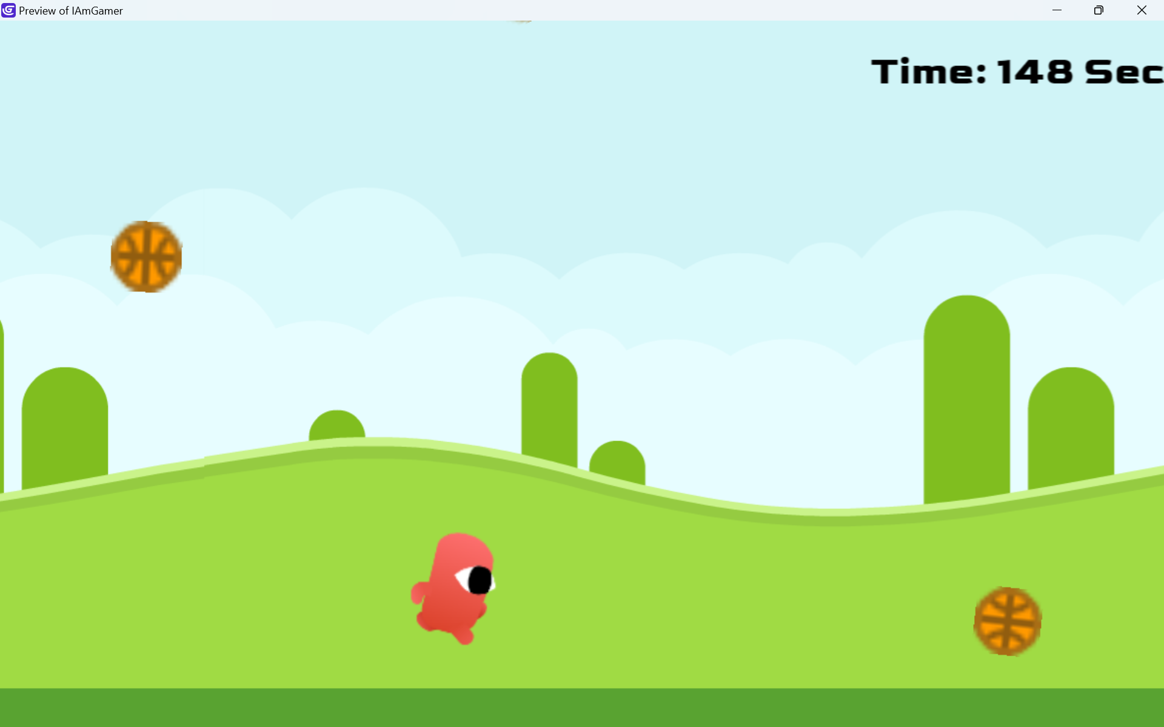

The keys we use while playing the game are:

* To run left side **[left arrow key]**
* To run right side **[right arrow key]**
* To jump **[up arrow key]**
* To pause FG **[space key]**
* To increase speed of FG **[f key]**

*My experience* through this journey has been interesting and exploring. I was able to understand the scenarios of the gaming environment which I never thought about earlier. I have been coding by writing commands and the set of instructions in the form of coding languages but working with UI (User Interface) conditioning, gave me another good experience about UI algorithmic functioning. I liked the step-by-step building procedure of the game most as it gave a kind of dimension to the game and the end result happened to be a part of a game. The game naming credit goes to Om.



