# Becoming a Reflective Information Scientist [Group-2]

## Task 1. Finding counterfeit coins:

1. There are eight identical-looking coins; one of these coins is counterfeit and is known to be lighter than the genuine coins. What is the minimum number of weighings needed to identify the fake coin with a two-pan balance scale (see image below) without weights?

Ans: There are 3 minimum number of weighings needed to identify the fake coin   
 with a two-pan balance scale (see image below) without weights.

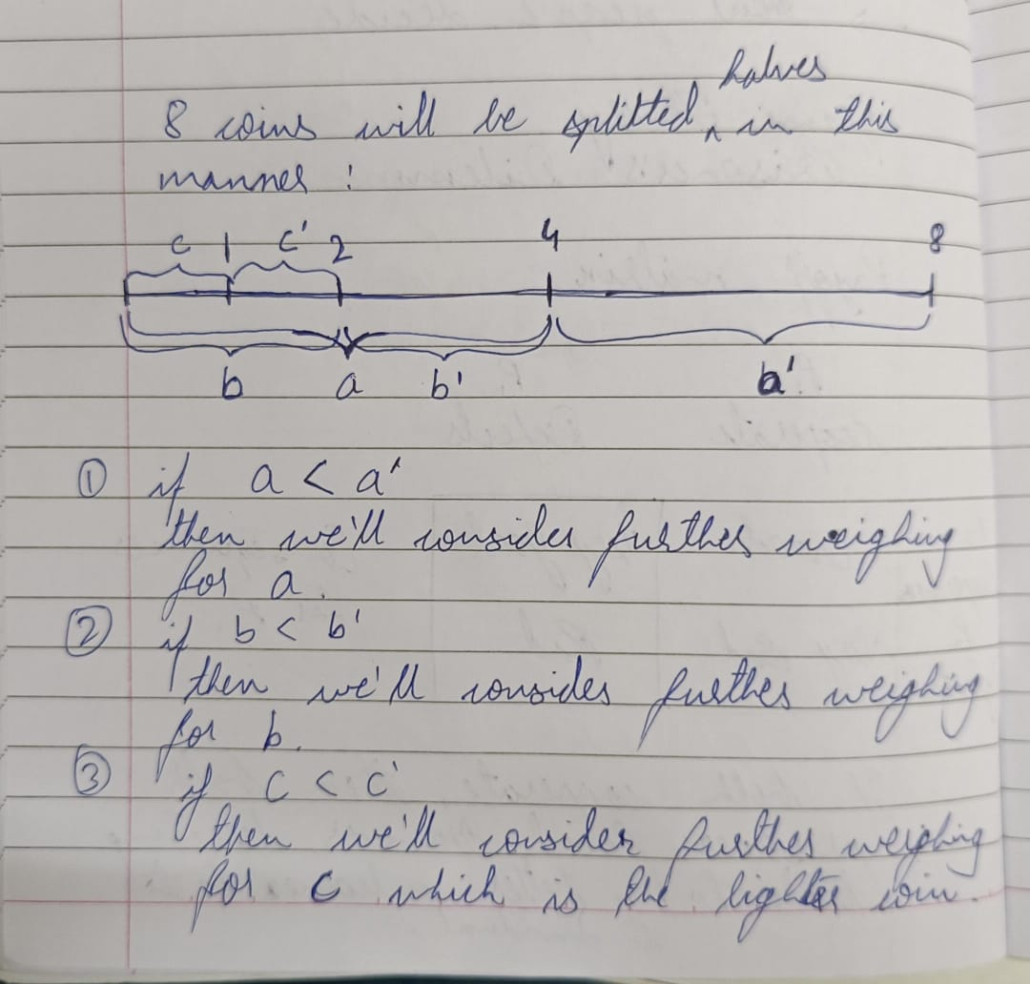

1. There are 10 stacks of 10 identical-looking coins. All of the coins in one of these stacks are counterfeit, and all the coins in the other stacks are genuine. Every genuine coin weighs 10 grams, and every fake weighs 11 grams. You have an analytical scale (see image below) that can determine the exact weight of any number of coins. What is the minimum number of weighings needed to identify the stack with the fake coins?

Ans: There are 4 minimum numbers of weighings needed to identify the stack  
 with the fake coins…

10 stacks will be divided into 5-5 stacks. 1 stack of genuine coins is 500g while 1 stack of counterfeit coins is 510g. If we weigh one of these 5-5 stacks and find it 500g then the other

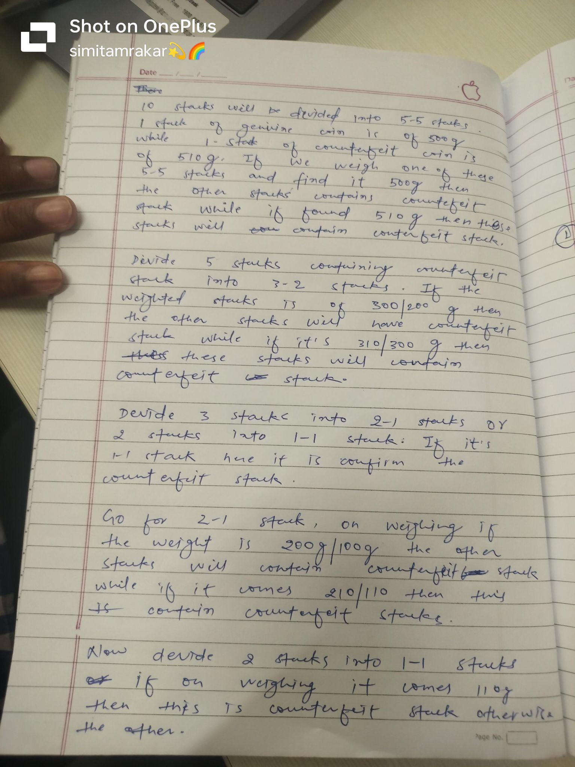

## Task 2. Course selection

Part a:

1. Argue that NH + NU is the same irrespective of the method used to allocate electives.

Ans:

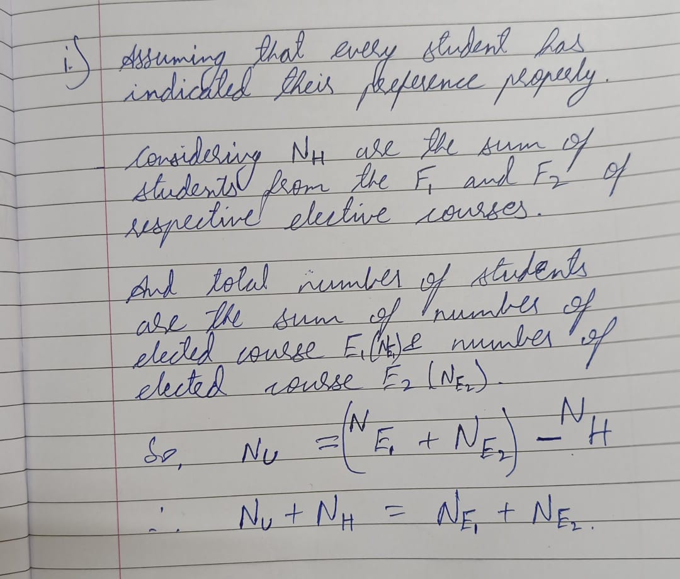

1. For each elective, define the excess demand (ED) as follows:

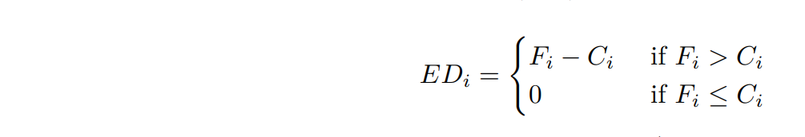   
Argue that irrespective of the allocation scheme, NU ≥ (ED1 + ED2).

Ans: NE1 = Number of total students in Course E1.

NE2 = Number of total students in Course E2.

Since Nu = (NE1 + NE2) - NH

And we also know that:  
 NH = F1 + F2

Similarly, (C1 - F1) + (C2 - F2) ≥ NU

We can say that *Unhappy* students elected for E2 but since the ED2 that option got  
 transferred to E1 and student got enrolled out of the remaining i.e. (C1 - F1) and   
 similarly for E1 i.e. (C2 - F2).

Therefore, ED2 + ED1 ≥ NU

i.e. NU ≥ ED1 + ED2

Part b:

1. Is it still the case that NH + NU is the same irrespective of the method used to allocate electives?

Ans: Yes, it is still the case that NH + NU = Total number of students   
 i.e. NH + NU = NE1 + NE2 + … + NE9

1. Is it still the case that NU ≥ (ED1 + ED2 + ... + ED9)?

Ans: Yes, it is still the case that   
 NU ≥ (ED1 + ED2 + ... + ED9) from II of part a

1. It is easy to see that there are scenarios where no allocation can make every student happy. However, is it always possible to make every student unhappy?

Ans: No, it is not **always** possible to make every student unhappy. When the *happy*

*a student* is late in electing the *First preference(F)* course, then the *unhappy  
 students* will get the *F* course.

## Task 3. Generalizing the notion of distance

1. The fare required to travel from station x to station y.

Ans: The fare does not necessarily satisfy the triangle inequality as the fare from x to z  
 could be more or less than the sum of the fares from x to y and y to z, depending  
 on pricing structures or fare rules, so it cannot be considered to be a distance  
 function.

1. The number of trains plying between x and y.

Ans: This quantity does not satisfy the triangle inequality as having multiple trains  
 between x and y does not guarantee that the number of trains between x and z is  
 less than or equal to the sum of trains between x and y and y and z.

1. The absolute value of the difference in the latitudes of x and y.

Ans: This satisfies all the properties of a distance function, so the absolute value of the  
 difference in the latitudes of x and y can be considered a distance function.

## Task 4. The MU System

1. Give a few examples (around 5) of strings that can be obtained using the rules. Show how to obtain these strings starting from MI.
   1. Ans:
   2. Example 1: MI -> MIU (rule 1)
   3. Example 1: MI -> MIU (rule 1) -> MIUIU (rule 3)
   4. Example 4: MI -> MII (rule 2)
   5. Example 2: MI -> MII (rule 2) -> MIIII (rule2)
   6. Example 3: MI -> MII (rule 2) -> MIIII (rule2)-> MUI (rule3)
2. Argue that it is not possible to obtain the string MU starting from MI using these rules

Ans:

We have to start from MI and get to MU. MU has zero times I

## Task 5. A model for auto fares

A Model Description for an Auto fare from Sarjapur Circle to University Campus:

| **Fare Factor** | **Fare Factor Description** | **Value** |
| --- | --- | --- |
| Regular | Fixed starting fare for first 2 kms | ₹ 30 |
| Distance | Fare for the remaining distance like 6 kms | ₹ 15/km |
| Traffic | Extra charge due to heavy traffic | ₹ 20 |
| Rainy | Extra charge for rainy weather | ₹ 25 |
| Peak hours | Extra charge due to rush hours or night hours demand | ₹ 20 |
| Luggage | Extra charge due to overload luggages | ₹ 50 |
| Over passenger | Extra charge due to over passenger with respect to the auto | ₹ 15/person |