# Reflection Journal

### **Post 1: Information (DIKW Model)**

Generally students introduce their degrees like BCA, B.Tech, BA English and so on which most of the people understand easily. But in my case it was not the same, I remember when people asked me about the degree I am pursuing right now. I used to say it’s BSc. (Honours) Information Sciences and expected from them that they would understand it. Apparently they always used to pause me there and ask first, “Wait wait… what is Information Sciences about…” and I used to ask the same question to myself. I used to be puzzled, not on my face but in my brain - what to say, what not to say. However I could manage to explain to them something related to computer sciences. Which was neither completely wrong nor completely right but a part of it. Let’s see how this explanation became better.

Let me take you to the real meaning and a brief reflective journey behind it. I guess our Instructor was already aware of this question. That’s the reason we had the tour about our own major and later made us feel learned and readied us for answering that next time with our full confidence. All started with a model called the DIKW pyramid. A pyramid model that explores the Information as one of the 2nd stages. The Data, Information, Knowledge, and Wisdom (DIKW) - Pyramid Model which explains each respective layered stages where we understood the growth of raw data/material to some meaningful and usable value. From here we extracted the meaning of Information and combined it with the term Sciences. So, when you ask me, what is Information Sciences about, then I would reply, with a nice and peaceful breath in with confident voice that anything which answers the basic questions like “who”, “what”, “where”, and “when”; and is organized well, maintained in structure, and properly contextualized could be referred as Information and blends the nature of Sciences which is evolving interdisciplinary major Information Sciences.

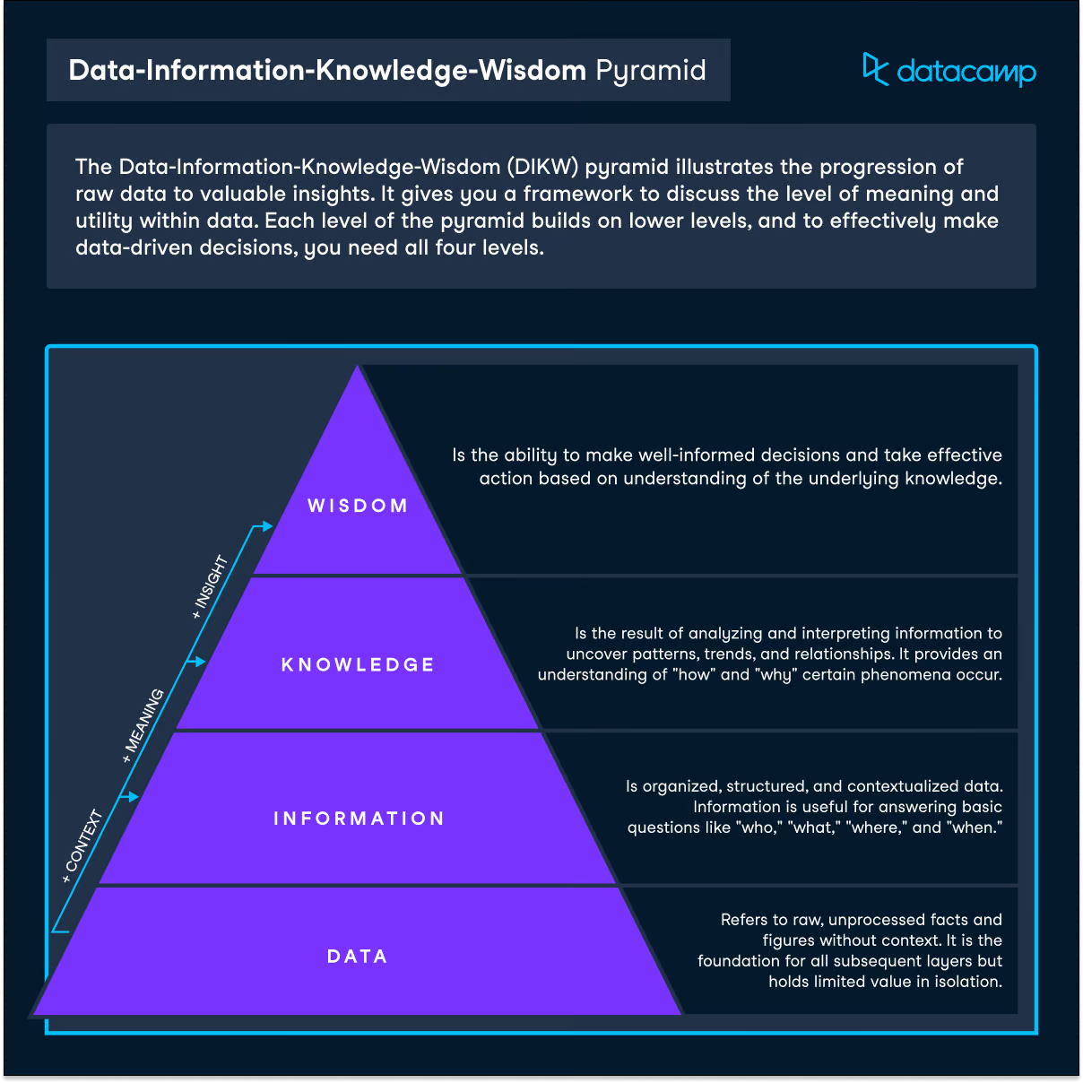

### **Post 2: Abstraction**

Since childhood until now I have observed teachers drawing the human as stick figures whenever they wanted to explain something about the human or anything related to humans, with the class pace. As an art interested child I always questioned myself about drawing some sticks together on the board to represent the human figure and the walking human in the real world. How are they both the same? And perhaps we also understand that the figure drawn, represents a human being. A complex idea of different human body postures, which we abstracted into a simple and easier, stick figure that represented a human. Now I should reveal that to you, this is the power of abstraction that we have been observing and using most of the time. This is one sampling that presented here but I’m sure you’d be experiencing many.

As a reflective information science student, I could reflect back that abstraction has generalised and simplified most of the complicated and complex problems into easier understanding. One of the interesting and perfect examples that was used in the class was the train graphs, which was the abstraction skill to resolve complex problems of the conflicting trains schedules and their routes. The metro maps routes on the metro stations and the digital routes of buses and trains on our smartphones shows the clear and precise path by excluding the extra details of surrounding and focusing on the routes that the specific vehicles followed. Also the interesting idea about metro maps is that the routes are designed in a straight line rather than the exact proportion of the routes. The idea of abstraction inspired me to think creatively when it comes to simplifying and generalizing complex problems. Which not only helps the software engineers and computer scientists like we are going to be, who creates clear and effective products and programs solutions but is also liked by many people in this generation.

### Post 3: Decision Theory

Daily in our life we make decisions on the basis of our preferences out of the available choices. In fact humans make decisions every moment based on their experiences and information from wearing dresses to eating food. All these actions of thoughts fall under the multidisciplinary field called Decision Theory. Let’s explore a glimpse of Decision Theory in this reflection.

Decision Theory is the study of rational decision making, basically how a person makes choices in a particular situation. We call decision-making under risk when we make rational decisions based on uncertainty and known probabilities, that is when the chances of each outcome are specified. When we talk of this theory, it becomes important to understand its branches too. It has two primarily branches known as Normative and Descriptive Decision Theory. A normative decision is how a person **should** be making decisions based on their ideal rationality. Whereas descriptive decision is how a person **actually** makes decisions based on their experiences. These two branches of statements are often used in our daily speeches in the form of moral arguments. For example a person living on the 14th floor should be taking a lift to come down on the ground floor as it reduces human energy. But in a case where a person is already experienced about the timing of reaching the lift on the floor is too long and the person is fine with the stairs then the person takes the stairs to reach the ground floor in a time while a lift reaches the floor. This example fits when you are running out of time, especially when you have a class of Becoming a Reflective Information Scientist (a single seconds matter). These two glimpses of examples are of normative and descriptive decisions theory respectively.

I really enjoyed and got interested in this field as I am also interested in Psychology. During the course we also covered Game Theory, a part of Decision Theory where we took the examples of Prisoner’s Dilemma and also the Game of Chicken. The images below would explain better.

### Post 4: Hugo server

In the course we came across many technologies and softwares. For image processing we used a software called Image J, to learn markdown script (tags which is used to format the content) we used a platform called Wiki. And now Hugo software by the help of which you are able to see all these reflection posts in the form of User Interface (UI). Let me take you to the journey of this exciting and amazing reflection.

Hugo is an open source and free to use software framework. Which is used for generating the websites and webpages. It is a static (not dynamic) site generator where a few sets of commands builds a website in the fastest way. We have been using this for creating reflection websites and one of them is this. Where we get a set of built in themes and on the basis of selected themes, we create different pages that show up on the web in the form of websites (having multiple pages) and webpages (a single page or a landing page). And when the pages are ready to be live, then we just need to upload all the folders and files from the ‘public’ folder to a server which makes them available on the internet (visible for everyone) that is called deployment.

I was amazed with this framework because I have been using different softwares and frameworks like React JS, Next JS where we actually need to write the code. The difference is only that in the Hugo server we write script in the form of markdown whereas in these softwares we actually code using HTML (Hyper Text Markup Language) tags and make use of dynamic data to show on the UI. We have more control on each aspect of the pages and its behaviour. So if you are looking to generate your own static websites then you can explore hugo framework.

### Post 5: Can AI replace Human

The way Artificial Intelligence is improving, it seems like it can replace humans. But my dear friends, that is too far from now. Although there is some veracity to this, from my point of view, this will never be possible. As one of my friends Arnav mentions in his post about the similar thought.

Alan Turing, one of the fathers of the computer science revolution. The fact that now there are a lot more layers integrated into the Turing test, such as the Winograd Schema Challenge and the Lovelace test 2.0, as he mentioned in his presentation, AI is evolving day by day, coming closer to human intelligence. We indeed are falling into the Turing Trap. We want artificial intelligence to do our household chores and give us more time to think and not the vice-versa. I do agree with Arnav. Research must not be driven towards AI having emotions and consciousness. Even if it does so, I do believe that there are laws of nature that humans cannot tamper with. This might be a bizarre thought, but as we invest more into AI, there should be some mechanism in the making of AI that can disable it completely. This is to be just on the safe side.

My topic for the presentation was the 'Energy Consumption & Climate Impact of Digital Infrastructure'. It was rightly a good content to explore. As being an Information Sciences student, it becomes our duty to get aware of impacts of the technologies on our surroundings and climate change and also power consumptions by them. I got introduced to a new topic called Information Communication Technology (ICT) which is nothing but software and hardware that is used to share and create information on the Internet. I used to think that reading on e-book is more of a nature saving resource than reading/using books/papers but I was amazed when I came across this learning. We know that paper is created from Trees which harms a sort of environment but we have been recycling most papers so some reduction of environmental impacts seen. Similarly the ICT also uses the powers by burning the fossil fuels to generate electricity which is used in high amounts to maintain its data centers and the devices usage. Which accounts into the Climate Change and Greenhouse Gases (GHGs) emissions. There is a solution for this too that usage of renewable energy can reduce GHGs. I learnt by proper usage of these technologies and books can balance the impacts and reduce the Energy Consumption & Climate Impact of Digital Infrastructure.

The presentation by group 5 on the topic ‘The power and influence of Big Tech’ made me think a bit about the restriction on policy and access given by the MNCs for opensource technologies. There are some open source softwares and technologies which need access by the admin to be able to make changes and add features. These softwares would be free to use but not granted access to make changes because of their data, and privacy precautions. And this is not a fully private source as well. In private we don’t have access to review and see the code and not even have access to use that software without subscription. I was incited to know this information and to be able to reflect back to our course that is becoming an information scientist.