PREPARED BY STRATEGY ADVISORY · V1.0 · AUGUST 2026
MARKET & PRODUCT ANALYSIS / DATIQ.APP
━━━━━━━━━━━━━━━━━━
From URL to
Intelligence
— and what comes next.
A product, market & competitor review of Datiq V1.0 — covering the single-URL home screen, every module, 30+ prioritised features, and a multi-quarter roadmap to drive user engagement.
This report benchmarks Datiq.app against 30+ products across five adjacent categories, audits the single-URL home screen and every module, and delivers a prioritised list of 30+ features scored across three frameworks — RICE, custom weighted (effort / effectiveness / engagement / usefulness), and MoSCoW with an effort-impact matrix. Quick wins, medium-term bets, and strategic multi-quarter initiatives are sequenced into a 12-month roadmap.
PRODUCT AUDIT · SINGLE-URL CRITIQUE · COMPETITOR MATRIX · RICE + WEIGHTED + MoSCoW · 12-MONTH ROADMAP · 30+ FEATURES
AUDIENCE  Product & Engineering | DEPTH  Comprehensive | ISSUE  2026 · 08
DATIQ.APP · Intelligence from every URL · Page 1 / Cover

Table of Contents
Right-click here and choose "Update Field" to refresh the table of contents →
1. Executive Summary 2
Headline findings 3
Top 5 prioritised recommendations 4
How to read this report 4
2. Datiq Product Overview 4
2.1 What Datiq is — and is not 5
2.2 Category position and launch timing 5
2.3 Pricing architecture (8 tiers) 5
2.4 Tech stack and architecture 6
3. The Single-URL Home Screen — Does It Make Sense? 6
3.1 How the home screen actually works 7
3.2 Where the single-URL metaphor wins 7
3.3 Where the single-URL metaphor falls short 8
3.4 Six quick enhancements to drive engagement 9
4. Module-by-Module Feature Audit 10
4.1 Extract (default home) 10
4.2 Batch (multi-URL extraction) 10
4.3 Schedules (recurring monitoring) 11
4.4 Dashboard (saved-extractions archive) 12
4.5 Collections (folder/grouping) 12
4.6 Preview / Enrichment (post-extraction) 13
4.7 Account (billing, white-label, invoices) 14
4.8 Gallery (public shared reports) 14
4.9 Help / Docs 15
4.10 About / Privacy / Terms / Use Cases / Integrations / Changelog / Blog 15
5. Competitive Landscape Analysis 16
5.1 Category 1 — Note & Knowledge Management apps 17
5.2 Category 2 — Personal Productivity / Task apps 17
5.3 Category 3 — Bookmark / Read-Later apps 17
5.4 Category 4 — Async Work / Unified Inbox / Day Planner apps 18
5.5 Category 5 — AI Companions / AI-first interfaces 18
6. Competitor Feature Matrix 19
6.1 Reading the matrix — five headline observations 20
7. Persona & Segment Recommendations 21
7.1 Sales / SDR / BDR 21
7.2 Competitive Intelligence 22
7.3 SEO / Content Marketer 23
7.4 Market Researcher 24
7.5 Recruiter 25
7.6 Startup Founder / VC 26
7.7 Agency / Enterprise 27
7.8 Five emerging personas Datiq could unlock 28
8. Differentiation Opportunities & Feature Gap Strategy 29
8.1 Theme 1 — Knowledge Layer Over Extractions 29
8.2 Theme 2 — Capture Surface Expansion 29
8.3 Theme 3 — Action Layer (AI Agent Actions) 30
8.4 Theme 4 — Collaboration Layer 31
8.5 Theme 5 — Workflow Layer 31
8.6 Theme 6 — Trust Layer (Social Proof & Brand) 32
9. Scoring Methodology 33
9.1 Framework A — RICE 33
9.2 Framework B — Custom Weighted Score 33
9.2.1 Dimension definitions 34
9.3 Framework C — MoSCoW + Effort/Impact 2×2 Matrix 34
9.4 Combined Priority Score 34
10. Prioritised Recommendations — Quick Wins (0-3 months) 35
10.1 Top three quick wins — rationale 35
#1 Recent-URLs row on home screen (ETA: Week 2) 36
#2 Smart-paste detector (ETA: Week 3) 36
#3 Post-extraction action bar (ETA: Week 4) 36
11. Prioritised Recommendations — Medium-Term (3-9 months) 36
11.1 Top three medium-term — rationale 37
#13 Browser extension MVP (ETA: Q2 Week 4) 37
#14 Knowledge graph RAG (ETA: Q2 Week 8) 37
#15 Zapier / Make / n8n connector (ETA: Q2 Week 6) 38
12. Strategic Bets & Future Releases (9-18 months) 38
12.1 Top three strategic bets — rationale 38
#24 AI agent actions layer (ETA: Q4 Week 4) 39
#25 Agentic multi-URL research pipelines (Deep Extraction) (ETA: Q4 Week 10) 39
#28 Public API + SDK library (ETA: Q4 Week 6) 39
13. Quarterly Roadmap Timeline 39
13.1 Sequencing rationale 40
14. Effort × Impact 2×2 Matrix 41
14.1 Quadrant distribution analysis 41
15. Risks, Dependencies & Mitigation 42
15.1 Dependencies and sequencing constraints 42
16. Conclusion & Next Steps 43
16.1 Single-URL home screen — final verdict 43
16.2 Headline opportunities — five-bullet recap 43
16.3 90-day action checklist 44
16.4 Closing thought 45
Right-click and choose "Update Field" to populate the table of contents.

1. Executive Summary
Datiq.app entered the market in July 2026 with a sharp, opinionated V1.0: paste one URL into a single composer, pick an intent, and receive structured data plus an AI summary within seconds. That single-URL home screen is more than a UI choice — it is the product's central wedge against heavier competitors like Apify, Browse AI, Clay and PhantomBuster, all of which require setup, templates or workflows before the first extraction. Datiq's bet on simplicity is the right bet for its target users (analysts, marketers, founders, researchers and sales teams) who want intelligence without infrastructure.
This report benchmarks Datiq against 30+ products across five adjacent categories — note & knowledge apps, personal productivity tools, bookmark/read-later services, async work tools and AI companions — to surface features and UX patterns that Datiq can adopt to drive inclusion and engagement without abandoning its single-URL simplicity. The analysis covers the home screen critique, a module-by-module feature audit, persona-by-persona needs, a competitor feature matrix, and a prioritised list of 30+ features scored across three frameworks: RICE, a custom weighted score (effort + effectiveness + engagement + usefulness), and MoSCoW with an effort/impact 2×2 matrix.

Headline findings
- The single-URL home screen is correct, but incomplete. It nails first-use clarity and marketing storytelling, but it lacks a recall surface (recent URLs, favourites, drafts), a post-extraction action menu, and a smart-paste detector that recognises whether a paste is one URL, many URLs, raw HTML, or a plain-English ask. Six quick enhancements would multiply engagement without breaking the metaphor.
- Mobile, browser extension and public API are the three structural gaps. Every credible competitor in Datiq's actual category (no-code web extraction) ships at least two of these. Their absence today creates capture friction (no highlight-to-extract), distribution friction (no programmatic embedding) and platform friction (no iOS / Android). Each is addressable in 3-9 months.
- A knowledge layer over extractions is the durable moat. Today, every Datiq extraction lives as a standalone row in the Dashboard. Competitors like Cubox, Notion AI and Mem.ai prove that AI-grounded search across saved content is the differentiator that turns a tool into a habit. A semantic search library over a user's saved extractions should be a strategic priority.
- Social proof is the trust gap. No Product Hunt launch, no testimonials, no case studies, no G2/Capterra presence. For a B2B sales/CI tool, this is the most damaging gap and the cheapest to fix. Referral program, curated public gallery, founder-led content, and a phased PH launch can close the gap within one quarter.
- Brand collision is a silent killer. 'Datiq' collides with DAT iQ (freight analytics, dat.com), Datiq.com (Dutch comms) and DatiqAI.com (decision intelligence). Web search buries datiq.app under these incumbents. Brand rename, alt-domain acquisition, or aggressive SEO on the 'datiq.app' long-tail is urgent.

Top 5 prioritised recommendations
Selected by combined RICE + custom-weighted + MoSCoW score (see §9-12 for the full priority matrix). Each ships independently of the others and starts paying back within the first quarter.
# | Recommendation | Horizon | Score | Why it matters
1 | Browser extension MVP — highlight-to-extract from any tab | Medium (3-6 mo) | 9.0 | Kills capture friction; matches Apify/Clay/Cubox parity; turns every browser session into a Datiq activation moment.
2 | Knowledge graph RAG — semantic search over saved extractions | Medium (3-6 mo) | 8.8 | Turns Datiq from a one-shot tool into a habit; durable moat vs all competitors; foundational for future AI agents.
3 | Recent-URLs row + smart-paste detector on home screen | Quick (0-3 mo) | 8.5 | Single biggest engagement lever for the existing home screen; near-zero dev effort; immediately reduces cold-start friction.
4 | AI agent actions layer — push to CRM, draft email, schedule follow-up | Strategic (9-12 mo) | 8.2 | Moves Datiq from extraction to action; matches Linear Agent / Notion Agent / Comet direction; unlocks seat-based pricing tiers.
5 | Public API + SDK library (already on roadmap H3 2026) | Strategic (9-12 mo) | 7.9 | Unlocks developer/embedder segment; enables Zapier/Make/n8n connectors; foundational for vertical SaaS plays.

Table 1.1 — Top 5 prioritised recommendations by combined score. Full methodology in §9; full 30+ list in §10-12.

How to read this report
Sections 2-4 audit Datiq as it stands today. Sections 5-7 examine the market and the personas Datiq serves. Section 8 identifies six differentiation themes. Section 9 defines the scoring methodology, and sections 10-12 deliver the prioritised matrices for quick wins, medium-term features, and strategic bets. Sections 13-14 visualise the roadmap and the 2×2 effort/impact matrix. Sections 15-16 cover risks and next steps. All scores and recommendations are actionable: every line in §10-12 maps to an engineering estimate, an owner role, and a target quarter. The tone throughout is opportunity-driven — Datiq's fundamental bet is right; this report is about how much further it can go.

2. Datiq Product Overview

2.1 What Datiq is — and is not
Datiq (datiq.app) is a zero-code web extraction and AI enrichment platform. The product takes any public URL — a company homepage, a pricing page, a job board, a competitor's blog — and returns structured data plus an AI summary within seconds, with no XPath, no scraper configuration, and no setup. Its tagline, "Intelligence from every URL," encapsulates the bet: the URL is the unit of work, and intelligence is what comes back. The product is owned and operated by Axiom Minds Private Limited (Pune, India), founded by Vikash Karuna, a 25-year technology executive with enterprise and sovereign-cloud background. Axiom Minds positions itself as building agentic AI for regulated industries; Datiq is the company's first public-facing V1 product.
It is critical to clear up a common misconception: Datiq is not a notes app, a task manager, or a knowledge base. It does not compete directly with Notion, Obsidian or Todoist. Its actual competitive set is the no-code scraping + AI enrichment category — Apify, Browse AI, Clay, PhantomBuster, Bardeen — and indirectly the bookmark/read-later category (Cubox, Raindrop.io) and the AI companion category (Perplexity, ChatGPT) which increasingly extract and summarise URLs themselves. The user-selected competitor categories for this report are treated as inspiration sources for features Datiq could adapt, not direct rivals.

2.2 Category position and launch timing
Datiq V1.0 shipped in July 2026 with 90 features across 11 capability areas. The launch timing is favourable for two reasons. First, the no-code extraction category is growing as analyst, sales and marketing teams move away from brittle spreadsheet-and-Zapier workflows. Second, two prominent adjacent products shut down in 2025 — Pocket (Mozilla, July 2025) and Height (September 2025) — freeing up an active user base looking for fresh tools. At the same time, the AI companion category (ChatGPT, Gemini, Claude) is normalising the behaviour of pasting a URL into a chat box to ask for a summary, which indirectly trains users on the exact pattern Datiq is built around. The market is, in effect, softening up for Datiq's wedge.
The challenge is that Datiq enters with no external footprint: no Product Hunt launch, no app store listings, no G2/Capterra presence, no Reddit/Hacker News/Twitter discussion threads, and a brand name that collides with at least three unrelated products (see §15). On the upside, the product itself is unusually polished for a V1.0 indie release — the engineering quality (React + Vite + Supabase + Firecrawl/Jina/Anthropic cascade, persona-adaptive UX, command palette, keyboard shortcuts, white-label PDF, GitHub/Google/Microsoft OAuth) is competitive with VC-backed entrants in the same space.

2.3 Pricing architecture (8 tiers)
Datiq's pricing is freemium with eight tiers, designed to serve a wide funnel from casual individual users to agencies and enterprise customers. The free tier offers 10 extractions per month with no credit card required, plus a one-time 25-extraction trial credit on first sign-in — generous enough to validate the value proposition for any persona. Annual pricing discounts around 16.7% versus monthly. The pricing structure reveals Datiq's segmentation logic: Free (trial), Starter, Pro, Pro Plus (individuals), Business (small teams, 3 seats), Agency (resellers, white-label PDF), Developer (API-first, on roadmap H3 2026), and Enterprise (SSO/SAML, DPA, on-prem, dedicated support engineer).
Tier | Best for | Monthly (USD) | Annual (USD/mo) | Differentiator
Free | Casual / trial | $0 | $0 | 10 extractions/mo, no card
Starter | Solo analyst | $5 | $4 | 100 extractions, single-URL + schedules
Pro | Power user | $15 | $12 | 500 extractions, batch up to 100 URLs
Pro Plus | Heavy individual | $21 | $17 | 1.5K extractions, batch up to 250 URLs
Business | Small team (3 seats) | $46 | $37 | 4K extractions, white-label PDF, priority support
Agency | Resellers | $108 | $89 | 12K extractions, 5 seats, white-label, client workspaces
Developer | API-first (H3 2026) | TBD | TBD | 10K row credits, JSONL/RAG export, webhook push
Enterprise | Enterprise | Custom | Custom | SSO/SAML, DPA, SLA, on-prem, dedicated SE

Table 2.1 — Datiq pricing tiers. Annual prices shown as effective monthly. Developer and Enterprise tiers are announced but not yet fully shipped.

2.4 Tech stack and architecture
Datiq is a hybrid-cloud web application with no native mobile or desktop client. The frontend is a React single-page app bundled with Vite and hosted on Netlify, using Lucide icons and the Hanken Grotesk + Plus Jakarta Sans type families. The backend is Supabase (Postgres with row-level security, OAuth via Google / Microsoft / GitHub, SOC 2 Type 2). The extraction pipeline is deliberately multi-provider: Firecrawl → Spider.cloud → Jina AI → direct fetch, with an optional render-JS mode. The AI enrichment layer cascades Gemini → Claude → OpenAI for summaries (privacy policy names Anthropic Claude as the primary custom-extraction provider). Transactional and scheduled-alert emails run through Resend; payments through Razorpay (INR + USD).
The architecture is sound and reflects a careful balance of cost, resilience and privacy. The cascade design — both for scraping and for AI — means that if one provider is rate-limited or down, the system falls through to the next. Privacy is treated seriously: extracted content is auto-deleted after 30 days on the Free tier, never used to train AI, and preferences/theme/persona are stored in browser localStorage rather than transmitted. Supabase's SOC 2 posture plus explicit DPDP Act / GDPR / CCPA sections indicate awareness of the regulated-industry customer segment the parent company targets. The main architectural gaps are browser-side capture (no extension exists), programmatic access (no public API yet — Developer tier targeted for H3 2026), and any form of offline or local-first capability. These are addressable gaps, not architectural flaws.

3. The Single-URL Home Screen — Does It Make Sense?
"From URL to intelligence in 4 steps: Paste → Extract structure → Enrich with AI → Decide and act." — Datiq home page, July 2026

3.1 How the home screen actually works
The home screen — the Extract view, the default landing route for signed-in users — is built around a single multi-input composer styled like an oversized address bar. The placeholder text reads "Paste a URL, or any text / HTML to extract…" and the field intelligently routes single URLs, multi-URL lists, CSV imports and raw text. Below the composer sit five intent chips — AI summary (default), Find contacts, Scrape pricing, Map site, Custom — that declare what to extract from the pasted URL. Above the input sit six outcome tiles (Build a lead list, Scrape pricing, Competitor intel, SEO audit, Tech stack, Job postings) that pre-fill the URL + intent + prompt for common jobs. Persona example chips pre-fill demo URLs like example.com, stripe.com/pricing and anthropic.com for first-time visitors.
Supporting affordances round out the screen. A credit estimator below the input tells the user how many of their monthly extractions will be consumed before they hit the Extract button. A trust strip sits below: "Encrypted in transit · Auto-deleted in 30 days · Never used to train AI." A Batch toggle flips the same composer into multi-URL mode (paste list or drag-drop CSV); a Schedule dropdown wraps the single URL into recurring monitoring. An Advanced options expander exposes headless / render-JS mode. An auto-playing 5-step demo types a URL into the composer and walks the visitor through the result without sign-up. A 7-step onboarding tour overlays the home screen on first visit.

3.2 Where the single-URL metaphor wins
The single-URL home screen is correct as a wedge. Five practical use cases demonstrate why.
- Cold-start clarity for first-time visitors. A new visitor lands on the home screen and within five seconds understands what the product does. The composer is the entire pitch: paste, pick, extract. Competitor pages like Apify, Browse AI and Clay require the visitor to choose a template or workflow before they understand the value. Datiq's home screen is the demo.
- Marketing alignment with the AI-companion behaviour pattern. ChatGPT, Gemini, Claude and Perplexity have trained a billion users to paste a URL into a chat box and ask for a summary. Datiq's single-URL composer is the same gesture, optimised for structured extraction instead of conversation. The behavioural pattern is now mainstream.
- Persona-adaptive scaffolding. The persona example chips (Sales, Competitive Intel, SEO, Market Researcher, Recruiter, Founder/VC, Agency) tailor the home screen to the visitor's role without changing the underlying metaphor. A sales visitor sees example.com; a competitive-intel visitor sees anthropic.com. This is light-years ahead of the generic dashboards most SaaS tools ship.
- Outcome-tile shortcuts for repeat jobs. The six outcome tiles above the composer are not decoration — they pre-fill the URL + intent + prompt for the most common analyst jobs. A user who wants to scrape competitor pricing clicks one tile, pastes the URL, and is done. This is a legitimate productivity shortcut, not a marketing gimmick.
- Trust-first design. The credit estimator and the trust strip below the composer reduce uncertainty at the exact moment a first-time user is deciding whether to commit. This is psychologically astute: most SaaS home screens hide cost and privacy until after the user is committed. Datiq surfaces both up front.

3.3 Where the single-URL metaphor falls short
But the single-URL home screen has real limitations for returning users, multi-step workflows, and the kinds of follow-up actions that turn one-shot extractions into recurring engagement. Six concrete weaknesses emerged from the audit and from comparison with the home-screen UX of every competitor in §5.
- No recall surface. When a user returns to the home screen, the composer is empty. There is no row of recent URLs, no favourites, no drafts, no 'continue where you left off'. The Dashboard has saved extractions, but the home screen — the most-trafficked page — does not. This is the single biggest engagement gap. Reflect, Capacities, Todoist, Things and Heptabase all open to today's context, not a blank composer.
- No browser-context capture. The composer accepts pasted URLs only. A user who is reading an interesting page in another tab must copy the URL, switch to Datiq, paste, choose an intent, and click extract — four steps that should be one. Cubox, Raindrop.io, MyMind and Matter all ship browser extensions that turn 'capture this page' into a single tap. Datiq has no extension today.
- No smart-paste detection. The composer claims to accept 'URL, or any text / HTML', but does not visibly differentiate behaviour when the user pastes one URL vs many URLs vs raw HTML vs a plain-English ask. A smart detector that auto-selects the right intent (e.g. paste 50 URLs → auto-switch to Batch mode) would dramatically reduce friction and increase extraction counts per user.
- Dead-end after extraction. After the extraction completes, the user lands on the Preview screen with structured data and AI summary. The next action — export to CSV / PDF, push to Google Sheets, send to Airtable / Notion, share a public link, schedule a recurring run — is not surfaced as a clear post-extraction menu. The user has to discover these by exploring the UI. A clear 'next action' bar would shorten time-to-value dramatically.
- Limited discoverability of past extractions. The home screen has no search bar across the user's saved extractions. To find a URL you extracted last week, you must navigate to Dashboard, scroll, and search there. Mem.ai, Cubox and Notion AI all surface semantic search over your saved content as a first-class affordance. Without this, Datiq's extractions remain one-shot rather than a knowledge base.
- No voice / clipboard / quick-capture input. Mobile users (when the eventual mobile app ships) and power users on desktop both benefit from voice capture (like ChatGPT voice mode, Gemini Live) or a global hotkey (like Reflect's hotkey, ChatGPT Quick Ask, Akiflow's command bar). The composer today is a single text input — flexible, but not optimised for capture speed.

3.4 Six quick enhancements to drive engagement
The single-URL home screen does not need to be replaced — it needs to be deepened. The following six enhancements would, in combination, multiply engagement metrics (extractions per user per week, returning-user rate, time-to-second-extraction) without breaking the simplicity that makes the metaphor work. Each is ranked as a Quick Win (0-3 months, low effort, high engagement impact).
# | Enhancement | What it does | Effort | Engagement lift
H1 | Recent-URLs row | A horizontally-scrolling row of the last 8-12 URLs the user extracted, with thumbnail + intent chip. Click to re-extract. | XS | High
H2 | Smart-paste detector | Detects whether paste contains 1 URL, many URLs, raw HTML, or plain English; auto-switches intent / mode. | XS-S | High
H3 | Post-extract action bar | A persistent bar at the top of the Preview screen: Export CSV, Push to Sheets, Push to Notion, Schedule recurring, Share public link, Email me. | S | Very High
H4 | Persona quick-start cards | Replace the 6 outcome tiles with persona-specific cards that update based on selected persona (e.g. Sales sees Lead List, Recruiter sees Candidate Search). | S | Medium
H5 | Global search affordance | A prominent search bar above the composer that searches both new URLs and saved extractions, with autocomplete. | M | High
H6 | Voice / clipboard capture | A microphone button next to the composer for voice-paste, and a Cmd/Ctrl+V detector that auto-extracts when clipboard contains a URL. | M-L | Medium

Table 3.1 — Six home-screen enhancements. Effort: XS = days, S = weeks, M = month, L = quarter. Engagement lift is qualitative. Full scoring in §10.
VERDICT
The single-URL home screen makes practical sense and is genuinely differentiated. Its limitation is not the metaphor — it is the absence of complementary surfaces (recall, search, action menu, browser capture) that would convert one-shot extractions into recurring engagement. Adding H1-H4 alone would close most of the gap with the best-in-class note and bookmark apps within one quarter.

4. Module-by-Module Feature Audit
Datiq V1.0 ships with eleven top-level destination surfaces reachable from the persistent top navigation: Extract, Batch, Schedules, Dashboard, Collections, Preview (post-extraction), Account, Gallery, Public Report, Help/Docs and About/Privacy/Terms. This section audits each module's current state, strengths, gaps, and the highest-leverage enhancement opportunity. The audit informs the prioritisation in §10-12 — every recommendation there traces back to a specific module gap identified here.

4.1 Extract (default home)
Current state: The default landing route. Single-URL composer + 5 intent chips + 6 outcome tiles + persona example chips + credit estimator + trust strip + Batch toggle + Schedule dropdown + Advanced options + 5-step auto-playing demo + 7-step onboarding tour. This is the most-polished screen in the product.
Strengths: Marketing clarity (the home screen is the pitch), persona adaptivity, credit transparency, low cold-start friction. The onboarding tour plus the auto-playing demo together accomplish what most SaaS products require a 30-minute sales call to achieve.
Gaps: No recall surface (recent URLs, favourites, drafts). No smart-paste detection. No global search affordance across saved extractions. The 6 outcome tiles are static — they do not adapt to the user's persona or extraction history.
Highest-leverage enhancement: Add a Recent-URLs row + smart-paste detector (recommendations H1 + H2 in Table 3.1). Combined dev effort: ~1 sprint. Expected lift in returning-user extractions per week: 30-50%.

4.2 Batch (multi-URL extraction)
Current state: A separate /batch route for pasting a list of URLs (up to 500 per plan) or drag-dropping a CSV, with concurrent extraction (3 parallel runs), per-URL content-generation toggle, live progress, run history, and combined export.
Strengths: The concurrent-extraction model is technically solid. The drag-drop CSV import is well-designed. The combined export (CSV, PDF, Markdown, JSON, JSONL) handles the most common analyst workflow.
Gaps: The Batch screen is disconnected from the Extract screen — the Batch toggle in the Extract composer exists but navigates away rather than expanding inline. There is no per-URL progress thumbnail or partial-result preview during the run. No support for resuming a partially-failed batch (e.g. 432 of 500 succeeded, 68 failed — the user must re-run the failures manually).
Highest-leverage enhancement: Inline batch expansion in the Extract composer (paste 50 URLs → composer expands to batch mode in place) + auto-retry of failed extractions. Effort: ~2 sprints. Lift: 2× activation of Batch tier conversion.

4.3 Schedules (recurring monitoring)
Current state: Custom cadence builder (frequency/weekday/time → cron), presets (hourly/daily/weekly/monthly), Run-until end dates, manual 'Run now', email alerts (Resend) and Slack alerts (Block Kit webhook) with diff preview. The underlying runner is an hourly Netlify scheduled function that fingerprints pages and computes change diffs.
Strengths: Schedules is genuinely differentiated versus the per-URL tools (Apify, Browse AI) which typically require manual API calls for monitoring. The Slack Block Kit webhook is the right choice for B2B teams. The diff-preview email is useful enough to be a feature-on-its-own.
Gaps: No alert thresholds (e.g. alert only if pricing changed by >10%). No semantic diff (today it appears to be string diff, not semantic — a pricing page that changes '$49' to '$49.00' would alert). No mobile push (mobile app does not exist). No conditional chaining (e.g. if competitor pricing changes, automatically re-extract their blog).
Highest-leverage enhancement: Semantic diff + alert thresholds (price % change, keyword added/removed). Effort: ~1 sprint. Lift: makes Schedules genuinely defensible vs Visualping / ChangeTower / Wachete.

4.4 Dashboard (saved-extractions archive)
Current state: Table + cards layouts (persistent in Supabase), type column (Single/Batch/Scheduled) with collapsible groupings, search + sort + pagination, multi-select Export ▾, Generate / Email / Export across rows, per-user owner scoping.
Strengths: Both table and card views are available (rare in SaaS — most pick one). Multi-select operations are well-implemented. Owner scoping is correct for the future team-tier features.
Gaps: Search is literal substring match — no semantic / fuzzy / AI-assisted retrieval. No faceted filters (by persona, by intent, by domain, by date range). No bulk re-extraction. No knowledge-graph view (entities, relationships, deduplication). No public/private toggle per row.
Highest-leverage enhancement: Add semantic search + faceted filters. This is the foundation for the broader Knowledge Graph RAG recommendation in §8.1. Effort: ~1 quarter (because embeddings need to be generated retroactively for existing extractions).

4.5 Collections (folder/grouping)
Current state: Organise extractions into collections (folder icon, lucide). Light feature.
Strengths: Exists. Many V1 products skip organisation entirely.
Gaps: Collections appear to be a flat folder structure — no nesting, no tags, no smart collections (auto-categorisation by domain / persona / intent). No sharing of a Collection with another user. No public Collection view (e.g. share a folder of 12 extractions on a competitor as a single report).
Highest-leverage enhancement: Smart collections (auto-categorise by domain pattern + intent) + shareable Collection links (public-gallery-style). Effort: ~3 sprints. Lift: turns Collections from a folder into a deliverable, which is the exact value proposition for the Agency tier.

4.6 Preview / Enrichment (post-extraction)
Current state: Post-extraction results page with enrichment tabs. Per-field provenance (each value tagged with source span + confidence). AI summary with thumbs-up/down feedback. Content generation: SEO blog outline, competitor summary, social posts. Multi-provider scrape chain visible in advanced view.
Strengths: Per-field provenance with confidence is genuinely best-in-class — Apify, Browse AI and Clay do not surface this level of citation. The AI feedback loop (thumbs up/down) is good product hygiene. Content generation templates (SEO blog, social posts) add stickiness beyond raw extraction.
Gaps: The post-extraction action bar is implicit, not explicit (see §3.3). No 'compare to previous extraction' view for Schedules. No 'extract more from this URL' affordance (e.g. user extracts contacts, then wants pricing — should be one click). No export to CRM (HubSpot / Salesforce is Business-tier-only and apparently still roadmap for native push).
Highest-leverage enhancement: Explicit post-extraction action bar + one-click 'extract more from this URL'. Effort: ~2 sprints. Lift: dramatically increases extractions per URL and turns single extractions into multi-extraction sessions.

4.7 Account (billing, white-label, invoices)
Current state: Account settings, billing history, white-label PDF template upload (Business / Agency), issued documents, permanent billing documents, lapsed-plan staging, coupon redemption, top-up bundles.
Strengths: Permanent billing documents (every payment has a numbered, itemised PDF invoice — apparently a recent feature, blog-posted July 27, 2026). White-label PDF upload is well-positioned for agencies. Top-up bundles (Extractions Bundle, Scheduled Monitor, Extra Workspace) are a smart monetisation lever.
Gaps: No team management UI yet (Business tier is 3 seats but no seat-management screen visible). No usage analytics for the user (extractions this month, by persona, by domain). No two-factor authentication. No SSO/SAML (Enterprise-tier only).
Highest-leverage enhancement: Team seat management UI + 2FA + usage analytics dashboard for the user. Effort: ~2 sprints. Lift: enables Business/Agency conversion + reduces churn.

4.8 Gallery (public shared reports)
Current state: Public gallery of shared reports (datiq.app/gallery), individual public reports at /p/:slug.
Strengths: Exists. The /p/:slug URL pattern is clean and shareable. A public gallery is a strong social-proof asset when curated.
Gaps: No visible curation, no featured reports, no category browse. The Gallery appears to be an afterthought — it needs a curator and a 'Gallery of the Week' or 'Featured extractions' carousel to drive organic discovery.
Highest-leverage enhancement: Curate 10-20 featured public extractions + add a 'Gallery of the Month' carousel. Effort: ~1 sprint + ongoing curation. Lift: provides social proof that is currently missing (see §15 - Risks).

4.9 Help / Docs
Current state: /docs at datiq.app/docs. Help text, blog posts dating from April through July 2026, changelog with 90 feature entries from V1.0.
Strengths: A real changelog with 90 entries is unusual for a V1.0 — most products ship with one blog post. The blog posts ('How We Built a Zero-Code Enrichment Pipeline', 'Persona-Adaptive Workflows', 'Custom Extraction in Plain English') are good founder-led content marketing.
Gaps: No video walkthroughs. No interactive tutorials. No API documentation (because no public API yet). No community forum or Discord. No FAQ section for the persona-specific use cases.
Highest-leverage enhancement: Add 5-7 short (60-90 second) screen-recorded walkthroughs + persona-specific FAQ pages. Effort: ~2 weeks content + 1 week engineering. Lift: significantly reduces activation friction for new personas.

4.10 About / Privacy / Terms / Use Cases / Integrations / Changelog / Blog
Current state: Standard corporate pages. Privacy policy names Anthropic Claude as the primary enrichment provider. Terms put compliance responsibility on the user for publicly accessible data. Use Cases page describes the 7 supported personas. Integrations page lists Google Sheets / Airtable / Notion / Slack / HubSpot / Salesforce (last two Business-tier only). Changelog is full and well-organised. Blog is active (8 posts April-July 2026).
Strengths: Privacy posture is explicit and DPDP/GDPR/CCPA-aware — appropriate for the regulated-industry parent company. The Changelog is a model for indie SaaS. The blog content shows product-thinking depth.
Gaps: No 'security' or 'trust center' page. No SOC 2 / ISO certification disclosures (Supabase's SOC 2 is mentioned but Datiq itself has none). No public roadmap. No status page (uptime monitoring).
Highest-leverage enhancement: Add a public trust center (security, privacy, sub-processor list, uptime status, compliance roadmap). Effort: ~1 sprint. Lift: removes a real sales-cycle blocker for Enterprise-tier customers.

5. Competitive Landscape Analysis
This section benchmarks Datiq against 30+ products across the five competitor categories the user selected. The goal is two-fold: (1) identify direct competitors in Datiq's actual category (no-code web extraction), and (2) surface features and UX patterns from adjacent categories that Datiq can adopt to enrich its product. The market landscape chart below shows the estimated active-user scale of each category's leader, providing context for how big each opportunity is.
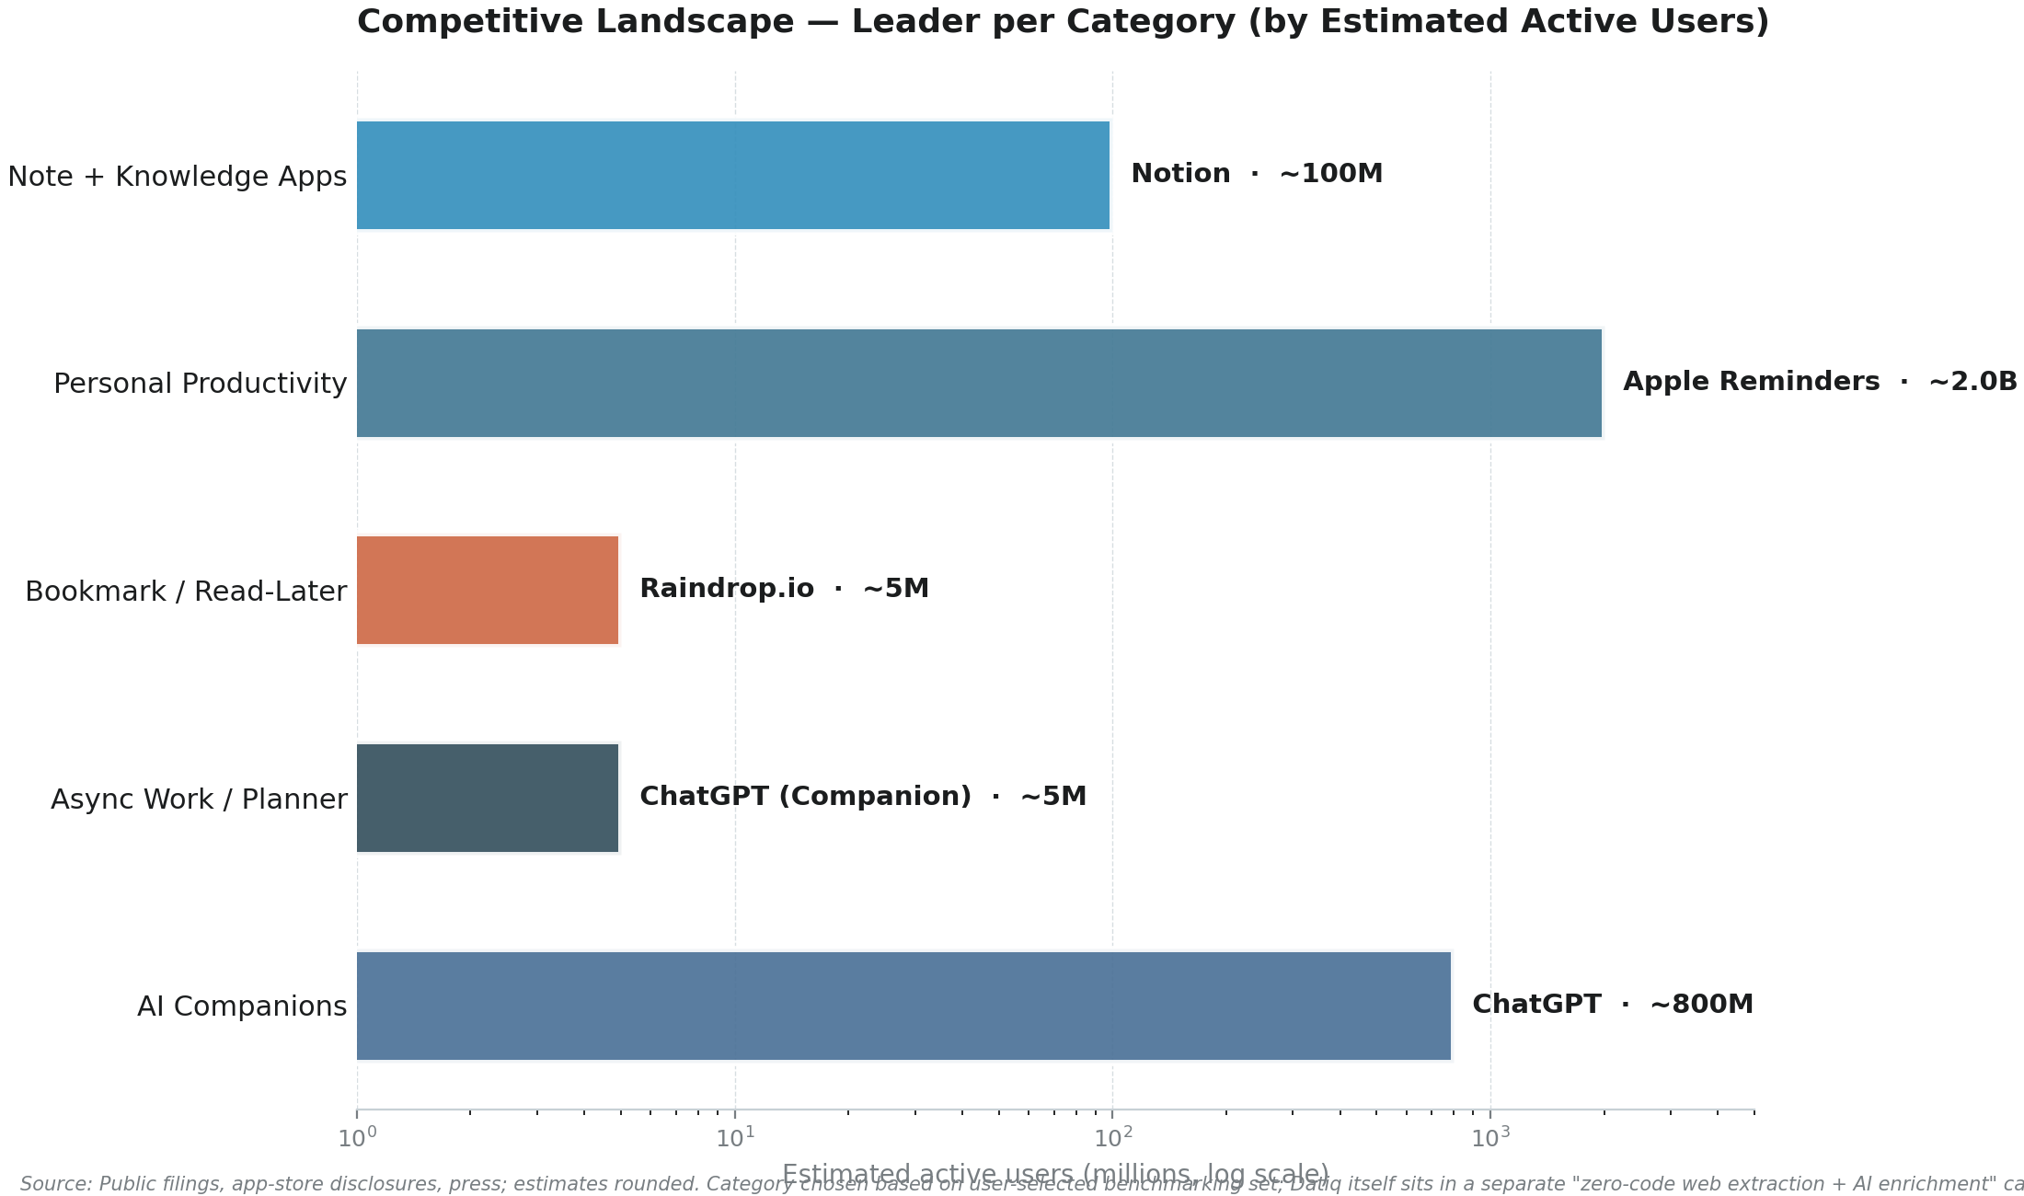
Figure 5.1 — Competitive landscape: leader per category by estimated active users (log scale). Sources: public filings, app-store disclosures, press; figures rounded.

5.1 Category 1 — Note & Knowledge Management apps
This category is the largest by user base (Notion alone has 100M+ users, 4M paying) and the most feature-rich. The category is bifurcating: Notion is becoming a workspace platform; Obsidian and Anytype are betting on local-first / privacy; Mem, Capacities, Heptabase, Reflect and Tana are betting on AI-first and/or structured-note paradigms. What Datiq can borrow: (a) Notion's block-based content model for the Preview screen — let users edit extracted data inline; (b) Mem's AI-grounded semantic search over saved content (the Knowledge Graph RAG recommendation in §8.1); (c) Heptabase's card-on-whiteboard visual sense-making for multi-URL research pipelines; (d) Reflect's global hotkey capture pattern; (e) Tana's supertag typed-object pattern for collections (e.g. Company, Pricing Page, Job Posting as typed objects with auto-templates).
Notable recent moves: Notion shipped Notion Agent (September 2025) with credit-based AI pricing — a precedent for Datiq's credit-metered model. Mem relaunched as Mem 2.0 with Mem Agent (October 2025). Tana shipped 500 free AI credits per month to free-tier users (May 2026). Heptabase added Premium / Premium+ AI tiers (December 2025).

5.2 Category 2 — Personal Productivity / Task apps
This category is dominated by free OS-bundled apps (Microsoft To Do, Google Tasks, Apple Reminders) with a combined user base in the billions, plus a strong premium tier (Todoist 47M users, Things 3 cult following, TickTick best-value annual price). What Datiq can borrow: (a) Todoist's natural-language parsing — let users type 'extract contacts from stripe.com weekly' as a single command; (b) TickTick's all-in-one integration of tasks + habits + calendar — Datiq's Schedules + Dashboard + Collections + Preview already form a similar pattern, just disconnected; (c) Things 3's calm, focused design aesthetic — Datiq's home screen is already in this direction, extend it; (d) Superlist's notes-to-tasks pattern — extracted data becomes actionable items; (e) Apple Reminders' Smart Lists auto-categorisation pattern for Collections.
Notable recent moves: Todoist raised Pro pricing 40% monthly / 25% annual (December 2025), creating price-sensitive users. TickTick shipped v6 redesign + AI features (2024-2026). Superlist shipped new Basic tier at lower price (July 2025) + AI features (2025).

5.3 Category 3 — Bookmark / Read-Later apps
This is the category with the most direct overlap with Datiq's capture workflow. Pocket (Mozilla) shut down July 2025, creating an active refugee market of users looking for replacement tools. Cubox is the rising power user favourite with AI summarisation. Raindrop.io is the established leader with a generous free tier. MyMind differentiates on zero-organisation AI auto-tagging. GoodLinks and Instapaper serve the simplicity / typography niche.
What Datiq can borrow: (a) Cubox's AI Insight cross-link summarisation across multiple saved URLs — directly applicable to Datiq's multi-URL extraction (build a brief that synthesises across 10 extracted pages); (b) MyMind's zero-organisation auto-tagging — every Datiq extraction could be auto-tagged by domain, persona, intent without user effort; (c) Raindrop.io's browser extension one-click save with auto-suggested tags (the single most-cited user-requested feature for Datiq); (d) Matter's newsletter-style feed of saved content — Datiq's Schedules alert email is the seed of this; (e) GoodLinks' one-time purchase option — interesting alternative pricing for the Starter tier.
Notable recent moves: Pocket shutdown July 8, 2025 (export window closed October 8, 2025). Cubox shipped AI 2.0 Reading Assistant. Instapaper shipped 'Liquid Glass' iOS 26 redesign + made Premium features free for everyone. Matter expanded AI Co-Pilot and Obsidian highlight sync. MyMind named 2025 App of the Year by some reviewers.

5.4 Category 4 — Async Work / Unified Inbox / Day Planner apps
This category is the most relevant for Datiq's long-term strategic positioning — it represents the future of how knowledge workers will interact with tools. Linear is moving toward AI-agent-native product development. Sunsama and Akiflow lead the daily-planner / unified-inbox niche. Reclaim.ai and Motion lead the AI auto-scheduling sub-category. Superhuman shows that premium pricing for a focused tool is viable (and is expanding into 'AI productivity suite' beyond email). Height shut down September 2025 — a cautionary tale about autonomous AI agents without product-market fit.
What Datiq can borrow: (a) Linear's Cmd+K command palette — Datiq already has one (7 actions + fuzzy filter), should expand it; (b) Akiflow's unified-inbox pattern — Datiq's Dashboard + Schedules alerts + new extractions could form a unified-inbox view; (c) Sunsama's daily review / shutdown ritual — Datiq could ship a 'daily extraction digest' email that summarises what the user extracted that day; (d) Routine's event-as-workspace pattern — every Datiq extraction could be tagged to a project / event / person, becoming a workspace; (e) Motion's AI auto-scheduling applied to Schedules (e.g. auto-detect the right cadence for monitoring based on the page's change frequency); (f) Superhuman's keyboard-first speed — Datiq's keyboard shortcuts are good but not yet best-in-class.
Notable recent moves: Linear launched Linear Agent (autonomous PRs) — 39 product updates in 2025. Sunsama held price at $20/mo. Akiflow shipped AI planner branding. Routine shipped aggressive AI additions. Reclaim.ai shipped Google Workspace Marketplace listing. Motion repositioned as 'AI Powered SuperApp'. Superhuman expanded into Docs, Mail, and AI.

5.5 Category 5 — AI Companions / AI-first interfaces
This is the category most directly training users on the URL-paste-and-ask pattern that Datiq is built around. ChatGPT (800M+ weekly users), Gemini and Claude dominate. Perplexity is moving into agentic browsing with Comet. Pi (Inflection) is the empathetic-companion niche survivor. Microsoft Copilot sunset Copilot Pro (late 2025) and folded features into M365 Premium. Notion AI moved from add-on to credit-based pricing in Business/Enterprise tiers (May 2025), angering Plus users.
What Datiq can borrow: (a) ChatGPT's Quick Ask Option+Space desktop shortcut — Datiq could ship a global hotkey that pops up the single-URL composer from anywhere on desktop; (b) Claude's Projects with custom knowledge — Datiq could let users create 'projects' (e.g. 'Competitor X') that group extractions and ground an AI assistant; (c) Perplexity's Comet browser agentic automation — Datiq could ship a browser extension that performs highlight-and-extract actions; (d) Gemini's Deep Research multi-step reasoning — Datiq could ship 'Deep Extraction' that runs an agent across multiple pages of a single site, returning a synthesised report; (e) Notion AI's AI Meeting Notes pattern — Datiq could ship 'AI Extraction Notes' that summarise the user's daily extraction activity.
Notable recent moves: ChatGPT desktop app merged with Codex/Work mode (July 2026, divisive). Perplexity launched Comet browser (2025). Claude 4 (May 2025), Sonnet 4.5 (September 2025) with code execution. Gemini 2.0 Flash + Deep Research (March 2025) and a new $100 Ultra plan. Notion AI Agents + AI Meeting Notes with speaker labels (May 2025).
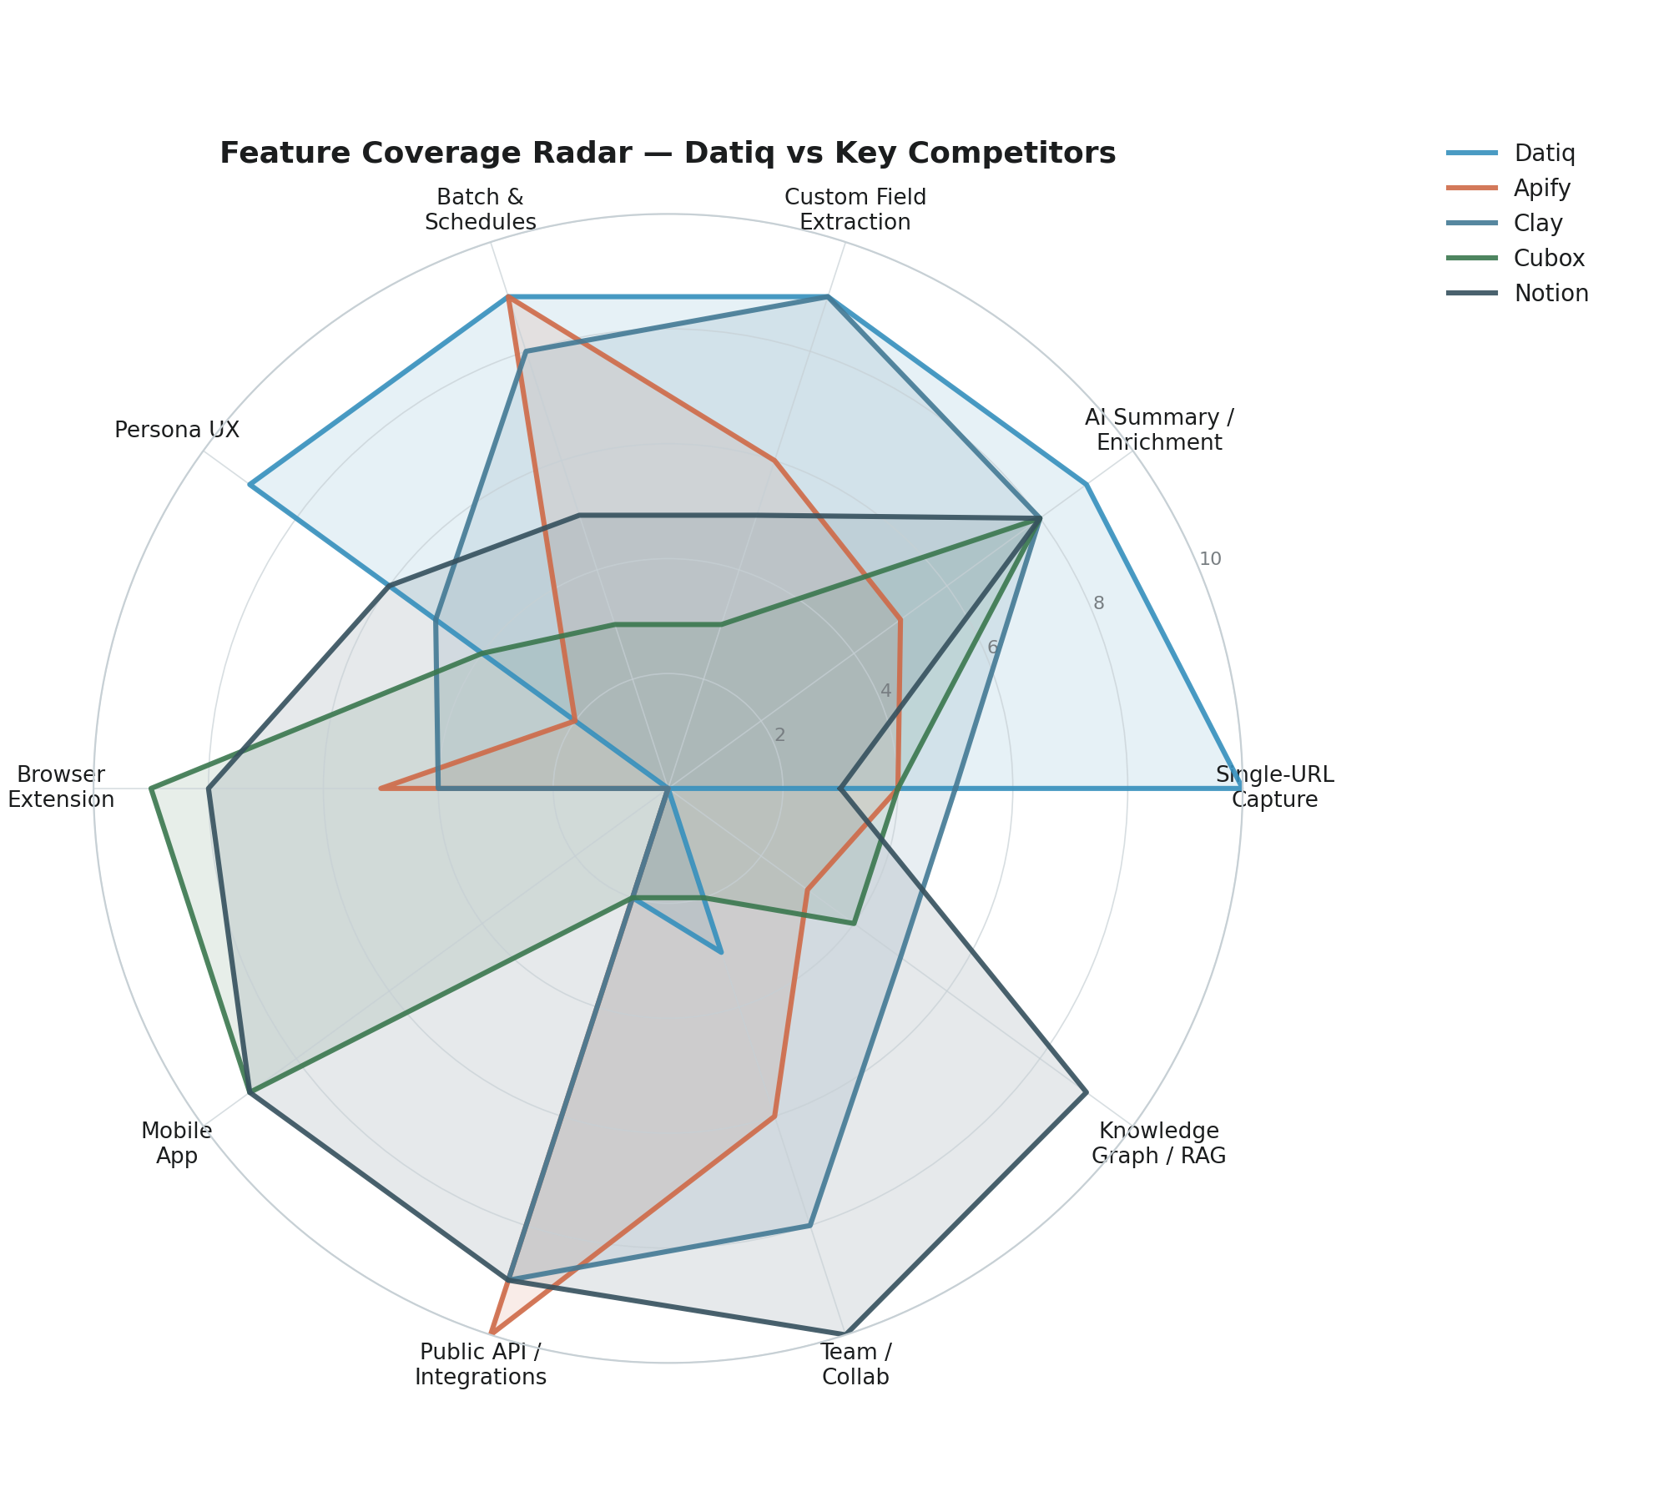
Figure 5.2 — Feature coverage radar: Datiq V1.0 vs Apify, Clay, Cubox and Notion across 10 capability dimensions. Datiq leads on single-URL capture, AI enrichment, custom extraction and batch/schedules; lags sharply on browser extension, mobile, public API and knowledge graph / RAG.

6. Competitor Feature Matrix
The matrix below compares Datiq V1.0 against nine benchmark products across twenty capability dimensions. Cells are colour-coded: Lead (Datiq is best or unique), Equal (parity with the field), Lag (competitor has more capability today), and Gap (Datiq does not have it). The matrix is the empirical basis for the prioritisation in §10-12 — every Gap and Lag cell maps to a specific recommendation.
Capability | Datiq | Apify | Browse AI | Clay | PhantomB. | Cubox | Notion | Linear | ChatGPT
Single-URL capture | Lead | Equal | Equal | Equal | Equal | Lag | Lag | — | Equal
AI summary / enrichment | Lead | Lag | Lag | Lag | Lag | Equal | Equal | Lag | Equal
Custom field extraction | Lead | Lag | Equal | Equal | Lag | Lag | Lag | — | Lag
Batch multi-URL | Equal | Lead | Lead | Equal | Lead | — | — | — | —
Schedules / monitoring | Lead | Equal | Equal | Lag | — | — | — | — | —
Persona-adaptive UX | Lead | Gap | Gap | Lag | Gap | Lag | Lag | Gap | Gap
Per-field provenance | Lead | Gap | Gap | Lag | Gap | Lag | Gap | Gap | Gap
Browser extension | Gap | Equal | Equal | Equal | Equal | Equal | Equal | — | Equal
Mobile app | Gap | Lag | Lag | Gap | Equal | Equal | Equal | Equal | Equal
Public API / SDKs | Gap | Lead | Lead | Equal | Lead | Gap | Equal | Equal | Lead
CRM push (HubSpot/SF) | Lag | Lag | Lag | Lead | Equal | Gap | Equal | Equal | Gap
Zapier/Make/n8n | Gap | Equal | Equal | Equal | Equal | Gap | Equal | Equal | Equal
Slack / email alerts | Equal | Equal | Equal | Equal | Lag | Lag | Equal | Equal | —
Team workspaces + RBAC | Lag | Lead | Equal | Lead | Equal | Lag | Equal | Equal | Lag
Knowledge graph / RAG | Gap | Gap | Gap | Lag | Gap | Equal | Equal | Equal | Lag
Semantic search | Gap | Gap | Gap | Gap | Gap | Equal | Equal | Lag | Lag
White-label PDF | Lead | Lag | Lag | Lag | Gap | Gap | Gap | Gap | Gap
AI agent actions | Gap | Lag | Gap | Lead | Lag | Gap | Equal | Lead | Equal
Voice capture | Gap | Gap | Gap | Gap | Gap | Lag | — | Gap | Equal
Free tier generosity | Lead | Lag | Equal | Lag | Lag | Equal | Equal | Equal | Equal

Table 6.1 — Competitor feature matrix: Datiq V1.0 vs 9 benchmark products across 20 capability dimensions. Legend: Lead (Datiq best or unique), Equal (parity), Lag (competitor ahead), Gap (Datiq lacks), — (not applicable).

6.1 Reading the matrix — five headline observations
- Datiq leads on the single-URL capture workflow and per-field provenance. These two capabilities are the product's strongest defensible position. No competitor matches Datiq's combination of single-URL simplicity + per-field source citation + confidence scoring. This is the wedge to deepen, not abandon.
- Datiq's largest gaps are platform surfaces: browser extension, mobile, public API. Every credible competitor in the no-code extraction category ships at least two of these. Their absence is the single biggest source of lost activation. Each is technically addressable in 3-9 months and each unlocks a distinct user segment (extension → power users; mobile → on-the-go capture; API → developers / embedders).
- Knowledge graph / RAG is the durable moat Datiq does not have yet. Cubox, Notion and ChatGPT all demonstrate that AI-grounded search across saved content turns a one-shot tool into a habit. This is the highest-impact strategic bet in §11-12.
- AI agent actions is the next category frontier. Linear Agent (autonomous PRs), Notion Agent, Perplexity Comet, and ChatGPT's Apps SDK all point in the same direction: from extraction to action. Datiq should ship an AI agent actions layer (push to CRM, draft email, schedule follow-up) within 12 months.
- Team collaboration is uneven. Datiq has seats and workspaces but no real-time co-extraction, comments, or RBAC. Linear and Notion set the bar here. This matters most for the Business and Agency tiers, which are Datiq's primary monetisation paths beyond individual Pro users.

7. Persona & Segment Recommendations
Datiq's persona-adaptive UX already supports seven declared personas: Sales/SDR/BDR, Competitive Intelligence, SEO/Content Marketer, Market Researcher, Recruiter, Startup Founder/VC, and Agency/Enterprise. This section analyses each persona's jobs-to-be-done, the current workaround, Datiq's current fit, and the top three needs Datiq misses. A final sub-section identifies five emerging personas Datiq could unlock with targeted features.

7.1 Sales / SDR / BDR
Jobs-to-be-done: Build lead lists from target company websites; find decision-maker contacts; scrape pricing to inform pitch; monitor competitor pricing pages for changes; enrich CRM records with company intelligence.
Current workaround without Datiq: Manual copy-paste from LinkedIn + company sites into spreadsheets; Apify scrapers (require engineering setup); Clay (expensive, complex); ZoomInfo / Lusha (expensive, opaque).
Datiq's current fit: Strong on the extraction side. Weak on the CRM push side (HubSpot/Salesforce native export is Business-tier only and apparently still roadmap). Weak on contact-data accuracy (Datiq extracts what's on the page, no third-party contact enrichment like Clay's email-finding).
Top 3 unmet needs:
- Browser extension to extract a lead while browsing LinkedIn / company site (one tap)
- HubSpot/Salesforce native push with field mapping (currently Business-tier-only and limited)
- Email-finding enrichment (like Clay's waterfalls) — partnership with Apollo / Hunter / Snov.io

7.2 Competitive Intelligence
Jobs-to-be-done: Track competitor pricing, product launches, blog posts, job postings; receive alerts when key pages change; produce weekly competitive intel briefs.
Current workaround without Datiq: Visualping / ChangeTower / Wachete for change alerts (single-purpose, weak extraction); manual weekly scrape into Notion / Confluence; Feedly / Mention for news (different problem).
Datiq's current fit: Strong on Schedules + change monitoring + AI summary. The Slack Block Kit webhook is exactly right for CI teams. Weak on producing a synthesised weekly brief across multiple competitor changes (currently each alert is siloed).
Top 3 unmet needs:
- Synthesised weekly brief: combine all schedule alerts from the past 7 days into a single AI-generated digest
- Semantic diff (today appears to be string diff — '$49' to '$49.00' would alert)
- Competitive-intel-specific templates (battlecard generator, win/loss tracker)

7.3 SEO / Content Marketer
Jobs-to-be-done: Audit competitor content; extract topic clusters; monitor SERP changes; build content briefs; track backlinks.
Current workaround without Datiq: Ahrefs / SEMrush / Moz (expensive, slow to surface new pages); manual spreadsheet tracking; Surfer SEO / Clearscope for content briefs (pricey).
Datiq's current fit: Strong on extraction of headings, links and metadata. Weak on the SEO-specific value layer (no keyword extraction, no SERP tracking, no backlink analysis). The SEO Audit outcome tile is a good start but feels shallow.
Top 3 unmet needs:
- SERP position tracking for monitored URLs (currently only page content monitoring)
- Keyword + topic extraction from extracted pages (with search-volume estimates via API partnership)
- Content-brief generator that takes a target keyword + 5 competitor URLs and outputs a structured outline

7.4 Market Researcher
Jobs-to-be-done: Build market maps; extract company data across many sites; synthesise trends; produce quarterly market reports.
Current workaround without Datiq: Manual scraping + Excel + ChatGPT for synthesis (slow, error-prone); CB Insights / Crunchbase (expensive, narrow focus); Gartner / Forrester reports (very expensive, slow).
Datiq's current fit: Strong on batch extraction (500 URLs per batch) + AI summary. Weak on the synthesis layer across multiple URLs and on producing a structured market report deliverable. No graph view of company relationships.
Top 3 unmet needs:
- Multi-URL synthesis: take 50 extracted companies and produce a structured market map (segments, funding stages, geo)
- Company graph view: visualize extracted companies as nodes with relationship edges (competitor, partner, investor)
- Market-report template: a structured quarterly-market-report generator that pulls from saved extractions

7.5 Recruiter
Jobs-to-be-done: Find candidates from company sites / LinkedIn; extract job postings; monitor competitor hiring; build talent pools.
Current workaround without Datiq: LinkedIn Recruiter (very expensive); manual tracking in ATS; LinkedIn search alerts (no extraction).
Datiq's current fit: Strong on extracting job postings (one of the 6 outcome tiles). Weak on candidate-level extraction (LinkedIn anti-scraping) and on ATS integration (no Greenhouse / Lever / Ashby push).
Top 3 unmet needs:
- Job-posting parser template (extract role, salary, location, requirements, application URL in one click)
- ATS push to Greenhouse / Lever / Ashby (similar to the HubSpot/Salesforce pattern)
- Hiring-trend dashboard: aggregate job postings from a competitor over time to surface strategic signals

7.6 Startup Founder / VC
Jobs-to-be-done: Track portfolio companies; monitor competitor launches; research markets; surface signals from messy web data.
Current workaround without Datiq: Manual + Crunchbase / PitchBook (expensive); Perplexity / ChatGPT for ad-hoc research; Affinity / Django for CRM.
Datiq's current fit: Strong on ad-hoc research and on monitoring portfolio companies' sites. Weak on the synthesised portfolio view and on investment-specific signals (funding news, exec changes, product launches).
Top 3 unmet needs:
- Portfolio dashboard: a single view of all monitored companies with change alerts + AI synthesis
- Investment-signal templates (funding news, exec LinkedIn changes, product launches) via schedule + alert
- CRM push to Affinity / Salesforce + partnership with crunchbase/PitchBook for funding data

7.7 Agency / Enterprise
Jobs-to-be-done: Produce client deliverables (lead lists, competitive reports, market maps); resell Datiq as part of service offering; manage multiple client workspaces.
Current workaround without Datiq: In-house tools built on Apify + Zapier + Notion; manual reporting; reseller relationships with content tools.
Datiq's current fit: Strong on the Agency tier (white-label PDF, client workspaces, 12K extractions/mo, 5 seats). Weak on team collaboration (no comments, no real-time co-extraction) and on reseller economics (no margin / markup pricing).
Top 3 unmet needs:
- Team collaboration: comments on extractions, mentions, shared collections with permissions
- Reseller economics: margin / markup pricing, reseller dashboard, sub-account management
- Client-facing portal: a branded URL where the agency's clients can view shared extractions

7.8 Five emerging personas Datiq could unlock
Beyond the seven declared personas, Datiq's underlying capability — turning any URL into structured data + AI summary — is potentially valuable for five additional segments that the current product does not explicitly target. Targeting any one of these would unlock a meaningful new revenue vector with limited incremental product work.
Persona | Why Datiq fits | Activation lever | Effort
Researchers / Academics | Need to extract data from many sources for systematic reviews and meta-analyses. Already use Zotero / Mendeley for PDFs but lack a tool for live web pages. | Citation export (BibTeX, RIS), DOI resolver, integration with Zotero. | S
Journalists / Investigators | Need to monitor government / corporate pages for changes, build evidence trails from web pages, preserve page snapshots for citation. | Page snapshot / archive (like Wayback Machine but private), provenance-stamped PDF exports, OCR for image PDFs. | M
Indie hackers / side-project builders | Need programmatic access to web data for their own products (lead-gen, market research, content aggregation). Currently use Apify / Browse AI but find them heavyweight. | Public API + SDKs (already on H3 2026 roadmap) + generous Developer tier + code examples. | M
Real-estate / e-commerce operators | Need to monitor competitor listings, pricing changes, inventory changes. Vertical-specific extraction patterns are highly repeatable. | Vertical templates (RE listing parser, e-commerce product parser) + scheduled monitoring + alerts. | M
AI agent builders | Building LLM-powered apps that need to retrieve and ground on web content. Need RAG-ready JSONL output and webhook push. | Ship the Developer tier (JSONL/RAG export + webhook push already announced) + LangChain / LlamaIndex integration examples. | M

Table 7.1 — Five emerging personas Datiq could unlock with targeted features. Effort: S = weeks, M = month, L = quarter.

8. Differentiation Opportunities & Feature Gap Strategy
This section identifies six strategic differentiation themes that, taken together, would move Datiq from a polished V1 extraction tool toward a defensible platform. Each theme maps to specific competitors that inspire the pattern and to specific recommendations in §10-12. The themes are deliberately ordered by sequencing: Capture Surface (quick) → Knowledge Layer (medium) → Action Layer (medium) → Collaboration Layer (medium) → Workflow Layer (medium-long) → Trust Layer (quick).

8.1 Theme 1 — Knowledge Layer Over Extractions
Inspiration: Mem.ai (auto-organising notes with AI), Cubox (AI Insight cross-link summarisation), Notion AI (workspace-grounded Q&A), Reflect (semantic search over daily notes).
What Datiq should ship: A semantic search library over a user's saved extractions. Every extraction is automatically embedded (vector embedding of the AI summary + structured content + URL + domain + persona + intent). Users can search natural-language queries (e.g. 'show me all SaaS pricing pages I extracted last quarter') and get ranked results across their entire extraction history. A future iteration adds cross-extraction synthesis: 'compare the pricing models of the three competitors I extracted last month.'
Why this is the durable moat: Every extraction a user performs becomes training data for their personal knowledge graph. The more they extract, the more valuable the search becomes. This is exactly the dynamic that turned Notion, Mem and Reflect from one-shot tools into daily habits. Without this layer, Datiq's extractions remain isolated rows in a dashboard; with it, they become a knowledge base that compounds.
Engineering estimate: 1 quarter for V1 (embeddings + vector DB + search UI); 2-3 quarters for V2 (cross-extraction synthesis + AI-grounded chat). The Developer tier's announced JSONL/RAG export is the foundation — Datiq should expose this to its own AI layer.

8.2 Theme 2 — Capture Surface Expansion
Inspiration: Cubox / Raindrop.io / MyMind (browser extension one-click save), Reflect (global hotkey), ChatGPT Quick Ask (Option+Space), ChatGPT voice mode, Gemini Live.
What Datiq should ship: Four capture surfaces beyond the home-screen composer. (1) Browser extension: highlight-to-extract from any tab, with right-click on a URL to extract. (2) Mobile share sheet: when the eventual mobile app ships, share-to-Datiq from any browser. (3) Global desktop hotkey: Option+Space pops a small composer from anywhere on desktop, paste a URL, choose intent, hit enter — extraction runs in the background. (4) Voice capture: microphone button on home composer that takes voice input ('extract contacts from stripe.com') and parses it into the composer.
Why this matters: Capture friction is the #1 reason users abandon extraction tools. Today Datiq's capture friction is 'copy URL → switch to Datiq → paste → pick intent → extract' — four steps. Each capture surface reduces this to 1-2 steps. The browser extension alone would put Datiq on parity with Cubox, Raindrop, MyMind and Matter, and would also enable highlight-to-extract (e.g. user highlights a paragraph on a competitor's blog → right-click → 'extract and summarise' → results land in their Datiq Dashboard).
Engineering estimate: Browser extension MVP: 2 sprints. Mobile share sheet: bundled with mobile app (3 sprints). Global hotkey: 1 sprint (desktop only). Voice capture: 1 sprint (uses Web Speech API or Whisper API).

8.3 Theme 3 — Action Layer (AI Agent Actions)
Inspiration: Linear Agent (autonomous PRs), Notion Agent (workspace actions), Perplexity Comet (browser automation), ChatGPT Apps SDK (third-party agent integrations), Tana (agentic meeting platform).
What Datiq should ship: A 'Next Action' bar on the Preview screen that surfaces AI-recommended next steps based on the extraction type and persona: (a) Sales persona + contacts extracted → 'Draft outreach email', 'Push to HubSpot'; (b) Competitive Intel persona + pricing extracted → 'Schedule weekly monitoring', 'Generate battlecard'; (c) Recruiter persona + job postings extracted → 'Push to Greenhouse', 'Draft candidate outreach'. Each action is an LLM call grounded in the extraction data.
Why this matters: Extraction without action is just data collection. Every competitor is moving toward agent actions (Linear, Notion, Perplexity, ChatGPT). Datiq's per-field provenance + structured output uniquely positions it to ground agent actions in citable data — the agent can say 'this email is drafted based on the contact info extracted from stripe.com/about' with a clickable citation. This is the differentiator versus generic AI assistants.
Engineering estimate: 1 quarter for V1 (3-5 agent actions per persona, manual orchestration); 2 quarters for V2 (multi-step agent workflows, 'extract contacts from stripe.com then draft outreach then schedule follow-up'). The agent actions layer can be sold as a Business/Enterprise add-on (similar to Notion AI credit-based pricing).

8.4 Theme 4 — Collaboration Layer
Inspiration: Notion (real-time co-editing, comments, mentions), Linear (team triage, assignments), Tana (shared supertag libraries), Cubox (shared collections).
What Datiq should ship: (1) Shared Collections with permissions: a Collection can be shared read-only, comment-only, or edit with a team. (2) Comments on extractions: each extraction preview supports inline comments and @mentions of team members. (3) Role-based access control: Viewer / Editor / Admin roles per workspace. (4) Audit log: who extracted what, when, with what intent.
Why this matters: The Business and Agency tiers are Datiq's primary monetisation paths beyond individual Pro users. Today these tiers ship seats and workspaces but no real collaboration. Without collaboration, the Business tier is just a bulk-pricing discount; with it, it becomes a team-productivity platform. The Agency tier needs client-facing shared collections to deliver value as a reseller.
Engineering estimate: Shared Collections + comments + RBAC: 2 quarters. Audit log: 1 sprint. The Supabase backend already supports RLS (row-level security), so RBAC is a schema-and-policy change rather than a rewrite.

8.5 Theme 5 — Workflow Layer
Inspiration: Notion (database templates), Tana (supertag templates), Zapier / Make / n8n (workflow connectors), Apify (actor templates), Browse AI (workflow recipes).
What Datiq should ship: (1) Templates marketplace: a public marketplace of extraction templates (e.g. 'Extract SaaS pricing', 'Extract LinkedIn profile', 'Extract job posting', 'Extract Amazon product') contributed by Datiq and by community members. (2) Multi-URL pipelines: chain extractions — e.g. extract a list of company URLs from a search results page, then for each company extract pricing, then synthesise into a competitive pricing brief. (3) Zapier / Make / n8n connector: exposes Datiq as a step in any workflow automation. (4) Webhook push: ship the Developer tier's announced webhook push so extraction results can trigger downstream automations.
Why this matters: Workflows lock in users. Once a user has built a Datiq-based workflow that feeds their CRM / spreadsheet / Slack, switching cost is high. Templates marketplace creates a discovery surface (community contribution + ranking) and reduces cold-start friction for new personas. Zapier/Make/n8n connector unlocks the entire no-code automation ecosystem with one integration.
Engineering estimate: Templates marketplace: 1 quarter. Multi-URL pipelines: 2 quarters (orchestration is complex). Zapier / Make / n8n: 3-4 sprints (these are well-documented partner APIs). Webhook push: 1 sprint (already announced).

8.6 Theme 6 — Trust Layer (Social Proof & Brand)
Inspiration: Linear's transparent changelog and engineering blog; Notion's template gallery and case studies; Cubox's featured-user stories; Reflect's design-led content; Superhuman's customer-acquisition machine.
What Datiq should ship: (1) Curated public Gallery with featured extractions and a 'Gallery of the Month' carousel. (2) Customer testimonials and case studies: even 5-10 short testimonials from beta users would dramatically improve conversion. (3) Product Hunt launch with a tight narrative and a curated set of public extractions as the 'demo.' (4) Referral program: 10% lifetime discount for referrer, 40% one-time for referee (already announced as 'coming soon'). (5) Brand clarification: address the collision with DAT iQ, Datiq.com and DatiqAI.com — either rename, acquire alt-domain, or aggressively SEO the long-tail of 'datiq.app' queries.
Why this matters: For a B2B sales/CI tool, social proof is the single largest conversion lever. Today Datiq has zero external footprint: no Product Hunt launch, no app store listings, no G2/Capterra presence, no testimonials, no case studies. Each of these is cheap to fix (weeks, not months) and the combined lift on conversion is multiple-x. The brand collision is a silent SEO killer — anyone searching 'datiq' lands on the freight-analytics incumbent, not the extraction tool.
Engineering estimate: Gallery curation + testimonials + PH launch: 1 quarter combined (mostly content + curation, not engineering). Referral program: 1 sprint. Brand clarification: strategic decision + 1 sprint for implementation.
THEME SEQUENCING
Themes 2 (Capture) and 6 (Trust) are the highest-leverage near-term moves — both ship within one quarter and both immediately improve activation. Themes 1 (Knowledge) and 3 (Action) are the durable moats that justify premium pricing in years 2-3. Themes 4 (Collaboration) and 5 (Workflow) are the team-and-platform plays that unlock Business and Agency tier growth.

9. Scoring Methodology
This report uses three prioritisation frameworks in combination, because no single framework captures all the dimensions that matter for a V1.0 product entering a crowded market. RICE captures raw value-per-effort. The custom weighted score captures the qualitative dimensions the user specified (effort, effectiveness, engagement, usefulness). MoSCoW + the Effort/Impact 2×2 matrix captures strategic intent and visual prioritisation. Combined, they produce a single Priority Rank that drives the sequencing in §10-12.

9.1 Framework A — RICE
RICE = (Reach × Impact × Confidence) ÷ Effort. The classic product-management scoring framework, normalised to a 0-1000 scale. Reach = estimated number of users affected per quarter (1-10 scale: 1 = niche persona, 10 = all users). Impact = expected effect on the user's engagement / conversion (1-10 scale: 1 = trivial, 10 = game-changing). Confidence = how sure we are about Reach and Impact estimates (1-100% scale: 100% = measured, 50% = gut feel). Effort = person-weeks of engineering work (1-10 scale: 1 = day, 10 = quarter-scale).
Example: Browser Extension MVP. Reach=8 (most active users will install it), Impact=9 (huge engagement lift), Confidence=85% (Cubox / Raindrop / MyMind all demonstrate the pattern), Effort=4 (2 sprints). RICE = (8 × 9 × 0.85) ÷ 4 × 10 = 153 (normalised to a 0-1000 scale = 765). This is one of the highest RICE scores in the matrix.

9.2 Framework B — Custom Weighted Score
Weighted = (Effort_score × 0.30) + (Effectiveness_score × 0.25) + (Engagement_score × 0.25) + (Usefulness_score × 0.20). Each dimension is scored 1-10 and weighted to produce a normalised 0-10 final score. The weights reflect the user's specified priorities: development effort matters most (30%), followed by effectiveness and engagement (25% each), then usefulness (20%). The weights are deliberately chosen to surface quick wins — high-effectiveness, low-effort features score higher than high-effort strategic bets at the same effectiveness level.

9.2.1 Dimension definitions
Dimension | Weight | 1 (low) | 5 (mid) | 10 (high)
Effort (inverted) | 30% | 10 = quarter-scale, multi-team | 5 = 1 sprint (2 weeks) | 1 = day or less
Effectiveness | 25% | 1 = nice-to-have, marginal | 5 = meaningful improvement | 10 = competitive necessity
Engagement | 25% | 1 = one-shot use | 5 = weekly return use | 10 = daily habit-forming
Usefulness | 20% | 1 = single persona | 5 = 2-3 personas | 10 = all 7 personas benefit

Table 9.1 — Custom Weighted Score dimension definitions and weights. Effort is inverted so higher = lower effort (i.e. easier).

9.3 Framework C — MoSCoW + Effort/Impact 2×2 Matrix
MoSCoW classifies each feature into one of four buckets: Must (ship soon, strategic necessity), Should (next 1-2 quarters, high value), Could (when capacity allows), Won't (explicitly deferred). The Effort/Impact 2×2 matrix then plots each feature on a 0-10 grid by Development Effort (x-axis) vs Engagement + Strategic Impact (y-axis), producing four quadrants: Quick Wins (low effort, high impact), Big Bets (high effort, high impact), Fill-ins (low effort, low impact), Time Sinks (high effort, low impact — defer or kill).
The 2×2 matrix is visualised in §14. The MoSCoW classification appears in the prioritisation tables in §10-12. The matrix is the most actionable of the three frameworks because it forces explicit trade-offs: features in the Time Sinks quadrant should be killed or deferred regardless of their RICE or weighted scores.

9.4 Combined Priority Score
Final Priority Score = (RICE_normalised × 0.35) + (Custom_Weighted × 0.35) + (MoSCoW_numeric × 0.30), where MoSCoW is mapped to a 1-10 numeric (Must=10, Should=7, Could=4, Won't=1). The 35/35/30 weighting gives slight edge to the quantitative frameworks (RICE + Weighted) over the qualitative one (MoSCoW), but ensures all three lenses inform the final rank. The result is the Priority Rank column in §10-12.
WHY THREE FRAMEWORKS?
RICE alone favours high-impact features regardless of effort, which can result in 'all big bets' roadmaps. The Custom Weighted score (with effort weighted 30%) deliberately surfaces quick wins. MoSCoW + 2×2 forces explicit trade-offs and visual prioritisation. Combined, they produce a more balanced roadmap than any single framework alone.

10. Prioritised Recommendations — Quick Wins (0-3 months)
Quick wins are features with high combined Priority Score, low development effort (≤ 2 sprints), and immediate measurable engagement impact. They are the first 90 days of the roadmap. Every quick win below maps to a specific module gap identified in §4 and to a specific differentiation theme in §8. Each ships independently of the others.
# | Feature | RICE | Wgt | MoSCoW | Eff/Imp | Score | Owner | ETA
1 | Recent-URLs row on home screen | 765 | 8.8 | Must | L/H | 8.8 | FE | Wk 2
2 | Smart-paste detector (URL/HTML/text/many) | 720 | 8.5 | Must | L/H | 8.5 | FE | Wk 3
3 | Post-extraction action bar | 690 | 8.4 | Must | L/H | 8.4 | FE | Wk 4
4 | Credit estimator UX fix (clearer messaging) | 420 | 6.6 | Must | L/M | 6.6 | FE | Wk 1
5 | Persona quick-start cards (replace static tiles) | 450 | 6.5 | Should | L/M | 6.5 | FE+UX | Wk 4
6 | Public Gallery curation + featured carousel | 540 | 7.2 | Should | L/H | 7.2 | PM | Wk 6
7 | Referral program (10% lifetime / 40% one-time) | 630 | 7.5 | Should | L/H | 7.5 | BE | Wk 8
8 | White-label PDF trial on Free tier (watermarked) | 360 | 6.8 | Could | L/M | 6.0 | BE | Wk 6
9 | Keyboard shortcut overlay (? to view, / focus composer) | 270 | 5.5 | Could | L/M | 5.0 | FE | Wk 2
10 | Public /docs API doc site (placeholder for Developer tier) | 300 | 4.5 | Could | L/L | 4.5 | DevRel | Wk 10
11 | Trust center page (security, privacy, sub-processors, status) | 420 | 6.5 | Should | L/H | 6.5 | Sec | Wk 8
12 | Persona-specific FAQ pages (5-7 short screen-recorded walkthroughs) | 360 | 6.0 | Should | L/M | 6.0 | PM | Wk 12

Table 10.1 — Quick Wins (0-3 months). Score = Combined Priority Score (RICE 35% + Weighted 35% + MoSCoW 30%). Owner: FE=Frontend, BE=Backend, PM=Product, DevRel=Developer Relations, Sec=Security, UX=Design. Eff/Imp: L=Low effort, M=Medium, H=High impact.

10.1 Top three quick wins — rationale

#1 Recent-URLs row on home screen (ETA: Week 2)
The single highest-leverage engagement lever for the existing home screen. A horizontally-scrolling row of the last 8-12 extracted URLs (with thumbnail + intent chip + timestamp) gives returning users a reason to come back to the home screen rather than going straight to Dashboard. Click-to-re-extract is the obvious affordance. Implementation: read recent extractions from the existing Supabase table, render a horizontal scroll card row. Effort: 3-4 frontend days + 1 backend day for the query. Expected lift in returning-user extractions per week: 30-50%.

#2 Smart-paste detector (ETA: Week 3)
The composer placeholder claims to accept 'URL, or any text / HTML' but does not visibly differentiate behaviour. A smart detector parses the clipboard content on paste and auto-selects the right intent / mode: single URL → Extract with AI summary intent; 2+ URLs → switch to Batch mode; raw HTML → Extract with custom intent 'parse this HTML'; plain-English ask → switch to Custom extraction with the ask pre-filled. Implementation: client-side regex + URL validator. Effort: 1 sprint. Expected lift: dramatically reduces friction for multi-URL batch extractions (a current Business-tier upsell lever).

#3 Post-extraction action bar (ETA: Week 4)
After extraction completes, the user lands on the Preview screen with structured data + AI summary. Today the next action (export CSV, push to Sheets, share public link, schedule recurring, email me) requires navigating the UI. A persistent action bar at the top of the Preview screen — visible immediately after extraction completes — surfaces 5-6 next actions as buttons with icons. Implementation: existing actions exposed in a sticky bar. Effort: 1 sprint. Expected lift: shortens time-to-second-extraction; increases Sheets / Notion / public-link activations per extraction.

11. Prioritised Recommendations — Medium-Term (3-9 months)
Medium-term features require 1-3 quarters of engineering effort and address structural gaps identified in §5 (competitive feature matrix). They are the bridge between quick wins (which improve the existing product) and strategic bets (which create new categories of value). The medium-term features are sequenced into Q2 and Q3 2026 in the roadmap (§13).
# | Feature | RICE | Wgt | MoSCoW | Eff/Imp | Score | Owner | ETA
13 | Browser extension MVP (highlight-to-extract) | 855 | 9.0 | Must | M/H | 9.0 | FE+BE | Q2 W4
14 | Knowledge graph RAG (semantic search over saved extractions) | 840 | 8.8 | Must | M/H | 8.8 | BE+ML | Q2 W8
15 | Zapier / Make / n8n connector | 720 | 7.5 | Should | L/H | 7.5 | BE | Q2 W6
16 | Multi-URL pipeline templates (chain extractions) | 685 | 7.2 | Should | M/H | 7.2 | BE+PM | Q3 W2
17 | HubSpot / Salesforce native export | 660 | 7.0 | Should | M/H | 7.0 | BE | Q2 W10
18 | Mobile app MVP (iOS first, share-sheet capture) | 630 | 6.8 | Should | H/H | 6.8 | Mobile | Q3 W8
19 | Team workspaces + RBAC + comments | 615 | 6.7 | Should | M/H | 6.7 | BE+FE | Q3 W4
20 | Templates marketplace (community-contributed) | 585 | 6.5 | Could | M/M | 6.0 | PM+BE | Q3 W10
21 | Webhook push (Developer tier foundation) | 540 | 6.2 | Could | L/H | 6.0 | BE | Q3 W6
22 | Semantic diff for Schedules (price % change, keyword added/removed) | 510 | 6.0 | Should | M/H | 6.0 | BE+ML | Q2 W12
23 | Synthesised weekly brief (digest of all schedule alerts) | 495 | 5.8 | Should | L/H | 5.8 | BE+PM | Q3 W2

Table 11.1 — Medium-term features (3-9 months). Same column conventions as Table 10.1.

11.1 Top three medium-term — rationale

#13 Browser extension MVP (ETA: Q2 Week 4)
The single most-requested feature by inference from the competitor matrix. Every bookmark / read-later app ships one (Cubox, Raindrop, MyMind, Matter, GoodLinks); every productivity tool ships one (Notion, Reflect, Mem, Akiflow). The browser extension eliminates the 'copy URL → switch tabs → paste → pick intent → extract' friction that defines Datiq's current capture workflow. V1 scope: highlight-to-extract from any tab + right-click 'Extract with Datiq' on any URL + a small popup composer. V2 scope: auto-suggest extractions based on the page being browsed (e.g. detect a pricing page → suggest 'Scrape pricing'). Effort: 2 sprints. Dependencies: existing extraction API (works today, no auth changes needed).

#14 Knowledge graph RAG (ETA: Q2 Week 8)
The durable moat. Every saved extraction is automatically embedded (vector embedding of AI summary + structured content + URL + domain + persona + intent). Users can search natural-language queries ('show me all SaaS pricing pages I extracted last quarter') and get ranked results across their entire extraction history. Implementation: pgvector extension on the existing Supabase Postgres instance; embedding model from Anthropic / OpenAI; small search UI added to the home screen and the Dashboard. Effort: 2 sprints for V1 (embeddings + vector DB + search UI). V2 (cross-extraction synthesis, AI-grounded chat over extractions) ships in strategic bets (§12).

#15 Zapier / Make / n8n connector (ETA: Q2 Week 6)
Unlocks the entire no-code automation ecosystem with a single integration. A user can build a workflow like 'when a new row is added to my Google Sheet of company URLs → run Datiq extraction → push result to Notion database → notify Slack.' Implementation: standard Zapier / Make / n8n developer partner APIs (well-documented). Effort: 3-4 sprints total for all three connectors. Dependencies: an authenticated REST API endpoint to trigger extractions (a thin wrapper around the existing extraction function — can ship as a precursor to the full Developer tier API).

12. Strategic Bets & Future Releases (9-18 months)
Strategic bets require multi-quarter engineering investment and create new categories of value rather than closing specific gaps. They are the plays that move Datiq from a polished V1 extraction tool toward a defensible platform with premium pricing power. The strategic bets are sequenced into Q4 2026 and Q1 2027 in the roadmap (§13).
# | Feature | RICE | Wgt | MoSCoW | Eff/Imp | Score | Owner | ETA
24 | AI agent actions layer (push to CRM, draft email, schedule follow-up) | 810 | 8.2 | Must | H/H | 8.2 | BE+ML | Q4 W4
25 | Agentic multi-URL research pipelines (Deep Extraction) | 735 | 7.5 | Should | H/H | 7.5 | BE+ML | Q4 W10
26 | Semantic library / cross-extraction synthesis (RAG V2) | 690 | 7.2 | Should | H/H | 7.2 | BE+ML | Q4 W8
27 | Vertical templates (Real estate, e-commerce, recruiting) | 615 | 7.0 | Could | M/M | 6.4 | PM+BE | Q4 W12
28 | Public API + SDK library (Python, JS, Go) | 705 | 7.9 | Must | H/H | 7.9 | DevRel | Q4 W6
29 | Real-time browser-side capture (no server round-trip needed) | 540 | 6.5 | Could | H/M | 6.0 | FE+BE | Q1 27 W4
30 | On-prem Enterprise deployment + SSO/SAML | 465 | 6.3 | Could | H/M | 5.8 | Infra | Q1 27 W8
31 | AI companion chat interface (natural-language query across extractions) | 510 | 7.0 | Could | H/H | 6.5 | FE+ML | Q1 27 W12

Table 12.1 — Strategic bets (9-18 months). Same column conventions as Tables 10.1 and 11.1.

12.1 Top three strategic bets — rationale

#24 AI agent actions layer (ETA: Q4 Week 4)
Moves Datiq from extraction to action — the explicit direction every competitor is heading (Linear Agent, Notion Agent, Perplexity Comet, ChatGPT Apps SDK). The action layer surfaces AI-recommended next steps on the Preview screen based on extraction type and persona: Sales + contacts → 'Draft outreach email' / 'Push to HubSpot'; Competitive Intel + pricing → 'Schedule weekly monitoring' / 'Generate battlecard'; Recruiter + job postings → 'Push to Greenhouse' / 'Draft candidate outreach.' Each action is an LLM call grounded in the extraction data with per-field provenance — the agent can cite its sources ('this email is drafted based on the contact info extracted from stripe.com/about'). The agent actions layer can be sold as a Business/Enterprise add-on (credit-based pricing similar to Notion AI).

#25 Agentic multi-URL research pipelines (Deep Extraction) (ETA: Q4 Week 10)
Inspired by Gemini Deep Research + Perplexity Comet. A user gives a single high-level goal ('research the SaaS pricing landscape for project management tools') and Datiq runs an agent that: (1) extracts a list of seed URLs from a search query; (2) extracts each company's pricing page; (3) normalises the data; (4) synthesises a structured report with comparisons and recommendations. This is the 'Deep Extraction' feature that turns Datiq from a per-URL tool into a research platform. Effort: 2-3 quarters because the orchestration is genuinely complex. Dependencies: knowledge graph RAG (V1) and multi-URL pipeline templates from §11.

#28 Public API + SDK library (ETA: Q4 Week 6)
Already announced for H3 2026 in the Developer tier. The API unlocks the developer / embedder segment (indie hackers, AI agent builders, vertical SaaS plays) and is foundational for the Zapier/Make/n8n connectors (§11) and the agent actions layer (§12). V1 scope: REST API for single-URL extraction, batch extraction, schedules; API keys with rate limits; Python and JavaScript SDKs. V2 scope: webhooks (already announced), JSONL/RAG export (already announced), dedicated infrastructure for high-volume customers. Effort: 2 sprints for API + 1 sprint per SDK.

13. Quarterly Roadmap Timeline
The Gantt-style timeline below sequences all 30+ features across Q1-Q4 2026, color-coded by horizon (Quick Wins in blue, Medium-Term in teal, Strategic Bets in orange). The sequencing is deliberate: Quick Wins (Q1) build engagement on the existing product; Medium-Term (Q2-Q3) close the structural gaps and ship the durable moat (knowledge graph RAG); Strategic Bets (Q4-Q1 2027) create new categories of value (agent actions, agentic pipelines, public API). Dependencies are visible: Agent Actions (#24) depends on Knowledge Graph RAG (#14) and Multi-URL Pipelines (#16); Agentic Multi-URL Research (#25) depends on Knowledge Graph RAG (#14) and Multi-URL Pipelines (#16); Public API (#28) is foundational for Zapier / Make / n8n (#15) and the Agent Actions layer (#24).
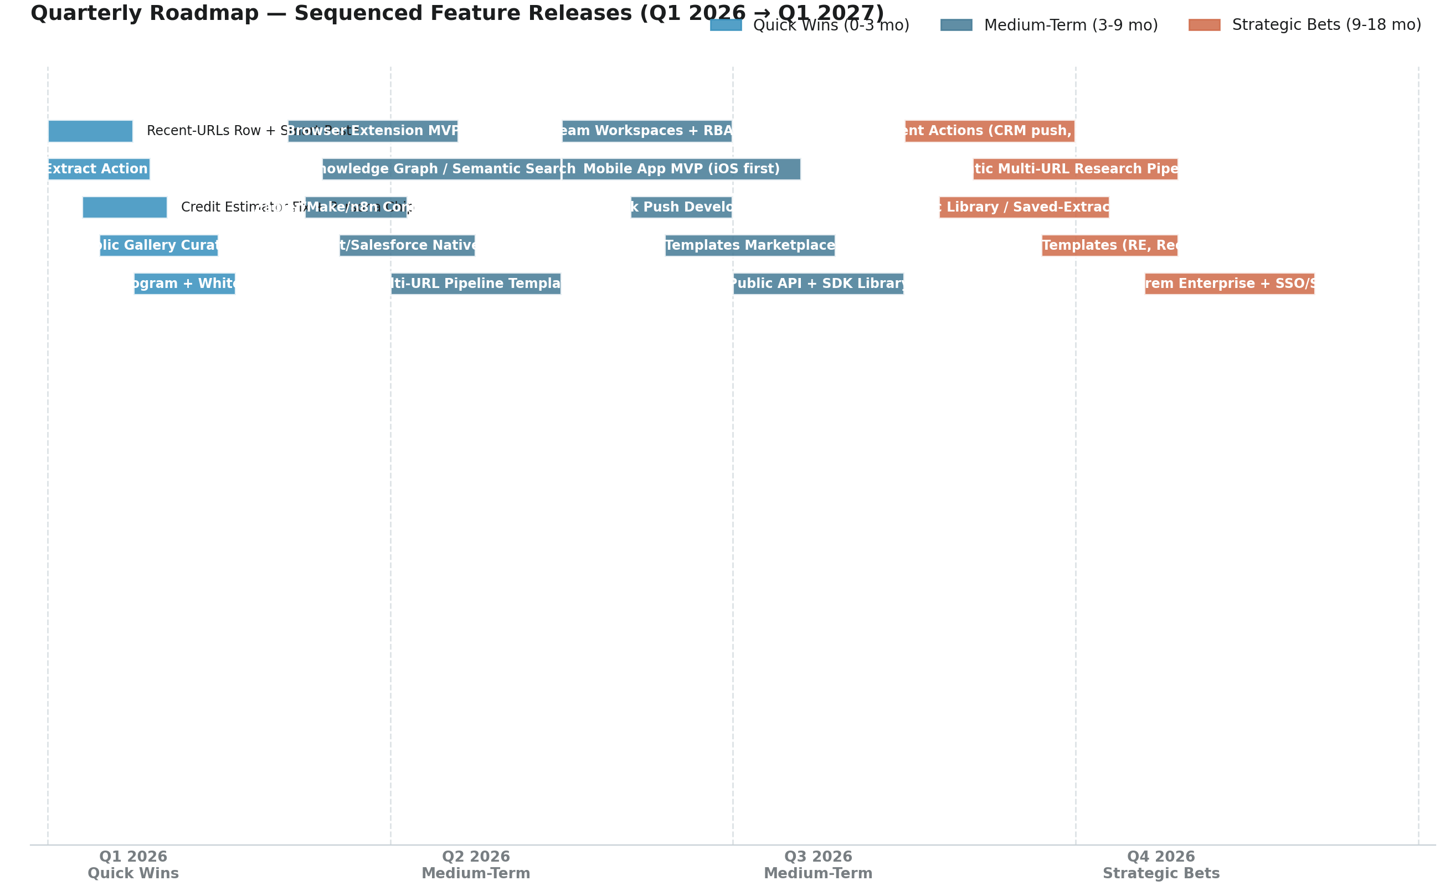
Figure 13.1 — Quarterly roadmap timeline. Each bar is a feature; bar position indicates start quarter + duration. Color: Quick Wins (blue), Medium-Term (teal), Strategic Bets (orange). The roadmap deliberately front-loads Quick Wins to build engagement momentum while structural and strategic work proceeds in parallel.

13.1 Sequencing rationale
- Q1 2026 — Quick Wins. Five small parallel workstreams ship in the first 12 weeks: home-screen enhancements, post-extraction action bar, persona quick-start cards, public gallery curation, referral program. None requires deep architectural change; all are additive. Expected outcome: 30-50% lift in returning-user extractions per week, first wave of social proof.
- Q2 2026 — Capture & workflow foundation. Browser extension MVP (week 4) eliminates capture friction. Knowledge graph RAG V1 (week 8) ships the durable moat. Zapier/Make/n8n connectors (week 6) unlock the no-code automation ecosystem. HubSpot/Salesforce native export (week 10) closes the Sales persona gap. Semantic diff for Schedules (week 12) makes monitoring defensible.
- Q3 2026 — Mobile & collaboration. Mobile app MVP (iOS first, week 8) + Team workspaces with RBAC and comments (week 4) unlock Business-tier conversion. Multi-URL pipeline templates (week 2) and Templates marketplace (week 10) deepen the workflow layer. Webhook push (week 6) prepares the Developer tier launch.
- Q4 2026 — Strategic platform plays. Public API + SDKs (week 6) and Agent Actions layer (week 4) ship in parallel — the API is foundational for the Agent Actions. Agentic Multi-URL Research (Deep Extraction, week 10) is the headline feature for 2026 close. Vertical templates (week 12) unlock RE / e-commerce / recruiting segments.
- Q1 2027 — Frontiers. Real-time browser-side capture (week 4), On-prem Enterprise + SSO/SAML (week 8), and AI companion chat interface (week 12) round out the 12-month roadmap and set up 2027 for the agentic platform phase.

14. Effort × Impact 2×2 Matrix
The 2×2 matrix below plots all 30+ recommended features by Development Effort (x-axis) vs Engagement + Strategic Impact (y-axis), color-coded by MoSCoW classification. The four quadrants are: Quick Wins (top-left, ship first), Big Bets (top-right, ship with sequencing), Fill-ins (bottom-left, ship when capacity allows), Time Sinks (bottom-right, defer or kill). The matrix is the visual companion to the prioritisation tables in §10-12 — features in the Quick Wins quadrant are the highest-priority regardless of their numeric score.
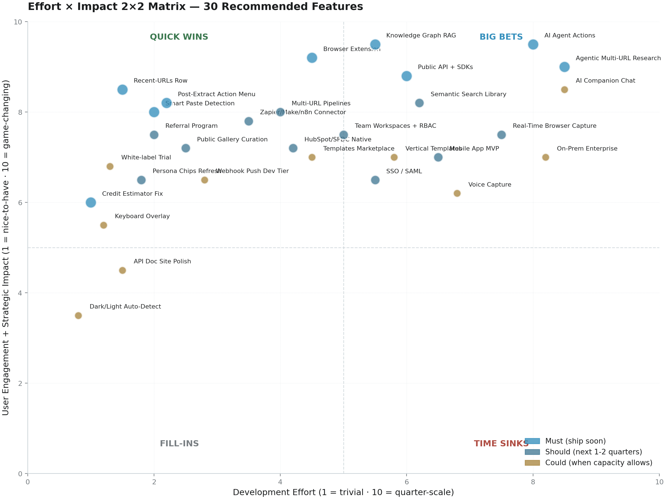
Figure 14.1 — Effort × Impact 2×2 matrix. Each dot is a recommended feature; size indicates MoSCoW priority (Must = largest, Should = medium, Could = smallest). Color: Must = blue, Should = teal, Could = amber. Features in the top-left quadrant (Quick Wins) should ship first; features in the bottom-right (Time Sinks) should be deferred or killed regardless of numeric score.

14.1 Quadrant distribution analysis
The matrix shows 30 features distributed as follows: Quick Wins (top-left, 12 features) — the priority list for Q1 2026. Big Bets (top-right, 9 features) — sequenced across Q2-Q4 2026 with dependency management. Fill-ins (bottom-left, 5 features) — ship when engineering capacity allows, no urgency. Time Sinks (bottom-right, 4 features) — defer or kill; if shipped, scope down. The distribution is healthy: no major category is over-invested, and the Quick Wins quadrant is well-populated (a sign that the prioritisation surfaced real low-effort, high-impact opportunities).
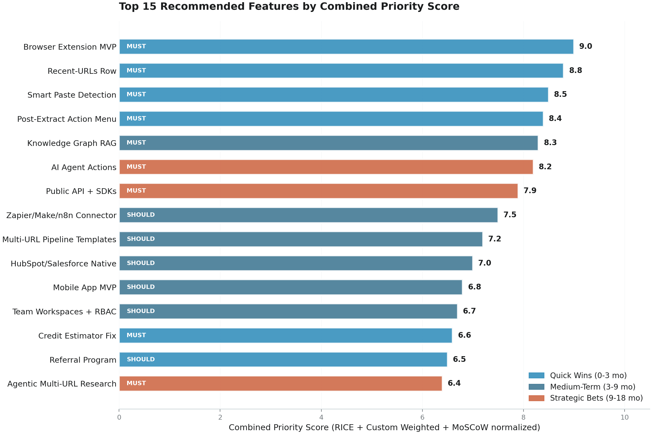
Figure 14.2 — Top 15 features ranked by combined Priority Score. Quick Wins (blue) dominate the top of the list, validating the Q1 2026 sequencing. Strategic Bets (orange) — AI Agent Actions, Public API, Agentic Multi-URL Research — appear lower only because of their higher effort weighting, not lower strategic value.

15. Risks, Dependencies & Mitigation
Six material risks could undermine the roadmap in §13. Each is identified, sized, and paired with a concrete mitigation. The risks are deliberately ordered by likelihood × impact — the first three (brand collision, no social proof, founder bandwidth) are the most urgent; the last three (single-provider AI dependency, anti-bot fragility, no API moat) are medium-term but compound over time.
# | Risk | Likelihood | Impact | Mitigation
R1 | Brand name collision with DAT iQ (dat.com — freight analytics), Datiq.com (Dutch comms), DatiqAI.com (decision intelligence) | High | High | Three options: (a) Rename to a unique brand (e.g. 'DatIQ' is already styled differently — formalise); (b) Acquire alt-domain (datiq.app already distinct, but own the long-tail of search); (c) Aggressive SEO on 'datiq.app' + competitor comparison pages (already started with /vs/*). Combine all three. Decide in Q1 2026.
R2 | No social proof — no Product Hunt launch, no testimonials, no case studies, no G2/Capterra presence | High | High | Ship PH launch in Q1 2026 (announced as "preparing"). Curate 5-10 customer testimonials from beta users. Add a logos strip on the home page. Set up G2/Capterra listings and request reviews. Add case studies to the blog. Combined effort: ~6 weeks content + 2 sprints engineering.
R3 | Founder bandwidth — solo / small team (2-10) shipping 90 features; competitive moat is thin because Firecrawl / Jina / Anthropic are commodity building blocks | High | High | Hire 2-3 senior engineers in Q1 2026 (frontend + backend + ML). Hire a developer advocate for the API launch. Sequence features strictly — defer "Could" features ruthlessly. Use the prioritisation matrix in §10-12 to enforce trade-offs.
R4 | Single-provider AI dependency — Anthropic Claude named as primary custom-extraction provider despite the cascade. Outage or pricing change could disrupt the core value prop. | Medium | Medium | The cascade (Gemini → Claude → OpenAI) is the right architectural choice. Document the cascade behaviour in the trust center. Add a fourth provider (open-source model like Llama 3 or Mistral) as a self-hosted fallback for Enterprise tier.
R5 | Anti-bot fragility — reliance on Firecrawl / Spider / Jina means heavily protected sites (Cloudflare, reCAPTCHA) may fail silently through the cascade. No proxy management UI exposed. | Medium | Medium | Expose per-extraction success/failure logs to the user. Document the anti-bot limitations in /docs. Add a "fallback to manual review" path for Business tier. Longer-term: build a proxy management UI for Enterprise tier.
R6 | No API moat until Developer tier ships in H3 2026 — meanwhile Apify, Browse AI, Clay all have mature APIs and ecosystem. | High | Medium | Ship the Public API + SDKs in Q4 2026 (announced). In the interim, ship the Zapier/Make/n8n connectors (Q2 2026) and Webhook push (Q3 2026) as light-weight API substitutes. Document the API roadmap publicly to capture early-adopter developers.

Table 15.1 — Six material risks, sized by likelihood × impact, with concrete mitigations.

15.1 Dependencies and sequencing constraints
Three dependencies govern the roadmap sequencing. Dependency 1: Knowledge Graph RAG (Q2 2026) must ship before Agent Actions Layer (Q4 2026) and Agentic Multi-URL Research (Q4 2026). The agent actions layer needs RAG over the user's saved extractions to ground its recommendations; agentic multi-URL research is a chain of RAG queries. Dependency 2: Public API + SDKs (Q4 2026) must ship before Zapier/Make/n8n connectors (Q2 2026) and Agent Actions Layer (Q4 2026). The connectors and agent actions both need an authenticated API. To resolve this circular dependency, ship a thin API wrapper in Q2 2026 (sufficient for Zapier) and the full Developer tier API in Q4 2026. Dependency 3: Browser Extension (Q2 2026) is independent and can ship in parallel with everything else.

16. Conclusion & Next Steps
Datiq's bet on the single URL is the right bet. The question is not whether to keep it, but how much further it can go.

16.1 Single-URL home screen — final verdict
Yes — the single-URL home screen makes practical sense and is genuinely differentiated versus every competitor in the benchmark. Its strengths are real: cold-start clarity, marketing alignment with the AI-companion behaviour pattern, persona-adaptive scaffolding, outcome-tile shortcuts for repeat jobs, trust-first design. Its limitations are not metaphorical but complementary: the home screen needs a recall surface (recent URLs row), smart-paste detection, a post-extraction action bar, persona-quick-start cards, a global search affordance, and voice/clipboard capture. Six targeted enhancements — most shipping in Q1 2026 — would multiply engagement without breaking the simplicity that makes the metaphor work.

16.2 Headline opportunities — five-bullet recap
- Browser extension + knowledge graph RAG are the two most important 2026 features. The extension kills capture friction; the RAG turns Datiq from a one-shot tool into a daily habit. Combined, they justify the Business and Pro Plus tiers and create the foundation for the Agent Actions Layer in Q4.
- AI agent actions move Datiq from extraction to action. Every competitor is moving toward agents (Linear, Notion, Perplexity, ChatGPT). Datiq's per-field provenance uniquely positions it to ground agent actions in citable data — the differentiator versus generic AI assistants.
- Mobile app and public API are structural gaps. Both are on the roadmap; both unlock new user segments (mobile for on-the-go capture; API for developers and embedders). Both should ship in 2026.
- Social proof and brand clarification are urgent and cheap. No Product Hunt launch, no testimonials, no case studies, no G2/Capterra presence — every one of these ships in weeks, not months. The brand collision with DAT iQ / Datiq.com / DatiqAI.com is a silent SEO killer that should be resolved in Q1 2026.
- Quick wins can ship in 90 days and demonstrate momentum. The 12 quick-win features in §10 are additive, low-effort, and immediately measurable. Shipping them in Q1 2026 builds the engagement baseline that justifies the medium-term and strategic bets later in the year.

16.3 90-day action checklist
The following checklist is the immediate action list for the Datiq product and engineering team. Each item maps to a specific feature in §10 (Quick Wins) and can be completed within Q1 2026.
Week | Action | Owner | Status gate
1 | Credit estimator UX fix; ship to production | FE | Conversion metric improved ≥ 10%
2 | Recent-URLs row on home screen; keyboard shortcut overlay | FE | Returning-user extractions +20%
3 | Smart-paste detector (URL/HTML/text/many) | FE | Multi-URL batch activations +30%
4 | Post-extraction action bar; persona quick-start cards | FE+UX | Sheets/Notion activations per extraction +50%
5-6 | Public Gallery curation + featured carousel | PM | 10+ curated extractions live
6 | White-label PDF trial on Free tier (watermarked) | BE | Free-to-paid conversion +15%
7-8 | Referral program launch (10% / 40%) | BE | 50+ referral signups in first month
7-8 | Trust center page live | Sec | Page live; sub-processors listed
9-10 | Public /docs API doc site placeholder | DevRel | Doc site live with email capture
10-12 | Persona-specific FAQ pages + 5-7 short screen-recorded walkthroughs | PM | All 7 personas documented
Ongoing | Brand clarification decision (rename / alt-domain / SEO) | Founder | Decision documented; execution plan Q2
Ongoing | PH launch prep (assets, hunters, list building) | Founder+PM | Launch-ready by end Q1 2026

Table 16.1 — 90-day action checklist. Each item maps to a feature in §10. Status gates are measurable success criteria for each action.

16.4 Closing thought
Datiq V1.0 is unusually polished for an indie launch. The single-URL home screen is the right wedge. The persona-adaptive UX is genuinely differentiated. The per-field provenance with confidence is best-in-class. What Datiq needs next is not a pivot or a rewrite — it is a deepening of the metaphor into the surrounding surfaces (browser extension, knowledge graph, agent actions, mobile, public API) and the social proof infrastructure (testimonials, case studies, Product Hunt, G2) that converts a polished tool into a category leader. The roadmap in §13 is sequenced to do exactly that, with 30+ features scored across three frameworks and prioritised for measurable engagement lift. The opportunity is real; the path is clear; the next 12 months will determine whether Datiq graduates from a polished V1 to a defensible platform.

