DatIQ — Complete Product Documentation (Internal)
Contents

INTERNAL master reference. This document is the full product + architecture record, including technical sections (stack, data model, persistence, environment). It is not the public help site.
- Public, end-user help is generated from docs/DatIQ-User-Guide.md → public/help/ (sanitized: no code, DB, or internals). - Public developer API reference lives in docs/DatIQ-Developer-API.md → public/help/developers.html. - Keep anything code-, database-, or infrastructure-specific in THIS file only — never in the two public sources above.
Zero-code web extraction & enrichment platform Paste any URL → get its structure, an AI summary, and one-click B2B enrichment — no scraping scripts required.
Product | DatIQ
Documented version | v2.0 core + R5–R19 increments (current production release)
Live site | https://datiq.app (Netlify project datiqapp)
Repository | https://github.com/vikashkaruna/scrapelite
Document purpose | Internal master reference for the product, its screens, and its architecture. Source of truth for the public help split-outs above, onboarding, and support knowledge base.
Last updated | 2026-06-20 (R19 — scheduler + unified Home composer)

How to read this document
This document is written to serve three downstream uses, so it is deliberately structured and self-contained:
- In-app HTML help — every screen and feature has its own clearly-titled section with a screenshot, so each section can be exported to a standalone HTML help page reachable from the DatIQ menu.
- Onboarding & sales enablement — the persona, segment, and prioritization sections explain who each feature is for and why it exists.
- Chatbot / knowledge base — short, question-style headings, a glossary, and an FAQ make the content easy to chunk and retrieve.
Navigation map for the help menu — Each top-level numbered section below is intended to become one help page: Overview · What's New / Versions · Who It's For · Screens (Home, Preview, Dashboard) · Features A–Z · Workflows · Exports & Sharing · Technology & Architecture · Data & Privacy · FAQ · Glossary.

Table of contents
- Product overview
- Product evolution: MVP → v1 → v2.0 → latest
- Who it's for — personas, user groups & business segments
- Feature → persona / segment mapping
- Feature & functionality prioritization principles
- Complete feature catalog
- Application flow — screen-by-screen, with screenshots
- End-to-end workflows
- Exports & sharing
- Technology stack, their uses & architecture
- Data model & persistence
- Privacy, security & data handling
- FAQ & troubleshooting
- Glossary
- Appendix — regenerating screenshots & environment

1. Product overview
DatIQ turns any public web page into structured, usable data in seconds — without writing a single line of scraping code.
You paste a URL. DatIQ returns:
- the page's heading outline (H1–H6, in document order),
- every link on the page (internal & external, de-duplicated and AI-categorized),
- a plain-language AI summary of what the page is about and how it's structured,
and then lets you go further with enrichment — pulling specific facts out of the page in plain English (contacts, pricing, social links, mission, or any custom field you describe), mapping an entire domain's indexed URLs, and generating marketing content (SEO outlines, competitor briefs, social posts) from anything you've saved.
Everything you keep lands in a personal Dashboard, where it can be searched, re-opened, exported (CSV / PDF) or emailed.

The core promise
Pillar | What it means
No code | No selectors, no XPath, no Python. A URL and a toggle are the entire interface.
Structured in seconds | Results come back as clean, typed data (headings, links, JSON enrichments), not raw HTML.
**Extract and enrich** | v2.0's defining shift: DatIQ doesn't just read a page, it answers questions about it — contacts, pricing, mission — as reusable, saved tabs.
Always usable | The app degrades gracefully: with API keys it makes real calls; without them it runs on realistic mock data and browser storage, so it never hard-fails.

One-line positioning
"Firecrawl + an LLM, wrapped in a zero-config product that a non-technical operator can drive — and that remembers everything it learns about a URL."

2. Product evolution: MVP → v1 → v2.0 → latest
DatIQ grew in three product stages plus a deployment stage. Understanding the arc explains why the UI is layered the way it is (simple core, progressively-disclosed power features).

Stage 1 — MVP / v1: "Extract & summarize"
The original product answered one question: "What's on this page?"
- URL input with validation and example chips
- Firecrawl-backed scrape → headings (H1–H6) + links
- AI summary of the page (Claude)
- Preview screen to review the result
- Save to Dashboard; dashboard list with search and pagination
- CSV export
- Robust error handling (typed error modal with retry), toasts, light/dark theme
- Graceful fallback: mock data + localStorage when no API keys are configured
Design decisions locked in this stage (still in force): a hand-built CSS design-system (not Tailwind-ified), centralized icon map, mock-but-real-ready services, and a dashboard that starts empty (no seed data).

Stage 2 — v2.0: "Extract & enrich"
v2.0 is the current feature release. It transformed DatIQ from a reader into an enrichment platform. Everything from v1 remains; v2.0 adds:
# | v2.0 capability | What it does
1 | Custom extraction | Describe any field in plain English ("product name, price, rating") → Firecrawl's LLM extraction returns structured JSON.
2 | Domain mapping | Discover every indexed URL on a site via Firecrawl's /map endpoint, returned as a searchable list.
3 | Contacts & emails | One toggle auto-loads a leadership/board/contact-email extraction prompt.
4 | Quick enrichment | Five one-click capabilities (Contacts, Leadership & Board, Social Links, Mission, Pricing) that run in the background and are saved as persistent tabs per URL.
5 | Content generation | Turn any saved page into an SEO blog outline, competitor summary, or social posts (Claude).
6 | AI link categorization | Each link is tagged Internal / External / Social / Email / Document / Media (heuristics always, refined by Claude when available).
7 | Full-capability CSV export | CSV now deep-flattens meta + headings + links + domain map + every enrichment.
8 | PDF export | jsPDF report of the same complete content, lazy-loaded only on demand.
9 | Email selected extractions | Send saved pages to recipients (webhook → email API → mailto fallback).

The Home screen surfaces these as an 8-capability card grid, and the Preview screen gained tabs (Overview + one per enrichment) that persist across reloads and devices.

Stage 3 — Latest (deployment / operations)
The most recent commits after the v2.0 merge were infrastructure, not new product features:
- Deploy to Netlify with secrets-scanning bypass for the build (6e1d499)
- Merge of the deployment PR #1 (5b267d3)
- Addition of the in-repo project context file CLAUDE.md (5c803b5)
**So "the latest version" of the product is v2.0.** The latest changes made it publicly deployed and reproducible. There is no v3 feature set yet — the "Outstanding tasks" (Supabase migration, Netlify env vars, AI proxy, auth) are the runway toward it.

3. Who it's for — personas, user groups & business segments
DatIQ's enrichment prompts and content formats are unmistakably B2B go-to-market oriented (leadership contacts, pricing tiers, competitor briefs, SEO outlines). The product is built for non-technical operators who need web data fast.

Primary personas
Persona | Job to be done | Features they live in
Sales / SDR / RevOps | Build prospect lists; find decision-makers and contact emails; understand a target account's pricing and positioning. | Contacts & emails, Leadership & Board, Custom extraction, Email selected, CSV export
Marketing / Content / SEO | Repurpose competitor and reference pages into content; map a site's structure for an SEO audit. | Content generation (SEO outline, social posts), Domain mapping, Headings outline, AI summary
Competitive / Market intelligence | Track how competitors position, price, and structure their sites. | Competitor summary, Pricing & Plans, Company Mission, Custom extraction
Founders / Small teams / Agencies | Do research-grade web extraction without hiring an engineer or buying a scraping stack. | The whole product — zero-config is the point
Researchers / Analysts | Capture page structure + a readable summary; keep a searchable archive of sources. | AI summary, Headings, Links, Dashboard search, PDF export
Recruiters / BD | Find leadership/board members and general contact channels at target companies. | Leadership & Board, Contacts & emails, Social Links

User groups (by access pattern)
- Single operator / demo user — runs on localStorage, no backend needed. The app is fully functional with zero setup.
- Configured team — Supabase-backed; saved extractions and enrichment tabs sync across devices/browsers.
- Evaluator / prospect — lands on the live demo, which runs against real APIs or rich mock data.

Business segments
Segment | Fit | Why
SMB & startups | ★★★★★ | No code, no infra, instant value; the free/local mode removes all onboarding friction.
Sales & marketing agencies | ★★★★★ | Lead enrichment + content repurposing in one tool, exportable to CSV/PDF/email.
Mid-market GTM teams | ★★★★☆ | Quick enrichment + dashboard archive; would benefit from the planned auth + Supabase sync.
Enterprise | ★★★☆☆ | Needs the planned hardening (server-side AI proxy, auth, multi-user isolation) before broad rollout.
Solo researchers / journalists | ★★★★☆ | Fast structure + summary + durable, searchable archive.

4. Feature → persona / segment mapping
A consolidated cross-reference (useful as chatbot training data for "which feature should I use for X?").
Feature | Primary persona | Secondary | Business value
Heading structure (H1–H6) | Researcher, SEO | Marketing | Understand page intent & content hierarchy
Every link (AI-categorized) | SEO, Researcher | Sales | Link audit; find social, docs, contact channels
AI summary | Everyone | — | Instant "what is this page" without reading it
Custom extraction | Sales, Competitive intel | Everyone | Pull any field in plain English
Domain mapping | SEO, Researcher | Competitive intel | Site-wide URL discovery / audit
Contacts & emails | Sales, Recruiting | BD | Decision-maker outreach lists
Quick: Find Contact Info | Sales/SDR | Recruiting | Names, titles, emails, phones
Quick: Leadership & Board | Sales, Recruiting, BD | Investors | Org top-of-house mapping
Quick: Social Links | Marketing, BD | Sales | Multi-channel presence
Quick: Company Mission | Competitive intel, Sales | Content | Positioning & value prop
Quick: Pricing & Plans | Competitive intel, Sales | Product | Pricing benchmarking
Content: SEO Blog Outline | Content/SEO | Marketing | Ready-to-write structure
Content: Competitor Summary | Competitive intel, Sales | Strategy | Battle-card raw material
Content: Social Posts | Marketing | Founders | Quick promo copy
CSV export | Sales/RevOps | Analysts | Feed CRMs / spreadsheets
PDF export | Researcher, Marketing | Exec reporting | Shareable report
Email selected | Sales, Marketing | Anyone | Distribute findings
Dashboard search & archive | Everyone | — | Reusable, searchable knowledge store

5. Feature & functionality prioritization principles
These are the principles that guided what got built (and how), reconstructed from the product's locked architecture rules. They double as guidance for future features.
- Zero-config first, power on demand. The single most important rule: a brand-new user with no API keys and no database can use the entire product immediately (mock services + localStorage). Real integrations are additive, never required. Priority: removing onboarding friction beats every individual feature.
- Graceful degradation over hard failure. Every external dependency has a fallback:
  - No Firecrawl key → realistic mock scrape.
  - No AI key → heuristic link categorization + templated summary/content.
  - No Supabase → localStorage.
  - Un-migrated Supabase columns → save the v1 columns, store v2 data locally, log a warning — never block a save.
  - Webhook/email failure → fall through (webhook → email API → mailto), fire-and-forget, never blocks the UI.
- Progressive disclosure. The Home screen leads with one input and one button. Scrape options (toggles) sit below; the custom-extraction textarea only appears when toggled; advanced capabilities are surfaced as discoverable cards. Complexity is opt-in.
- Non-blocking enrichment. Quick Enrichment runs in the background — the page stays visible, only the clicked control spins. Users never hit a full-screen loader for a secondary action. This was an explicit, locked UX rule.
- Persistence & resilience of learned data. Anything DatIQ learns about a URL (enrichment tabs) is saved in two places (local cache + Supabase column) and merged newest-wins on read, so insights survive reloads, navigation, and device switches.
- Exports must be complete. CSV and PDF bundle everything known about a page — including every enrichment capability, deep-flattened — because the export is often the real deliverable for a sales/marketing user.
- Cost & performance discipline. AI calls are bounded (link categorization caps at 60 links; prompts are tight). Heavy libraries (jsPDF) are lazy-loaded only when the user actually exports. Concurrent work (summary + categorization) runs in parallel.
- Design-system integrity. A hand-authored CSS token system (design-system.css + screens.css) is treated as a locked asset — never rewritten into utility classes — so the product keeps a consistent, bespoke look.
- Safety of irreversible actions. Deletes are optimistic with rollback on failure; saves retry without losing the extraction; superseded async requests are ignored (request-id guard) so a fast second action can't be overwritten by a slow first one.

6. Complete feature catalog
A flat, exhaustive list (good for chatbot retrieval). Grouped by area.

6.1 Extraction (input)
- URL input with live validation and normalization (adds scheme if missing).
- Example chips — lumio.io, stripe.com/pricing, notion.so/help.
- Render JavaScript toggle — waits ~3s for client-side/SPA content to hydrate (Firecrawl waitFor).
- Map entire domain toggle — switches to URL discovery instead of single-page scrape.
- Contacts & emails toggle — auto-loads the leadership/board/contact-email prompt.
- Custom extraction toggle — reveals a free-text prompt box + 5 Quick-Action preset chips.

6.2 Extraction (output, on Preview)
- Page identity — favicon monogram, title, clickable URL, stat counts.
- AI summary — 3–5 sentence plain-language overview.
- Headings card — full H1–H6 outline, indented by level.
- Links card — de-duped links with AI category tags and an All / Internal / External filter; per-category counts.
- Domain map card (map mode) — searchable/filterable list of all discovered URLs.

6.3 Enrichment
- Quick Enrichment panel — 5 one-click capabilities:
  - Find Contact Info — names, titles, emails, phones.
  - Leadership & Board — execs, founders, directors + general contacts.
  - Social Links — LinkedIn, X/Twitter, Facebook, Instagram, YouTube, GitHub.
  - Company Mission — mission, value proposition, description.
  - Pricing & Plans — every tier: name, price, period, features.
- Background execution — page stays visible; only the clicked button shows a spinner, then a ✓ badge.
- Enrichment tabs — Overview + one tab per executed capability; the new result's tab auto-activates.
- Refresh — re-running a capability overwrites its tab (no duplicates).
- Persistence — tabs survive reload and re-open from Dashboard; merged from local cache + Supabase newest-wins.
- Structured-data renderer — renders arbitrary enrichment JSON: email links, URL links, primitives, arrays, nested objects.

6.4 Content generation (from saved pages)
- SEO Blog Outline — title, meta description (≤155 chars), 4–6 H2s with H3 sub-points, target keywords.
- Competitor Summary — what they do, positioning, target customers, strengths, likely gaps.
- Social Posts — three short LinkedIn-tone promotional posts.
- Copy button in the modal.

6.5 Dashboard (archive)
- Table / Card layout toggle (persisted).
- Smart search — AND-logic across title, URL, summary, headings, and links.
- Viewport-adaptive pagination — rows-per-page adjust to window height.
- Selection — per-row + select-all-on-page; selection bar with Clear / Generate / Send email.
- Row actions — View, Delete (optimistic with rollback).
- Header actions — CSV, PDF, New extraction.

6.6 Exports & sharing
- CSV — comprehensive, deep-flattened (all capabilities).
- PDF — jsPDF report, lazy-loaded, full content.
- Email — send selected extractions; webhook → email API → mailto fallback.
- Export scope = selected rows, or everything matching the current search if nothing is selected.

6.7 System / cross-cutting
- Light / dark theme (persisted).
- Toasts (2.6s auto-dismiss) for every action.
- Typed error modal with category-specific copy and a retry action.
- Reload resilience — last-viewed extraction restored on Preview after a browser reload.
- Webhook notification on save (fire-and-forget).

7. Application flow — screen-by-screen, with screenshots
DatIQ is a 3-screen single-page app with a persistent top navigation bar.
┌─────────────────────────────────────────────────────────────────┐
│ TopBar: DatIQ logo │ Extract · Dashboard │ 🌙 theme │ +New │
└─────────────────────────────────────────────────────────────────┘
│ │ │
▼ ▼ ▼
/ (Home) ──Extract──▶ /preview ──Save──▶ /dashboard
Extract screen Review & enrich Saved archive
▲ │ │
└──────── New ◀───────────┴────── View / Open ◀────┘
The end-to-end loop: Paste a URL on Home → review structure + summary on Preview → optionally enrich (tabs) → Save → it appears in the Dashboard → reopen, export, generate content, or email it.

7.1 Screen 1 — Home (Extract) · route /
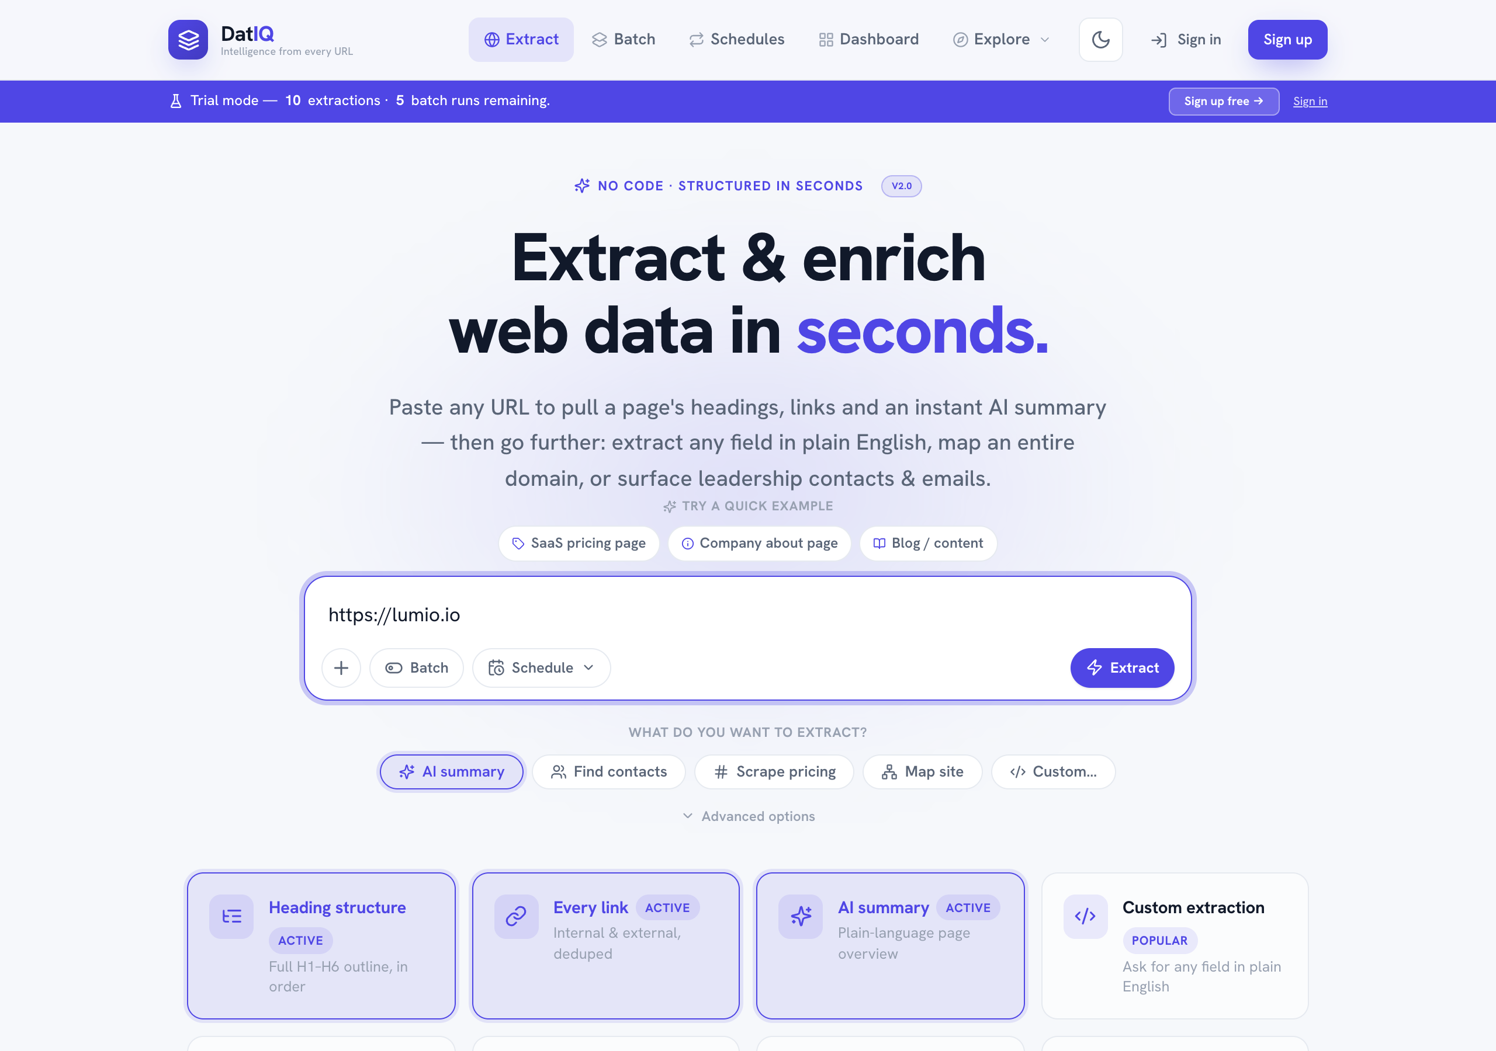
DatIQ Home screen
Purpose: the entry point — turn a URL into an extraction.
What's on the screen (top to bottom):
- Eyebrow — "No code · structured in seconds" with a v2.0 pill.
- Hero headline — "Extract & enrich web data in seconds." + a one-paragraph value proposition.
- URL field — a globe-led input with a primary Extract button (label becomes Map domain when the map toggle is on). Invalid input shows an inline error and a red field outline.
- Example chips — lumio.io, stripe.com/pricing, notion.so/help; click to fill the field.
- Scrape-option toggles (four):
  - ⚡ Render JavaScript — for dynamic/SPA pages (slower).
  - 🗺️ Map entire domain — lists every indexed URL instead of scraping one page.
  - 👥 Contacts & emails — leadership & board.
  - </> Custom extraction — ask in plain English (reveals the prompt box).
- Custom-extraction panel (appears when the Custom toggle is on) — a textarea plus 5 Quick Action preset chips that fill the prompt: Find Contact Info, Leadership & Board, Social Links, Company Mission, Pricing & Plans.
- Capability cards — an 8-card grid (3 v1 + 5 v2) describing everything the product can do.
Behavior notes:
- Map mode ignores per-page options and routes to the /map endpoint; a note explains this.
- Submitting shows a full-screen 4-step loading animation, then navigates to Preview.
- On failure, you're returned to Home with an error modal offering Try again (re-runs the same URL + options).
Dark mode (theme is one click in the top bar, and persists):
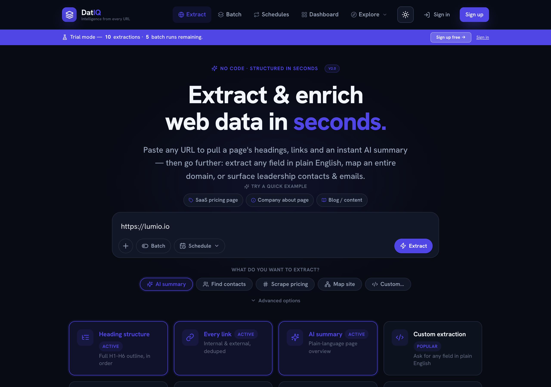
DatIQ Home in dark mode

7.2 Screen 2 — Preview (Review & Enrich) · route /preview
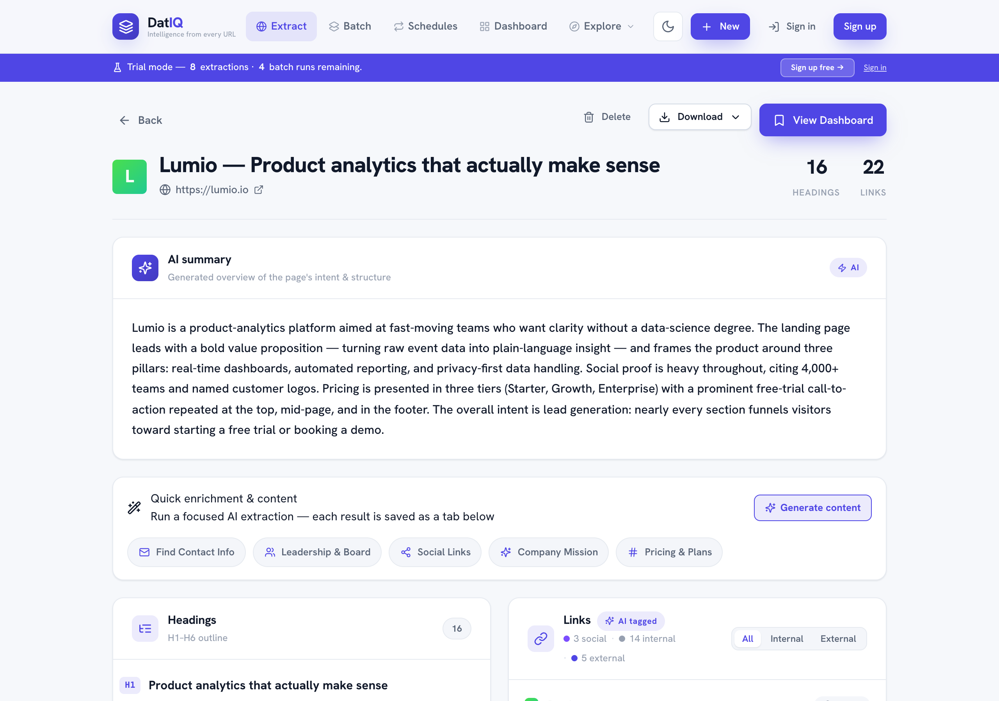
DatIQ Preview screen
Purpose: review the extraction, enrich it, then save or discard.
What's on the screen (top to bottom):
- Action bar — Back (to Home), Discard (drops it, returns Home), Save to Dashboard (persists + navigates to Dashboard, with a saving overlay).
- Page identity — favicon monogram, page title, clickable URL, and stats (headings & links count, or URL count in map mode).
- AI summary card — the generated overview, badged "AI".
- Quick enrichment panel — the five capability buttons. Each runs in the background:
  - while running → a spinner on the button,
  - when done → a green ✓ badge,
  - clicking a done button refreshes it.
(In the screenshot, Leadership & Board and Pricing & Plans show ✓ — they've been run.)
- Tabs — Overview plus one tab per executed enrichment (here: Leadership & Board, Pricing & Plans).
- Tab content:
  - Overview → the Headings card (H1–H6 outline) and the Links card (AI-tagged, filterable All/Internal/External, with per-category counts) side by side.
  - An enrichment tab → the structured data for that capability (e.g., a contacts list or pricing table), with a Refresh button and a "Saved N minutes ago" timestamp.
Map-mode variant — when you extracted with Map entire domain, the Overview tab shows a single Domain map card: a searchable list of every discovered URL, with a filter box and a count pill. (Quick enrichment is hidden in map mode.)
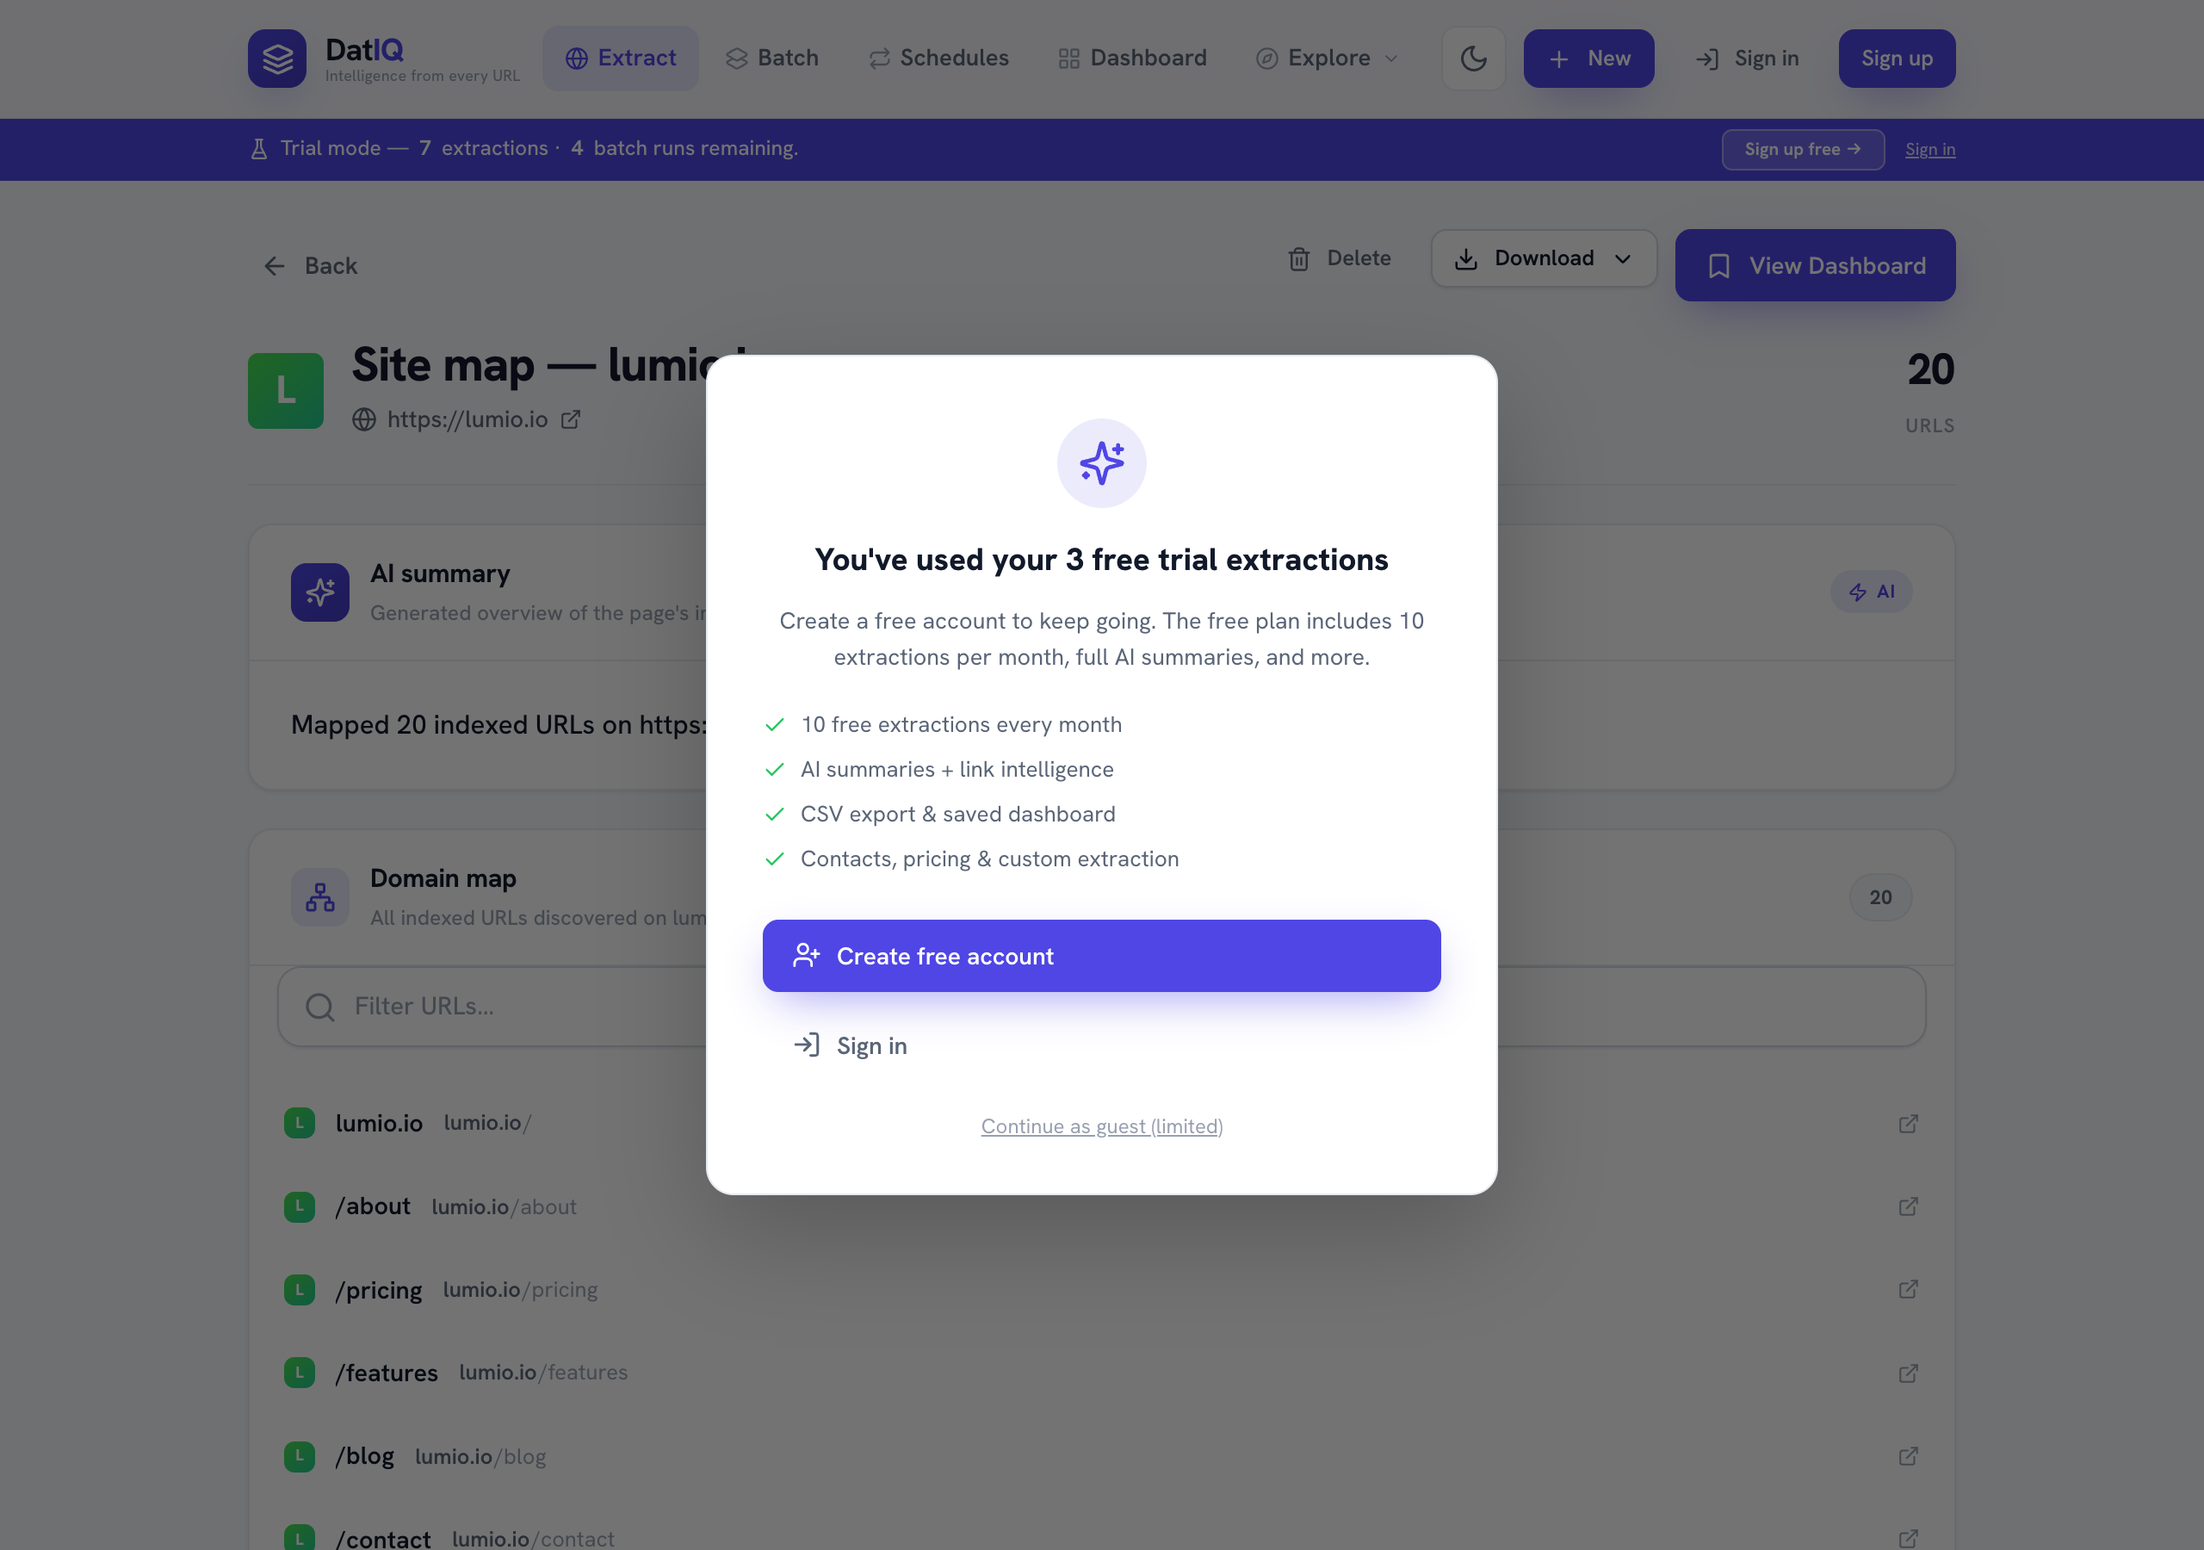
DatIQ domain map preview
Behavior notes:
- Quick enrichment never shows the full-screen loader or navigates — the page stays put.
- Enrichment tabs are saved per-URL and reappear when you reopen this page from the Dashboard, even on another device (when Supabase is configured).
- The last-viewed extraction is restored if you reload the browser on this screen.

7.3 Screen 3 — Dashboard (Saved archive) · route /dashboard
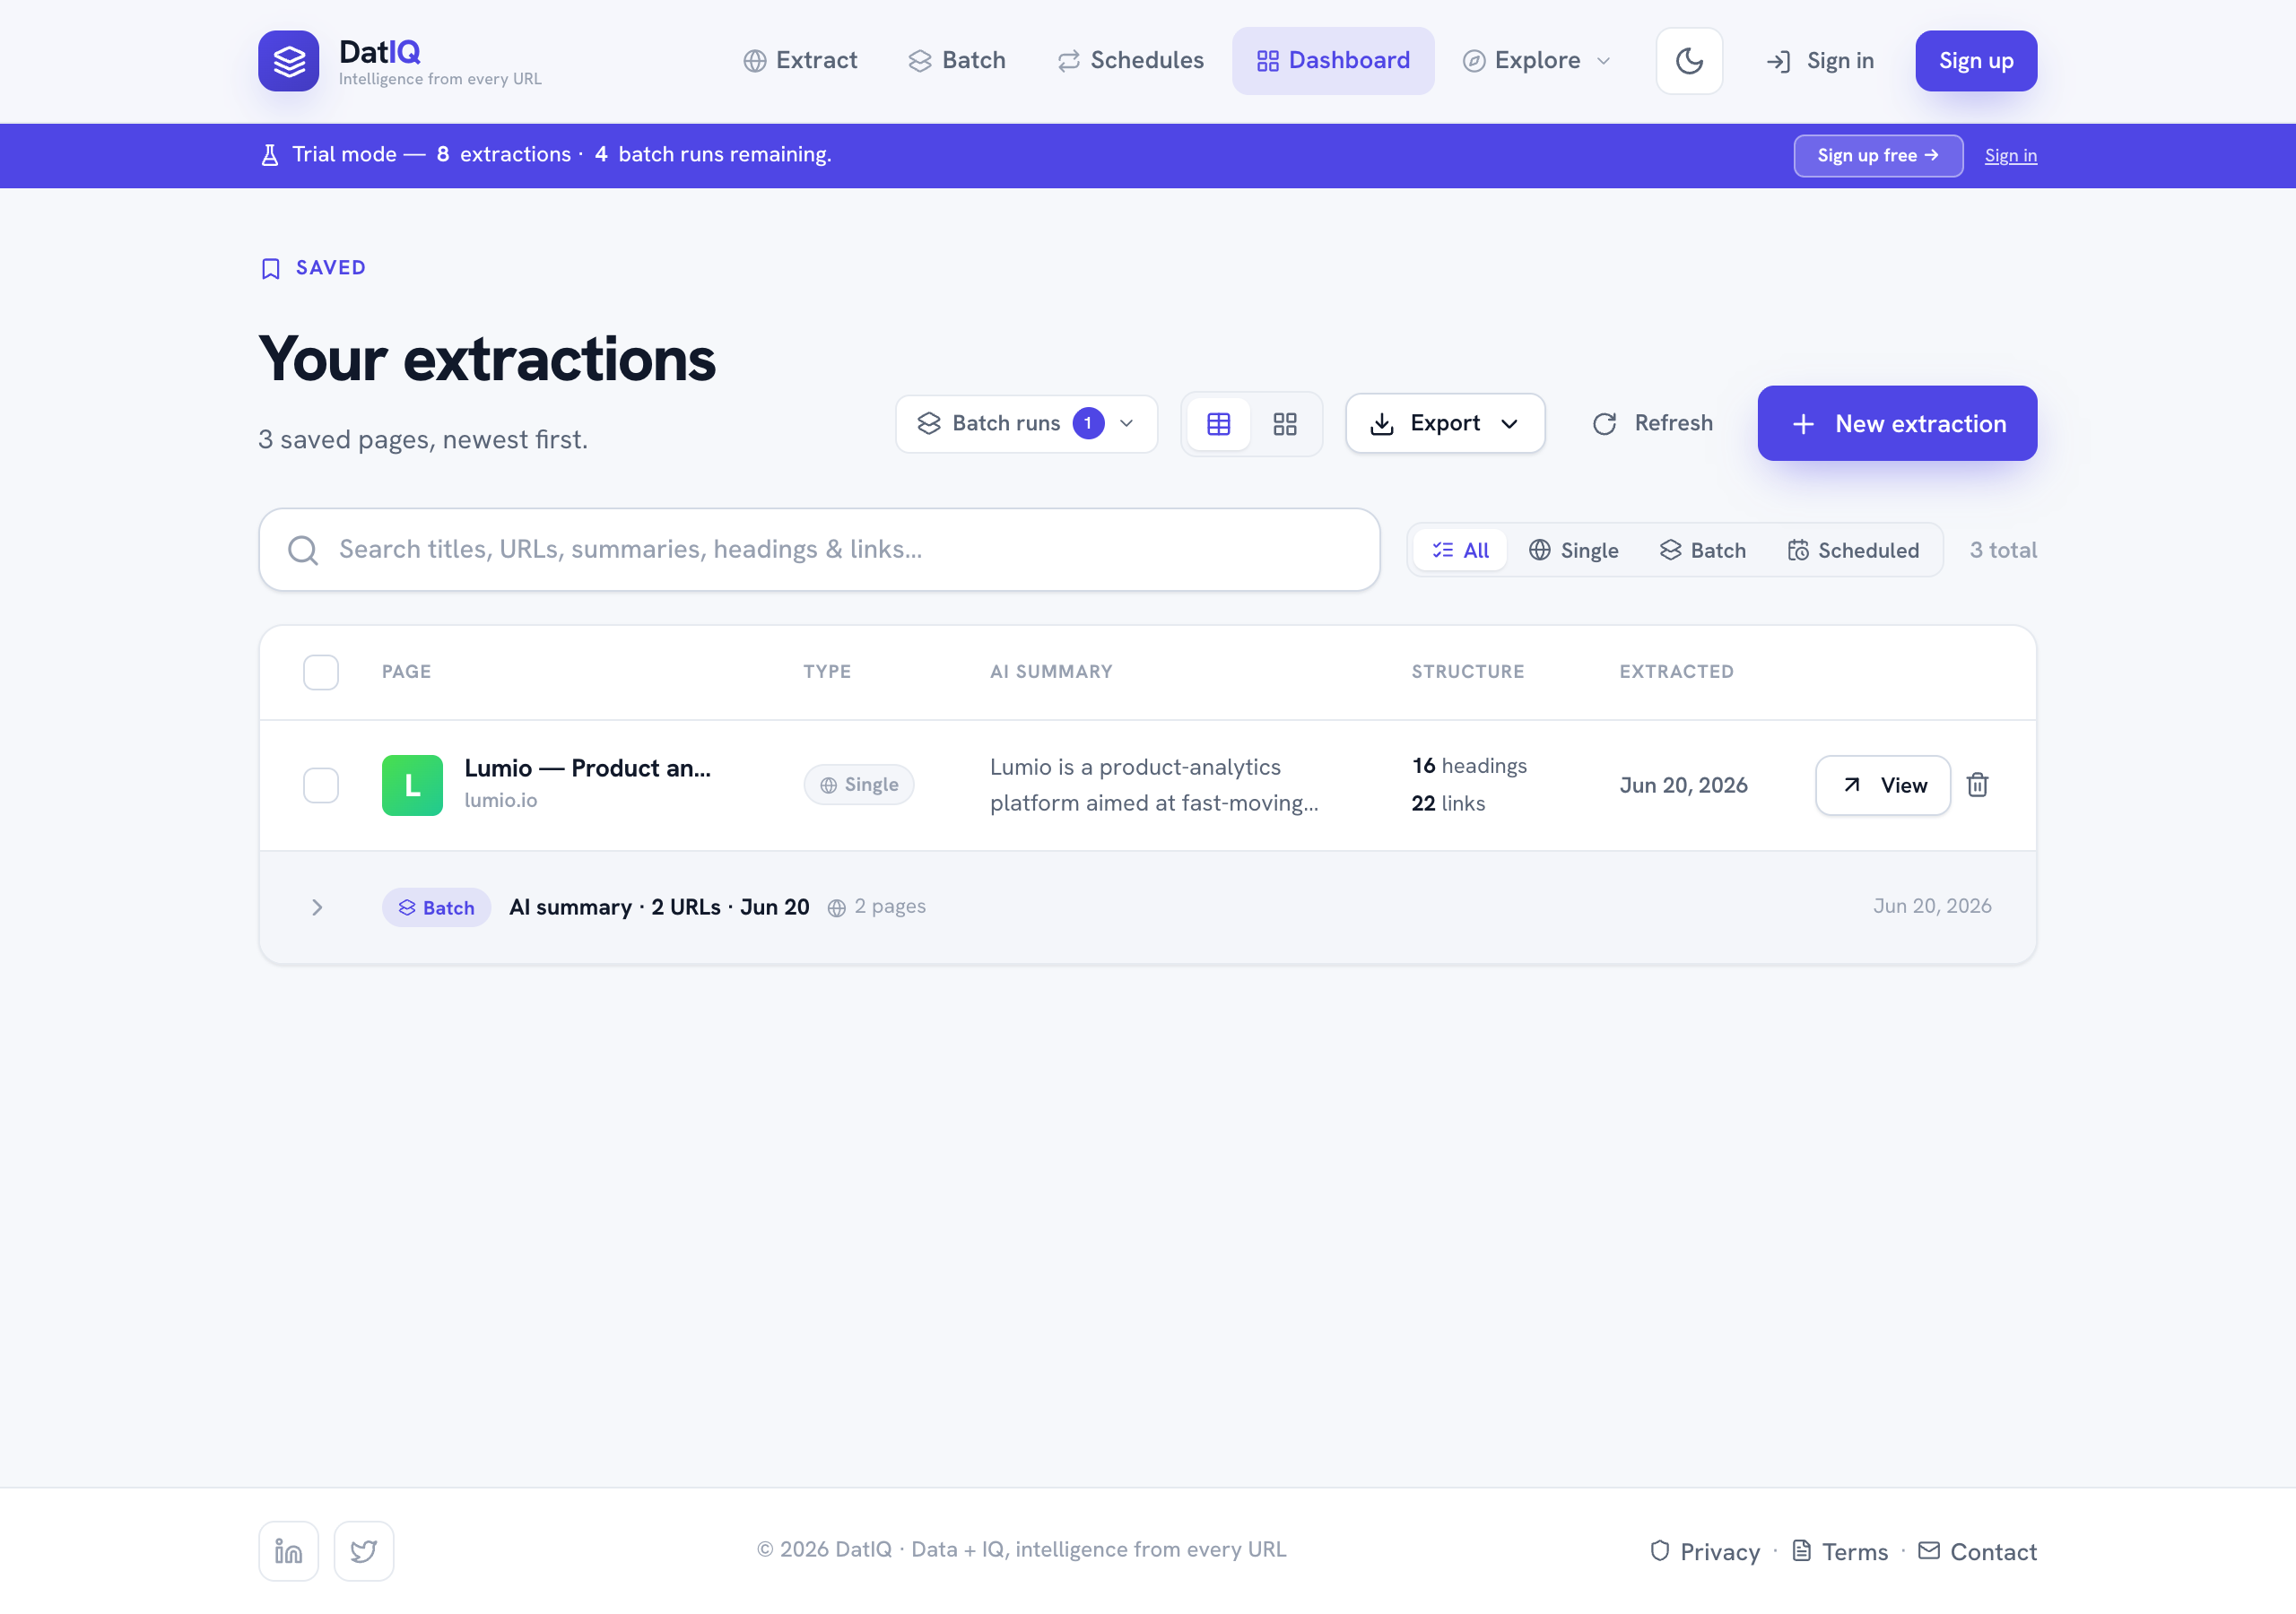
DatIQ Dashboard, table view
Purpose: your searchable archive of saved extractions; the hub for export, content generation, and email.
What's on the screen:
- Header — "Your extractions", a count subtitle, and the action cluster:
  - Table / Card layout toggle,
  - CSV and PDF export buttons,
  - New extraction (back to Home).
- Toolbar — a smart search box (matches across title, URL, summary, headings, links) and a count / selection bar.
- Table (default) — columns: select, Page (favicon + title + host), AI summary (snippet), Structure (heading & link counts), Extracted (date), and row actions (View, Delete). Clicking a row opens it in Preview.
- Pager — appears when results exceed the viewport-fit page size.
Selection bar — when you tick one or more rows, the toolbar swaps to: *N selected · Clear · Generate · Send email*.
- Generate opens the Content modal (SEO outline / competitor summary / social posts) for the first selected page.
- Send email opens the Email modal (multi-recipient) to send the selected pages.
Card view — the same data as cards (toggle persists):
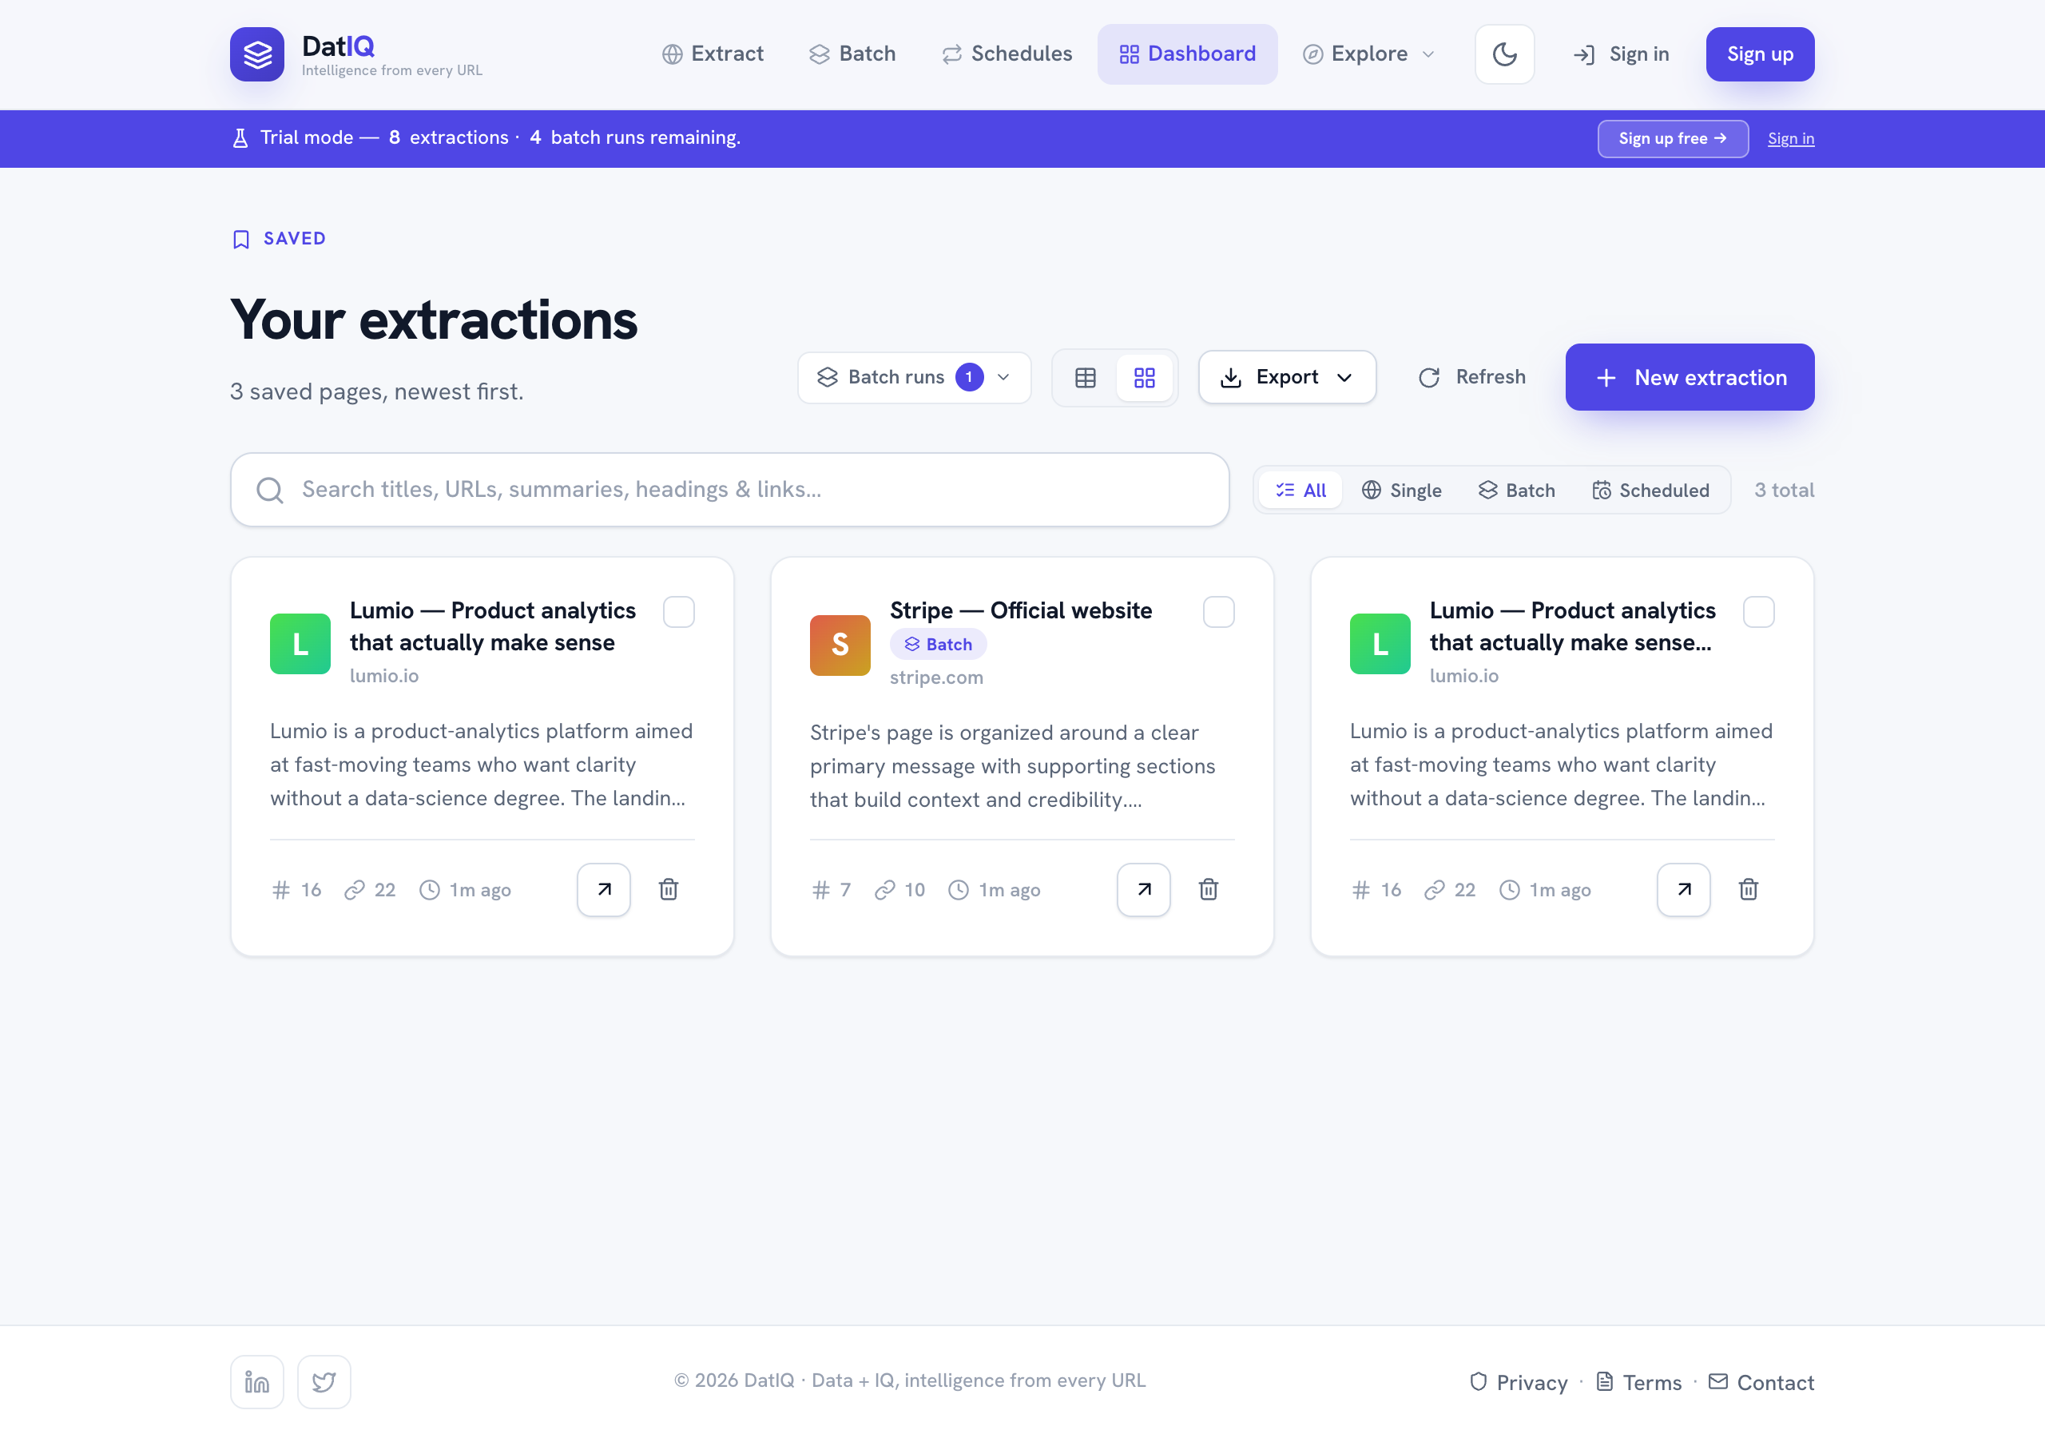
DatIQ Dashboard, card view
Empty states — a friendly empty state when nothing is saved ("No extractions yet") and a "No matches" state when a search returns nothing.

7.4 Screen 4 — Batch (Multi-URL extraction) · route /batch
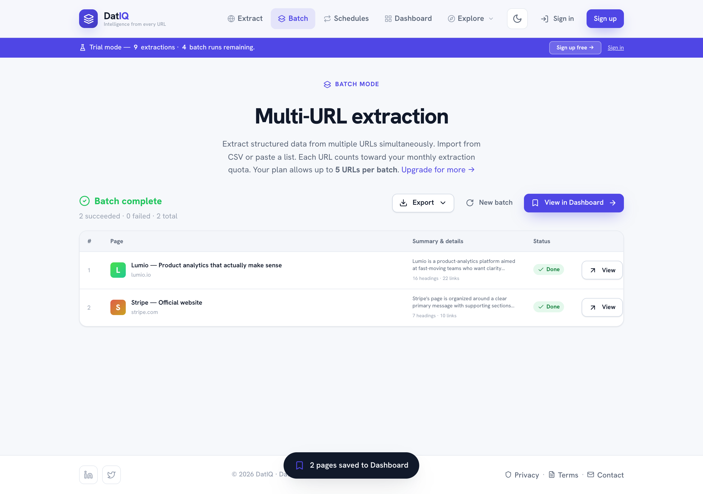
DatIQ batch results
Batch extracts many URLs in one run. Users paste a list (one URL per line) or Import CSV, choose an intent (same chips as single extraction), and run. A progress indicator tracks the run; on completion a results table lists each page with a summary snippet and per-URL status (failed URLs show a reason). All successful pages auto-save to the Dashboard and are grouped as one batch run. Results can be exported (CSV/PDF/Markdown/JSON) via a single Export ▾ dropdown. The typed list is persisted (draft) so it survives refresh and back-navigation; New batch clears it. Per-URL extraction counts toward the monthly quota; plans cap URLs-per-batch.

7.5 Screen 5 — Schedules (Monitoring) · route /schedules
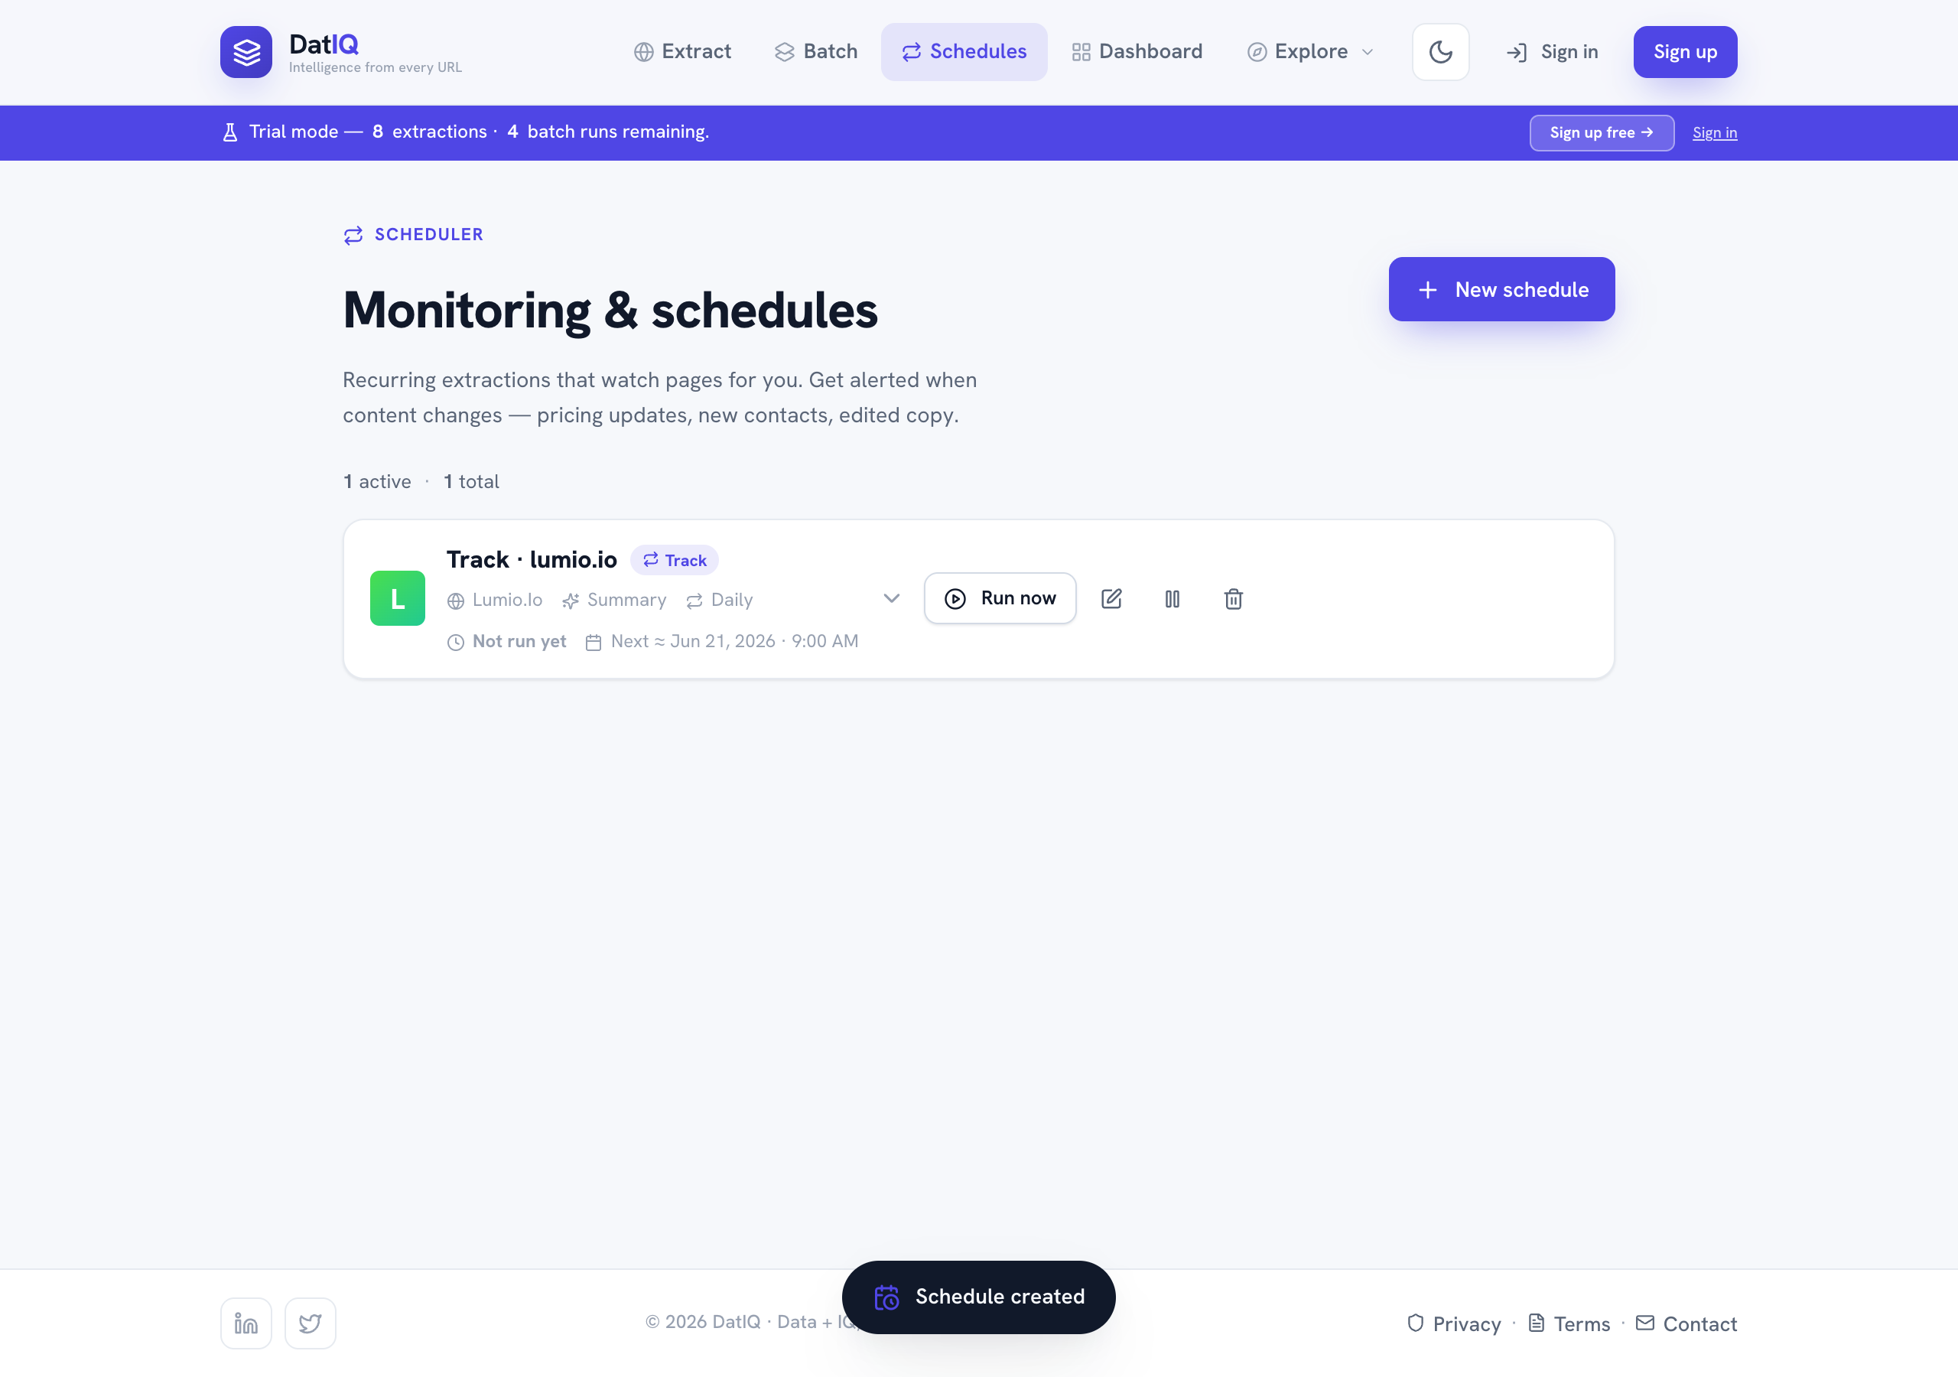
DatIQ schedules screen
Schedules are recurring extractions that watch a page for changes and optionally alert by email. They are created either from the Home composer (preset cadence) or here via the inline ScheduleEditor (no modal). The editor sets URL, intent, a cadence (presets or a custom frequency · day · time builder), an optional "run until" end date, an alert email, and a name. List cards show cadence, last/next run, and an expandable detail panel; each supports Run now (with change detection), Edit, Pause/Resume, and Delete. Automated (hourly) runs detect changes, record them, and fire the alert email + automation webhook; the manual Run now is client-side and only reports the change on screen.

7.6 Modals & system UI
Element | Trigger | What it does
Loading screen | Submitting an extraction | Full-screen 4-step animated progress.
Saving overlay | Save on Preview | Branded loader over the page while persisting.
Content modal | Generate (Dashboard) | Pick a format, generate via Claude, copy the markdown.
Email modal | Send email (Dashboard) | Enter recipients, send selected extractions.
Error modal | Any failed action | Category-specific message + Try again retry.
Toasts | Every action | Brief confirmation, auto-dismiss (~2.6s).
Theme toggle | Top bar | Light/dark, persisted.

8. End-to-end workflows
Concrete, step-by-step task recipes (ideal chatbot "how do I…" answers).

Workflow A — Extract a page and save it
- On Home, paste a URL (or click an example chip).
- (Optional) enable Render JavaScript for an SPA.
- Click Extract → wait for the loader → land on Preview.
- Review the AI summary, headings, and links.
- Click Save to Dashboard.

Workflow B — Build a contact / leadership list for a prospect
- Extract the company's homepage (or About page).
- On Preview, in Quick enrichment, click Leadership & Board (and/or Find Contact Info).
- The result saves as a tab — open it to see names, titles, emails.
- Save to Dashboard.
- Later, select the row → CSV to push the contacts into your CRM/spreadsheet, or Send email to share.

Workflow C — Benchmark a competitor's pricing
- Extract the competitor's pricing page (e.g., stripe.com/pricing).
- Click Pricing & Plans in Quick enrichment → a structured tier table is saved as a tab.
- (Optional) click Company Mission for positioning.
- Save → from the Dashboard, Generate → Competitor Summary for a battle-card draft.

Workflow D — Map a site for an SEO audit
- On Home, toggle Map entire domain, paste the domain, click Map domain.
- On Preview, use the Domain map card's filter to scan URLs by path.
- Save → export to CSV/PDF for the audit deliverable.

Workflow E — Turn a reference page into content
- Extract and save any page.
- On the Dashboard, select it → Generate.
- Choose SEO Blog Outline, Competitor Summary, or Social Posts.
- Copy the generated markdown into your CMS or doc.

Workflow F — Custom field extraction
- On Home, toggle Custom extraction.
- Type exactly what you want, e.g. "Extract the product name, price, and customer rating."
- Extract → the structured result appears as a Custom extraction tab on Preview, and persists.

9. Exports & sharing
Channel | Scope | Contents | Notes
CSV | Selected rows, or all search matches if none selected | Meta + headings + links + domain map + every enrichment capability, deep-flattened to JSON paths | Best for CRM/spreadsheet import
PDF | Same scope | Same complete content as a formatted report | jsPDF, lazy-loaded only on click
Email | Selected rows | Title, URL, AI summary, heading/link counts per page | Delivery chain: webhook → email API → mailto fallback

Export scope rule: if you've selected rows, exports use the selection; otherwise they export everything currently matching the search. Each exported page is hydrated with its enrichments from both local cache and Supabase before export, so nothing is missed.

10. Technology stack, their uses & architecture

10.1 Stack at a glance
Layer | Technology | Why it's used
Build tool | Vite 5 | Fast dev server + optimized production build; env handling via import.meta.env.
UI framework | React 18 | Component model; concurrent-friendly hooks.
Routing | React Router 6 (v7 future flags) | The 3-route SPA (/, /preview, /dashboard).
Styling | Tailwind (utilities only) + a bespoke CSS design system | Tokens (--accent, --bg, --surface, radii, shadows) live in CSS custom properties; Tailwind is used only for incidental utilities. The token system is a locked asset.
Icons | lucide-react via a central Icon.jsx map | One place to add/rename icons; no scattered imports.
Scraping | Firecrawl API (/v1/scrape, /v1/map, JSON/LLM extraction mode) | Turns URLs into HTML/structured data, including LLM-based field extraction and domain mapping.
AI | Anthropic Claude (claude-haiku-4-5 by default) | Summaries, link categorization, content generation.
Database | Supabase (Postgres + PostgREST) | Cloud persistence of saved extractions & enrichments, with RLS.
Local persistence | localStorage | Zero-config fallback + offline mirror + UI prefs (theme, layout, last-viewed, enrichment cache).
PDF | jsPDF 4.2.1 | Client-side PDF reports; lazy-loaded.
Automation | Webhook (n8n) + optional email API | Save notifications and email delivery.

No test framework or ESLint config is wired in; scripts are dev, build, preview only.

10.2 Architecture overview
DatIQ is a 100% client-side SPA. There is no custom backend server — the browser talks directly to Firecrawl, Anthropic, and Supabase. A layered design keeps this clean:
┌──────────────────────────────────────────────────────────────────────┐
│ React UI │
│ Pages: Home · Preview · Dashboard Components: modals, cards… │
└───────────────┬───────────────────────────────────────────────────────┘
│ React Context
┌───────▼─────────────────────────────────────────┐
│ ExtractionProvider (orchestrator) │
│ extract() · enrich() · save() · view() │
└───┬───────────────┬──────────────┬───────────────┘
│ │ │
┌────────▼──────┐ ┌──────▼───────┐ ┌────▼─────────────┐
│ firecrawl │ │ aiService │ │ extractionsRepo │
│ Service │ │ summarize/ │ │ + enrichmentStore│
│ scrape/map/ │ │ categorize/ │ │ (Supabase + │
│ customPrompt │ │ generate │ │ localStorage) │
└───┬───────────┘ └──────┬───────┘ └────┬─────────────┘
│ │ │
┌────▼────┐ ┌─────▼────┐ ┌────▼──────┐ ┌──────────┐
│Firecrawl│ │Anthropic │ │ Supabase │ │localStorage│
│ API │ │ Claude │ │ (Postgres)│ │ (browser) │
└─────────┘ └──────────┘ └───────────┘ └──────────┘
▲ ▲ ▲
└── config.js feature flags decide REAL vs MOCK per service ──┘
Key architectural ideas:
- config.js is the single source of truth for which integrations are live. Each flag (hasFirecrawl, hasAI, hasSupabase, hasWebhook, hasEmail) flips on automatically when its env var is present. It also supports a runtime override (public/runtime-config.js → window.__SCRAPELITE_RUNTIME__) so webhook/email endpoints can change without a rebuild.
- Mock-but-real-ready services. Every service has two code paths returning the same shape: a real API call when configured, a realistic mock otherwise. The rest of the app never knows or cares which ran. This is what makes the zero-config experience possible.
- ExtractionProvider orchestrates the flow. It exposes extract (scrape + summarize + categorize in parallel → Preview), enrich (background single-capability extraction → tab), save, and view (reopen a saved row, merging enrichments). It guards against race conditions with a monotonic request-id so a slow earlier request can't overwrite a newer one.
- Dual-write persistence with safe degradation. extractionsRepo writes to Supabase and mirrors to localStorage. If the Supabase schema lacks the v2 columns (custom_extraction, domain_map, enrichments), it detects the "missing column" error and retries with v1 columns only, keeping v2 data locally — a save never hard-fails.
- Separation of concerns in lib/ — scraping (firecrawlService), AI (aiService), link heuristics (linkCategorizer), prompts (extractionPresets), persistence (extractionsRepo, enrichmentStore, supabaseClient), exports (utils CSV, pdfExport), delivery (webhook, emailService), config (config), and typed errors (errorMessages).

10.3 How a request flows (sequence)
Standard extraction (extract):
- UI calls extract(url, options).
- firecrawlService.extractStructure → real /v1/scrape (HTML parsed in-browser into headings/links; customPrompt adds JSON LLM extraction) or mock.
- In parallel: aiService.summarize + aiService.categorizeLinks.
- Result (+ any custom-extraction enrichment, + previously-saved enrichments for that URL) is committed to context & localStorage, then routes to Preview.
Background enrichment (enrich):
- UI calls enrich(url, preset) for one capability.
- firecrawlService runs a focused customPrompt extraction.
- The result is saved as an enrichment entry (local cache + context tab); if the row is already saved, the enrichment map is synced to Supabase (fire-and-forget).

11. Data model & persistence

11.1 The extractions record
{
"id": "uuid",
"created_at": "ISO-8601",
"url": "https://lumio.io",
"page_title": "Lumio — Product analytics…",
"headings": [ { "tag": "H1", "text": "…" }, … ], // H1–H6 in order
"links": [ { "text": "…", "href": "…", "category": "internal" }, … ],
"ai_summary": "…", // plain-language overview
"custom_extraction": { … }, // v2: LLM extraction output (optional)
"domain_map": [ "https://…", … ], // v2: discovered URLs (optional)
"enrichments": { // v2: capability tabs (optional)
"leadership": { "key", "label", "icon", "prompt", "data": {…}, "created_at" },
"pricing": { "key", "label", "icon", "prompt", "data": {…}, "created_at" }
}
}

11.2 Supabase schema (current target)
create extension if not exists "pgcrypto";

create table if not exists public.extractions (
id uuid primary key default gen_random_uuid(),
created_at timestamptz not null default now(),
url text not null,
page_title text,
headings jsonb not null default '[]'::jsonb,
links jsonb not null default '[]'::jsonb,
ai_summary text,
custom_extraction jsonb, -- v2
domain_map jsonb, -- v2
enrichments jsonb -- v2
);

alter table public.extractions enable row level security;
create policy "anon full access" on public.extractions
for all using (true) with check (true);
Migration note: the three v2 columns may not yet exist on the live database. Until the ALTER TABLE … add column if not exists … migration is run, the app saves the v1 columns to Supabase and keeps v2 data in localStorage, logging a non-blocking warning. Running the migration unlocks full cross-device sync of custom extractions, domain maps, and enrichment tabs.

11.3 localStorage keys
Key | Holds
datiq.saved | Saved extractions (the local mirror / fallback backend).
datiq.enrichments | Enrichment cache, indexed by URL → capability key.
datiq.current | The last-viewed extraction (restores Preview after reload).
datiq.theme | light / dark.
datiq.dashLayout | table / cards.
datiq.schedules | R19 — scheduled tasks (cadence, intent, lifecycle); synced to /api/schedules.
datiq.batchRuns | Batch + scheduled run summaries (max 50).
datiq.batchMap | { extractionId → runId } map for Dashboard grouping.
datiq.batchDraft | Persisted Batch textarea content.
datiq.plan | Active plan id (BillingProvider).
datiq.guestTrial | Guest trial counters; never cleared (bypass-prevention).
datiq.globalSettings | Cached guest-limit settings (5-min TTL).

The complete, authoritative key list (including scrapelite.* internal keys) lives in CLAUDE.md — treat that file as the live source of truth and this table as a summary.

11.4 Link categories
email · social · document · media · internal · external — assigned by host/extension heuristics first (always reliable), then optionally refined by a single batched Claude call (capped at 60 links). Any AI failure silently falls back to heuristics.

12. Privacy, security & data handling
- What DatIQ stores: the public page content you extract (headings, links, summary, enrichments) plus your UI preferences — in your browser (localStorage) and, when configured, your Supabase project (per-user when signed in).
- Accounts & auth: Supabase email + OAuth (Google/Microsoft/GitHub) auth is live (V3). Signed-in data is per-user; unauthenticated use is supported with localStorage and a guest-trial gate (soft + hard limits). Sign-out clears sensitive localStorage keys.
- Server-side keys. AI and scraping keys live server-side only (Netlify Function env, no VITE_ prefix). The browser calls /api/* proxies; provider keys are never shipped to end users (R4). Scraping uses a provider fallback chain; AI uses a multi-provider fallback chain — both server-side.
- Outbound calls go only to the configured services (scrape providers, AI providers, Supabase, your webhook/email endpoint), all from server functions. Endpoints are forced absolute (https://).
- Email delivery prefers the configured webhook/email API and falls back to the user's own mail client via mailto. Scheduled change alerts are sent server-side via the configured email provider.
- Privacy compliance — the public Privacy Policy covers applicable data-protection regulations (incl. DPDP Act 2023); Terms specify governing law/arbitration.

13. FAQ & troubleshooting
Do I need an API key or a database to use DatIQ? No. With nothing configured it runs on realistic mock data and stores everything in your browser. Keys and Supabase add real scraping/AI and cross-device sync.
What's the difference between "Custom extraction" and "Quick enrichment"? Custom extraction runs while you extract (from Home) using a prompt you type. Quick enrichment runs after, on the Preview screen, with one click per preset — and each result is saved as its own tab.
Why didn't my enrichment tabs sync to another device? Cross-device sync needs Supabase configured and the v2 columns migrated. Until then, tabs persist locally in the browser that created them.
I saw a warning: "V2 columns not found in Supabase." Expected if the v2 migration hasn't run. Saves still succeed (v1 columns to Supabase, v2 data local). Run the ALTER TABLE migration to enable full persistence.
The webhook says "Failed to fetch." Non-blocking. It's usually the n8n test URL (only live while the editor is open) or a CORS/activation issue. Switch to the production webhook URL and activate the workflow; saving is never blocked by this.
Map mode didn't show headings or links. By design — domain mapping returns a list of URLs, not a single page's structure. The Overview tab shows the searchable URL list instead.
Export looks empty / missing enrichments. Exports hydrate from both local cache and Supabase. If a capability was run in a different browser without Supabase sync, export from the browser that has the local cache, or enable Supabase sync.
Re-running a Quick Action — does it duplicate the tab? No. Re-running refreshes (overwrites) the existing tab.

14. Glossary
Term | Meaning
Extraction | One run against a URL → the saved record (headings, links, summary, enrichments).
Enrichment | A focused, AI-extracted answer about a page (contacts, pricing, etc.), saved as a tab.
Quick Action / preset | A one-click enrichment with a built-in B2B prompt.
Custom extraction | A free-text prompt you write to pull arbitrary fields.
Domain mapping | Discovering all indexed URLs on a site (Firecrawl /map).
Capability card | A Home-screen tile describing one product capability.
Mock path | A service's offline/no-key code path returning realistic demo data.
Dual-write | Saving to Supabase and localStorage together.
Request-id guard | A counter that ignores stale async results so a newer action wins.
Runtime override | public/runtime-config.js values that beat build-time env vars without a rebuild.

15. Appendix — regenerating screenshots & environment

15.1 Screenshots in this document
All screenshots live in docs/assets/screenshots/ and were captured from the running app at 1280px width:
File | Screen
01-home.png | Home (light) — unified composer
02-home-dark.png | Home (dark)
03-preview.png | Preview with enrichment
04-batch.png | Batch results
05-schedules.png | Schedules / monitoring
06-dashboard-table.png | Dashboard, table view
07-dashboard-cards.png | Dashboard, card view
08-pricing.png | Pricing
09-domain-map.png | Preview in domain-map mode

Regeneration is now scripted. With the dev server running (npm run dev):
node docs/capture-screenshots.mjs
This drives the running app with Playwright (system Chrome via channel:"chrome", 1280px, 2× DPR), performs real flows (extraction, batch, schedule), and writes all PNGs to docs/assets/screenshots/. Then run node docs/build-help.mjs to copy them into the help site.

15.2 Environment variables (current)
Browser-safe (VITE_ prefix) and server-only (Netlify env, no VITE_ prefix). Provider/payment secrets are server-only. The exhaustive, authoritative list is in CLAUDE.md; key ones:
Variable | Side | Purpose
VITE_SUPABASE_URL / VITE_SUPABASE_ANON_KEY | browser | Auth + cloud persistence.
SUPABASE_URL / SUPABASE_SERVICE_KEY | server | Stats, pricing config, scheduler reads.
AI_API_KEY / GEMINI_API_KEY / OPENAI_API_KEY | server | AI provider fallback chain.
FIRECRAWL / SPIDER / JINA keys | server | Scrape provider fallback chain.
RESEND_API_KEY / ALERT_EMAIL_FROM | server | Scheduled change-alert email.
SCHEDULE_ALERT_WEBHOOK / VITE_WEBHOOK_URL | server / browser | Automation webhook + save/capture notifications.
Razorpay / Stripe keys | server (+ VITE_ publishable) | Payments.

Absent any of these, the corresponding feature uses its mock/fallback path. Never add a VITE_ prefix to a secret.

15.3 Run locally
npm install
npm run dev # http://localhost:5173
npm run build # production build → dist/
npm run preview # preview the production build

End of document. This file is the canonical source for DatIQ's HTML help pages and future knowledge-base/chatbot content. Keep it in sync with the product as features ship.

