# FacialRecognitionTransferLearning

**What is Mobilenet?**

MobileNet is a streamlined architecture that uses depthwise separable convolutions to construct lightweight deep convolutional neural networks and provides an efficient model for mobile and embedded vision applications. The structure of MobileNet is based on depthwise separable filters and can be visualized as in the image

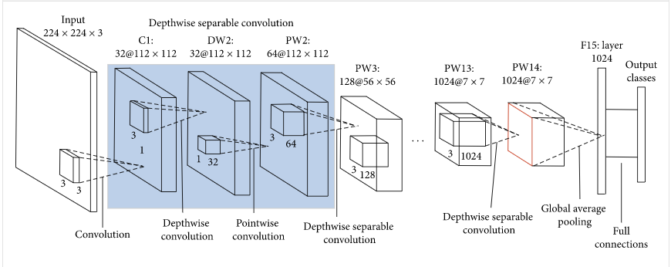

Layers in MobileNet:

It has the following layers.

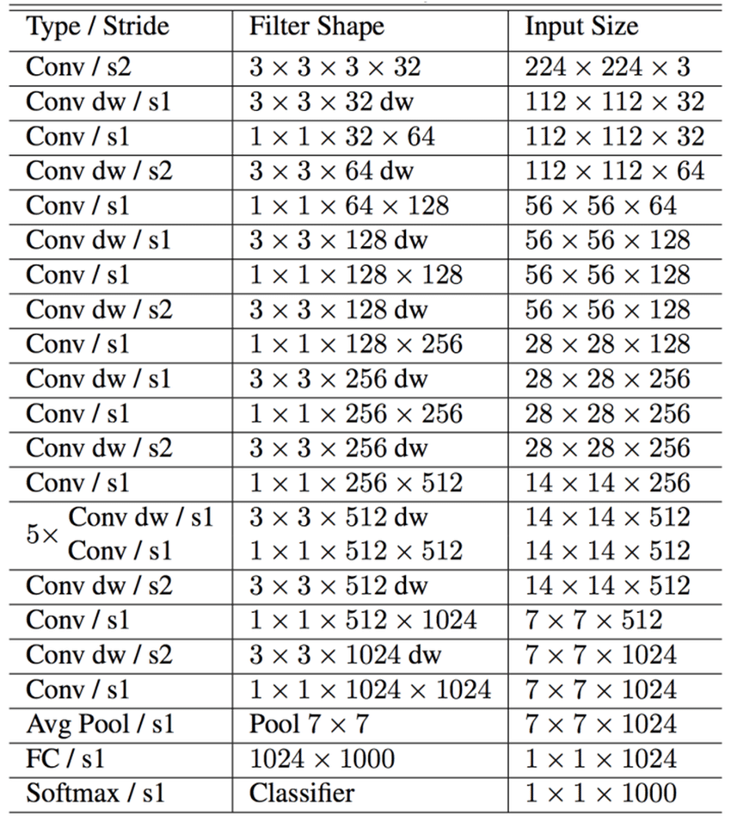

It is one of the best model for image detection so we use this model for transfer learning in order to make it learn our own face and recognise it when needed.

For this we remove the last output layer and freeze the other layers in it so that the weights in then do not change.

Then we add the fully connected layers on it which we are going to train for our model