**Database Assignment 2**

1. Write a SQL query to know the winner of the 1971 prize for Literature.

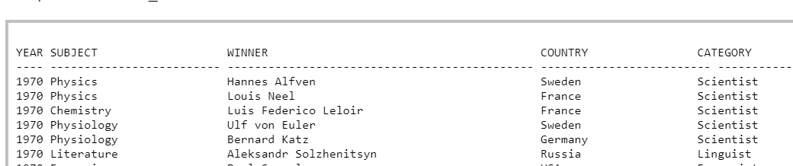

1. For the above data write a SQL query to give the name of the 'Physics' winners since the year 1950.

* Write a SQL query to Show all the details (year, subject, winner, country ) of the Chemistry prize winners between the year 1965 to 1975 inclusive.
* Write a SQL query to show all details of the Prime Ministerial winners after 1972 of Menachem Begin and Yitzhak Rabin.(NOTE : Use ‘in’ clause)
* Write a SQL query to show all the winners of nobel prize in the year 1970 except the subject Physiology and Economics(NOTE: Can use ‘not in’).
* Write a SQL query to show the winners of a 'Physiology' prize in an early year before 1971 together with winners of a 'Peace' prize in a later year on and after the 1974.(NOTE : can use ‘union’)

1. Write a SQL query to find all the products with a price between Rs.200 and Rs.600.

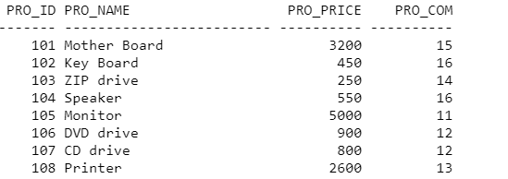

* Write a SQL query to calculate the average price of all products of the manufacturer which code is 16.
* Write a SQL query to find the pro_name as item name and pro_price as price in Rs.
* Write a SQL query to display the name and price of all the items with a price is equal or more than Rs.250, and order it by price in descending order.
* Write a SQL query to find the name and price of the cheapest item(s).

1. Write a query in SQL to find the last name of all employees, without duplicates.

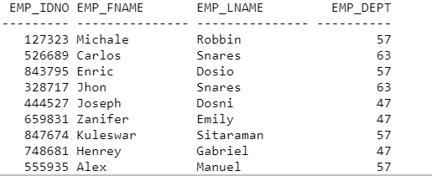

* Write a query in SQL to display all the data of employees that work in the department 57.

1. Consider the following relation:

Emp(ename,company_name,salary,job,depno)

Write the following sql queries:

* Display the salary by increasing the salary column by 3000
* Find the company name whose salary is lowest salary
* Find the total salary where company name is TCS.