Session-1
- Install MySQL Workbench on your computer, connect to the local MySQL server, and take a screenshot of the default databases shown in the Schemas panel.
Ans.
1.Open the xampp control panel on your computer.
2.Click the start button next to mysql(and apache if needed).
3.Ensure the MySQL text turns green, indicating it is running successfully.
I am using the xampp control panels show the screen shorts
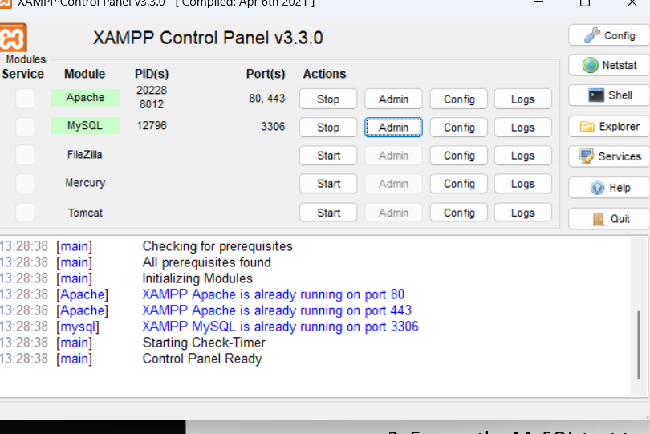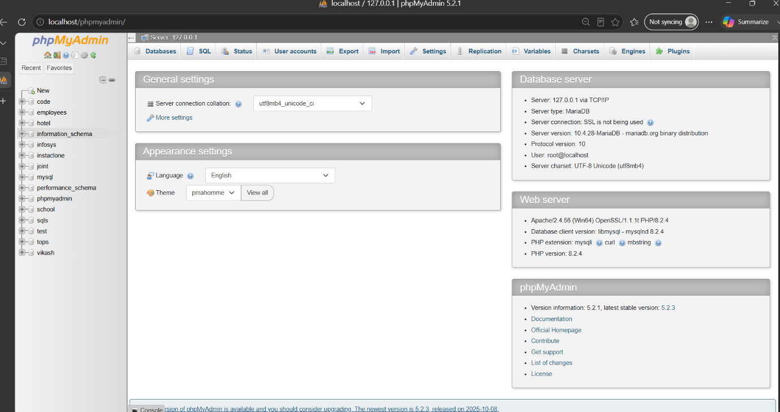

- Create a new database called InstaClone in MySQL Workbench, then create a table named Users with columns: user_id (INT, primary key), username (VARCHAR), email (VARCHAR), and followers_count (INT).
Ans.
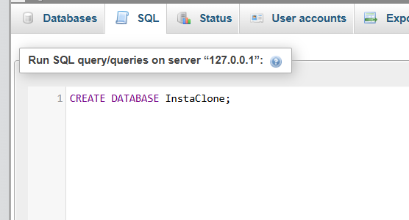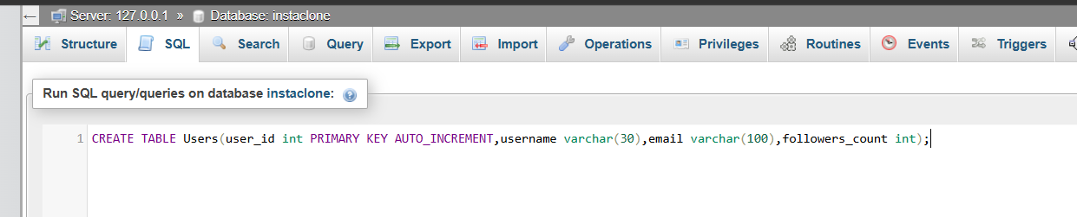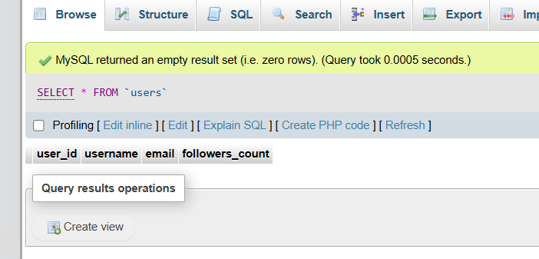
- Insert 3 sample users into the Users table you created, using realistic Instagram-style usernames and follower counts.
Ans.
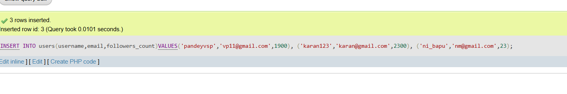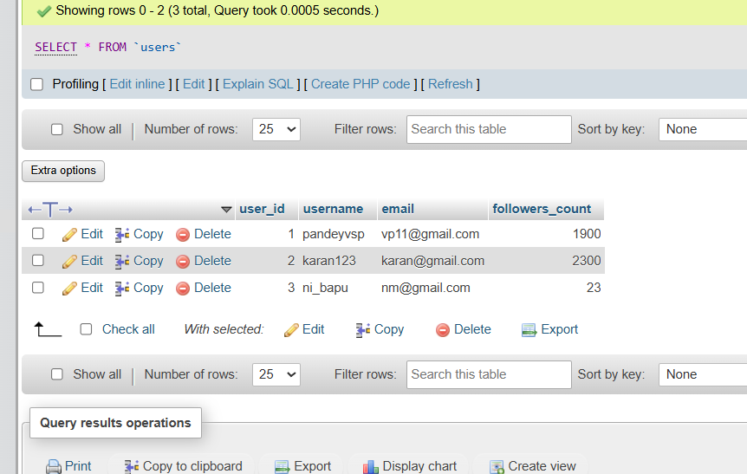
- Create another table in the InstaClone database called Posts with columns: post_id (INT, primary key), user_id (INT), caption (VARCHAR), and post_date (DATE). Add a foreign key from Posts.user_id to Users.user_id to establish a relationship.
Ans.
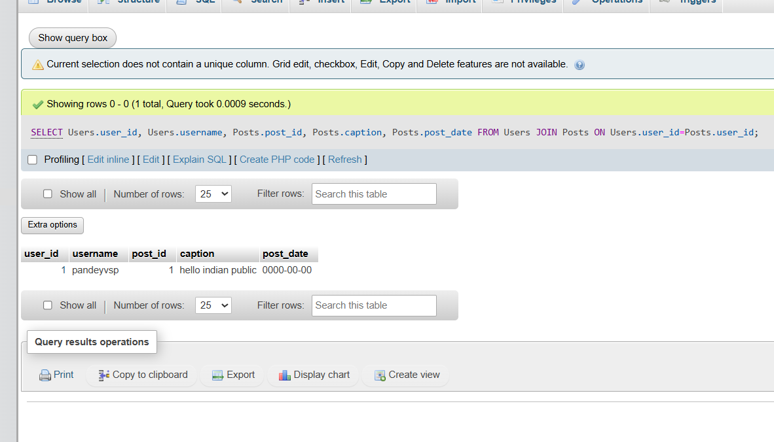
- Write a short comparison (3-4 lines each) of MySQL, PostgreSQL, Oracle, and SQLite, focusing on where each one is commonly used (for example: web apps, mobile apps, enterprise systems, etc.).
Ans.

MySQL
MySQL is the standard database choice for web applications, content management systems like WordPress, and e-commerce platforms. It balances speed, reliability, and ease of use, making it popular among startups and giant tech platforms alike. This database excels in read-heavy environments where rapid data retrieval is essential.

PostgreSQL
PostgreSQL is a powerful object-relational database favored for complex web applications, financial systems, and data analytics. It offers advanced data types, strict SQL compliance, and robust support for concurrent write operations. Developers choose it when data integrity, extensibility, and complicated queries are primary requirements.

Oracle
Oracle is a high-performance enterprise database designed for massive corporations, banking systems, and large-scale industrial applications. It provides top-tier security, unmatched scalability, and advanced features for handling mission-critical, high-volume transactions. Organizations choose it when they require dedicated vendor support and have the budget for premium licensing.

SQLite
SQLite is a lightweight, file-based database built directly into mobile applications, desktop software, and internet-of-things (IoT) devices. It operates without a separate server process, storing the entire database within a single file on the host machine. This makes it perfect for local storage, rapid prototyping, and applications with low-concurrency needs

Session-2
- Open MySQL Workbench or CLI and write a CREATE TABLE statement to create a table called 'restaurants' with columns: id (INT, primary key, auto-increment), name (VARCHAR(100)), location (VARCHAR(100)), and rating (DECIMAL(2,1)).
Ans.

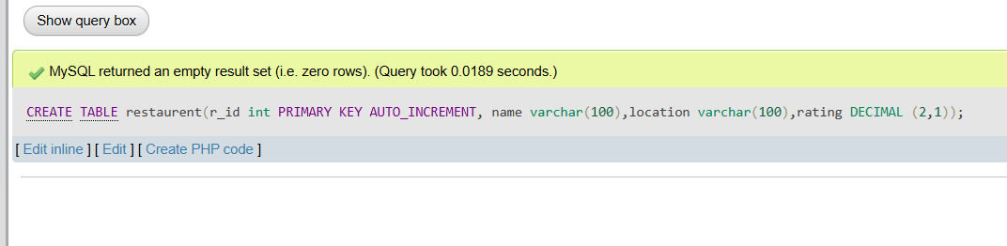
- Use the ALTER TABLE command in MySQL to add a new column 'average_cost' (INT) to your 'restaurants' table.<br><br><em><strong>Hint:</strong> Remember to specify the data type when adding a new column.</em>
Ans.
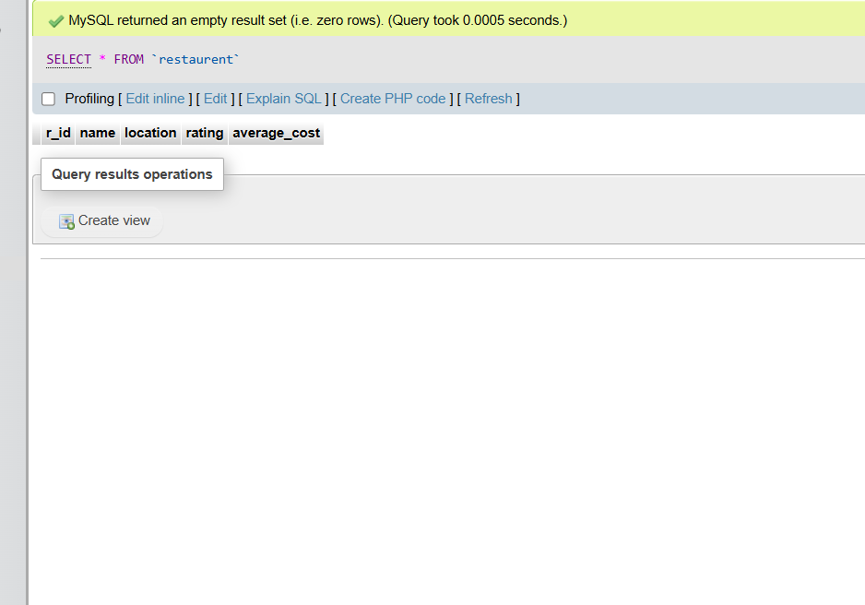
- Write a SQL statement to DROP the 'restaurants' table you created earlier. Double-check your command before running it to avoid accidental data loss.
Ans.
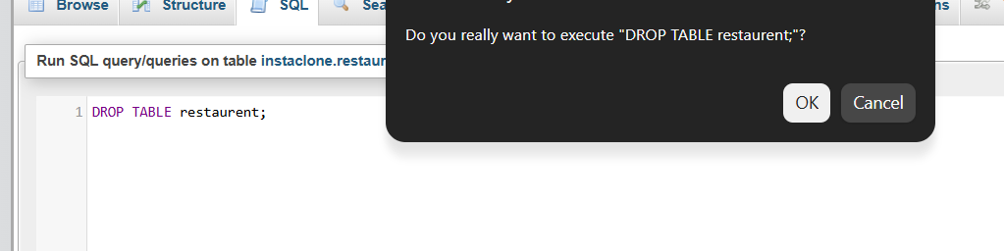
- Create a new table called 'playlists' for a music app like Spotify, with columns: playlist_id (INT, primary key, auto-increment), title (VARCHAR(50)), created_by (VARCHAR(50)), and created_at (DATE).
Ans.
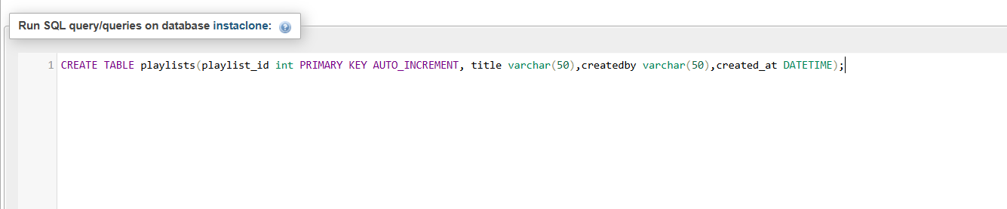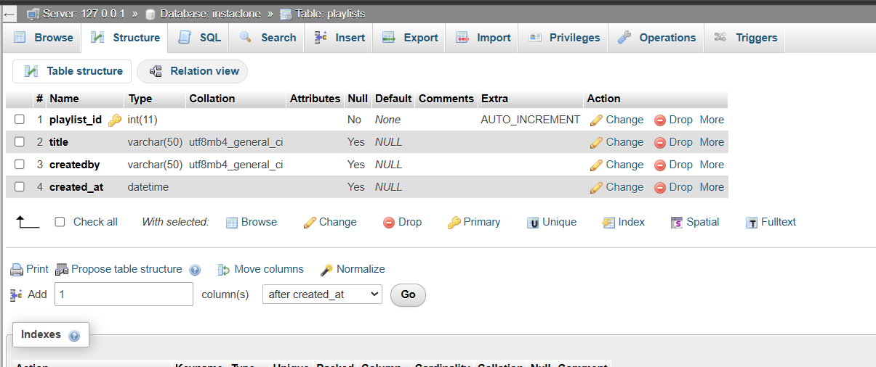

Session-3
- Create a SQL table called Restaurants with columns: id (INT, auto-increment), name (VARCHAR), cuisine (VARCHAR), rating (DECIMAL), and city (VARCHAR). Insert 5 sample restaurants into the table, each with a different cuisine and rating.
Ans.

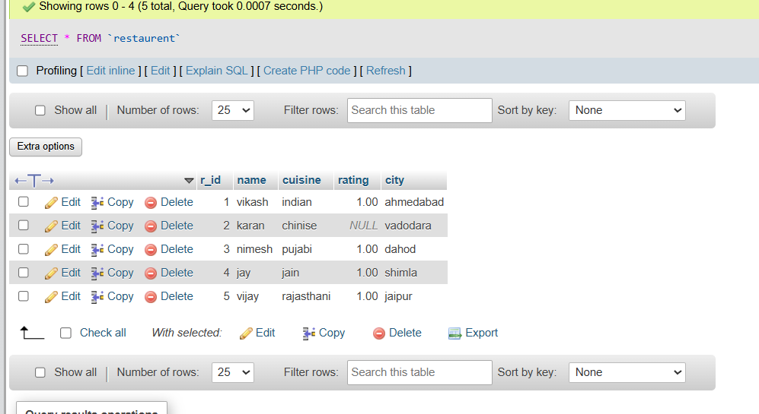

- Write a SQL UPDATE statement to change the rating of the restaurant named 'Spice Villa' to 4.7 in the Restaurants table.
Ans.
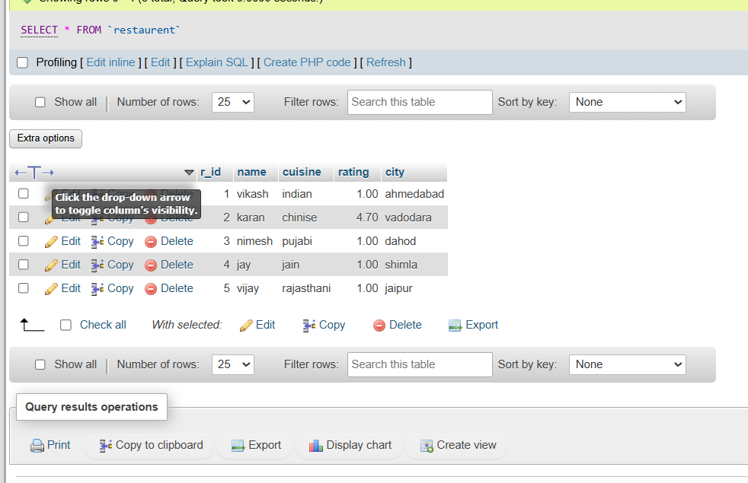

- Delete all restaurants from the Restaurants table where the rating is less than 3.5 using a SQL DELETE statement.
Ans. 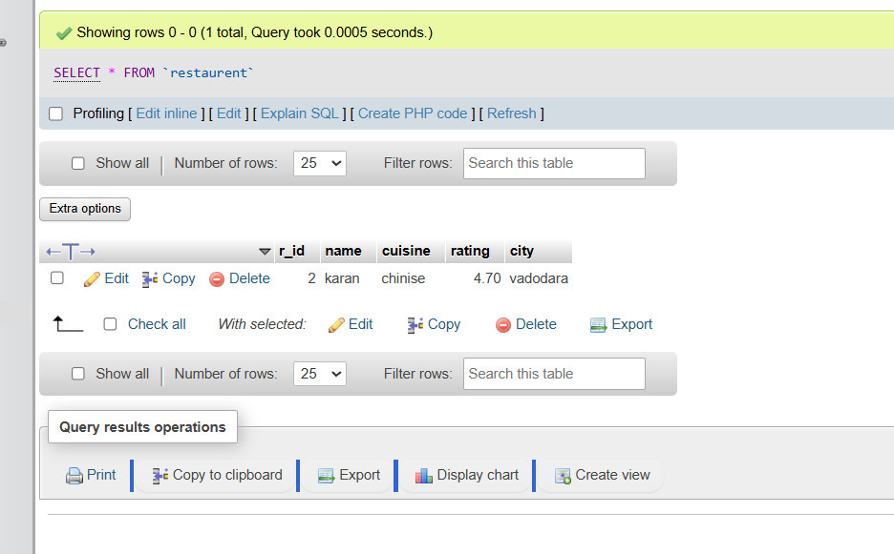

- Use a SELECT query with WHERE and LIMIT to fetch the top 2 restaurants in the city 'Ahmedabad' with a rating above 4.0 from the Restaurants table.<br><br><em><strong>Hint:</strong> Combine WHERE for city and rating, and LIMIT to restrict the number of results.</em>
Ans.
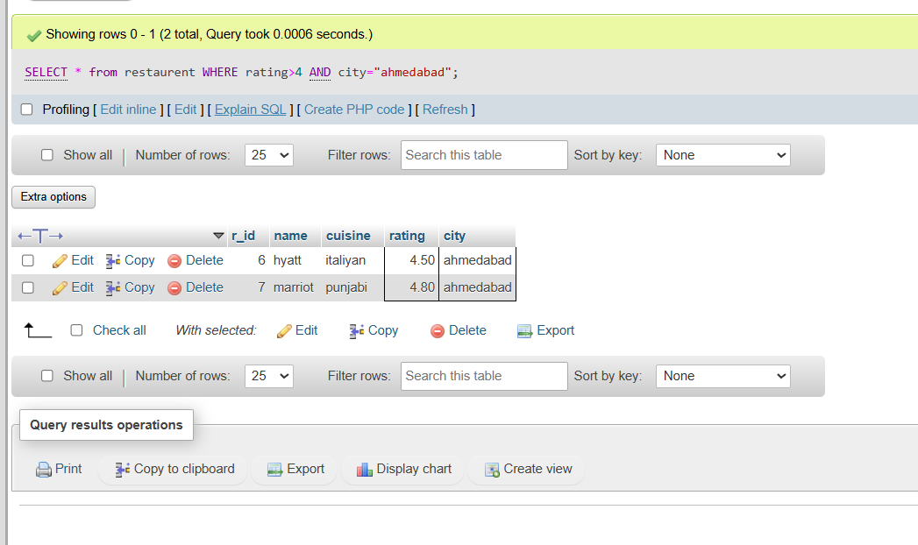

Session-4
1.Create a table called Playlist with columns: id, song_name, artist, genre, and play_count. Insert at least 5 sample records representing your favorite songs from Spotify.
Ans. 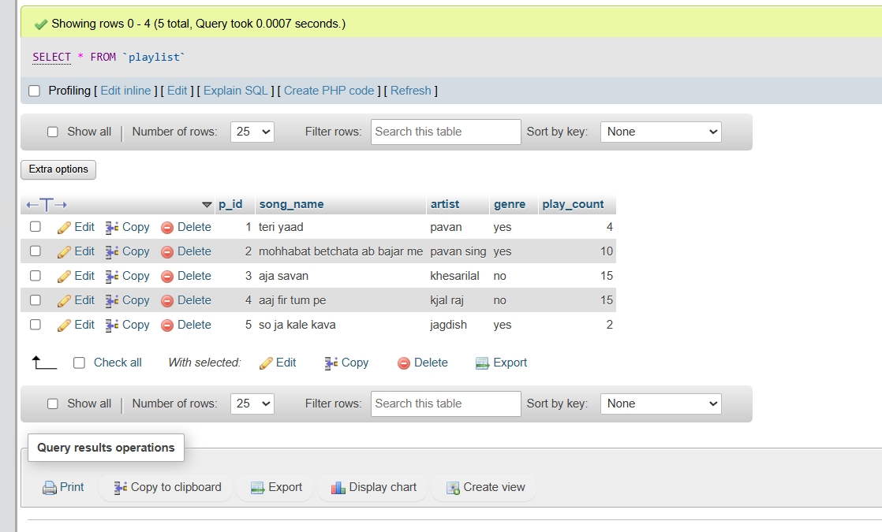

2.Write a SELECT query to display only the song_name and artist from the Playlist table, but show the artist column as 'Singer' using an alias.
Ans.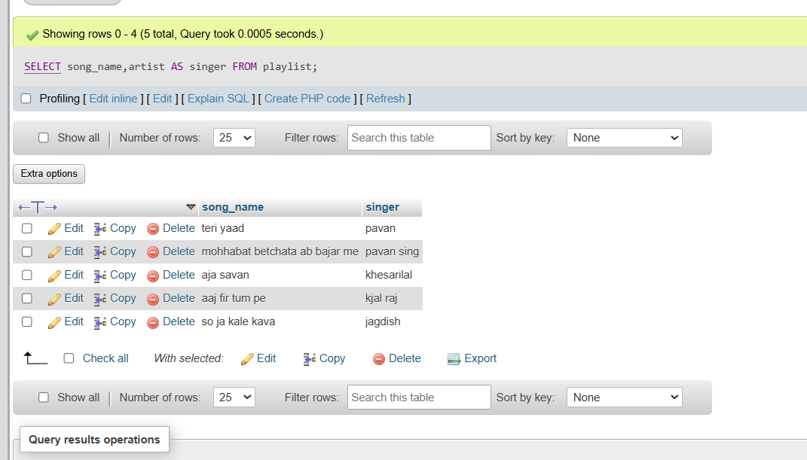

3.Write a SELECT query to find all songs in the Playlist table where the genre is 'Pop' and play_count is greater than 100. Sort the results by play_count in descending order.
Ans.
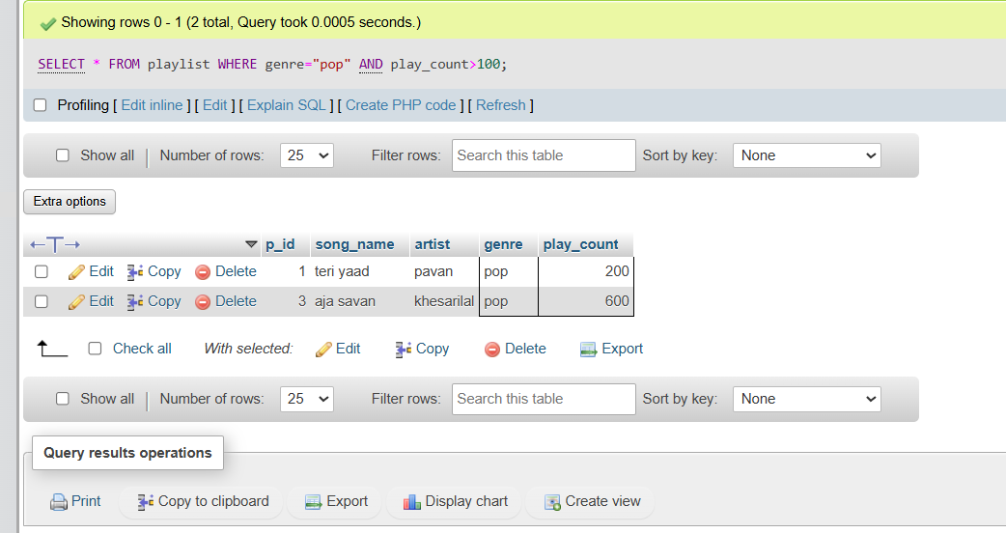

4.Use the COUNT aggregate function to find out how many songs in your Playlist table belong to the genre 'Hip-Hop'.
Ans.
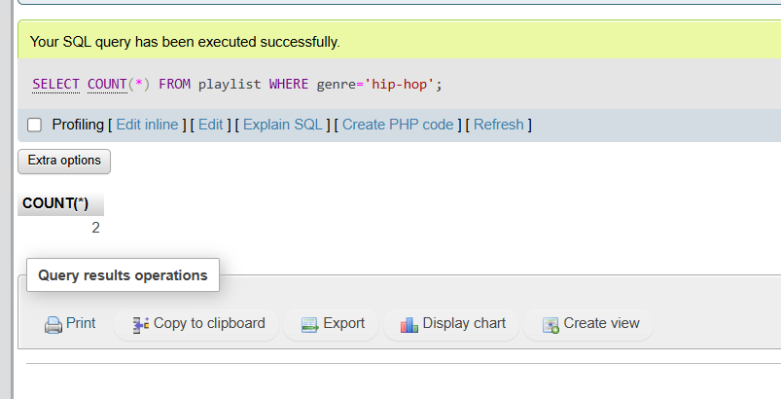

5.
Write a SELECT query that shows the total number of plays (SUM of play_count) for each genre in your Playlist table, grouped by genre.<br><br><em><strong>Hint:</strong> Use GROUP BY with the SUM function to aggregate play counts by genre.</em>
Ans.

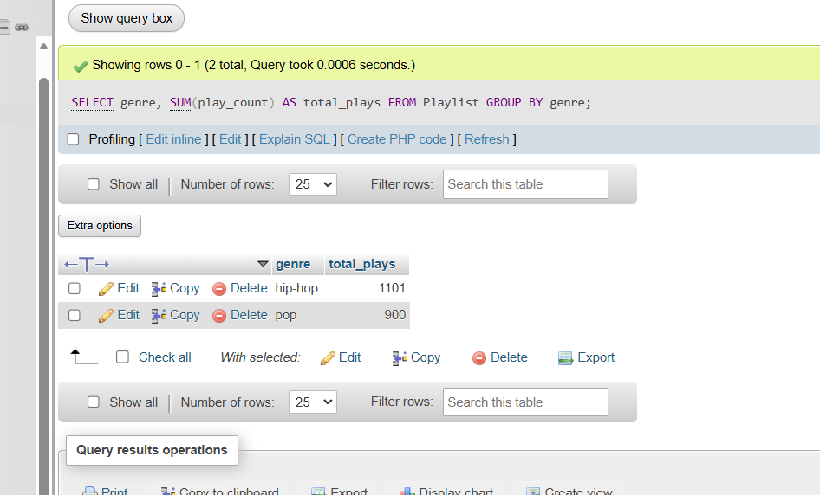

Session-5
- Create two tables in SQL: influencers (with influencer_id as PRIMARY KEY and name) and posts (with post_id as PRIMARY KEY, influencer_id as FOREIGN KEY, and caption). Insert at least 3 influencers and 2 posts for each influencer.
Ans.
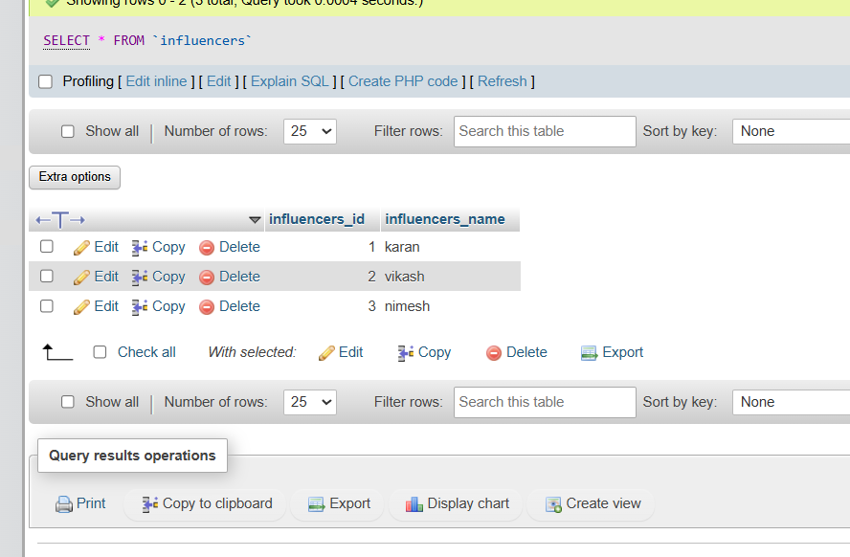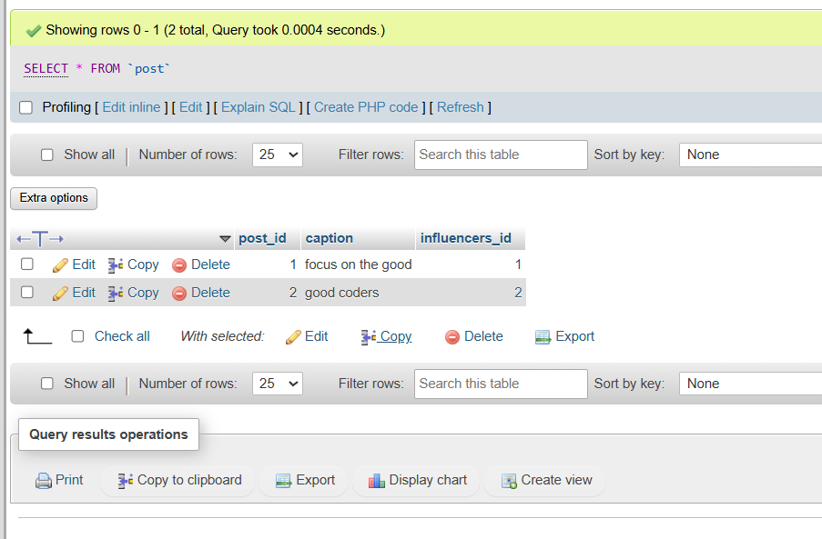
2.Write an SQL query using INNER JOIN to display each post's caption along with the name of the influencer who posted it, based on the tables you created.
Ans.
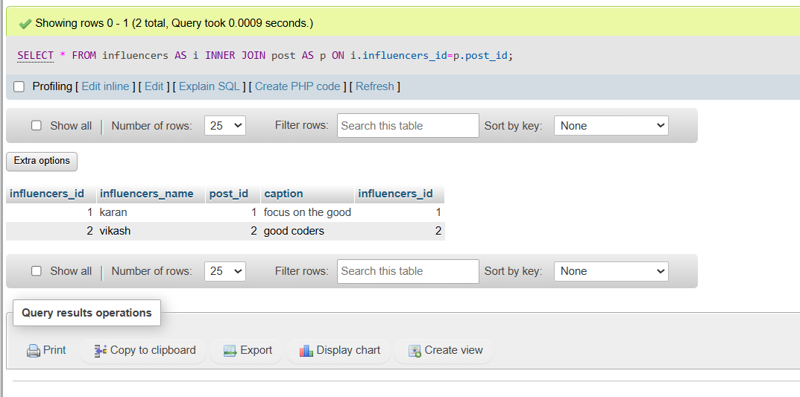

3.Write an SQL query using LEFT JOIN to show all influencers and their posts, including influencers who haven't posted anything yet. If an influencer has no posts, display 'No Posts' in the caption column.<br><br><em><strong>Hint:</strong> Use IFNULL or COALESCE to handle NULL values in the result.</em>
Ans.
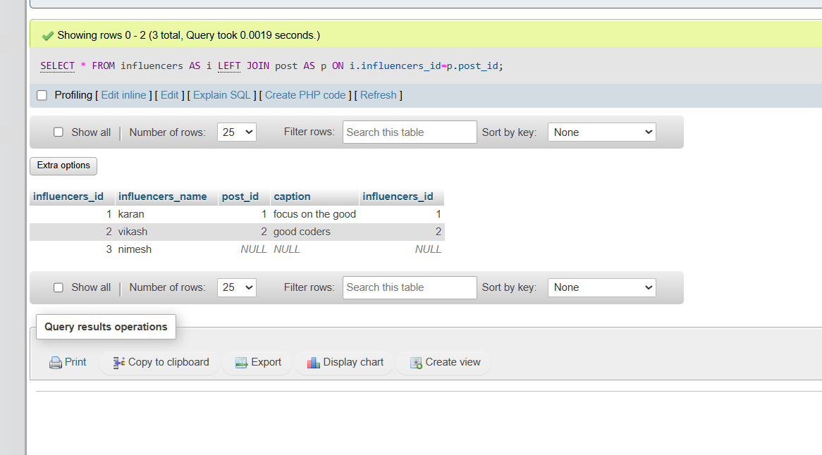

4.Write an SQL query using RIGHT JOIN to list all posts and the corresponding influencer's name, ensuring that even posts without a matching influencer_id (if any) are shown.
Ans. 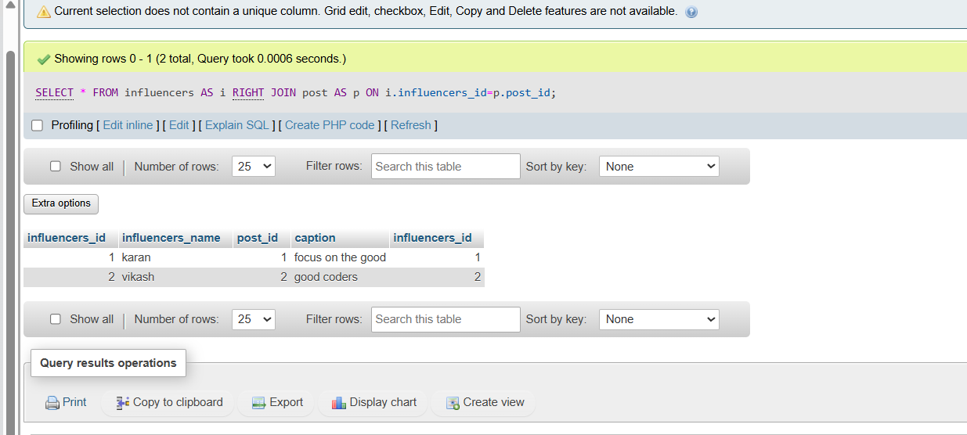

Session -6
- Create a SQL query using GROUP BY to show the total number of orders placed by each user in an 'orders' table, displaying user_id and order_count.
Ans. 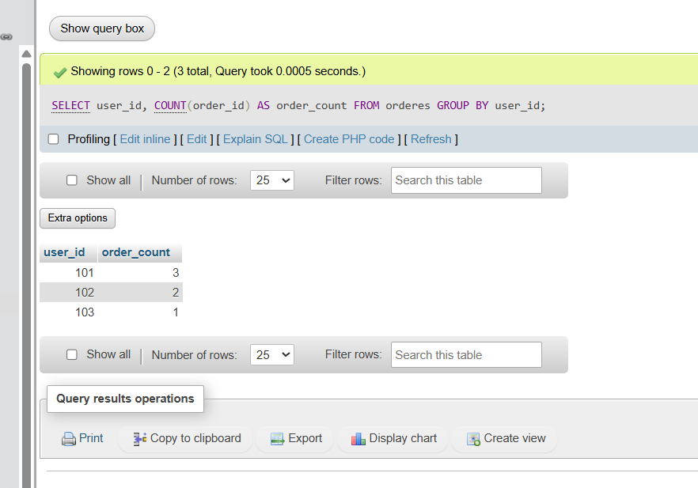

2 . Write a SQL query to display the names of restaurants from a 'restaurants' table that have received an average rating above 4.0, using GROUP BY and HAVING.
Ans.
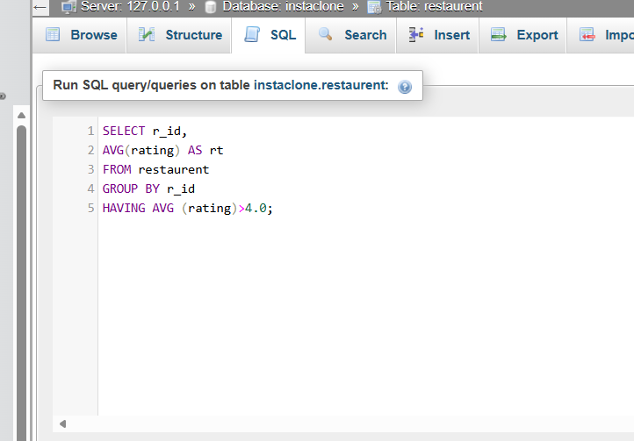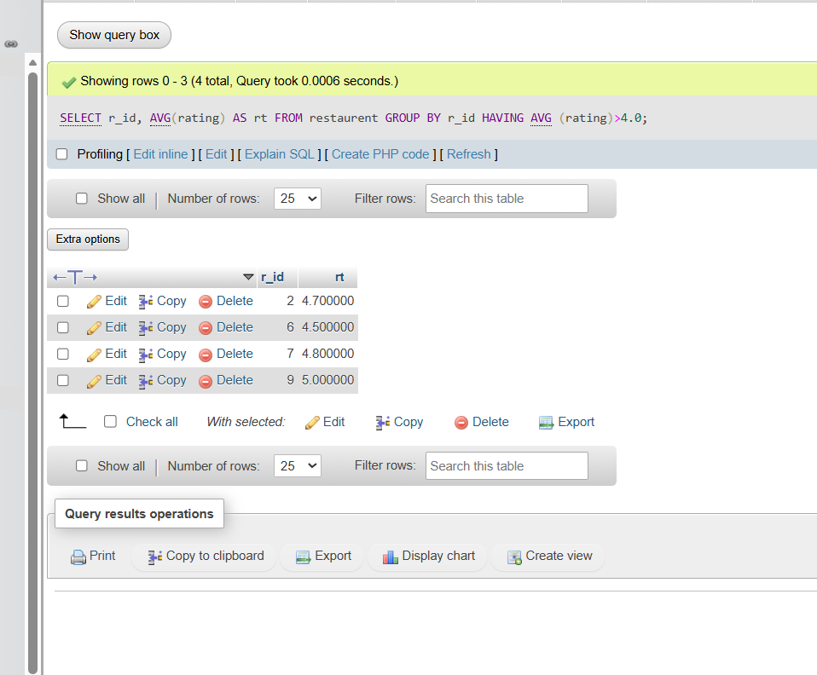

- Suppose you have a 'payments' table with columns user_id, amount, and payment_date. Write a subquery to find user_ids who have made a single payment above ₹2000 in any transaction.
Ans.
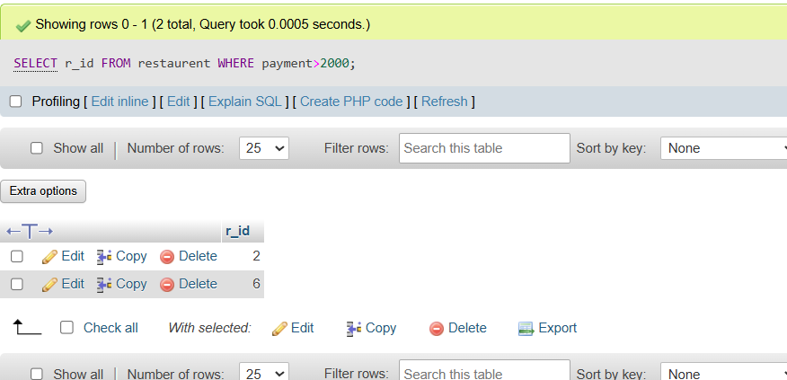

- Using a nested subquery, display the names of movies from a 'movies' table that have a higher average rating than the overall average rating of all movies.<br><br><em><strong>Hint:</strong> Use a subquery to calculate the overall average rating, then compare each movie's average rating against it in the main query.</em>
Ans. 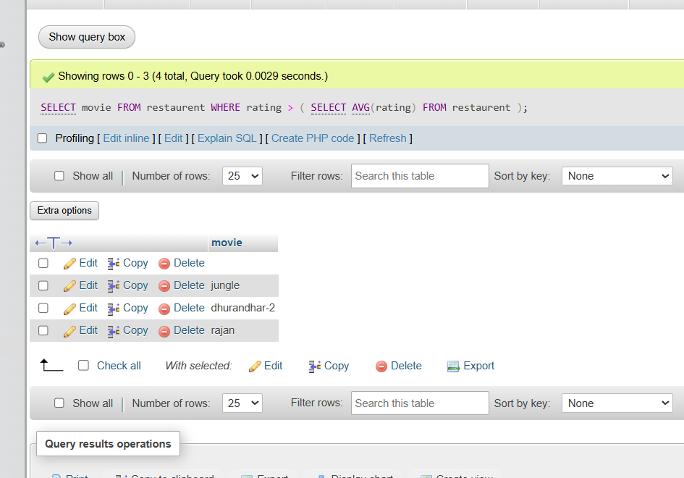

Session-7
- Create a table called Restaurant with columns: id, name, location, and cuisine. Apply NOT NULL constraint to name and location, and make id the PRIMARY KEY.
Ans.
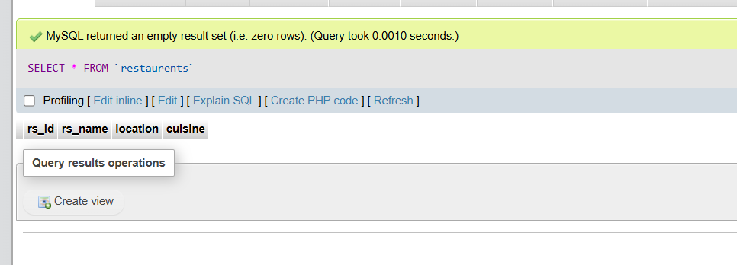

- Create a table called FoodOrder with columns: order_id, restaurant_id, user_id, and order_total. Set order_id as PRIMARY KEY, and add a FOREIGN KEY constraint on restaurant_id referencing Restaurant(id).
Ans. 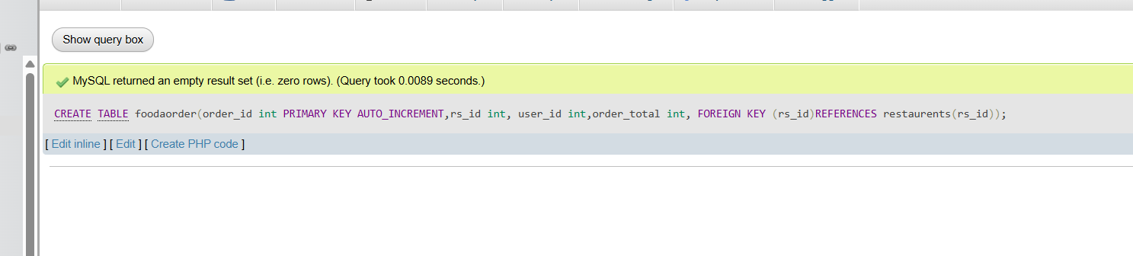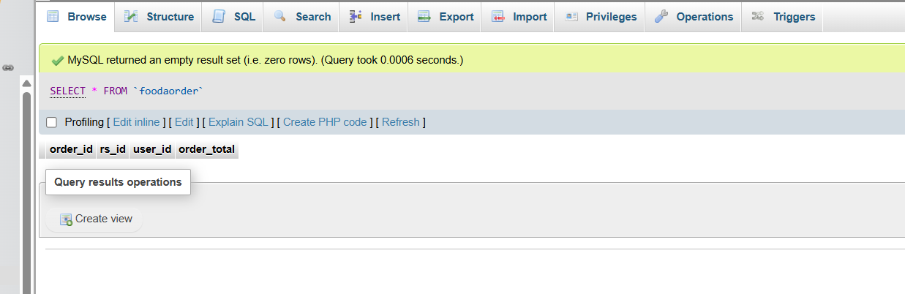

- Insert 6 rows into a table called SpotifyUser with columns: user_id, username, email, and subscription_type. Ensure that username is UNIQUE and email is NOT NULL.<br><br><em><strong>Hint:</strong> Use the UNIQUE and NOT NULL constraints when creating the table.</em>
Ans. 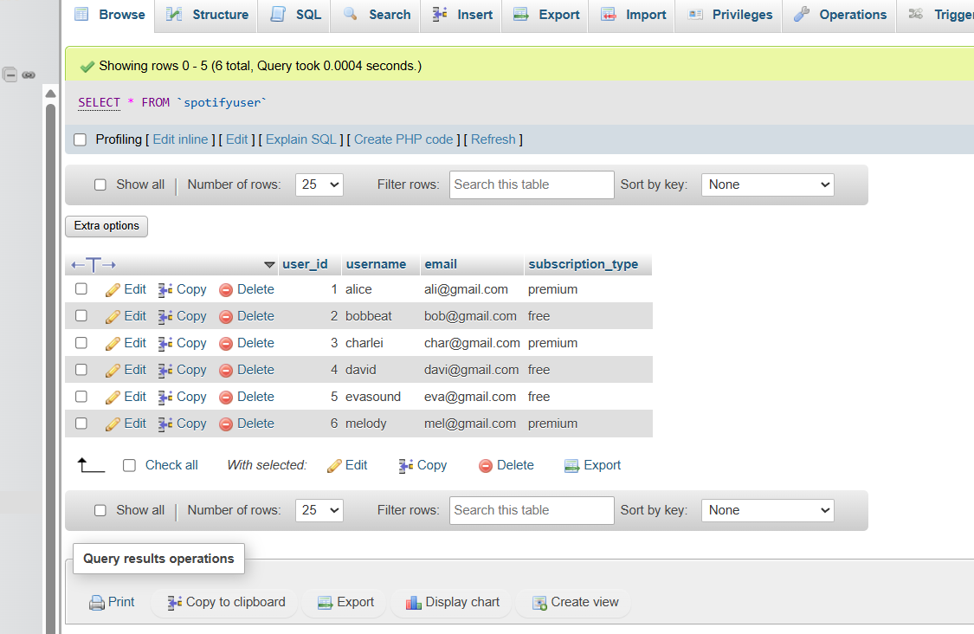

- Create a VIEW named TopSpendersView that shows usernames and order_total from a FoodOrder table where order_total is greater than 1000.
Ans. 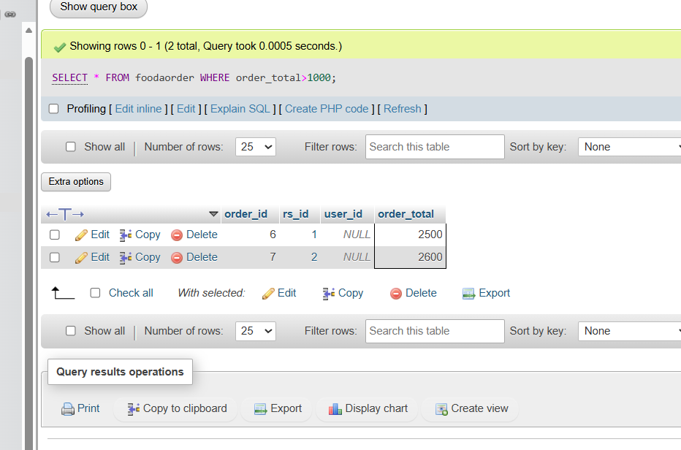
SESSION -8
- Write a PL/SQL block that declares two variables: one for a user's name (VARCHAR2) and one for their age (NUMBER). Assign values and print both using DBMS_OUTPUT.PUT_LINE.
Ans.

- Create a PL/SQL block that uses an IF statement to check if a given order amount is above 500. If yes, print 'Eligible for free delivery', else print 'Delivery charges apply'.
Ans. 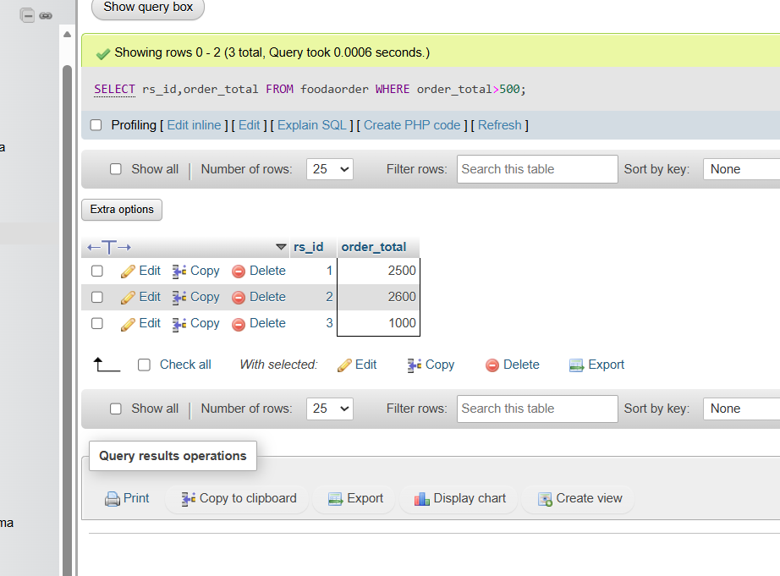

- Write a PL/SQL block that uses a simple LOOP to print the numbers 1 to 5 using DBMS_OUTPUT.PUT_LINE.<br><br><em><strong>Hint:</strong> Use a counter variable and EXIT WHEN condition inside the loop.</em>
Ans.

- Declare a cursor in PL/SQL to select all product names from a table called PRODUCTS. Fetch each product name and print it using DBMS_OUTPUT.PUT_LINE.<br><br><em><strong>Hint:</strong> Assume the PRODUCTS table has a column PRODUCT_NAME.</em>
Ans.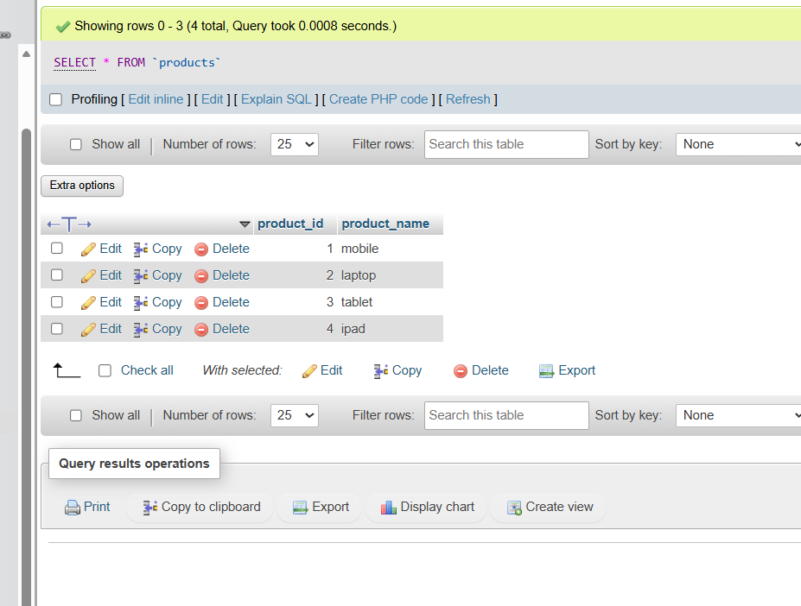

- Write a PL/SQL block that tries to divide two numbers entered as variables. If a division by zero occurs, catch the exception and print 'Cannot divide by zero'. Otherwise, print the result.
Ans.

Session-9

1.Create a SQL script to insert a new order into an Orders table, then use COMMIT to save the transaction and verify that the new order persists after reconnecting to the database.
Ans.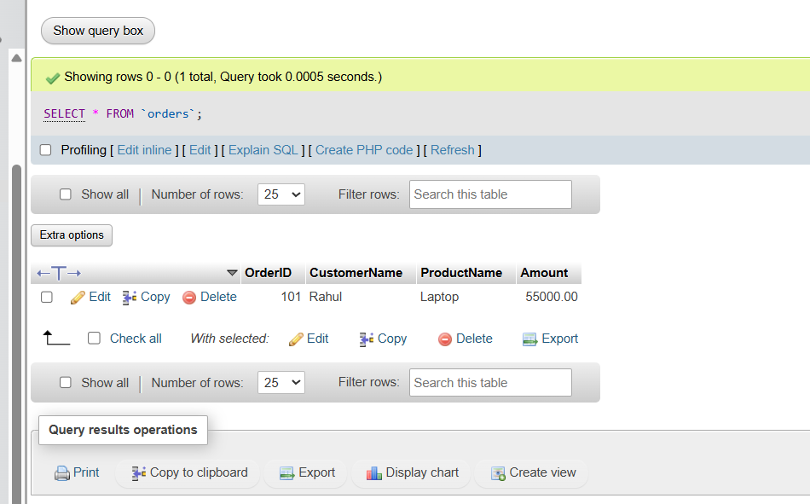

2.Simulate a Zomato-style food order process: insert two new items into an OrderItems table, then use ROLLBACK to undo the changes before committing. Check that no new items remain in the table after rollback.
Ans. 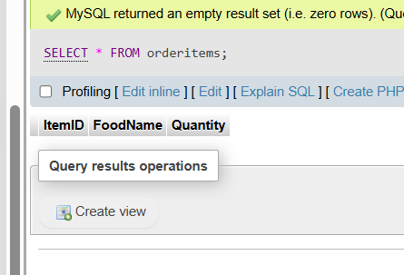

3.In a Flipkart-like shopping cart scenario, use SAVEPOINT to mark a point after adding a product to the Cart table, add another product, then use ROLLBACK TO SAVEPOINT to undo only the last addition. Show the final contents of the Cart table.
Ans.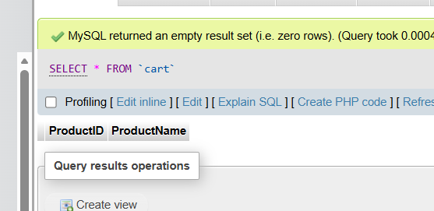

4.Write a trigger on a Wallet table that automatically deducts the purchase amount from the user's balance whenever a new transaction is inserted, similar to how Paytm updates wallet balance after a payment.
Ans. 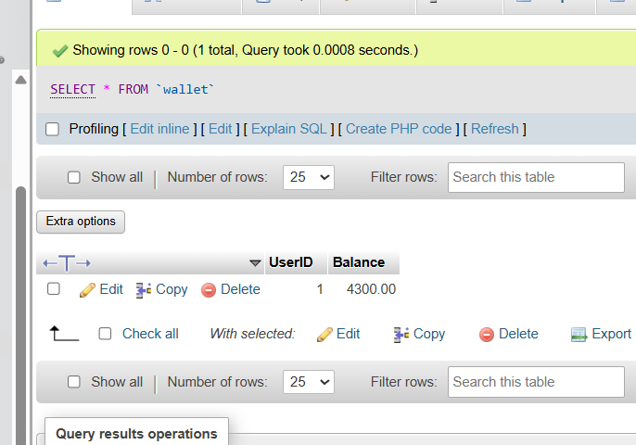

5.Use ChatGPT to generate a SQL test scenario where a trigger incorrectly updates a user's balance after an expense entry. Paste the scenario and your corrected trigger code, explaining how you fixed the error.<br><br><em><strong>Hint:</strong> Ask ChatGPT for a buggy trigger example and a test case that exposes the bug.</em>
Ans. 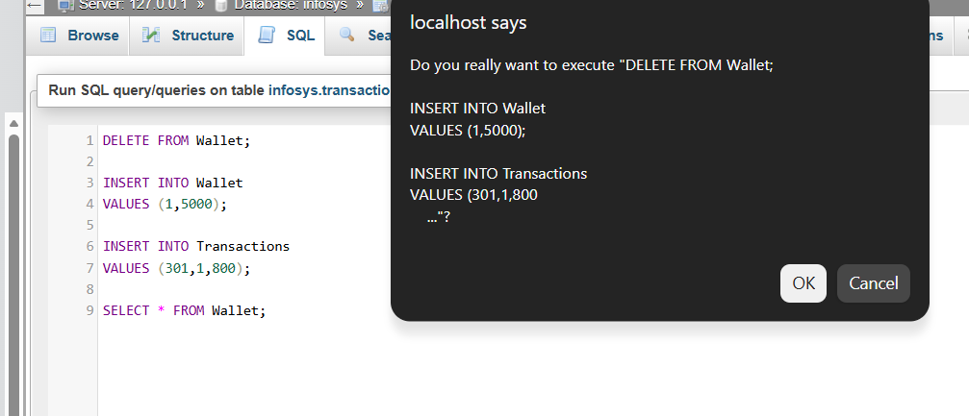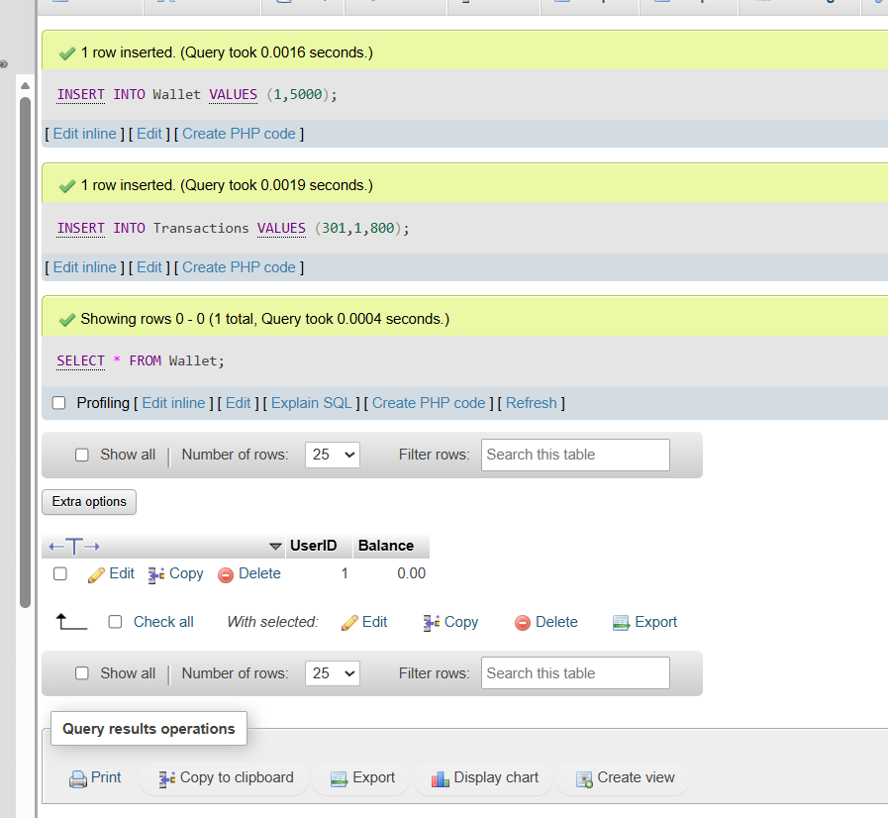

MiniProject
- Create a SQL script to insert a new order into an Orders table, then use COMMIT to save the transaction and verify that the new order persists after reconnecting to the database.
Ans. 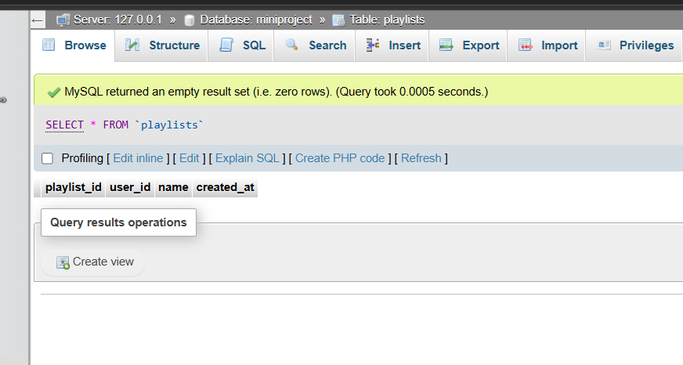

- Insert three sample records into the playlists table: one for a user with a 'Workout Mix', one with a 'Chill Vibes', and one with a 'Top Hits' playlist. Use realistic data for each field.

Ans. 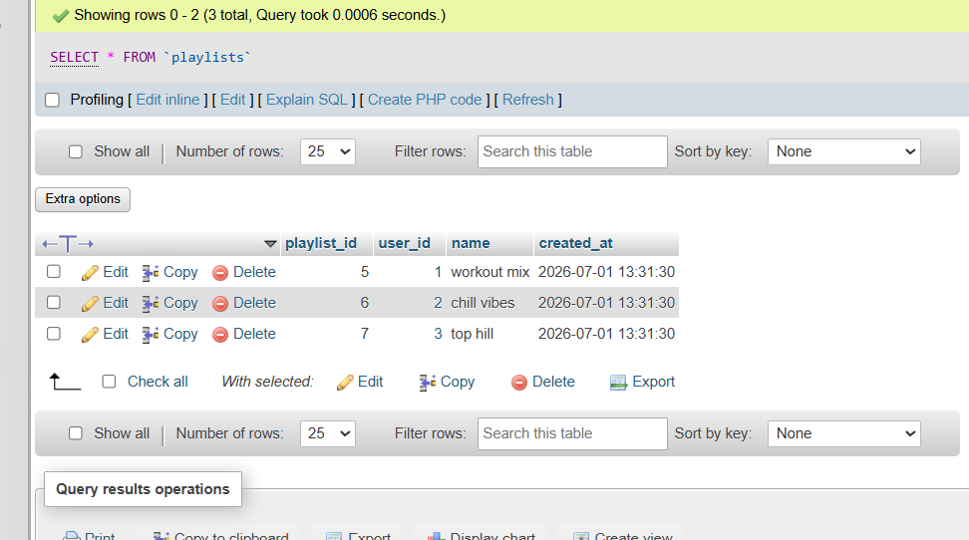
- Write an SQL UPDATE statement to rename the 'Chill Vibes' playlist to 'Evening Chill' for a specific user_id.
Ans. 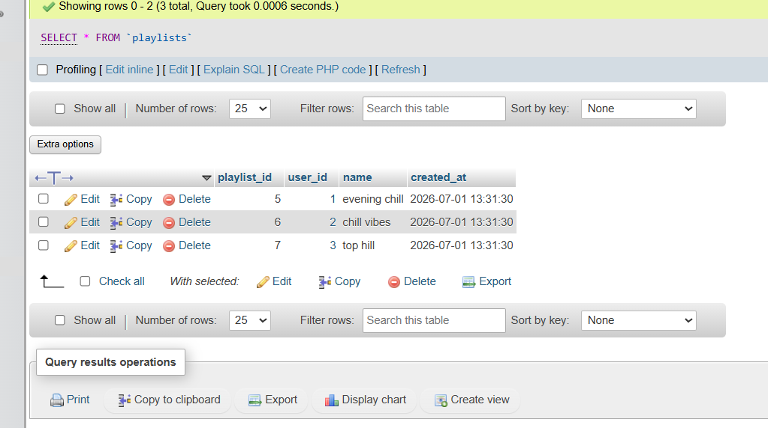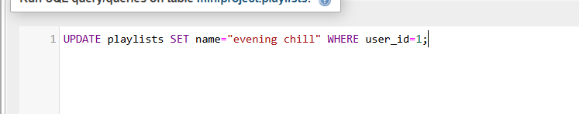

- Write a DELETE statement to remove a playlist named 'Workout Mix' for a given user_id from the playlists table.<br><br><em><strong>Hint:</strong> Make sure your WHERE clause targets only the intended row.</em>
Ans. 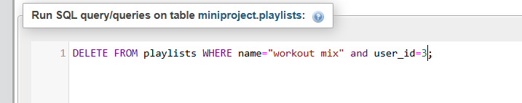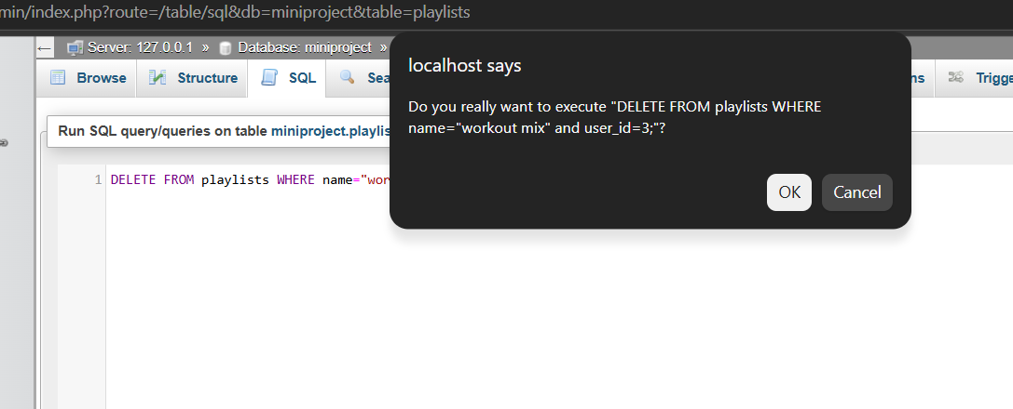

- Create a stored procedure named GetMonthlyPlaylistCount that takes a user_id and a month (as an integer) as input, and returns the total number of playlists the user created in that month.<br><br><em><strong>Hint:</strong> Use the MONTH() function in your WHERE clause.</em>
Ans.
